Figure 1 Thermogravimetric analyses for the Ni samples.
Figure 2 H₂-TPR analyses for the Ni samples.

Figure 3 X-ray diffraction patterns of the fresh Ni samples and the γ-Al₂O₃ support.

Figure 4 TEM images of the fresh (a, b) Ni_{inc}, and (c, d) Ni_{wet} samples.

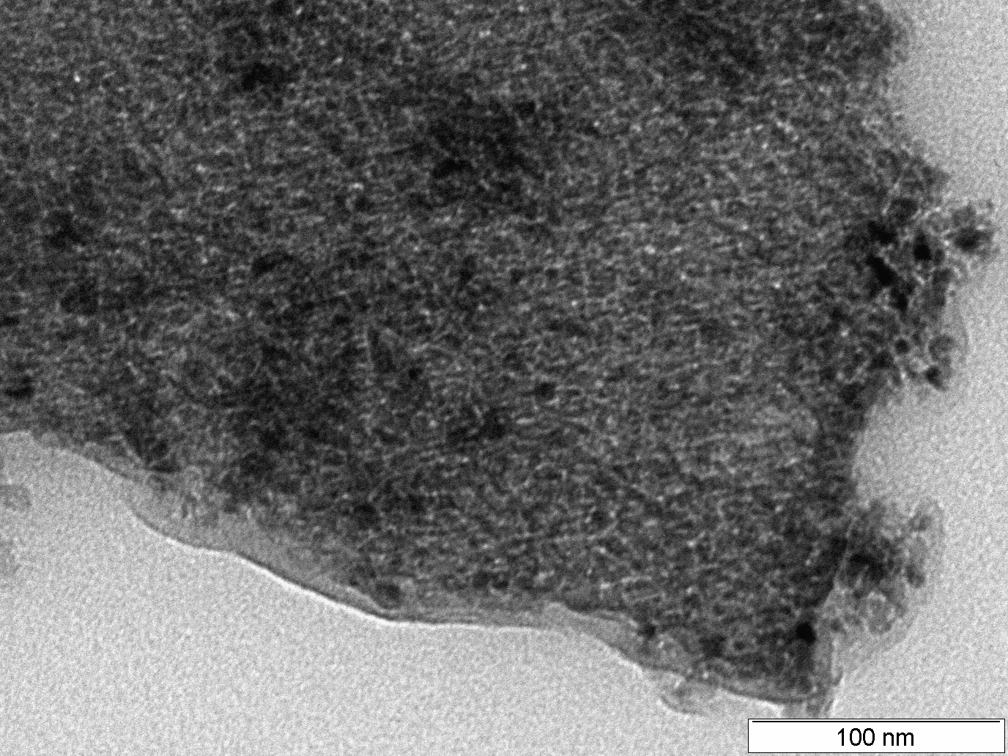  (a) | 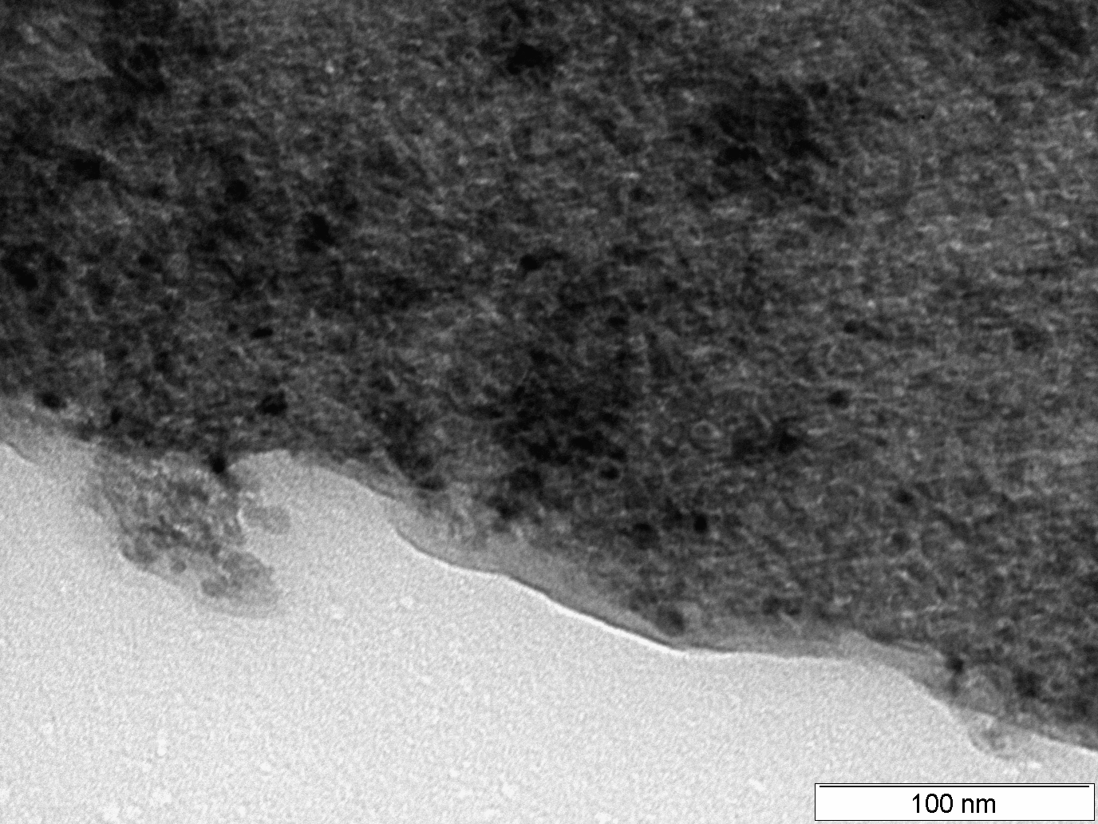  (b)
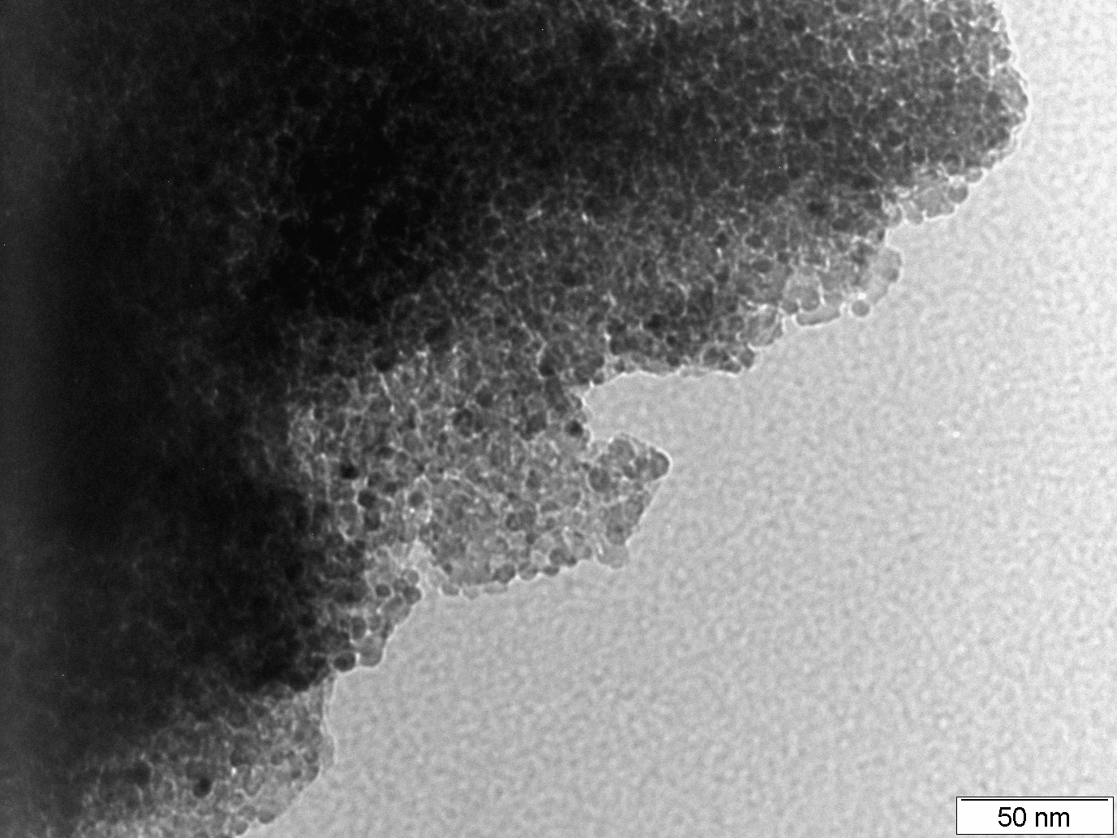  (c) | 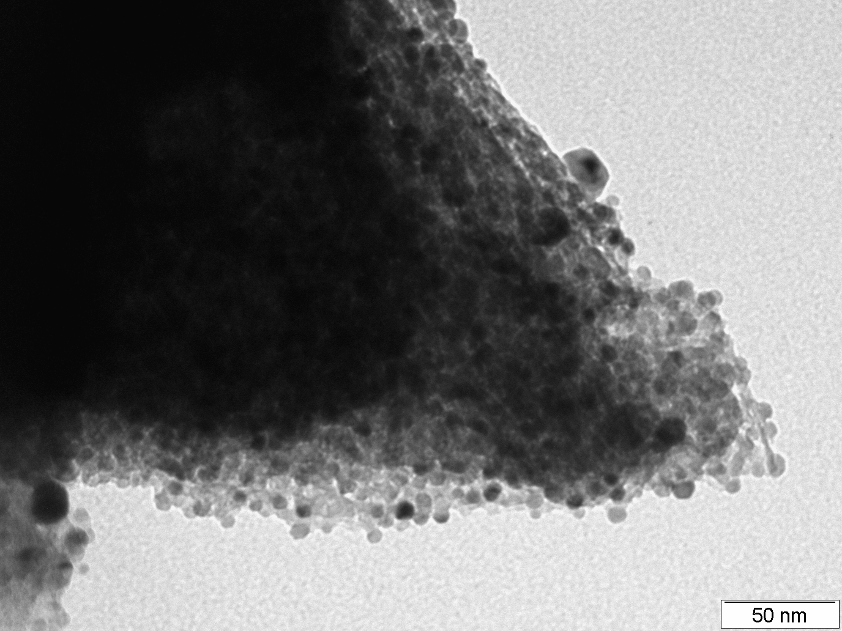  (d)

Figure 5 (a) N2-physisorption isotherms, and (b) Pore size distribution of the fresh Ni/γ-Al2O3 samples

Figure 6 Catalytic performances of the Ni catalysts in function of time of reaction.

Figure 7 Time-on stream product selectivity in glycerol conversion over (a) Ni_{inc} and (b) Ni_{wet}

Figure 8 Infrared spectra of reduced Ni catalysts after evacuation of CO.

Figure 9 Raman spectra of the used Ni catalysts.

Table 1 Textural and physical-chemical properties of fresh Ni catalysts and γ-Al₂O₃ support.
Sample | S_{BET}  (m²/g) | Pore volume  (cm³/g) |  | Pore size  (nm) | NH₃-TPD  (µmol/g_{sample}) | Number of exposed  Ni atoms
γ-Al₂O₃ | 113 | 0,20 | 4,54 |  | 182,1 | -
Ni_{inc} | 99 | 0,17 | 4,54 |  | 205,4 | 3,43 x 10¹⁹ (33%)ª
Ni_{wet} | 108 | 0,17 | 4,15 |  | 224,5 | 9,22 x 10¹⁹ (82 %)ª

