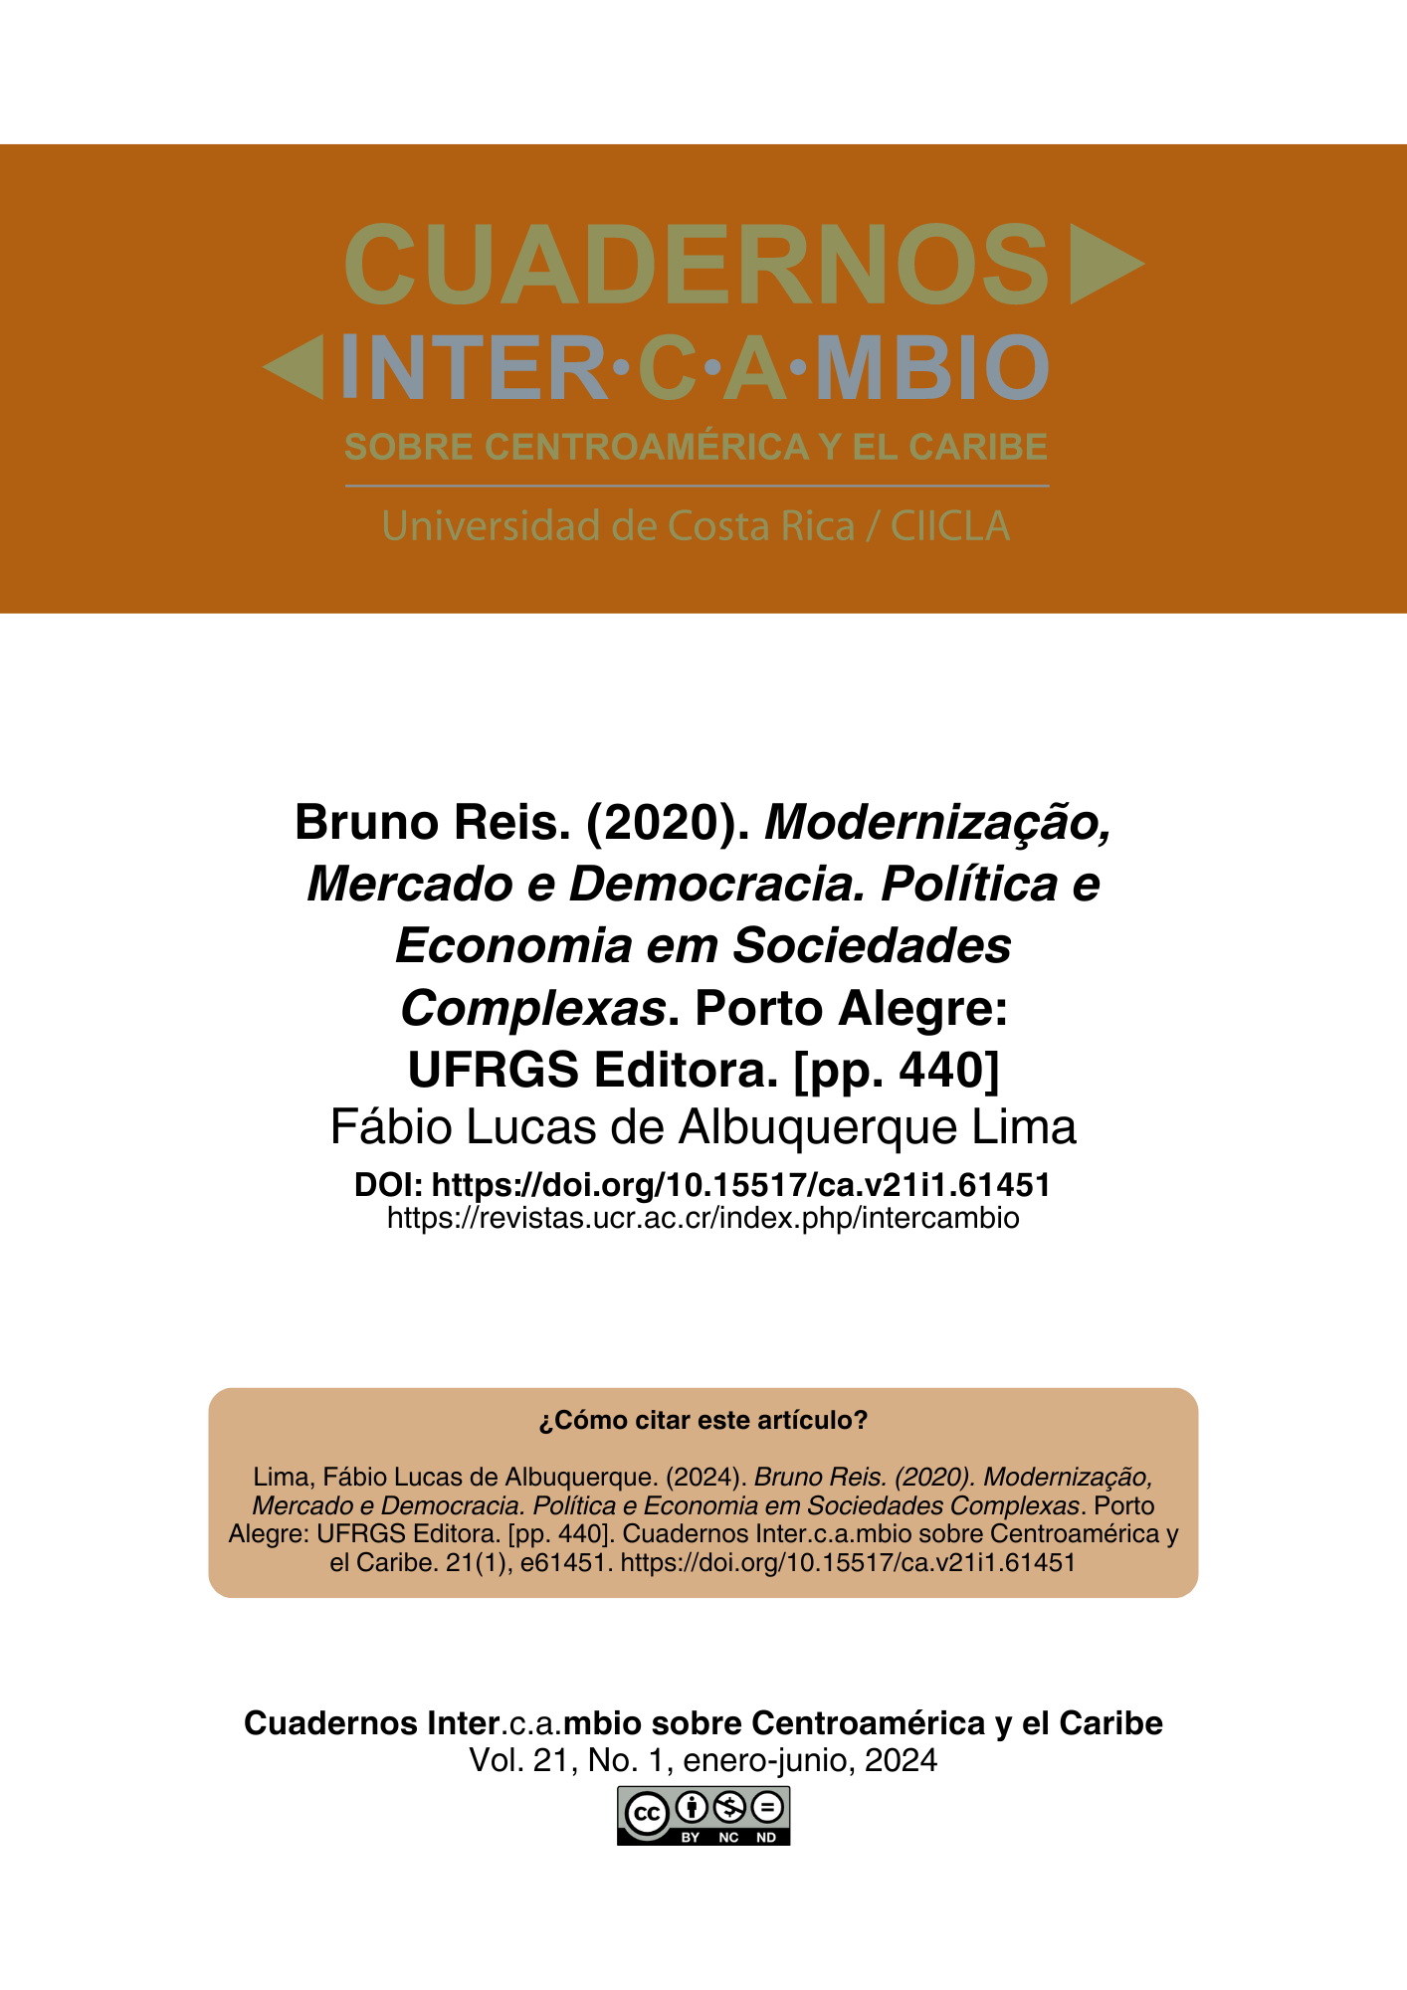
Nota aclaratoria: este PDF no corresponde a la diagramación final del texto, sin embargo, puede ser citado sin problema ya que cuenta con un DOI y paginación electrónica. Al cerrar el número en construcción se reemplazará este PDF por la versión final y se agregarán las otras galeradas (EPUB y HTML).

Reseñas (sección no arbitrada)

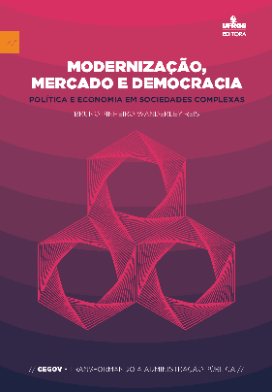
Bruno Reis. (2020). Modernização, Mercado e Democracia. Política e Economia em Sociedades Complexas. Porto Alegre: UFRGS Editora. [pp. 440]

Fábio Lucas de Albuquerque Lima
Centro de Estudos Jurídicos Celso Barroso Leite
fabiolucas74@gmail.com

DOI: https://doi.org/10.15517/ca.v21i1.61451

Introduction

The mechanisms that involve the dynamics of social reality have a camouflage that is difficult to understand. Interactions between state, society, and market are built through the socially established institutional system. One of the roles of Social Sciences and Political Science is to analyze how these interactions happen in social construction. This task is not simple or commonplace in a complex society like Brazil's. In this sense, Bruno Reis, in Modernização, Mercado e Democracia. Política e Economia em Sociedades Complexas [“Modernization, Market, and Democracy. Politics and Economics in Complex Society"], had the difficult challenge of carrying out his work.
Since the beginning of the colonization of Brazil, this mystery or hidden way of how society, state, and economy interact has posed a challenge to researchers. In the 19th century, mainly with Tobias Barreto and Sylvio Romero at the Recife Law School (Chacon, 2008), the paths of social facts have been the reason for lectures and books. At the beginning of the 20th century, the work of another sociologist from Sergipe, Brazil, Manoel Bomfim: "América Latina, Males de Origem " (1993) and "O Brasil Nação" (1996) pointed out many social problems of Brazilian society. Thus, an analysis of politics, law, and society does not dispense with the aspect of historicity. It is very evident in the work reviewed.
Discovering in detail and through systematic discussion how the elements and vectors that influence the functioning of the state, under the influence of economic and political power, can be interpreted in the Brazilian reality is a fascinating topic.
Bruno Pinheiro Wanderley Reis has a degree in Economic Sciences from the Federal University of Minas Gerais, a master's Degree in Political Science from the Instituto Universitário de Pesquisas do Rio de Janeiro (IUPERJ), Universidade Cândido Mendes (UCAM), and a PhD in Political Science from IUPERJ. He is a professor at the Department of Political Science at the Faculty of Philosophy and Human Sciences at the Universidade Federal de Minas Gerais. His work, now reviewed, is the result of his doctoral thesis. No reviews of the work were found in web research, and the book's interdisciplinary approach deserves its presentation and dissemination in academic journals. The review's objective is to present the content of the book's chapters, discuss its main categories, discuss cross-cutting issues in the text, present its merits, and criticize them. Final comments are made on the work and this critical review.

Modernization, market, and democracy

The book is divided into two parts, which in turn are subdivided into four chapters. Chapter 1 brings theory and discussion about the concept of modernity and modernization and its contact with political science. Chapter 2 approaches modern politics, bringing the main sociology and political science scholars to discuss the formation of institutions and the State. Chapter 3 brings to the debate the connections and distances between the economy and the state, discussing the extent to which the state can intervenes in the economy. Finally, Chapter 4 brings all the support and categories discussed in the previous chapters to a debate on the economy and politics of contemporary Brazil.
Starting the discussion of the problem between state, market, and society, Reis (2020) initially confesses, as an economist, the intention of working on these categories in the face of game theory. However, right at the beginning of the book, he moves away from this paradigm and starts to discuss economic and political issues based on great sociological writers.
The author makes a critical analysis of two utopian ways of understanding the state, in the utilitarian view of liberalism or in the Marxist view of class struggle and the resolution of the problem of scarcity as a way of eliminating conflict in society. After discussing the conceptual differences between modernity and modernization, Reis (2020) adds that the complexity of modern societies causes governments and bureaucracy to need to legitimize themselves to meet social expectations as much as possible through what Gabriel Almond called the exercise of state capabilities. Thus, capabilities will range from extractive to regulatory, distributive, and responsive.
The fulfillment of these state functions requires adaptive arrangements and processes. One of the most important in terms of evolution, always emphasizing that democracy is understood as the best of systems in the political panorama, is the process of institutionalization.
The tension between the market stakeholders’ movement towards occupying positions in the bureaucracy was a movement that was sensitively perceived with the bourgeois revolution.
Analyzing the Brazilian political and economic situation, Reis (2020) begins by outlining how the bureaucracy was structured in Brazil, with the hierarchical and non-meritocracy way of distributing and occupying positions in Brazilian public administration. According to Reis:

In effect, public authorities have the complex and paradoxical task of continually interfering in the operation of the market in order to permanently "refound" the market itself by maintaining it in a state as close as possible to "perfect competition" and minimally supporting cases of failure, given the concentrating tendency that results from the free interaction of economic agents in the market (Reis, 2020, p. 246).

In the political scenario, there is no doubt that an oligarchy has always dominated power in the country. Thus, the change from the monarchical to the republican regime itself did not mean democratizing relations between the state and society; it was merely an occupation of the bourgeois class ascending to command positions (Fernandes, 2006).
At the end of the book, Reis seeks to contextualize the theoretical content of the doctoral thesis with the economic stability brought by the FHC’s Plano Real, as well as with the political reality of openness and greater popular participation, characteristics of the Lula first government (2003-2010).

Critical Review

The text follows an exciting theoretical journey from the moment in which the state, in Hobbes' doctrine, under the pretext of avoiding man's domination over man, concentrates political power in the hands of kings in the last scenes of the feudal system. Faced with the centralization of powers in the person of the despot, other theorists such as John Locke emerged, and the absolute power should be curbed on its concentration: there is a limit to the game of power; the limit is what the law promulgated by Parliament provides. This duality in the political administration of power tension between the Legislative and Executive branches lasted in the United Kingdom until 2009, when the powers of the Supreme Court were established in the British monarchy (Dantas, 2022).
The tendency to strengthen judicial review or the judicialization of politics in contemporary times is a reality. The Brazilian State's ability to meet social expectations in a way that addresses the various cleavages in the Brazilian social fabric demands resources, which are finite material goods. In the Brazilian context, the effort of left-wing parties to respond to the complexity of modern society involves criticism from right-wing parties, which proudly adopt neoliberalism, which also often seeks and finds help from the State, as occurred in the crisis of 2008.
Fitting the theory into social reality is complicated, especially in Brazil, a country of continental dimensions. The influence or authority of the kingdom had difficulty being obeyed in the colonial period. In the 19th century, Centralization unified the language but not necessarily the people, so that in the Brazil Republic, we could witness the continuity or increase of inequality between a small portion of the rich and a majority portion of the population in precarious conditions of education, culture, and economic resources.
In this process of evolution of Brazilian society, whether from the point of view of the economy or political stability or even from the point of view of the maturity of a bureaucracy that suppresses the legacies of patrimonialism (Weber, 2022), there is a lot to work for the education of our people.
In the evolution of social and political history, although the thesis approach does not have this objective, the author could perhaps deepen the discussion on human rights and their violations in the critical period in which Brazil was under military dictatorship from 1964 to 1985, when the military, after a failure with a developmental bias, surreptitiously sought to return power without further damage to the image of the Armed Forces (Cardoso, 1993).
In this arrangement, in the chapter that brings the toolbox from the more theoretical chapters of the thesis to center the analysis on Brazil, the author could explore the issue of Centralization as a vector that hinders democracy. According to Anastasia, democracy is usually associated with the dispersion of power. Thus, this author, citing the Madisonian argument of the organization of institutional checks and balances between the constituted powers, recommends political decentralization in federative arrangements, which in Brazil had been suppressed on at least three occasions: in the Brazil Empire, in the Vargas Era and during the military dictatorship with the 1964 coup (Anastasia, 2015).
Despite these observations, they do not take away from the book's brilliance, which is undoubtedly a long-winded work with careful writing and a pleasant read. Thus, the book has strength that balances in a pertinent way and with interdisciplinary deep knowledge of sociology and political science, with the fundamentals of Economics, to explain the complex socioeconomic reality: the interaction between market, state, and society.

Final considerations

In this critical review, the work Modernization, Market, and Democracy Politics and Economy in Complex Societies by Bruno Pinheiro Wanderley Reis was presented, with a discussion of the content of the book's chapters and the transversality that the author's ideas bring to the understanding of society and political economy in the context of Brazilian reality.
The conclusion is that the book is an essential work in the Brazilian bibliography of political and social science, bringing light to understanding the sociological mechanisms of the network relationship between state, the market, and society.

References

Anastasia, Fátima. (2015). Federação e relações intergovernamentais. In: Sistema Político Brasileiro: Uma Introdução (pp. 143-156), 3ª ed. Fundação Konrad Adenauer.
Bomfim, Manoel. (1993). A América Latina, Males de Origem. 3ª ed. Topbooks.
Bomfim, Manoel. (1996). Brasil Nação: realidade da soberania nacional. 2ª ed. Topbooks.
Cardoso, Fernando Henrique. (1993). A construção da democracia. Estudos sobre a política brasileira. Editora Siciliano.
Chacon, Vamireh. (2008). Formação das Ciências Sociais no Brasil. Da Escola do Recife ao Código Civil. Fundação Editora da Unesp.
Dantas, Fabrício. (2022). Direito Financeiro Estratégico. D’Plácido.
Fernandes, Florestan. (2006). A Revolução Burguesa no Brasil: ensaio de interpretação sociológica. 5ª ed. Globo.
Reis, Bruno Pinheiro Wanderley. (2020). Modernização, Mercado e Democracia.
Política e Economia em Sociedades Complexas. UFRGS EDITORA.
Weber, Max. (2022). Economia e Sociedade. Edições 70.

Nota de autor Brasileño. Máster en Administración Pública por la Fundação Getulio Vargas, Rio de Janeiro, Brasil. Coordinador General del Centro de Estudos Jurídicos Celso Barroso Leite (CEJUD), Brasilia, Brasil. Correo electrónico: fabiolucas74@gmail.com. ORCID: https://orcid.org/0009-0000-2881-3853

