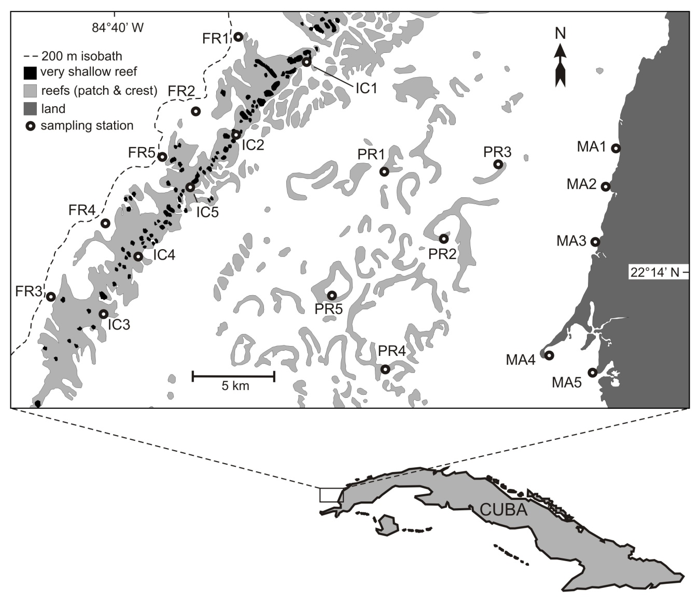
Figure 1. Study area. Positions of sampling stations are given by white circles. MA: mangrove, PR: patch reefs, IC: inner crest, FR: Fore reef. Numbers indicate replicates inside each habitat.

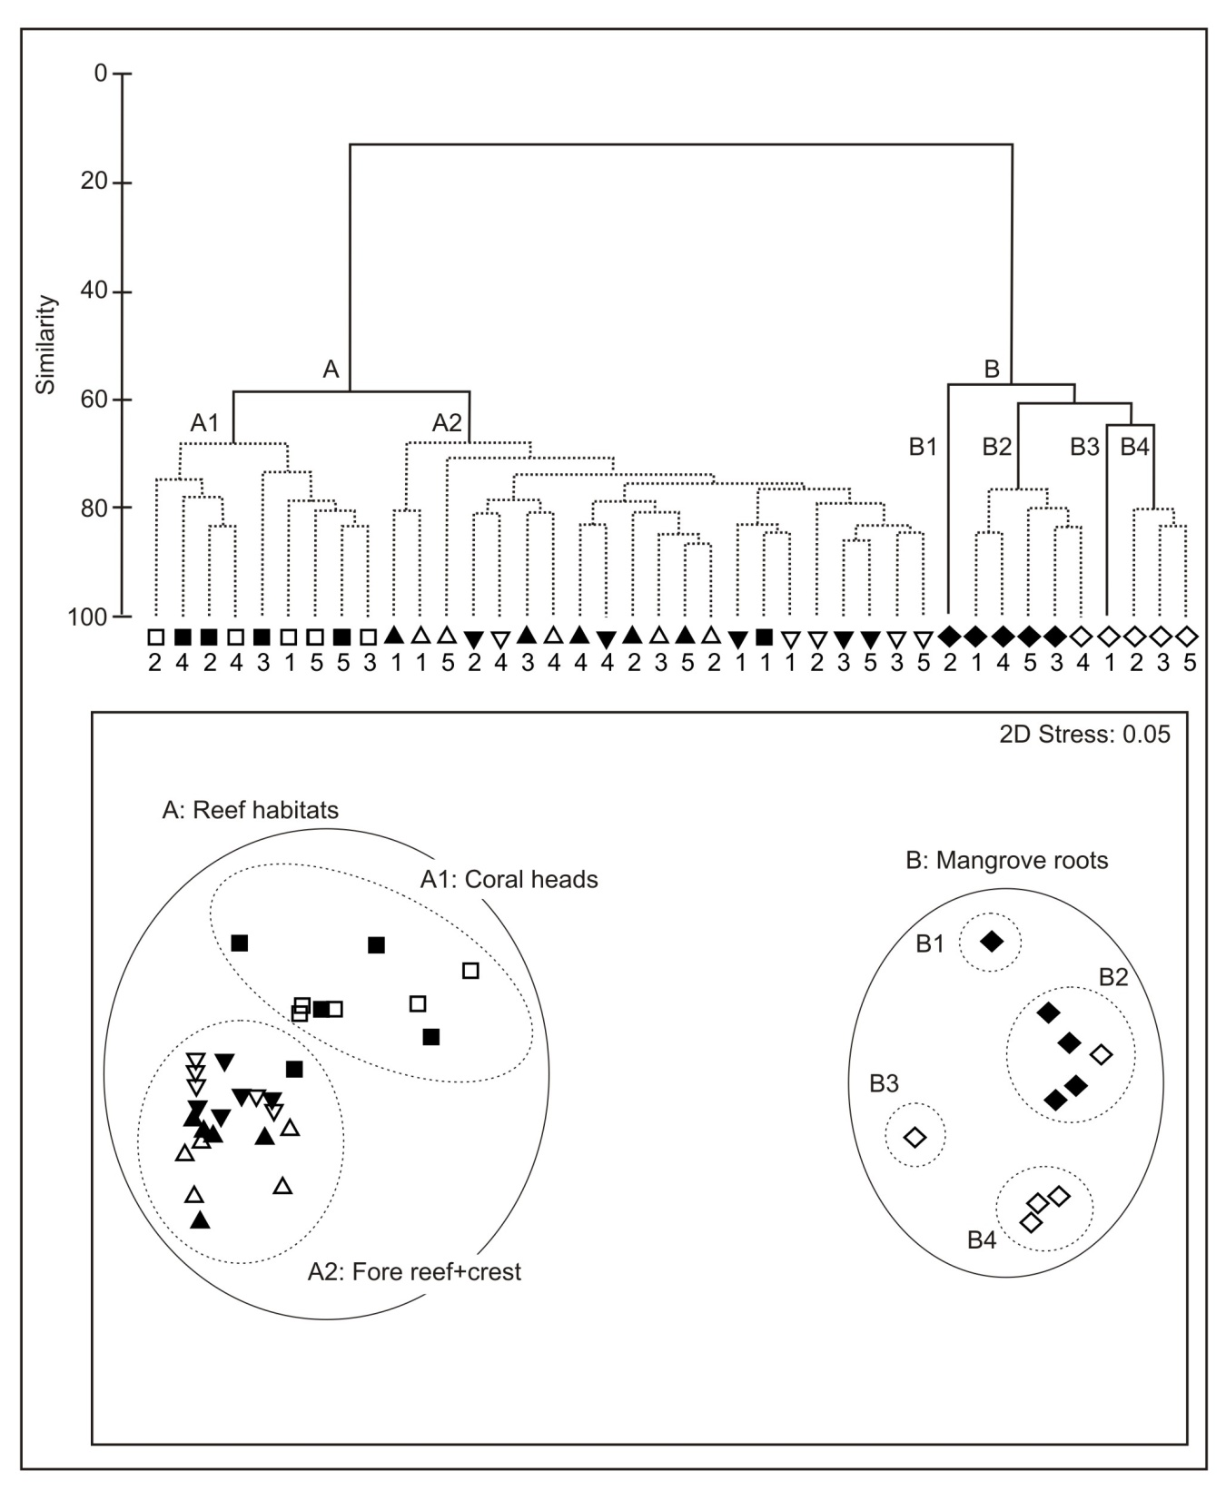
Figure 2. Numerical classification (top panel) and MDS diagram (bottom panel) of samples. Symbols’ shapes identify habitats (up-triangles: fore reefs, down-triangles: inner crest, squares: patch reefs, diamonds: mangrove) and symbols’ colors identify sampling dates (black: June, white: September). Numbers identify replicates. Envelopes indicate groups and subgroups of cluster analysis.
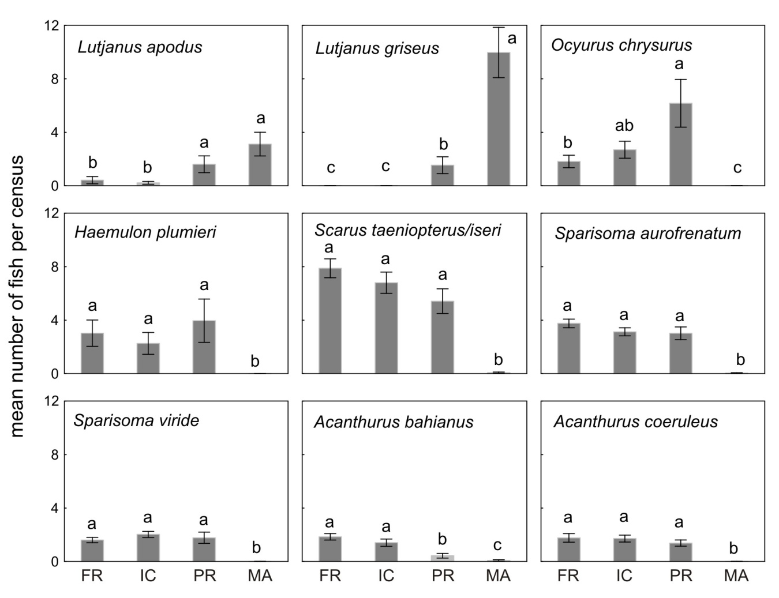
Figure 3. Mean number of individuals per census (± standard error) for selected species. Means with same letters are not significantly different after the SNK test.
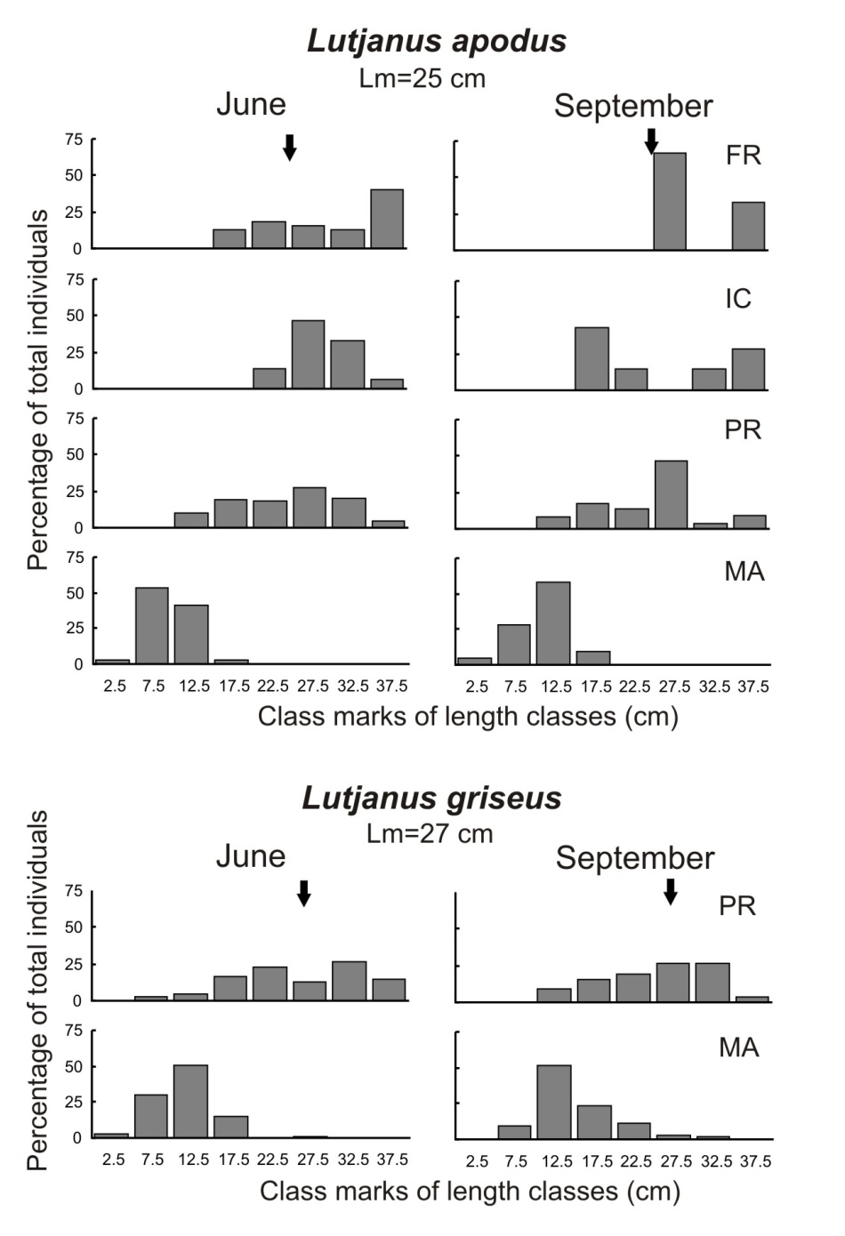
Figure 4. Length composition of fish censused in different habitats for two species of lutjanids. Lm=Length at maturation (arrows). MA: mangrove, PR: patch reefs, IC: inner crest, FR: Fore reef.

