APPENDIX

Appendix 1. Sampling sites.

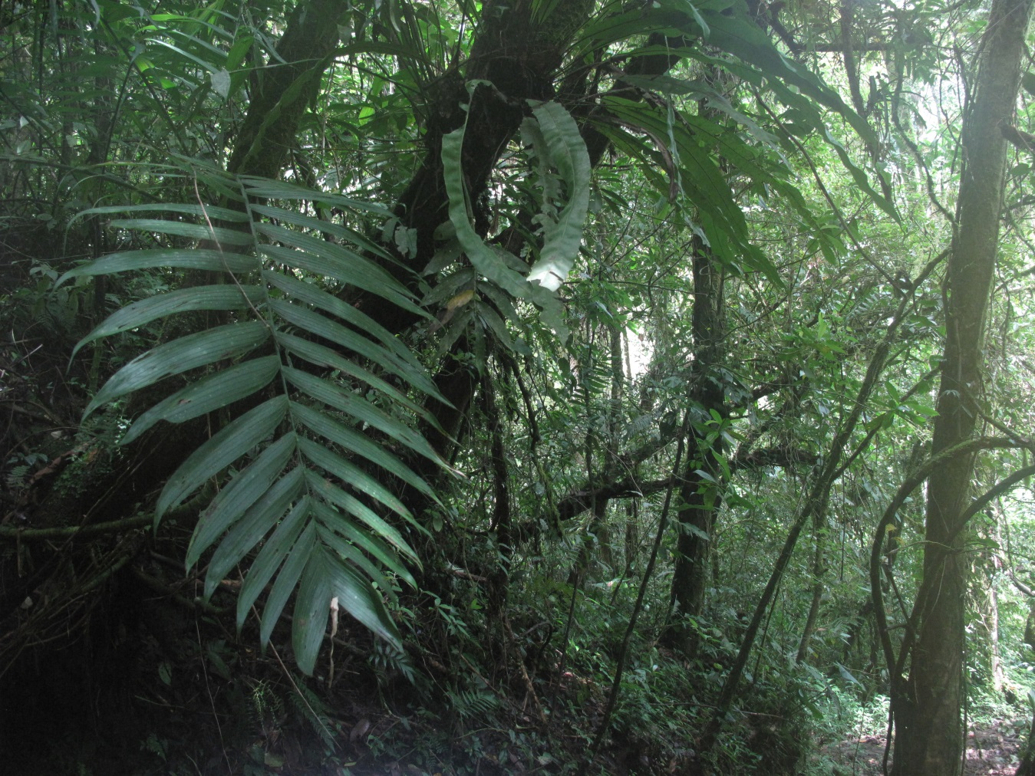

Understory in the Old Growth Forest.

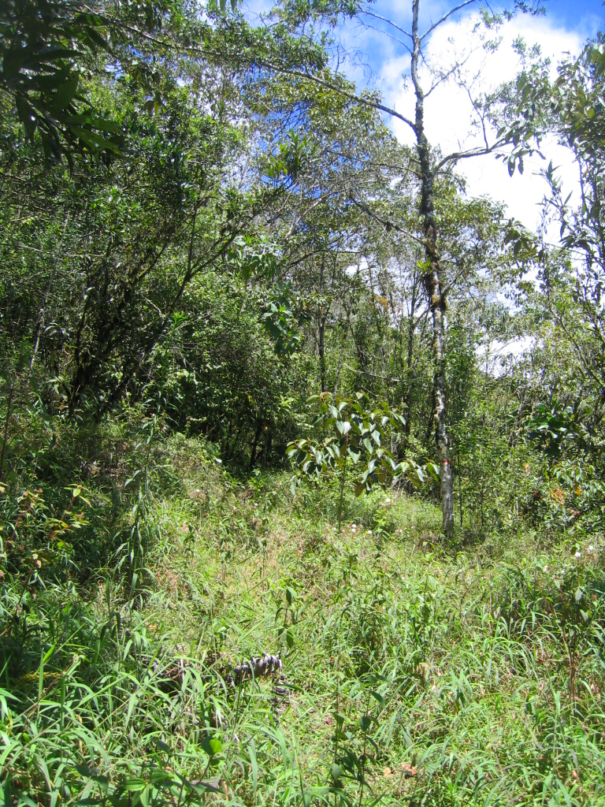
Understory and sampling in the Young Secondary Forest.

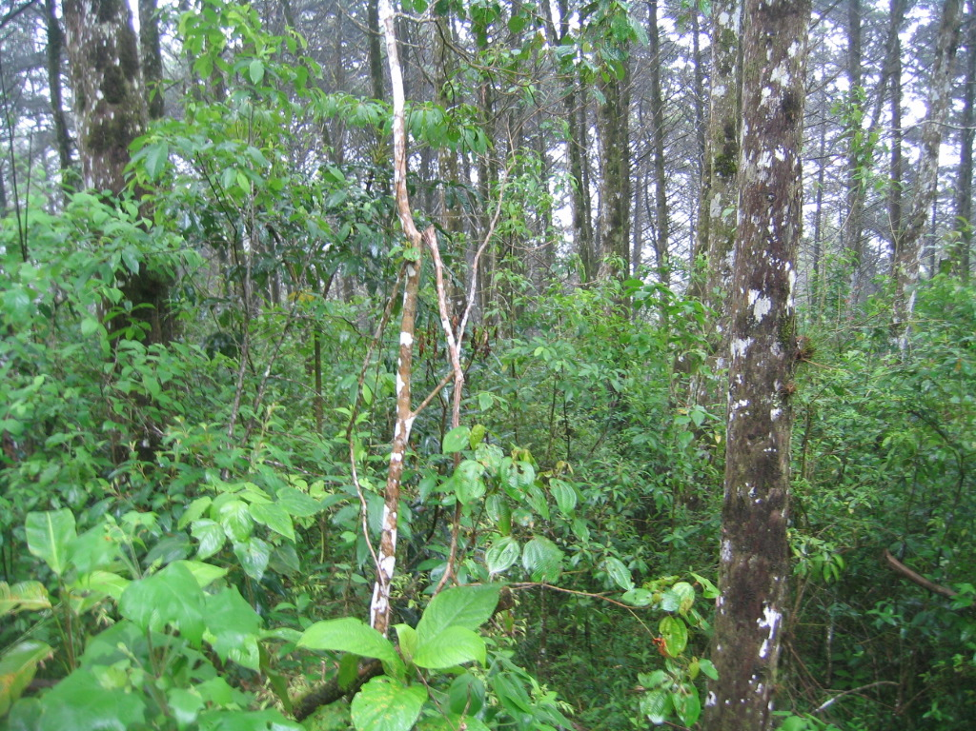

Understory in the Cupressus lusitanica plantation.

Appendix 2. Sampling methods

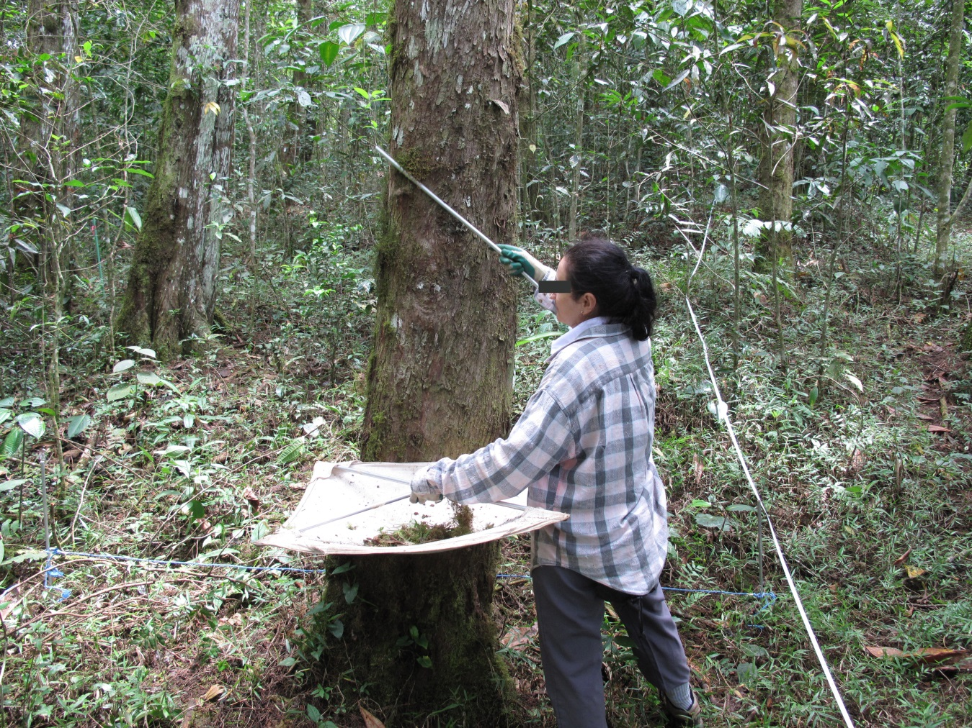
Arboreal snail sampling in a 3x3 m plot.

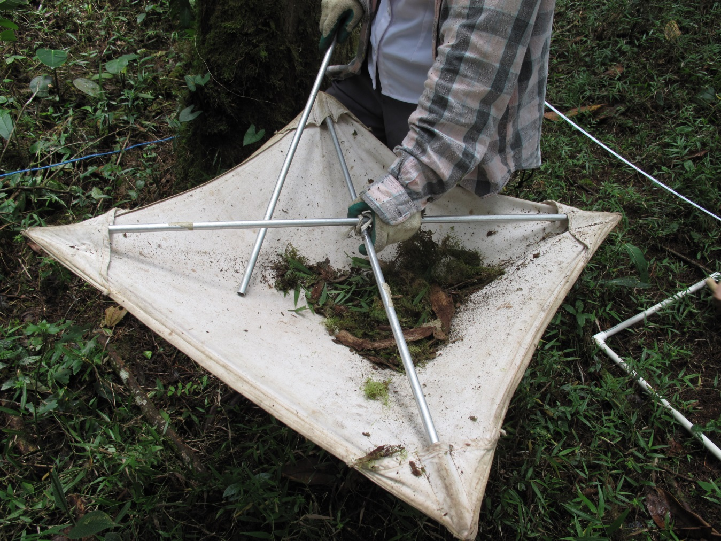
Leaf litter collected with a 50x 50 cm beat sheet.

Leaf litter sampling in a 50x50 cm subplot.

Appendix 3. Daily cycle activity sampling methodology.
On each sampling day I walked along a trail for about an hour and repeated the hike every 3 hours in a 24 hour period.

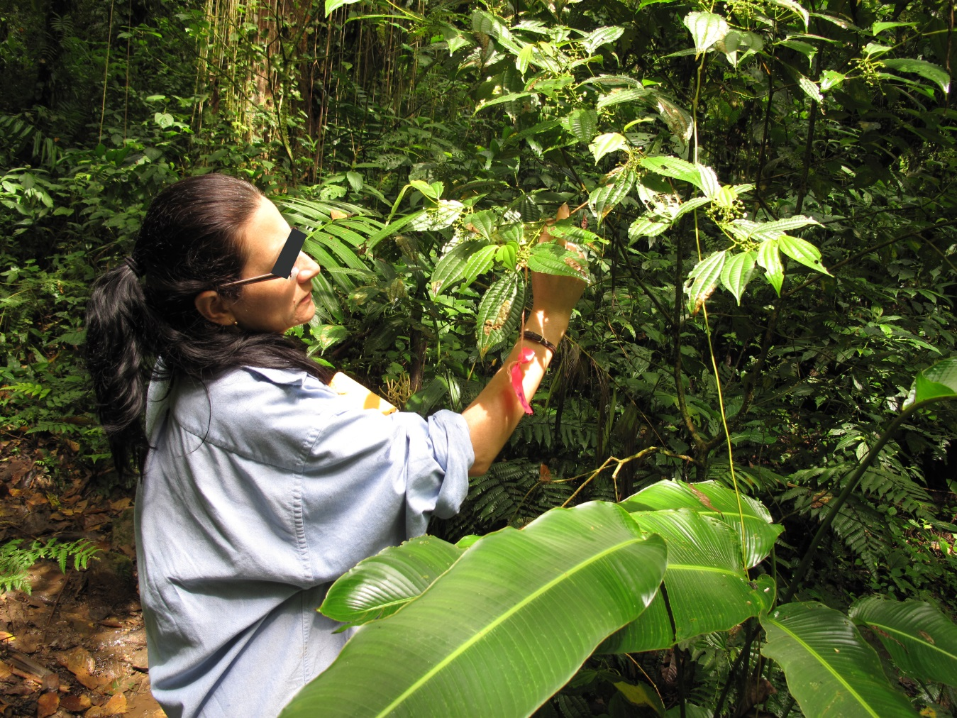
I used color ribbons to mark trails, plants, stems and leaves so that I could follow each specimen individually.
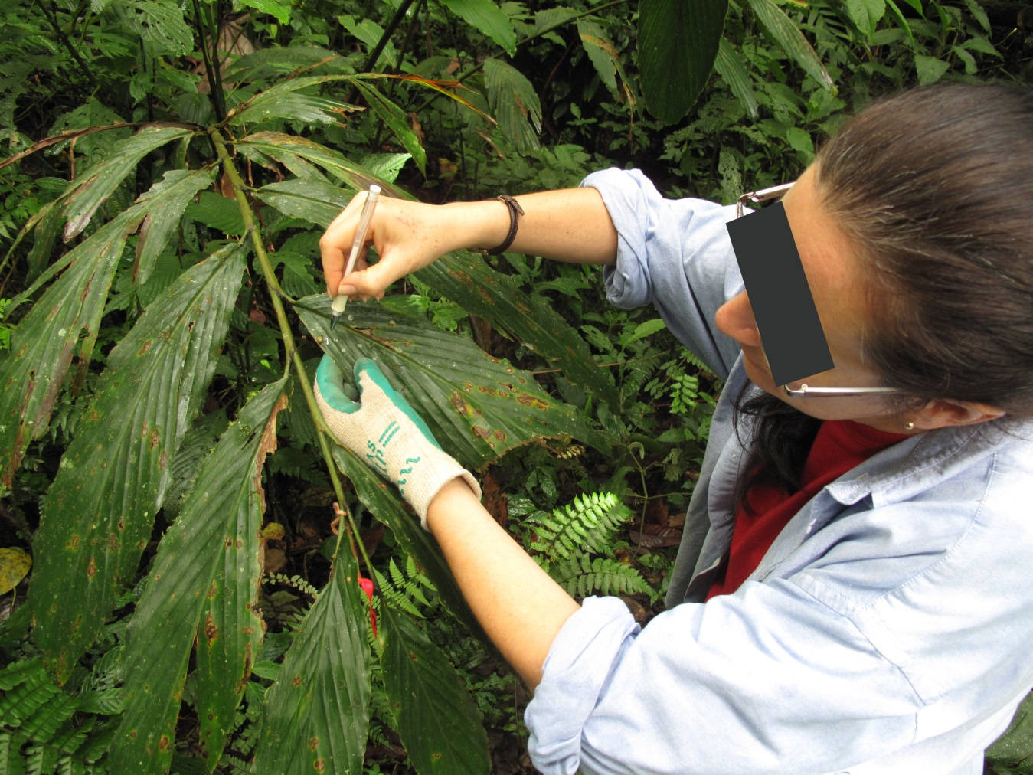
I marked specimen location on leaves with a felt-tipped marker.
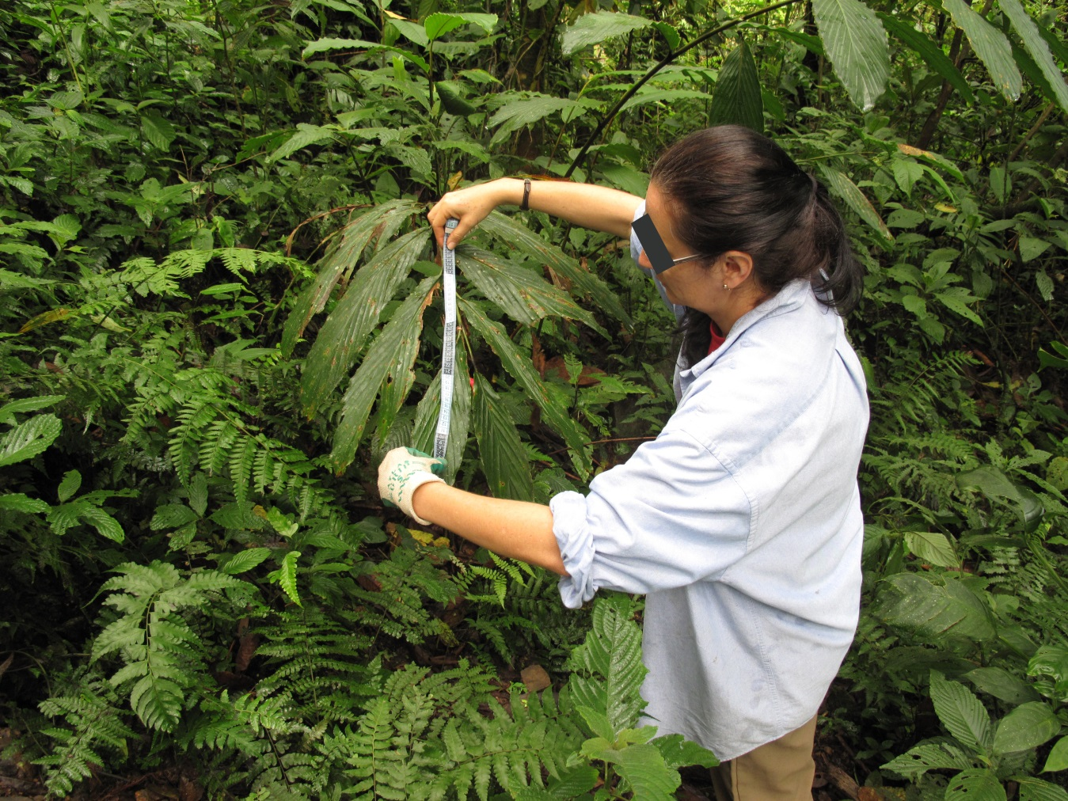

When possible I followed and measured the snail`s trail, when not, I measured the shortest and simplest trail that the snail could have followed when they moved away from the original place.

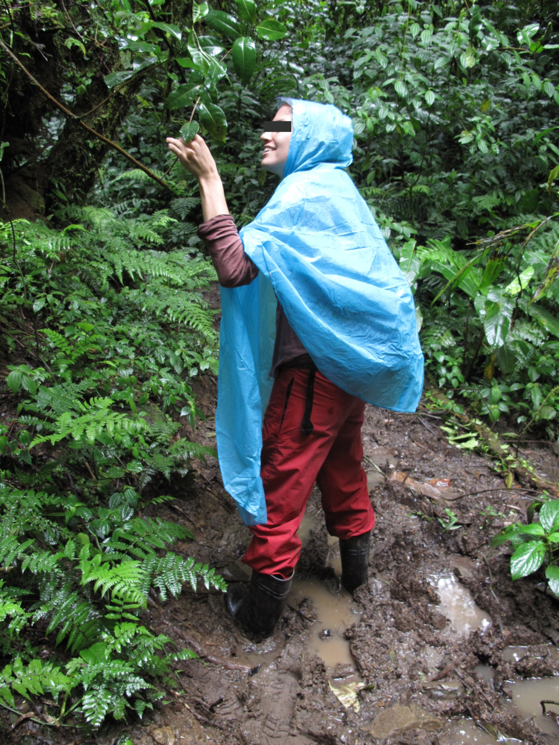

I took note of coverage of visible epiphyllous and weather (“rainy”, “cloudy with wet soil”, “cloudy with dry soil or sunny”, I merge sunny and cloudy with dry soil categories as these two conditions appeared to be similar in terms of humidity of microhabitat of the snail in an old growth forest).

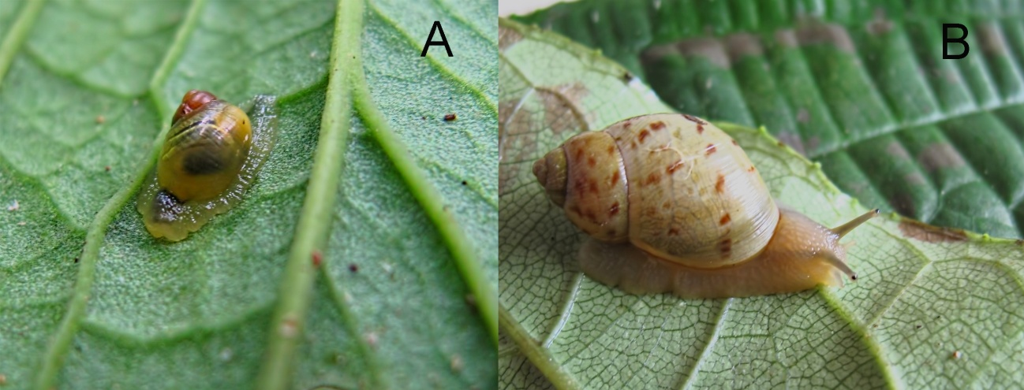
Drymaeus tripictus in Rio Macho Forest Reserve, Costa Rica. A. Inactive juvenile classified as “flattened”. B. Active adult classified as “resting”.

Appendix 4. Detail of activity results

I recorded 92 activity events in total.
Active and inactive behavior: There was no difference between the number of specimens being still and moving (Active snails =33%, n=92, chi-square = 1.34, df=1, p= 0.247). Most specimens (67%, n=92) were inactive (chi-square=10.44, df=1, p= 0.0012); of these 86% were flattened and 14% resting (chi-square= 28.98, df=1, p<0.0001).
Activity and leaf side: Active snails were mostly on the upper side of the leaf (Chi-square=6.76, df=1, p= 0.0093) but inactive snails were equally frequent on both leaf sides (51% were in the upper side of the leaf, chi-square=2.44, df=1, p= 0.1183).
Weather and activity: I found more active specimens when the weather was “cloudy with wet soil” (chi-square= 12.24, df= 2, p= 0.538).
Leaf side and time, leaf side and weather: There was no effect of time (analyzing differences between 4 time categories: chi-square=3.0, df=3, p= 0.378: day versus night analysis: Fisher exact probability test, p=0.52587) and weather (chi-square = 2.31, df=3, p= 0.51) on leaf side distribution.
Activity and day time: During day time more specimens (77%, n=53) were inactive (chi-square= 14.8, df=1, p <0.0001), especially in the afternoon (chi-square= 22.65, df=3, p <0.0001). At night there was no difference between the number of active and inactive snails (chi-square= 0.1, df=1, p= 0.7518). More inactive snails were flattened (84%, n=49) than resting (chi-square=20.9, df=1, p= <0.0001).
Height: On average, I found specimens on plants 1.5m above ground (S.D.= 0.5, max= 3.00m, min= 0.5m, n=90).
Displacement: Most displacements (92%, n= 13) took place at night or early morning between 20:00 pm and 08:00 am; on average they moved 65cm a day (S.D.= 61, min= 8cm, max= 200cm, n= 9).
Epiphyllous coverage: 90% of the specimens were on leaves with visible epiphylls covering up to 25% of the leaf area (chi-square= 200.66, df=3, p <0.0001, n=92).

