Belo Horizonte, April 9th 2015

To: Dr. Julián Monge-Nájera,
Universidad de Costa Rica, Vicerrectoría de Investigación
Revista de Biología Tropical, Costa Rica

Dear Dr. Julián Monge-Nájera,

Please find enclosed the original manuscript entitled “Resource allocation in Copaifera langsdorffii (Fabaceae): how a supra-annual fruiting affects plant traits and herbivory?” authored by Fernanda Vieira da Costa, Antônio César Medeiros de Queiroz, Maria Luiza Bicalho Maia, Ronaldo Reis Júnior and Marcílio Fagundes for your appreciation to be published in Revista de Biología Tropical. In this study we investigated the trade-off between years of high and low fruiting in the investment of resources on growth and defence, and their indirect effects on herbivory in Copaifera langsdorffii (Fabaceae). For the first time a study explored the importance of supra-annual fruiting on the internal allocation of resources and indirect effects on trophic higher levels. This important component of insect-plant interactions is fundamental to decipher coevolutionary life histories and the role of reproduction on herbivory, and vice versa; thus supporting the development of strategies for tropical trees conservation. The manuscript is not being considered for publication elsewhere, either in whole or substantial part. We all agree with this publication, as well we are aware about the ethical requirement of the journal and agree to pay excess page fee charges if it is required. In addition, see bellow the names, addresses and e-mail addresses of three potential referees. Thank you for your attention.

Sincerely,
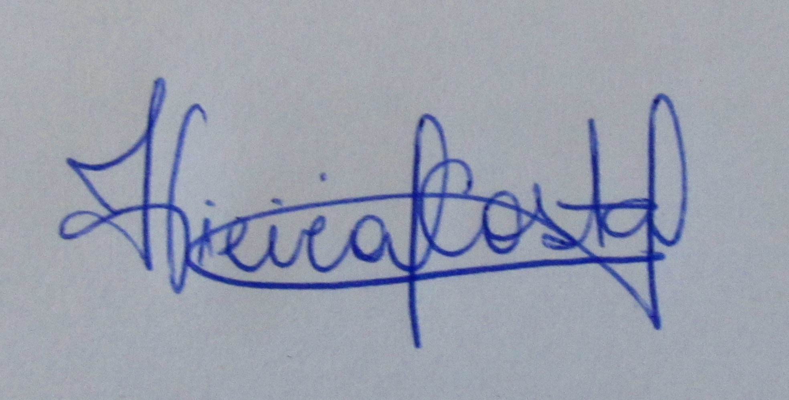

_________________
Fernanda Vieira da Costa
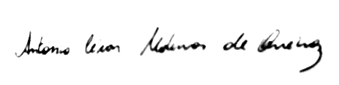

_____________________________________ Antônio César Medeiros de Queiroz,
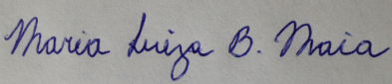

____________________________________________ Maria Luiza Bicalho Maia


____________________ Ronaldo Reis Júnior
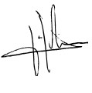

______________________ Marcílio Fagundes

Potential referees:

1. Dr. Fernando A. O. Silveira Universidade federal de Minas Gerais, Departamento de Botânica, Brazil. Email: faosilveira@gmail.com

2. Dr. Jhonathan de Oliveira Silva Universidade Estadual de Montes Claros, Departamento de Biologia Geral, Brazil. Email: jhonathanos@gmail.com

3. Dr. Mauricio Quesada Centro de Investigaciones en Ecosistemas (CIECO), Universidad Nacional Autónoma de México (UNAM), Mexico. Email: mquesada@oikos.unam.mx

