Appendix 1. Galling morphotypes (1 to 23) associated with Copaifera langsdorffii. Values in parentheses correspond to the galling abundance sampled in 2008 and 2009, respectively. The arrows indicate the location of galls on the host plant and the straight line corresponds to photo scale (adapted from Costa, Fagundes & Neves, 2010).
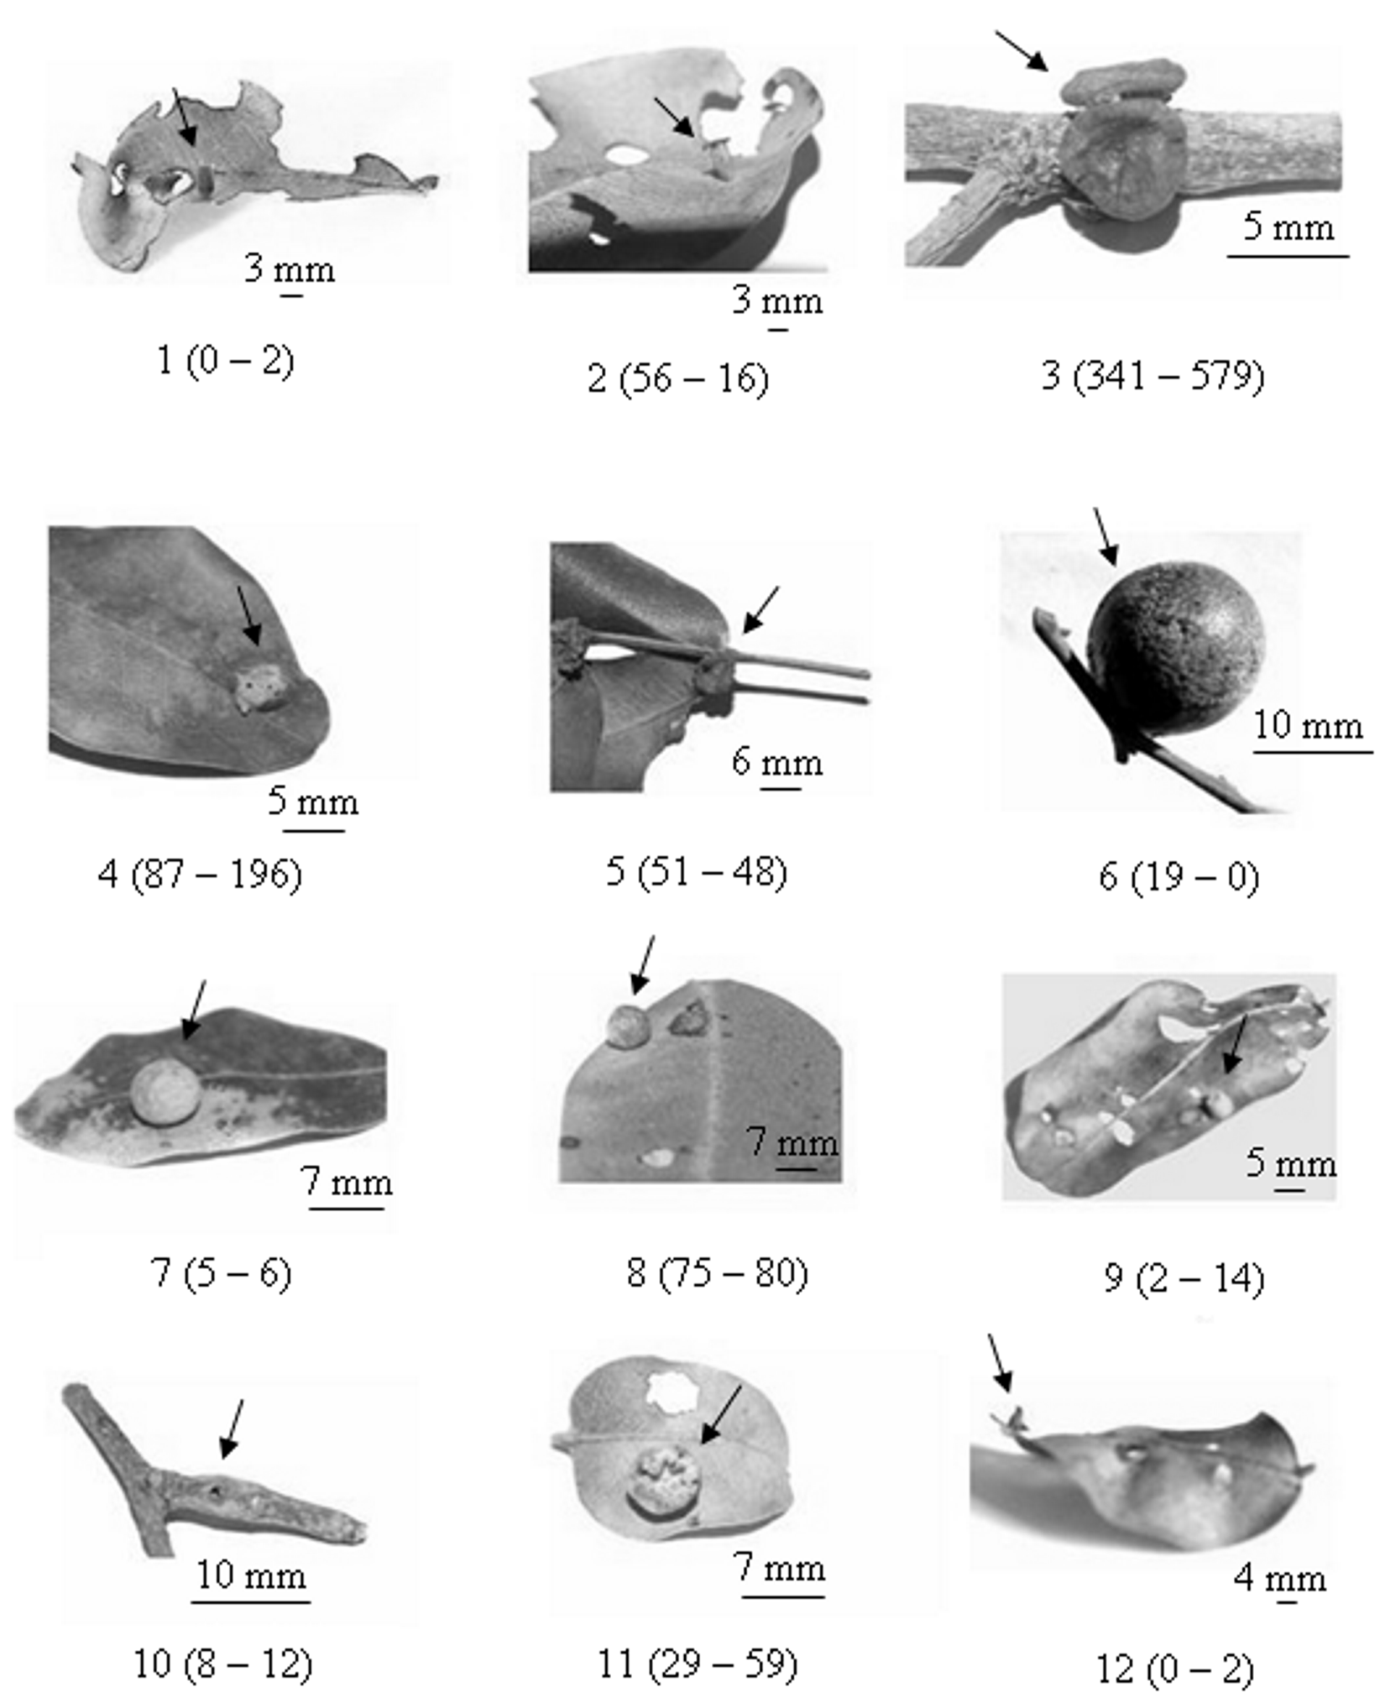

Appendix 1. (Continued)
