Bloom of Trichodesmium and seasonality of other potentially toxic and harmful phytoplankton in tropical San Pedro Bay, Leyte, Philippines in 2012-13

Leni G. Yap-Dejeto¹* and Haide S. Batula¹

¹Division of Natural Science and Mathematics, University of the Philippines in the Visayas-Tacloban College, Magsaysay Ave., Tacloban City, 6500 Leyte, Philippines; leny.yap@upou.edu.ph, llenigy@yahoo.com

Abstract: Since 1983, San Pedro Bay in the Philippines had been reported to be the site of episodic Pyrodinium bahamense var. compressum blooms that cause paralytic shellfish poisoning in its nearby coastal communities. This bay is also subjected to numerous typhoons, the strongest of which was super typhoon Haiyan in November 8, 2013. Phytoplankton ecology of this bay must have unique characteristics. For the first time, the seasonal dynamics of potentially toxic and harmful phytoplankton in this bay is elucidated. This is also the first record of a bloom of the cyanobacteria, Trichodesmium erythraeum that reached 90,000 cells/L in April 2013. There were 19 other potentially toxic and harmful phytoplankton encountered during the sampling period. This consisted of a haptophyte, Phaeocystis globosa, the diatom Pseudo-nitzschia and 17 dinoflagellates. Seven of these harmful algae had densities high enough to be traced through time. Normally, diatoms abound during the dry season. But here, Pseudo-nitzschia increased in abundance during the wet season of 2012 and 2013. The dinoflagellates behaved as expected and exhibited a relative increase in cell density during the rainy season of both years. Phaeocystis globosa also increased during the wet season. High nutrient availability during this season must have influenced the behavior of the phytoplankton despite differences in temperature and light intensity among seasons. Other notable but rare harmful species found only in plankton net tows during the study were Pyrodinium bahamense var. compressum, Alexandrium tamiyavanichii, Cochlodinium polykrikoides, and Noctiluca scintillans.

Keywords: Trichodesmium, Pseudo-nitzschia, harmful dinoflagellates, season, San Pedro Bay, Leyte, Philippines

Total Words: 3578

Recent studies have proven that changes and successions of phytoplankton communities also occur in coastal tropical areas seasonally (Franco-Herrera et al. 2006). Harmful phytoplankton are few; however, these species can cause small or large-scale shellfish, fish kills (Sellner et al. 2003) and even human deaths when they form blooms. Hence, bio-monitoring of phytoplankton composition is important to predict occurrences of harmful algal bloom incidents that directly affect commercial shellfish production, mariculture industries and overall food safety.
San Pedro Bay (11°00’00” to 11°15’00”N and 125°00’00” E) is found in the center of the Philippines and confined within the coastlines of Leyte and Samar islands. It includes the narrow San Juanico Strait and a shallow U-shaped embayment, Cancabatoc Bay. Its outer portion opens to the Pacific Ocean. A characteristic feature of this bay is its relatively shallow depth averaging to only 20 m. Its total area is 625 km² (Campos, 2003). Parts of the bay are mariculture zones for fish and shellfish. This is also an important fishing ground for people in its coastal communities. Thus, updated information on the water quality of the bay is important.
The Philippine Atmospheric Geophysical Astronomical Services Administration (PAG-ASA) classifies Leyte Island under Type IV of the Corona system of classification. This is characterized by even distribution of rainfall throughout the year and short dry season from February to March (DOST-PAGASA, 2011). This bay is also subjected to numerous typhoons, the strongest of which was typhoon Haiyan in November 8, 2013. Ecological studies of this bay will thus provide as a glimpse of possible effects of climate change in the marine ecosystem.
Episodes of Pyrodinium bahamense var. compressum blooms have been reported since 1983. In January 1983, toxic bloom of Pyrodinium bahamense var. compressum affected 300 km of coastlines of Samar and Leyte including San Pedro Bay. The said red-tide incidence was repeated in 1987 and 1988 (Bankoff, 2003; Gonzales, 1989). Human fatalities accompanied some of these blooms in history. The latest recorded bloom was in October 2007. Laboratory analyses of shellfish samples that time from Cancabato Bay showed positive result of saxitoxin beyond the regulatory limit of 40 micrograms saxitoxin equivalent/100 grams meat (LMBTC, 2007). In November 2012 however, all coastal waters in Eastern Visayas region including San Pedro Bay covering Palo and Tanauan, and Cancabato Bay in Tacloban City, were declared free from this toxic red tide (BFAR, 2012).
There are two other harmful algae previously recorded here. Nitzschia navis-varingica was detected in San Pedro Bay in 2004 and was found to produce the major toxin composition types, domoic acid and isodomoic acid B (Kotaki et al., 2005). Pseudo-nitzchia spp. were also recorded to be present. Higher cell densities of Pseudo-nitzchia were observed during the dry season from December to May (Yap-Dejeto et al., 2008 and 2013).
This paper thus aims to elucidate the seasonal dynamics of harmful phytoplankton in San Pedro Bay, Leyte, Philippines from 2012-2013; and to conduct a thorough search of potential harmful phytoplankton here. This is the first study of this kind that has been done in this region (Visayas) of the Philippines.

MATERIALS AND METHODS

Sampling Strategy: Three representative stations of San Pedro Bay were established. Station 1 (11°13’270’’ N and 125°02’471’’E) was located near Dio Island, Station 2 (11°15’46’’ N and 125°04’5’’ E ) located within Cancabato Bay and Station 3 (11°17’22’’ N and 124°58’30’’E) located along the San Juanico Strait. A GPS unit (Handheld Garmin 76) was used to record the coordinates of the stations which were then traced and plotted using Manifold.
Station 1 is located near Dio Island, far from coastal settlements. Station 2 is located within the shallow and restricted Cancabato Bay near residential areas and mangrove area. Station 3 is along the San Juanico Strait, which harbors a mariculture area and a number of fish cages.
A quantitative monthly data of phytoplankton was recorded to represent the three (3) climactic seasons in the Philippines namely, the rainy season, the cold dry season and hot dry season. This was done in January to March 2012, then August to December 2012. Phytoplankton counts for 2013 were from 15 samples of phytoplankton collected bimonthly from April to December (see Table 1). Samples for qualitative observations were taken using plankton net while that for phytoplankton counts were from a 2-L Van Dorn sampler.

Physico-chemical Analysis: Physical variables were assessed in situ. Temperature, salinity, light intensity and depth readings were recorded using a mercury-filled centigrade field thermometer, ATTAGO refractometer, EXTECH light meter and a calibrated rope, respectively. Current velocity was determined through drift method which used a fabricated drogue attached to a calibrated string. Secchi Disc Transparency (SDT) readings (turbidity of the water column) were estimated using the Secchi disc. Measurements for pH and amount of dissolved oxygen were taken using EUTECH Multiparameter Handheld Meter (PCD 650).
For nutrient analysis, each of the water samples collected was filtered using Whatman filter paper and a filtration set. The filtered samples were stored in an acid-washed bottle and were frozen. The prepared samples were then sent to the Chemical Oceanography Laboratory of the Marine Science Institute of University of the Philippines, Diliman for analysis.

Phytoplankton Species Identification: To concentrate the 1L samples for quantitative analysis, a settling and siphoning procedure was followed to obtain an approximately 50 ml final concentrated phytoplankton sample (USEPA, 1994). One (1) ml of the 50 ml concentrated sample was then dispensed into a gridded Sedgwick-Rafter counting chamber and was examined in triplicate under a light compound microscope. The harmful phytoplankton species present were identified using identification guides and keys of Omura et al., 2012; Yamaji, 1984; Tomas, 1997; Botes, 2001 and Larink and Westheide, 2006. The number of cells counted in three replicates was averaged in order to calculate cell density per species. Cell density was obtained by multiplying the averaged cell density counted in 1 ml to the concentrated volume of sample.
RESULTS

4.1. Physico-chemical Parameters: The monthly and seasonal variation of the physical parameters obtained during the 2-year study period, 2012 and 2013 is shown in Figure 2. Mean monthly water temperatures varied over a relatively narrow range during the two consecutive years from 26.8°C to 31.0°C. Lowest temperatures were recorded during the cold dry season of both sampling years while highest temperatures were recorded during the rainy months of June and August 2013. Salinity varied from 29 ppt to 35 ppt within small amplitude, with the highest value recorded during the cold dry season of 2012 and 2013. pH values were all relatively alkaline and did not vary much between all the sampling months of both years.
Dissolved Oxygen (DO) concentrations of most sampling months were greater than the minimum value of 5 mg/L set by ASEAN water quality criteria. DO concentrations below the minimum value occurred however during the months of March, February (2012), and December (2013). On the other hand, least current velocity (0.2 m/s) was in Station 1 in December 2013 and greatest current velocity (0.78 m/s) was in Station 3 in January 2012.
Mean light intensity measurements ranged from 3477 fc to 6113 fc. Transparency measurements, on the other hand, fluctuate between 0.19m to 4.6m.
Mean soluble inorganic nitrogens (NO_{2;} NO₃) and soluble reactive phosphate (PO₄) concentrations in selected months of 2012 and 2013 are shown in Figure 3. Concentration of nitrates and phosphates were high during the rainy season of 2012 represented by the months of August and October. In contrast, nitrite concentration during the same months was low (0.4 µm); however, the concentration increased quite fairly during the rainy season and hot dry season of 2013, with mean values of 0.78 µm and 1.23 µm, respectively.
Toxic and harmful phytoplankton composition and seasonal cell density : A total of 20 potentially toxic and harmful phytoplankton taxa were identified during the whole study period (see Table 2) which consists of 1 cyanobacterium, 1 diatom, 1 haptophyte and 15 dinoflagellates belonging to the following divisions: (17) Dinophyta, (1) Bacillariophyta, (1) Cyanophyta and (1) Haptophyta. Dinophysis spp., Prorocentrum spp, Protoperidinium spp., Pseudo-nitzschia spp., and Trichodesmium erythreaum were the most abundant taxa observed over the 2-year study period leaving the other phytoplankton taxa recorded rare and in low cell numbers. General phytoplankton number in 2012 increased during the rainy season with an average total cell density of 30,000 cells/L contrary to year 2013 in which the total phytoplankton number increased significantly during the hot dry season (average of 75,000 cells/L) dominated largely by Trichodesmium (70,000 cells/L).
Shown in Figure 4 are the seasonal fluctuations in abundance of harmful microalgae that were found in San Pedro Bay over the last two years. As observed, the apparent upturn in abundance of the recorded harmful diatoms and cyanobacteria occurred during the rainy season for both years. While low diatom cell densities occurred during the rest of the years, except for the month of April 2013, in which species of Trichodesmium escalated into a peak reaching an average total of 70,000 cells/L.

Shown in Figure 5 is the graphic representation of the seasonal fluctuations in abundance of dinophytes which frequently occurred in the samples obtained from 2012 to 2013. By August, the density of the harmful dinophytes that were frequently recorded in most stations and sampling months (Dinophysis spp., Gymnodinium sp., Prorocentrum spp., and Protoperidium spp.) increased remarkably as compared to their previous and succeeding recorded cell numbers. On one side, those dinophytes that were found rare and in very few cell numbers (Alexandrium tamiyavanichii, Cochlodinium polykrikoides, Nociluca scintillans, and Pyrodinium bahamense var. compressum) were spotted mostly during the rainy season especially during the months of June and August (See Table 2).

DISCUSSION

In tropical and subtropical areas, diatoms usually dominate or form blooms during the summer season where there is relatively high temperature and light intensity (Phlips et al., 1997). However, in this study, higher temperatures and light intensities were observed during the rainy season of both years. This was accompanied by peaks in abundance of the diatom Pseudo-nitzschia spp. during this season. There was even a moderate negative relationship calculated between Trichodesmium erythraeum and light intensity (Pearson’s r=-0.3). This could mean that light was too strong for the phytoplankton in this area during these years.
Instead of diatoms, a cyanobacterium bloomed during the hot dry season of 2013. There was a sudden increase in abundance of Trichodesmium erythraeum particularly in April which contributed to the high nitrite content of the water body during the same month. A strong positive relationship (Pearson’s r=0.6) was shown with nitrite concentration and Trichodesmium density. Trichodesmium is a filamentous and colonial nitrogen fixing cyanobacteria, pervasive in tropical and subtropical regions of the world’s oceans. This species occur at higher abundances in greatly stratified, low-nutrient waters and is primarily found in waters between 20 and 34°C. Its presence is more prominent in nitrogen poor water and easily seen during blooms (Capone et al., 1997). These blooms release carbon, nitrogen and other nutrients into the environment which contributes to nutrient loading (Capone et al., 1998).
Generally, Trichodesmium is dangerous as a food source for other organisms. Only few specialized animals feed on it actively. Some strains of Trichodesmium do produce toxins such as Trichodesmium erythraeum and T. thiebautii causing mortalities in some copepods, oysters and fish. Some blooms were found to produce toxins leading to clupeotoxism in humans after ingestion of fish contaminated by Trichodesmium-toxins (Post, 2005). There were no reports of fish mortalities here however. The bloom was more pronounced in the semi-enclosed Cancabatoc Bay (Station 2) which reached 90,000 cells/L. See Figure 4. Mariculture areas were found in Station 1 which harbored lesser phytoplanton.
Anthropogenic activities here seen in elevated phosphate loading through fertilizer pollution, waste disposal and aquaculture activities may have reduced growth limitations due to limited phosphate and brought the increase Trichodesmium bloom occurrences (Bergman et al., 2012). The increased nitrite concentration in April must have resulted from this bloom.
Low light and lower temperatures favor the growth and survival of dinoflagellates. In the results, dinoflagellates showed an increase in abundance during the rainy season of both years in which relatively lower light intensity and temperatures were observed. There was a weak negative relationship between Gymnodinium and light (Pearson’s r= -0.2) while a strong positive correlation was seen between the same genus and nitrite (Pearson’s r=0.5). Dinophysis spp., Gymnodinium sp., Prorocentrum spp., and Protoperidinium spp. peaked during the rainy season of 2012 and 2013 with relatively high cell densities ranging from 400 to 3500 cells/L. High nutrient availability during the season might have a strong influence on both diatoms and dinoflagellates inducing both groups to increase in abundance during the same season.
High nutrient input in Station 2 within the Cancabato bay explains the continued occurrence of high total cell density of phytoplankton in the area (Macanip and Yap-Dejeto, 2012; Oracion and Yap-Dejeto, 2011). The shallow and restricted morphology of this bay increases contact to nutrients in the bottom and susceptibility to nutrient-related algal problems and risk of bloom formation (Anderson, 2005).
Aquaculture activities such as cage and pen fish farming present in Station 3, also affect nutrient loading. These anthropogenic inputs have changed the nutrient pool in that area which, in turn, may or may not create a favorable environment for HAB species. Inorganic nutrients released can affect phytoplankton in upper waters. Fish farming activities contribute to the release of inorganic nutrients (NH₄ and PO₄), particulate organic nutrients, and dissolved organic nutrients (Olsen and Olsen, 2008). One potential threat of aquaculture to environment is the effect of bio-deposits such as fish feces and uneaten feed. These impacts include physiological effects to fish caused by low dissolved oxygen levels in the water column, toxic effects of H₂S and ammonia from bio-deposit degradation, and toxic effects of harmful algal blooms related to eutrophication (Degefu et al., 2011) .
Station 3 was observed to come second to Station 2 in terms of potentially toxic and harmful phytoplankton abundance. In comparison with Stations 2 and 3, Station 1 has relatively low total phytoplankton cell density. This station is far from coastal settlements, there are no fish cages, and thus low amounts of nutrients are loaded into the area. Hence it registered the lowest phytoplankton abundance among all three stations.
Episodic environmental events, such as typhoons induce extensive ocean−atmosphere interactions which have profound influences on phytoplankton ecology (Chung et al., 2012). The occurrence of typhoon Haiyan on November 8, 2013, caused severe devastation in Eastern Visayas including San Pedro Bay. The sampling for December was conducted a month after the typhoon and water was observed to have high transparency, low DO concentration and low phytoplankton abundance. Total phytoplankton was only 14,000 cells/L. This is contrary to reports of increased phytoplankton density after a typhoon (Chung et al., 2012). Accounts of people and based on first hand observation, during the onslaught of Haiyan, a storm surge which covered the city occurred. The water coming in was murky almost black in color. This must have been mostly silt and sewage. It also must have brought inland most of surface coastal phytoplankton. There was however, an increase in nitrate concentration which might be due to the increase land run-offs and mixing of nutrients from the bottom sediment to the surface of the water.
The results of this study show that the taxonomic composition and abundance of harmful and potentially toxic phytoplankton in San Pedro Bay vary seasonally. The relative importance of light, temperature, DO concentration and nutrient availability was also found to influence the spatial and temporal patterns observed in the abundance and composition of harmful phytoplankton.
The high dissolved oxygen concentrations during the rainy season reflect the high rate of rainfall experienced this season. Rainfall increases interaction of water and air which increases dissolved oxygen. More interaction of water and air was achieved through increased mixing of water brought by high rate of river flow into the ocean due to rainfall (Wehmeyer and Wagne, 2011). High input of rainwater, in return, decreased the salinity of seawater considerably but only during the rainy season of 2012. In 2013, however, the increase in salinity suggests that there is low input of rainwater or freshwater in the area and high DO levels might have been due to wind-assisted surface mixing or photosynthesizing algae and not necessarily the inflow of freshwater during the season (Ladipo et al., 2011).
Usually, in colder waters, there is high concentration of oxygen since oxygen dissolves more easily in cold temperatures (Jones, 2011). However, in the tropics, temperature is subject to comparatively less seasonal variation reflecting less change of temperatures between sampling seasons. This explains the low DO concentration during the cold dry season of both years specifically in stations 1 and 3 during the months of February and March 2012 and in all stations during the month of December 2013. In addition, absence of mixing brought by little rainfall and flow decreases interaction of air and water thereby decreasing oxygen solubility which happened here during the hot dry season.
During the rainy season, the relatively higher transparency and current velocity might have influenced the amount of light that penetrated the water column as well as the DO concentration during the season. High current velocity induces mixing of the water column, which increases dissolved oxygen concentrations (Jones, 2011) while high transparency values indicate high amount of light that can penetrate the water column conducive for diatom growth.
The high nitrite concentration during the months of June and April 2013 might be influenced by the contribution of nutrients coming from agricultural run-offs in Station 1, septic and sewage discharges in Station 2 and decaying fish material in Station 3. The nitrites in these organic matter and wastewater effluents, in effect, oxidize to form nitrate. Aside from this, nitrate can also be found naturally in soils particularly in agricultural areas such as Station 1 which has highest nitrate concentration recorded. Thus, high rate of rainfall and increasing anthropogenic activities must have influenced the deposition of nitrate from soil into seawater through run-offs from agricultural areas (Lapointe, 1989).
High phosphate concentration in August and October of 2012 might be due to a number of factors such as, presence of cage and pen fish farming which is present Station 3, influx of municipal wastewaters consisting of soap and detergent, wastes from mangrove ecosystems and discharge of raw human and animal feces which were present in Station 2 (ECE, 2002). These accumulated factors might have contributed to the release of wastes that are high in phosphate content.
The toxin-producing P. bahamense var. compressum was still detected in the bay but in lower cell densities. In 2011, it’s Atlantic counterpart, Alexandrium was first seen in the bay (Oracion and Yap-Dejeto, 2011). Cochlodinium polykrikoides and Noctiluca scintillans were spotted since 2004 (Salvacion and Yap-Dejeto, 2004) but in minute quantities. Although there was a bloom once observed during October 2007 of Noctiluca scintillans in this bay. Noctiluca has also been reported to bloom in Manila bay (Furuya et al., 2006). Gymnodinium sp. is common but never reached bloom proportions. This species must probably be G. catenatum, the same species found in Manila bay (Fukuyo, 1993). There are five Pseudo-nitzschia species so far recorded in the bay. These are P. brasiliana, P. micropora, P. pseudodelicatissima and P. pungens (Yap-Dejeto et al., 2013)
Thus, a total of 20 potentially toxic and harmful phytoplankton taxa were identified consisting of 1 cyanobacterium, 1 haptophyte, 1 diatom and 17 dinoflagellates. Trichodesmium erythraeum bloom was observed during the month of April in Station 2 reaching 90,000 cells/L. Phaeocystis globosa had the least cell density (820 cells/L) this was followed by Protoperidinium spp. (8,600 cells/L) and Prorocentrum spp. (4,200 cells/L). Other notable but sporadic harmful species found only in plankton net tows were Alexandrium tamiyavanichii, Cochlodinium polykrikoides, Noctiluca scintillans, and Pyrodinium bahamense var. compressum. Rainy season brought in the most number of harmful and potentially toxic phytoplankton due to high nutrient concentration. Among stations, Station 2, in Cancabato Bay, showed high relative abundance of harmful and potentially toxic phytoplankton.

ACKNOWLEDGEMENTS
It is with deep gratitude that we mention James Lloyd Ostrea, Elyrose Kim Ruizo, Richelle Ignacio and Divine Macanip for assisting and conducting field work and data gathering for this research. Transportation was provided in part by Fisheries Law Enforcement Team, Tacloban City Chapter and boat rentals of Ruel P. Robin Jr. This research is funded by University of the Philippines in the Visayas Office of the Vice Chancellor for Research and Extension, UPV-OVCRE SP12-06.

REFERENCES

Aligizaki, K., Nikolaidis, G., Katikou, P., Baxevanis, A.D., & Abatzopoulos, T.J. (2009). Potentially toxic epiphytic Prorocentrum (Dinophyceae) species in Greek coastal waters. Harmful Algae, 8, 299–311.

Anderson, D.M. (2005). The ecology and oceanography of harmful algal blooms: Multidisciplinary approaches to research and management, Anton Bruun Memorial Lecture. Intergovernmental Oceanographic Commission.

Anderson, C.R., Sapiano, M.R.P., Prasad, B.K., Long, W., Tango, P.J., Brown, C.W., & Murtugudde, R. (2010). Predicting potentially toxigenic Pseudo-nitzschia blooms in the Chesapeake Bay. Journal of Marine Systems, 14.

Bankoff, G. (2003). Cultures of Disaster: Society and Natural Hazard in the Philippines. Routledge, p. 256.

Bergman, B., Sandh, G., Lin, S., Larsson, H., & Carpenter, E.J. (2012). Trichodesmium – a widespread marine cyanobacterium with unusual nitrogen fixation properties. FEMS Microbiology Reviews, 1-17.

BFAR (2012). Bureau of Fisheries and Aquatic Resources Region 8: Shellfish Bulletin, No. 22 Leyte, Philippines.

Botes, L. (2001). Phytoplankton Identification Catalogue - Saldanha Bay, South Africa, April 2001., GloBallast Monograph Series, No. 7, London.

Campos W. (2003). An ecosystem model of San Pedro Bay, Leyte, Philippines: initial parameter estimates.In: Silvestre G, Garces L, Stobutzki I, Ahmed M and others (eds) Assessment, management and future directions for coastal fisheries in Asian countries. Proceedings of World Fish Center Conference, 67:353–364

Capone, D.G., J.P. Zehr, Paerl, H.W., Bergman, B., & Carpenter, E.J. ( 1997 ). Trichodesmium: A Globally Significant Cyanobacterium. Science, 276, 1221-1229.

Capone, D.G., Subramaniam, A., Montoya, J.P., Voss, M., Humborg, C., Johansen, A.M., Siefert, R.L. & Carpenter, E. (1998). An extensive bloom of the N2-fixing cyanobacterium, Trichodesmium erythraeum in the central Arabian Sea. Marine Ecology Progress Series, 172, 281-292.

Chung, C.C., Gong, G.-C., & Hung, C.-C. (2012). Effect of Typhoon Morakot on microphytoplankton population dynamics in the subtropical Northwest Pacific. Marine Ecology Progress Series, 44, 39-49.
Degefu, F., Mengistu, S., & Schagerl, M. (2011). Influence of fish cage farming on water quality and plankton in fish ponds: A case study in the Rift Valley and North Shoa reservoirs, Ethiopia. Aquaculture, 316, 129–135.

DOST-PAGASA, 2011. Climate Change in the Philippines. Philippine Asmospheric, Geophysical and Astronomical Services Administration (PAG-ASA) and Climatology and Agrometeorology Division (CAD), Agham Road, Diliman, Quezon City, Philippines, p. 91.

ECE, 2002. European Commission on Environment. Eutrophication of waters, Role of phosphates, Preventive measures. Retrieved May 23, 2014 from http://ec.europa.eu/environment/water/pollution/phosphates/pdf/phosphates_xsum.pdf

Franco-Herrera, A., Castro, L., & Tigrero, P. (2006). Plankton dynamics in the South-Central Caribbean Sea: strong seasonal changes in a coastal tropical system. Caribbean Journal of Science, 42(1): 24-38.

Fukuyo, Y., Kodama, M., Ogata, T., Ishimaru, T., Matsuoka, K., Okaichi, T., Maala, A.M., & Ordones, J.A. (1993). Occurrence of Gymnodinium catenatum in Manila Bay, the Philippines, In: Smayda, T.J., Shimizu, Y. (Eds.), Toxic Phytoplankton Blooms in the Sea Elsevier, New York, pp. 875–880.

Furuya, K., Saito, H., Sriwoon, R., Vijayan, A., Omura, T., Furio, E., Borja, V., Boonyapiwat, S., & Lirdwitayaprasit, T. (2006). Persistent whole-bay red tide of Noctiluca scintillans in Manila Bay, Philippines. Coastal Marine Science, 30(1), 74-79.

Gárate-Lizárraga, I., D.J.López-Cortes, Bustillos-Guzmán, J.J., & Hernández-Sandoval, F. (2004). Blooms of Cochlodinium polykrikoides (Gymnodiniaceae) in the Gulf of California, Mexico. Revista de Biología Tropical, 52, 51-58.

GEOHAB. (2010). Global Ecology and Oceanography of Harmful Algal Blooms in Asia: A Regional Comparative Programme, In: Furuya, K., Glibert, P., Zhou, M., Raine, R. (Eds.), p. 68.

Gonzales, C.L. (1989). Pyrodinium Blooms and Paralytic Shellfish Poisoning in the Philippines, In: Hallegraeff, G.M., Maclean, J.L. (Eds.), Biology, epidemiology and management of Pymdinium red tides. ICLARM Conference Proceedings, Fisheries Department, Ministry of Development, Brunei Darussalam, and International Center for Living Aquatic Resources Management, Manila, Philippines, pp. 39-47.

Gribble, K.E., Nolan, G., & Anderson, D.M. (2007). Biodiversity, biogeography and potential trophic impact of Protoperidinium spp. (Dinophyceae) off the southwestern coast of Ireland. Journal of Plankton Research, 29(11), 931–947.

Jones, B. (2011). Oxygen –The Most Important Water Quality Parameter? Water Column Spring 23(1).

Kotaki, Y., Furio, E.F., Satake, M., Lundholm, N., Katayama, T., Koike, K., Fulgueras, V.P., Bajarias, F.A., Takata, Y., Kobayashi, K., Sato, S., Fukuyo, Y., & Kodama M. (2005). Production of isodomoic acids A and B as major toxin components of a pennate diatom Nitzschia navis-varingica. Toxicon, 46, 946–953.

Ladipo, M.K., Adibola, V.O., & Oniye, S.J. (2011). Seasonal variations in physicochemical properties of water in some selected locations of the Lagos Lagoon. Science World Journal, 6(4).

Lapointe, B.E. (1989). Macroalgal production and nutrient relations in oligotrophic areas of Florida Bay. Bulletin of Marine Science, 44, 312-323.

Larink, O., & Westheide, W. (2006). Coastal Plankton: Photo Guide for European Seas. Verlag Dr. Friedrich Pfeil, München, Germany.

Larsen, J., Nguyen N.L. (2004). Potentially toxic microalgae of Vietnamese waters. Opera Botanica, 140: 5-216.

Le, T.T., Nguyen, V.N., & Fukuyo, Y. (2012). Dinophysis (Dinophyceae) in Vietnamese Waters. Coastal Marine Science, 35(1), 71-77.

LMBTC. (2007). Leyte Marine Biotoxins Testing Center - Red Tide Monitoring Province of Leyte.

Macanip, D.S., & Yap-Dejeto, L.,G. (2013). Nutrient concentration and surface phytoplankton composition in inner San Pedro Bay, Leyte, Philippines during August-December 2012. In: Program and Book of Abstract of the 13th National Scientific Conference. 21-25 May 2013. Cebu Business Hotel, Cebu City, Philippines. P. 134.

Olsen, Y., & Olsen, L.M. (2008). Environmental Impact of Aquaculture on Coastal Planktonic Ecosystems, In: Tsukamoto, K., Kawamura, T., Takeuchi, T., T. D. Beard, J., M. J. Kaiser (Eds.), Fisheries for Global Welfare and Environment, 5th World Fisheries Congress. Terrapub, pp. 181–196.

Omura, T., Iwataki, M., Borja, V.M., Takayama, H., & Fukuyo., Y. (2012). Marine phytoplankton of the western pacific. Kouseisha Kouseikaku Co., Ltd., Tokyo.

Oracion, L., & Yap-Dejeto, L. (2011). Potentially toxic and harmful phytoplankton in selected areas of San Pedro Bay, Leyte, Philippines. Proceedings of the 3rd National Harmful Algal Bloom (HAB) Conference and East Asia HAB 7 Meeting, Bohol Tropics Resort.

Phlips, E.J., Cichra, M., Havens, K., Hanlon, C., Badylak, S., Rueter, B., Randall, M., & Hansen, P. (1997). Relationships between phytoplankton dynamics and the availability of light and nutrients in a shallow sub-tropical lake. Journal of Plankton Research, 19, 319-342.

Post, A.F. (2005). Nutrient limitation of marine cyanobacteria: Molecular ecology of nitrogen limitation in an oligotrophic sea, In: Huisman, J., Matthijs, H.C.P., Visser, P.M. (Eds.), Harmful Cyanobacteria. Springer, Netherlands, pp. 87-108.

Salvacion, L.B., & Yap-Dejeto, L.G. (2004). A qualitative study of the marine surface
phytoplankton in four bays of Leyte, Philippines. In: Abstracts Proceedings of the 4th Annual National Scientific Convention, PSSN, Tagbilaran City, Bohol, Philippines, Vol.3 No. 1 ISSN 1655-3160. May 2004.

Sellner, K., Doucette, G., & Kirkpatrick, G. (2003). Harmful algal blooms: causes, impacts and detection. Journal of Industrial Microbiology and Biotechnology, 30, 383–406.

Sheridan, C.C., Steinberg, D.K., & Kling, G.W. (2002). The microbial and metazoan community associated with colonies of Trichodesmium spp.: a quantitative survey. Journal of Plankton Research, 24(9), 913-922.

Smith, W.O., Liu, X., Tang, K.W., DeLizo, L.M., Doan, N.H., Nguyen, N.L., & Wang, X. (2013). Giantism and its role in the harmful algal bloom species Phaeocystis globosa. Deep-Sea Research, I, 12.

Tomas, C.R. (1997). Identifying Marine Phytoplankton. Academic Press, USA.

UNEP. (2001). United Nations Environment Programme: Guidelines for the Integrated Management of the Watershed - Phytotechnology and Ecohydrology Freshwater Management. Newsletter and Technical Publications.

USEPA. (1994). US Environmental Protection Agency: Phytoplankton Sampling and Preservation Standard Operating Procedure. Enviroscience Corporation.

Usup, G., Ahmada, A., Matsuoka, K., Lim, P.T., & Leaw, C.P. (2012). Biology, ecology and bloom dynamics of the toxic marine dinoflagellate Pyrodinium bahamense. Harmful Algae, 14, 301–312.

Wehmeyer, L.L., & Wagne, C.R. (2011). Relation between Flows and Dissolved Oxygen in the Roanoke River between Roanoke Rapids Dam and Jamesville, North Carolina, 2005–2009, U.S. Geological Survey 2011–5040. U.S. Department of the Interior and U.S. Geological Survey, p. 29.

Yamaji, I. (1984). Illustrations of Marine Plankton of Japan, 3rd ed. Hoikusha Publishing Co., Ltd., Osaka, Japan.

Yap-Dejeto, L., Cobacha, M., & Cinco, G. (2008). The surface phytoplankton community in a mariculture zone and its adjacent waters of San Pedro Bay, Leyte Philippines. Journal of Nature Studies, 7(2), 123-128.

Yap-Dejeto, L.G., Omura, T., Cinco, G.F., Cobacha, M.M., & Fukuyo, Y. (2013). Species Account of Marine Diatoms of the Genus Pseudo-nitzschia in San Pedro Bay, Philippines. Philippine Journal of Science, 142 (1), 27-37.

TABLE 1
Representative months when phytoplankton samples were collected per season
Seasons | Inclusive Months | Representative Months
Seasons | Inclusive Months | 2012 | 2013
Rainy Season | June, July, August, September, October, November | August, September, October, November | June, July, August
Cold Dry Season | December, January, February | December, January, February | Dec
Hot Dry Season | March, April, May | March | April

TABLE 2
Potentially toxic and harmful phytoplankton species found in San Pedro Bay from year 2012 – 2013
Genus/Species | Impact | Months/Year | Stations | References
Dinophyceae
Alexandrium tamiyavanichii | PSP | Aug-13 | 1 & 2 | (GEOHAB, 2010)
Cochlodinium polykrikoides | Fish mortality | Aug-13 | 1,2 & 3 | Gárate-Lizárraga et al., 2004)
Dinophysis spp.¹ | DSP | Aug S D Jan F M-12  Jun Aug D-13 | 1,2 & 3 | (Le et al., 2012)
Gymnodinium sp. | PSP | Aug S O M-12  Jun Aug D-13 |  | (Larsen and Nguyen, 2004)
Noctiluca scintillans | Fish mortality | Apr Jun Aug-13 | 1 & 2 | (Cardoso, 2012)
Prorocentrum spp.² | Fish mortality | Aug S O D Jan F M-12  Apr Jun Aug O D-13 | 1,2 & 3 | (Aligizaki et al., 2009)
Protoperidinium spp.³ | Azaspiracid Poisoning (AZP) | Aug S O D Jan F M-12  Apr Jun Aug O D-13 | 1,2 & 3 | (Gribble et al., 2007)
Pyrodinium bahamense  var. compressum | PSP | Aug-13 | 1 | (Usup et al., 2012)
Bacillariophyceae
Pseudo-nitzschia spp. | ASP, toxic substance | Aug M F-12  Jun Aug O-13 | 1,2 & 3 | (Anderson et al., 2010)
Cyanophyceae
Trichodesmium erythraeum | Harmful to marine fauna | Aug O M-12  Jun Aug O D Apr-13 | 1,2 & 3 | (Sheridan et al., 2002)
Haptophyceae
Phaeocystis globose | Haemolysis, Foam-forming | Aug O M D Jan-12  Aug O D-13 | 1,2 & 3 | (Smith et al., 2013)

¹D. tripos, D. oblongum, D. miles, D. caudata; ²P. minimum, P.micans, P. sigmoides, ³P. pellucidum, P. pallidum, P. divergens, P. depressum, P. conicum
16

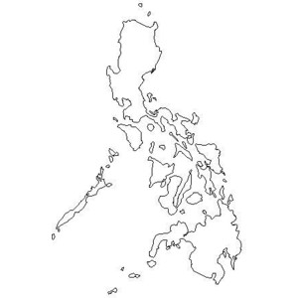
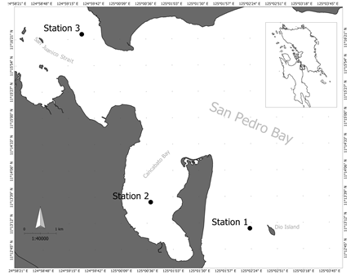
Fig. 1. Map of the inner portion of San Pedro Bay showing the location of the three sampling stations of sample collection from 2012 to 2013.

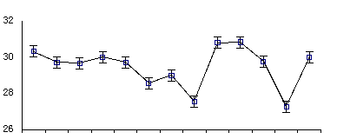
Temperature (C°)

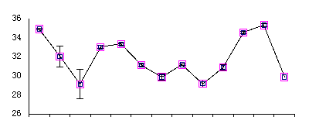
Salinity (ppt)

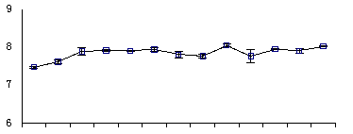

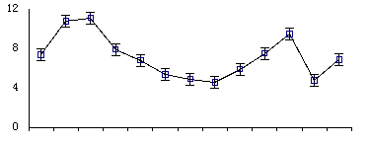
DO (mg/L)

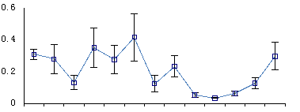
Transparency (m)

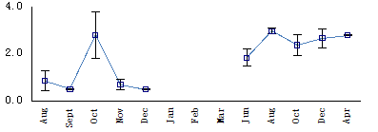
Light Intensity (fc)

2012
2013

Fig. 2. Mean temporal variations of physico-chemical parameters obtained during 2012 and 2013 sampling months. Bars indicate the standard error of each mean. Unavailable data values are indicated by broken lines.

Nitrites (NO₂) µM
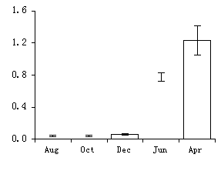
Rainy Season
Cold Dry Season
Hot Dry Season

0.55 µM

2012
2013
Nitrates (NO₃) µM
100 µM
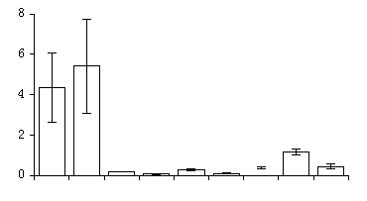

Phosphates (PO₄) µM
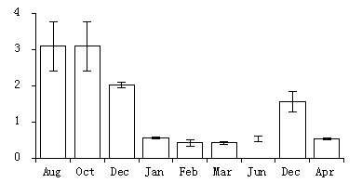

0.2 µM

2013
2012
Fig. 3. Mean concentrations of Nitrates, Nitrites and Phosphates during selected sampling months of 2012 and 2013. Standard error of each mean is represented by vertical error bars. The ASEAN acceptable nutrient concentration is indicated by black dashed line

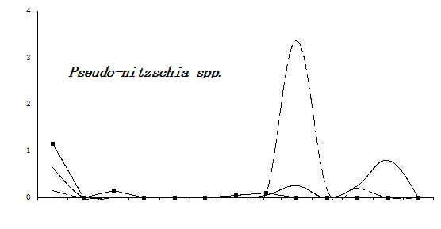
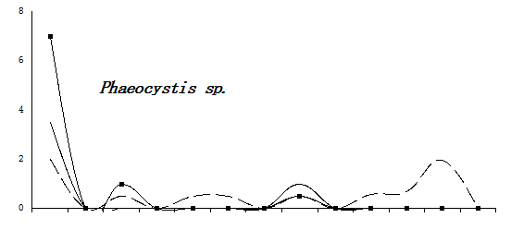
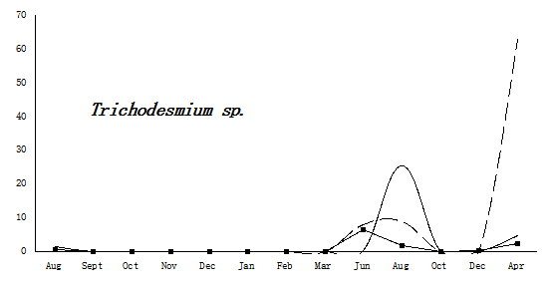
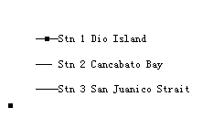
Density x 10³ cells/L
Density x 10³ cells/L
Density x 10² cells/L
Rainy Season
Cold Dry Season
Hot Dry Season

2012
2013
Fig. 4. Seasonal dynamics of the potentially toxic and harmful haptophyte, Phaeocystis (x10² cells/L), the diatom, Pseudo-nitzschia (x10³ cells/L) and cyanobacterium, Trichodesmium (x10³cells/L) in San Pedro Bay in 2012-2013
2013
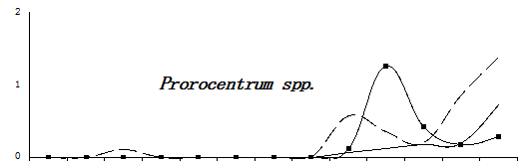
Rainy Season
Cold Dry Season
Hot Dry Season

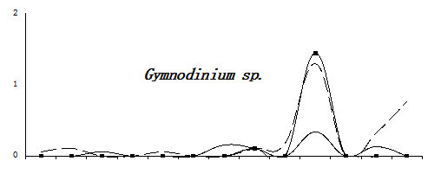

Density x 10³ cells/L

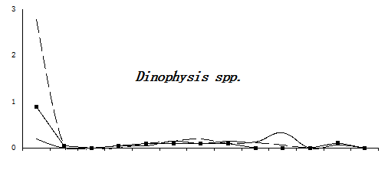

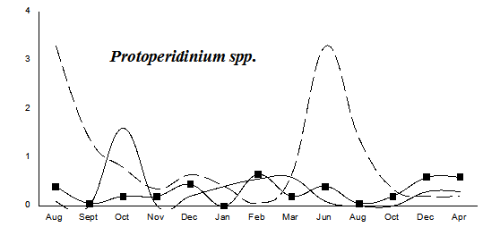

2012
2013

Fig. 5. Seasonal dynamics of potentially toxic and harmful dinophytes with relatively high cell densities in San Pedro Bay from 2012 – 2013

