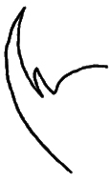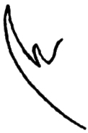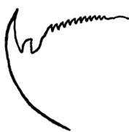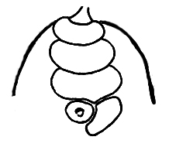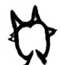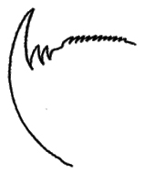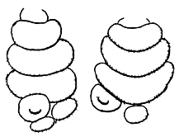

Outer Blade

Urinary papillae

Inner Blade

1/1/0

1/1/0/11

*E. nicaraguensis* (holotype), Matagalpa, female

1/1/0

*E.isthmicola* (holotype), San José, female

“remind from all points the jaws of the latter species”[*E. nicaraguensis*]

[ 1/1/0 ?]

[ 1/1/0/11 ?]

“similar to the type species”

[*E. nicaraguensis*]

?

Not explicitly described

1/2/0/10-12

*E. isthmicola* ? Cachí, Cartago, female

*E. isthmicola* ? Santa Clara – Siquirres

It is unclear whether this specimen is from Cachí or Santa Clara

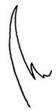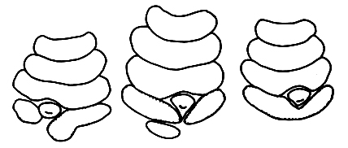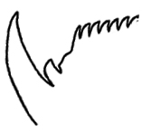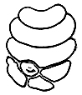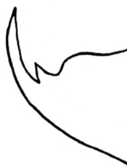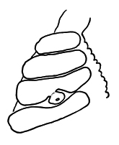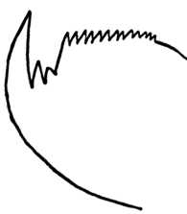

Outer Blade

Urinary papillae

Inner Blade

*E. biolleyi* (type), La Palma, San José, male

1/1/1

1/1/0/10-12

*E. biolleyi* (allotype) ?

Surubres, San Mateo,

female

*“*types: pads and urinary papillae of three legs”. It is not clear which belong to male from La Palma, which the female from Surubres

1/1/0/10-11

*…*Surubres, San Mateo,

another one (male)

Not explicitly described

1/1/0

1/2/0/13

*P. ruber* (type), Rancho Redondo, San José, female

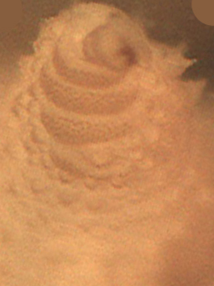

Outer Blade

Urinary papillae

Inner Blade

1/1/0

1/1/0/9

*E.isthmicola*, Plaza Viquez, San José city,

female