Genotypes of dengue virus 2 in the Central Highlands, Vietnam during 2010 to 2012
Le Van Tuan¹*, Nguyen Thi Tuyet Van¹, Pham Tho Duoc, Nguyen Hoang Quan
Department of Virology, Tay Nguyen Institute of Hygiene and Epidemiology
34 Pham Hung Street, Buon Ma Thuot city, DakLak, Vietnam
* Corresponding author. Phone: +84 (500) 3814 878; Fax: +84 (500) 3852 423. Email address: levantuan.tihe.gmail.com
¹ These authors contributed equallly to this work

Abstract:
The envelope (E) gene of 15 viruses isolated from dengue fever patients from 2010 to 2012 were sequenced to determine the genotype(s) of dengue 2 (DENV-2) viruses in the the Central Highlands region, Vietnam. The envelope sequence data were compared with different geographic sequences of DENV-2 obtained from GenBank data. Phylogenetic analysis revealed that Asian genotypes 1 are currently circulating locally in Cengtral Highlands region. Isolates of this genotype were closely related to viruses from Thailand, Laos, and Cambodia.
Keywords: dengue virus, genotype, envelope protein, phylogenetic anlaysis

Introduction
Dengue fever is a mosquito-borne disease in the tropical and subtropical regions with estimated 50 million cases of dengue infection occurring annually in more than 100 countries.1 Dengue virus (DENV) is a virus of the Flaviviridae family It is an enveloped positive-sense single-stranded RNA virus (Henchal & Putnak, 1990). There are four antigenically distinct DENV serotypes; DENV-1, DENV-2, DENV-3 and DENV-4 (Russell & Nisalak, 1967) and each serotype shows phylogenetically distinct genotypes (Holmes & Burch, 2000).
DENV are classified into six genotypes, including two genotypes confined to the Asian population (Asian 1 and Asian 2); the Cosmopolitan; American/Asian; American; and Sylvatic genotype (Twiddy et al., 2002)
Dengue fever is endemic in the Central Highlands region of Vietnam with all four DENV serotypes co-circulating. Multiple serotypes are transmitted during dengue outbreaks and usually more than one serotype predominates in the same outbreak.
Major epidemics of DF/DHF in the Central Highlands region were reported in 1998, 2010 and 2012(Dat & Huong, 2010; Duoc, Dat, Trang, & Van, 2014). The dengue epidemic of 1998 with the highest incidence estimated around 14,652 infected cases. DENV-2 has been the most frequently isolated serotype in this epidemic and in outbreaks/epidemics from 2008 to 2012.(Duoc et al., 2014)
The Central Highlands region has a history of outbreaks of dengue viral infection however, the responsible genotype/s is not well known. Therefore, the current study was aimed to determine the circulating genotype/s in the Central Highlands using isolates collected from outbreaks of DENV-2 (2010 to 2012) and the obtained sequences were compared to other sequences reported from other geographical regions of the world to deduce a phylogenetic relationship.
Materials and Methods
Virus strains
The DENV 2 strains used in this study were obtained from patients sera in DF/DHF epidemic in the Central Highlands during 2010 to 2012 (shown in Table 1). All strains were determined as DENV 2 serotype by reverse transcription polymerase chain reaction (RT-PCR) using Promega Access RT-PCR kit and DEN type specific primers
Virus stocks were prepared by single passage in C6/36 Aedes albopictus cell monolayers in Dulbecco’s Modified Eagle’s medium (D-MEM) supplemented with 10% fetal calf serum (FCS). Cells were incubated at 28°C for 5 to 7 days and observed for cytopathic effects. The presence of DENV in cell supernatants was confirmed by an immunofluoresent assay (IFA) during which cells were reacted with either DENV group-specific or serotype-specific monoclonal antibodies derived from hybridoma cultures (15F3-1, 3H5-1, 4D4-11, and 1H10-6). The fluorescein isothiocyanate-conjugated goat anti-mouse antibody was used as the detector
Preparation of viral RNA, amplification, and sequencing.
Viral RNA was extracted from infected cell culture supernatant using QIAamp Viral RNA Mini kit (Qiagen, Hilden, Germany) following the manufacturer’s instructions.
Conventional semi-nested PCR was performed using a modified procedure described by Lanciotti and colleagues (Lanciotti, Calisher, Gubler, Chang, & Vorndam, 1992). A one-step RT-PCR was performed using the AccessQuickTM RT-PCR System (Promega, Madison, WI, USA) in a 25 μl reaction volume containing 1X AccessQuickTM Master Mix, 5.0 units of AMV Reverse Transcriptase and 0.25 μM (each) of Primers D1 and TS2 (Lanciotti et al., 1992) using the following programme; reverse transcription at 45°C for 30 min, inactivation at 94°C for 3 min, and PCR amplification of 35 cycles under the following conditions: 94°C for 30 sec, 55°C for 30 sec, 72°C for 1 min, and a final extension at 72°C for 7 min.

RT-PCR and sequencing primers were designed on the basis of published DENV sequences. E gene of DENV was amplified using one-step RT-PCR amplification (Zhang et al., 2005). Overlapping fragments were amplified using AccessQuick RT-PCR System (Promega, Madison, WI, USA) with four sets of primers covering the entire E gene. Amplified products were purified prior to sequencing using QIAquick PCR purification kit (QIAGEN) following manufacturer’s instructions. Capillary-based Sanger sequencing was used to obtain E gene sequences (1,485 nt).
Genotype and phylogenetics analysis of DENV-2

Overlapping nucleic acid sequences obtained from individual sequencing reactions were combined for analysis and edited using the Lasergene package version 8.0 (DNASTAR Inc., Madison, WI, USA). Contiguous sequences were aligned using ClustalX program (Larkin et al., 2007) and compared with published sequences of DENV isolates in Genbank database. Phylogenetic analysis of E gene sequences was performed in MEGA5 program (Tamura et al., 2011) using the neighbor joining (NJ).
For genotype classification, we grouped the isolate sequences with the relevant reference sequences based on classifications by Twiddy et al.(Twiddy et al., 2002).
Phylogenetic trees were constructed from the aligned nucleic acid sequence using algorithms based on distance matrix/neighbor joining (NJ) in MEGA6.0. DENV 3 (H87, Philippines 1956) strain (GenBank accession numbers FJ850094) was used as outgroup to root the trees (shown in Table 2).

Results
Dengue incidence in the Central Highlands, Viet Nam
Dengue fever is endemic in the Central Highlands region where all four serotypes of dengue virus (DENV) are co-circulated anually. Data on passive dengue surveilance kindly provided by Tay Nguyen Institute of Hygiene and Epidemiology showed that serotypes DEN-2 is the predominant serotype in dengue infection in outbreaks of 2010 and 2012 in the Central Highlands region (shown in Figure 1).
Genotype and nucleotide sequence accession numbers
We determined the complete E gene nucleotide sequences of the 15 DENV-2 strains isolated from 2010-2012 from provinces of the Central Highlands. The sequences of all the strains reported in this paper have been deposited in GenBank database (shown in Table 3).
Genotype and Phylogenetic tree of DENV-2
A phylogenetic tree was constructed using pair-wise comparison of a 1,485 nt region from the E gene (nt 850–2726) of virus isolates sequenced in this study The resulting phylogenetic trees for the genotype grouping are described in Figure 2.
The phylogenetic tree demonstrated that all DENV-2 isolates were clustered in Asian genotype 1. Phylogenetic trees of DENV-2 generated by E gene sequences showed that DENV-2 strains are grouped into Asian genotype 1. Isolates from 2010 epidemic in Kon Tum province was closely related to the isolates from 2010 epidemic in Laos and Cambodia. However, isolates from 2012 epidemic in DakLak and GiaLai province was closely related to the isolates from 2011 epidemic in Southern of Vietnam and 2010 epidemic in Thailand (shown in Figure 1). It indicated that these epidemics maybe imported into the Central Highlands region from South-East Asia neighbor countries.

Discussion
Dengue fever has become an important arboviral infection in different geographical regions of the world where the growth of mosquitoes. It is estimated that over a hundred tropical and subtropical countries with more than 2.5 billion people at the risk of infection of dengue virus (Huang et al., 2012).
Asian genotype 1 is quite common in the region and is widely circulated in India, South East Asia, Africa, the Middle East, and Australia (Fahri et al., 2013). Dengue viruses also could be divided into different genotypes by the E gene (Lanciotti, Lewis, Gubler, & Trent, 1994; Wittke et al., 2002). No particular pattern of genotype distribution can be inferred for serotype 2 as different genotypes spread in diverse locations. In order to study the circulating DENV genotypes in the Central Highlands region, genotyping analysis was performed based on E gene sequences. The E gene sequences of the 15 isolates of the Central Highlands region were compared with the sequences of DEN-2 viruses isolated worldwide from GenBank aligned with reference sequences to generate genotype classifications
Previous study showed that the Asian genotype I of DENV-2 had displaced the previously dominant American/Asian genotype as the predominant DENV-2 lineage in the southern Vietnam (Vu et al., 2010). A large number of susceptible hosts in the population, and an associated increased force of infection, could help explain the seemingly short period in which genotype replacement occurred. However, South-East Asian DENV-2 viruses are less susceptible than American lineage viruses to cross-neutralization antibodies elicited by DENV-1 infection (Kochel et al., 2002; Wang et al., 2016). Population wide seroepidemiology, coupled with a better understanding of correlates of immunity, are clearly needed to understand serotype and genotype replacement in all endemic regions.
The displacement of Asian/American lineage viruses by Asian 1 viruses has also observed in Thailand and Cambodia. In Thailand, the Asian/American genotype of Thai DENV-2 viruses most likely co-circulated with the Asian 1 genotype for at least a decade prior to 1991, but is then replaced by the Asian 1 lineage from 1992 to 2006 (Lambrechts et al., 2012; Wittke et al., 2002). The same circumstance is also occurred in Cambodia as only Asian 1 genotype viruses circulating since 2005 (Vu et al., 2010). The Central Highlands region have border lines with both Laos and Cambodia and it’seemly to be sources of introduction of Asian 1 genotype viruses to the Central Highlands region by travelling transportation.
Acknowledgments
The authors wish to thank the Dengue surveillance team at the Tay Nguyen Institute of Hygiene and Epidemiology, for allowing us to use data on dengue incidence and serotype prevalence for the Central Highland region, Viet Nam
Conflict of interests
We have no conflict of interests to this manuscript

References

Dat, D. T., & Huong, V. T. (2010). Epidemiologic characteristics of Dengue fever in the Central Highlands of Vietnam, 1998-2010. Journal of Tay Nguyen Medicine Prevention, 2, 1-3.
Duoc, P. T., Dat, D. T., Trang, L. T. T., & Van, N. T. H. (2014). Epidemiologic characteristics of Dengue fever in the Central Highlands of Vietnam, 2008-2012. Journal of Tay Nguyen Preventive Medicine, 1, 41-47.
Fahri, S., Yohan, B., Trimarsanto, H., Sayono, S., Hadisaputro, S., Dharmana, E., . . . Sasmono, R. T. (2013). Molecular surveillance of dengue in Semarang, Indonesia revealed the circulation of an old genotype of dengue virus serotype-1. PLoS Negl Trop Dis, 7(8), e2354. doi: 10.1371/journal.pntd.0002354
Henchal, E. A., & Putnak, J. R. (1990). The dengue viruses. Clin Microbiol Rev, 3(4), 376-396.
Holmes, E. C., & Burch, S. S. (2000). The causes and consequences of genetic variation in dengue virus. Trends Microbiol, 8(2), 74-77.
Huang, J. H., Su, C. L., Yang, C. F., Liao, T. L., Hsu, T. C., Chang, S. F., . . . Shu, P. Y. (2012). Molecular characterization and phylogenetic analysis of dengue viruses imported into Taiwan during 2008-2010. Am J Trop Med Hyg, 87(2), 349-358. doi: 10.4269/ajtmh.2012.11-0666
Kochel, T. J., Watts, D. M., Halstead, S. B., Hayes, C. G., Espinoza, A., Felices, V., . . . Russell, K. L. (2002). Effect of dengue-1 antibodies on American dengue-2 viral infection and dengue haemorrhagic fever. Lancet, 360(9329), 310-312. doi: 10.1016/s0140-6736(02)09522-3
Lambrechts, L., Fansiri, T., Pongsiri, A., Thaisomboonsuk, B., Klungthong, C., Richardson, J. H., . . . Scott, T. W. (2012). Dengue-1 virus clade replacement in Thailand associated with enhanced mosquito transmission. J Virol, 86(3), 1853-1861. doi: 10.1128/jvi.06458-11
Lanciotti, R. S., Calisher, C. H., Gubler, D. J., Chang, G. J., & Vorndam, A. V. (1992). Rapid detection and typing of dengue viruses from clinical samples by using reverse transcriptase-polymerase chain reaction. J Clin Microbiol, 30(3), 545-551.
Lanciotti, R. S., Lewis, J. G., Gubler, D. J., & Trent, D. W. (1994). Molecular evolution and epidemiology of dengue-3 viruses. J Gen Virol, 75 ( Pt 1), 65-75. doi: 10.1099/0022-1317-75-1-65
Larkin, M. A., Blackshields, G., Brown, N. P., Chenna, R., McGettigan, P. A., McWilliam, H., . . . Higgins, D. G. (2007). Clustal W and Clustal X version 2.0. Bioinformatics, 23(21), 2947-2948. doi: 10.1093/bioinformatics/btm404
Russell, P. K., & Nisalak, A. (1967). Dengue virus identification by the plaque reduction neutralization test. J Immunol, 99(2), 291-296.
Tamura, K., Peterson, D., Peterson, N., Stecher, G., Nei, M., & Kumar, S. (2011). MEGA5: molecular evolutionary genetics analysis using maximum likelihood, evolutionary distance, and maximum parsimony methods. Mol Biol Evol, 28(10), 2731-2739. doi: 10.1093/molbev/msr121
Twiddy, S. S., Farrar, J. J., Vinh Chau, N., Wills, B., Gould, E. A., Gritsun, T., . . . Holmes, E. C. (2002). Phylogenetic relationships and differential selection pressures among genotypes of dengue-2 virus. Virology, 298(1), 63-72.
Vu, T. T., Holmes, E. C., Duong, V., Nguyen, T. Q., Tran, T. H., Quail, M., . . . Simmons, C. P. (2010). Emergence of the Asian 1 genotype of dengue virus serotype 2 in viet nam: in vivo fitness advantage and lineage replacement in South-East Asia. PLoS Negl Trop Dis, 4(7), e757. doi: 10.1371/journal.pntd.0000757
Wang, C., Katzelnick, L. C., Montoya, M., Hue, K. D., Simmons, C. P., & Harris, E. (2016). Evolutionarily Successful Asian 1 Dengue Virus 2 Lineages Contain One Substitution in Envelope That Increases Sensitivity to Polyclonal Antibody Neutralization. J Infect Dis, 213(6), 975-984. doi: 10.1093/infdis/jiv536
Wittke, V., Robb, T. E., Thu, H. M., Nisalak, A., Nimmannitya, S., Kalayanrooj, S., . . . Aaskov, J. G. (2002). Extinction and Rapid Emergence of Strains of Dengue 3 Virus during an Interepidemic Period. Virology, 301(1), 148-156. doi: http://dx.doi.org/10.1006/viro.2002.1549
Zhang, C., Mammen, M. P., Jr., Chinnawirotpisan, P., Klungthong, C., Rodpradit, P., Monkongdee, P., . . . Holmes, E. C. (2005). Clade replacements in dengue virus serotypes 1 and 3 are associated with changing serotype prevalence. J Virol, 79(24), 15123-15130. doi: 10.1128/jvi.79.24.15123-15130.2005

TABLE 1
Central Highlands DENV-2 isolates used in this study
Isolate | Origin | Passage history  (no. of passages) | Year
43GL10 | GiaLai | C6/36, 1 | 2010
46GL10 | GiaLai | C6/36, 1 | 2010
75GL10 | GiaLai | C6/36, 1 | 2010
07KT10 | KonTum | C6/36, 1 | 2010
14KT10 | KonTum | C6/36, 1 | 2010
23KT10 | KonTum | C6/36, 1 | 2010
32KT10 | KonTum | C6/36, 1 | 2010
30DN11 | DakNong | C6/36, 1 | 2011
07DL12 | DakLak | C6/36, 1 | 2012
129DL12 | DakLak | C6/36, 1 | 2012
134DL12 | DakLak | C6/36, 1 | 2012
142DL12 | DakLak | C6/36, 1 | 2012
16GL12 | GiaLai | C6/36, 1 | 2012
28GL12 | GiaLai | C6/36, 1 | 2012
29GL12 | GiaLai | C6/36, 1 | 2012

TABLE 2.
Geographic origin and year of isolation of dengue 2 viruses used in the study
Isolate | Country | Year | GenBank  accession no.
09DX698 | Viet Nam | 2011 | JX093619
1010aTw | Thailand | 2010 | JF968045
DaNang2 | Viet Nam | 2006 | HQ588140
0809aTw | Cambodia | 2008 | JF967966
Laos2010 | Laos | 2010 | JN568244
Vietnam 2010a | Viet Nam | 2010 | JN568281
DT-M-4056 | Viet Nam | 2010 | JN376793
C0167 | Thailand | 1996 | AF100464
M1 | Malaysia | 1987 | X15434
New Guinea C | New Guinea | 1980 | AF038403
New Guinea C | New Guinea | 1980 | M29095
43 | China | 1987 | AF204178
SG(EHI)D2/72054Y10 | Singapore | 2010 | JN030345
Inida 2003 | India | 2003 | JN568260
IQT1797 | Peru | 1985 | AF100467
ET00 300 | East Timor | 2000 | JN568254
D91-533 | Thailand | 1991 | AF195040
2 CTD226 | Viet Nam | 1998 | AF410367
Jamaica/N.1409 | Jamaica | 1983 | DEN2JAMCG
FPT0754/PER/12 | Peru | 2012 | KC847992
JA/DB021/2008 | Jamaica | 2008 | JF804034
DEN2/H/IMTSSA-MART/98-703 | Martinique | 1998 | AF208496
NIV_P23085 | India | 1960 | FJ538928
Tonga 1974 | Toga | 1974 | X54319
131 | Mexico | 1992 | AF100469
P8-1407 | Malaysia | 1970 | AF231717
DAKHD10674 | Senegal | 1970 | AF231720

TABLE 3
Genotypes of DENV-2 and accession numbers deposited on GenBank
Isolate | Origin | Year | Genotype | GenBank accession no.
43GL10 | GiaLai | 2010 | Asian genotype 1 | KP769811
46GL10 | GiaLai | 2010 | Asian genotype 1 | KP769812
75GL10 | GiaLai | 2010 | Asian genotype 1 | KP769813
07KT10 | KonTum | 2010 | Asian genotype 1 | KP706452
14KT10 | KonTum | 2010 | Asian genotype 1 | KP706451
23KT10 | KonTum | 2010 | Asian genotype 1 | KP706450
32KT10 | KonTum | 2010 | Asian genotype 1 | KP706449
30DN11 | DakNong | 2011 | Asian genotype 1 | KP769814
07DL12 | DakLak | 2012 | Asian genotype 1 | KP671756
129DL12 | DakLak | 2012 | Asian genotype 1 | KP706453
134DL12 | DakLak | 2012 | Asian genotype 1 | KP706455
142DL12 | DakLak | 2012 | Asian genotype 1 | KP706454
16GL12 | GiaLai | 2012 | Asian genotype 1 | KP769808
28GL12 | GiaLai | 2012 | Asian genotype 1 | KP769809
29GL12 | GiaLai | 2012 | Asian genotype 1 | KP769810

% of RT-PCR positive samples
Incidence/100,000 inhabitants

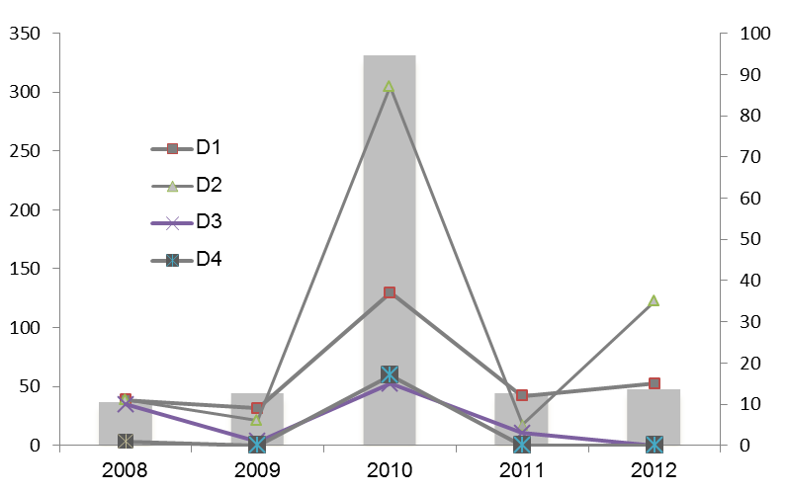

Figure 1. Dengue incidence and serotype abundance in the Central Highlands region, Viet Nam.

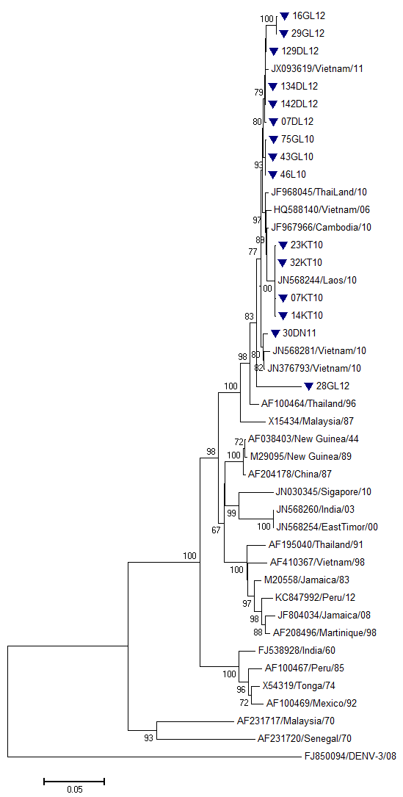
Asian Genotype 2
Cosmopolitan Genotype
Sylvatic Genotype
American/Asian genotype
American genotype
Asian Genotype 1
Outgroup
Figure 2. Neighbour-joinning tree depicting the phylogenetic relationships of dengue serotype 2 viruses based on the envelope gene (1,485 bases).

