Apéndice digital 1
Colecciones de las cuales provienen los registros geográficos usados para el modelado de nicho ecológico de Amazona finschi así como la institución a la cual se encuentran adscritas dichas colecciones
Collections from which are derived the geographical records used for the ecological niche modeling of Amazona finschi as well as the institution to which these collections are assigned
ID | Colección | Institución
1 | Ornithology Collection Non Passeriformes | Royal Ontario Museum
2 | Ornithology and Vertebrate Paleontology Collections | Michigan State University
3 | Bird Collection | Field Museum of Natural History
4 | Museum of Comparative Zoology | Harvard University
5 | Ornithology | California Academy of Sciences
6 | eBird Observation Dataset | eBird
7 | Reserach-Grade Dataset | iNaturalist
8 | NMNH Ocurrence DwC-A | Nacional Museum of Natural History
9 | Vertebrate Collection | Natural History Museum of Los Angeles County
10 | Audio and Video Collection | Macaulay Library
11 | Base de datos de aves mexicanas del Natural History Museum | Bases de datos SNIB2010-CONABIO
12 | Proyecto de evaluación y análisis geográfico de la diversidad faunística de Chiapas | Bases de datos SNIB2010-CONABIO
13 | UWBM Ornithology Collection | University of Washington Burke Museum
14 | Bird Collection | Louisiana State University
15 | Bird Collection | San Diego Natural History Museum
16 | CNAV/Coleccion Nacional de Aves | Instituto de Biología, Universidad Nacional Autónoma de México
17 | MMNH Museum Bird Collection | Bell Museum
18 | UCLA Donald R. Dickey Bird and Mammal Collection | University of California, Los Angeles
19 | Naturalis Biodiversity Center (NL) - Aves | Naturalis Biodiversity Center
20 | WFVZ Bird Collections | Western Foundation of Vertebrate Zoology
21 | MLZ Bird Collection (Arctos) | Moore Laboratory of Zoology
22 | Collection Aves (spirit preserved) SMF | Senckenberg world of biodiversity (Natural History Museum)
23 | Collection Aves (Bird skins) SMF | Senckenberg world of biodiversity (Natural History Museum)
24 | UAZ Bird Collection | University of Arizona Museum of Natural History
25 | AMNH Bird Collection | American Museum of Natural History
26 | Birds Collection | University of Washington Burke Museum
27 | Birds Collection | Carnegie Museum of Natural History
28 | Biodiversity Research and Teaching Collections - TCWC Vertebrates | Department of Wildlife and Fisheries Sciences
29 | Cowan Tetrapod Collection - Birds | University of British Columbia Beaty Biodiversity Museum
30 | UMMZ Birds Collection | University of Michigan Museum of Zoology
31 | DMNH Birds | Delaware Museum of Natural History
32 | MSB Bird Collection (Arctos) | Museum of Southwestern Biology, University of New Mexico, Albuquerque
33 | MVZ Bird Collection (Arctos) | Museum of Vertebrate Zoology (MVZ), University of California, Berkeley
34 | KUBI Ornithology Collection | University of Kansas

Apéndice digital 2
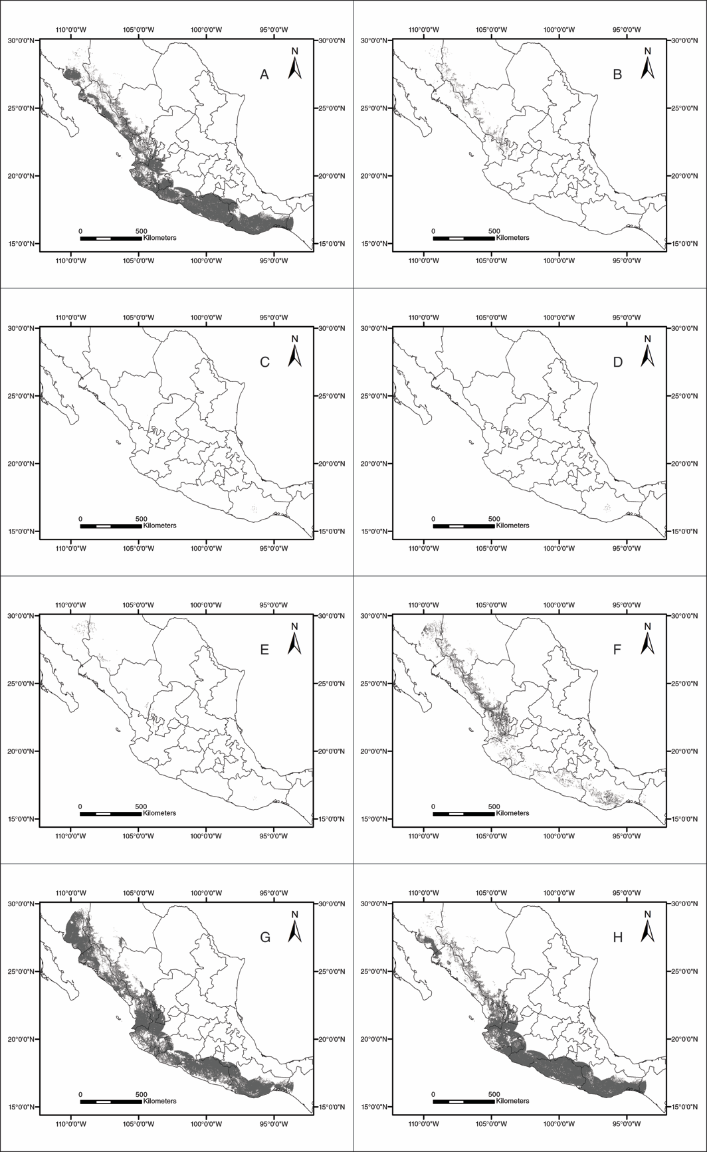
Fig. 1. Proyección del modelo de distribución potencial de la temporada reproductiva de: a) enero, b) junio, c) julio, d) agosto, e) septiembre, f) octubre, g) noviembre y h) diciembre.
Fig. 1. Projection of the potential distribution model from the reproductive season of: a) January, b) June, c) July, d) August, e) September, f) October, g) November and h) December.
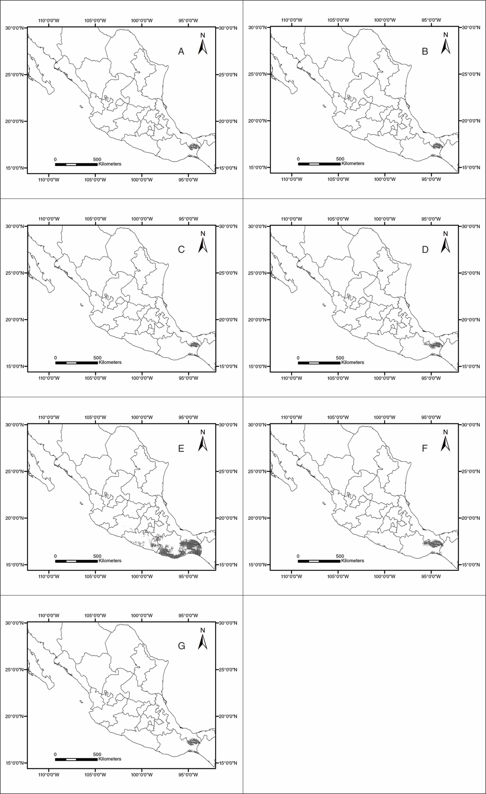
Fig. 2. Proyección del modelo de distribución potencial de la temporada no reproductiva hacia: a) enero, b) febrero, c) marzo, d) abril, e) mayo, f) noviembre, g) diciembre.
Fig. 2. Projection of the potential distribution model from the non-reproductive season to: a) January, b) February, c) March, d) April, e) May, f) November, g) December.

