29 June 2016

To the editor:

We are herewith submitting a manuscript entitled “Cetacean sightings and acoustic detections during a seismic survey off Nicaragua and Costa Rica, November-December 2004.” This is an original document and all coauthors agree with its publication. We believe that the information on cetacean occurrence and distribution on the shelf and slope waters of the Pacific coast of Costa Rica and Nicaragua fills a knowledge gap and is important to the study of tropical biology and conservation. All ethical requirements were met during the study, and we agree to pay excess page fee charges if required.

Three possible reviewers include:

Kristin Rasmussen: krill@aol.com
Dr. Laura J. May-Collado: lmaycollado@gmail.com
Dr. Alejandro Acevedo: acevedo@biol.wwu.edu

Sincerely,

Meike Holst Mari Smultea

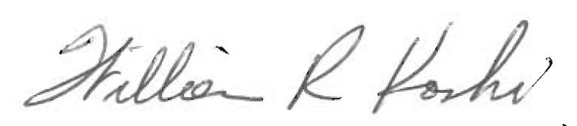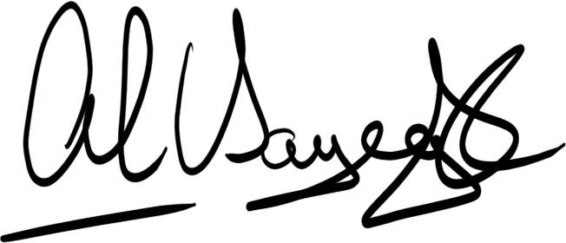

William Koski Alejandro Sayegh
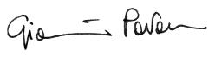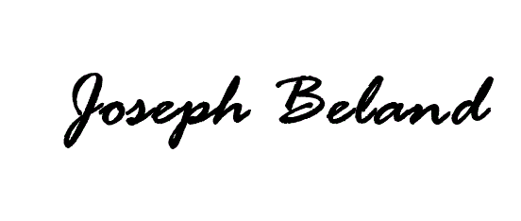
Gianni Pavan Joseph Beland

Howard Goldstein

