16th January 2017

Dear Dr. Julián Monge-Nájera,

I am pleased to submit an original research article entitled “Temporal and spatial variation of richness and abundance of the community of birds in the Pantanal wetlands of Nhecolândia (Mato Grosso do Sul, Brazil)” by Reginaldo J. Donatelli, Guilherme Sementili Cardoso, Renata Marques Vianna, Raphael Whitacker Gerotti, Fernanda Gonçalves Rodrigues, and Rafael Martos Martins, for consideration for publication in the journal Biologia.

In this manuscript, we present a detailed characterization of the bird community for four years in order to evaluate the effect of the year, season, habitat, period and categorized environments (aquatic, and open and close terrestrial habitats) in the dynamic of birds in the huge Nhecolândia sub-region of the Pantanal of Mato Grosso do Sul, Brazil.

This manuscript was submitted to Biología Tropical last year (another title) and has been rejected. However, we performed modifications according to reviewers’ criticism and this is a new submission to be under consideration for publication.

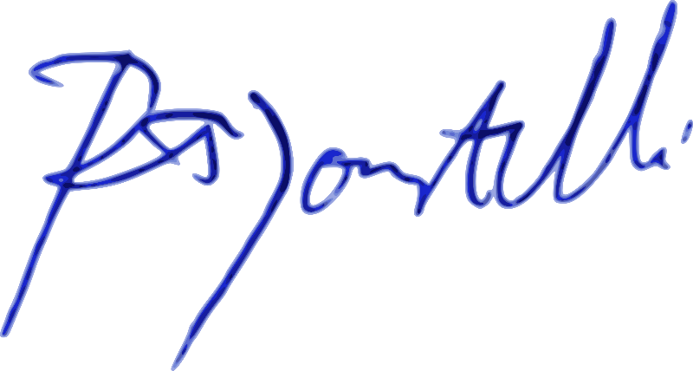Sincerely,

Prof. Dr. Reginaldo José Donatelli

Universidade Estadual Paulista (UNESP)

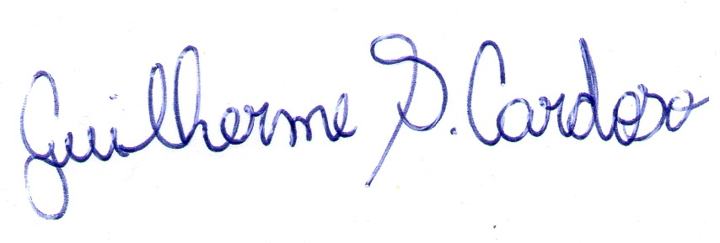

M. Sc. Guilherme Sementili Cardoso

Universidade Estadual Paulista (UNESP)

Master’s candidate Renata Marques Vianna

Universidade Estadual Paulista (UNESP)

Master’scandidate Raphael Whittacker Gerotti

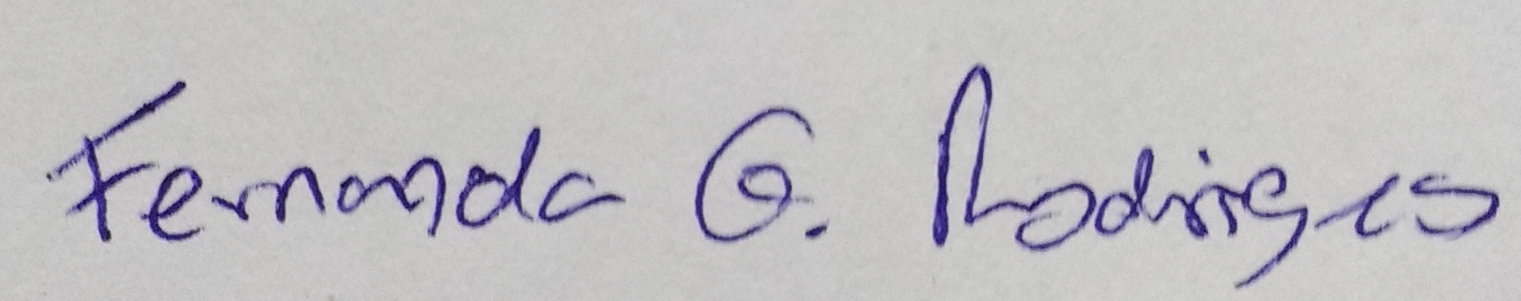Universidade Estadual Paulista (UNESP)

Master’s candidate Fernanda Gonçalves Rodrigues

Universidade Estadual Paulista (UNESP)

Master’s candidate Rafael Martos Martins

Universidade Estadual Paulista (UNESP)