LEGENDS OF FIGURES
Figure 1. Sampling station distribution over a four-year study (2008, 2010-2012) at the El Eden Ecological Reserve, Quintana Roo, Mexico.

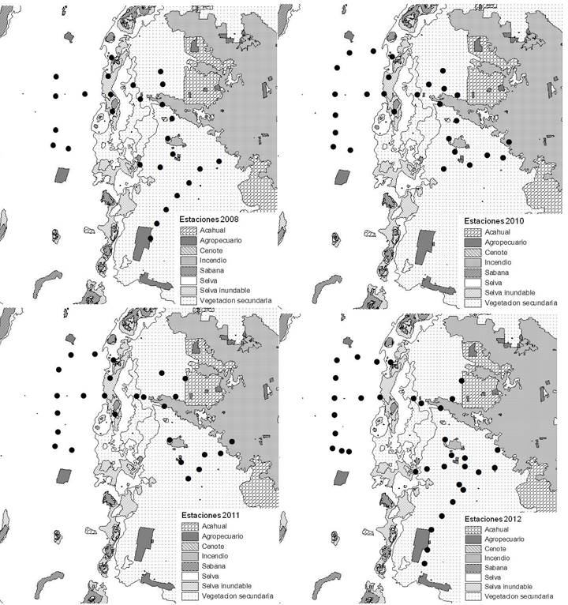

Figure 2. Cougar (Puma concolor) activity schedules at the el Eden Ecological Reserve, Quintana Roo, Mexico over a four-year study. Times of the day grouped in pairs.

