DIGITAL APPENDICES
Digital Appendix 1: Additional Tables
TABLE 3
Yearly distribution of articles, authors, pages and references for El Salvador articles after 1971

Year | TP | AU | AU/TP | NR | NR/TP | PG | PG/TP
1972 | 1 | 2 | 2.0 | 0 | 0 | 8 | 8.0
1973 | 4 | 8 | 2.0 | 34 | 8.5 | 39 | 9.8
1974 | 8 | 29 | 3.6 | 94 | 12 | 53 | 6.6
1975 | 14 | 34 | 2.4 | 161 | 12 | 84 | 6.0
1976 | 11 | 22 | 2.0 | 120 | 11 | 87 | 7.9
1977 | 14 | 39 | 2.8 | 136 | 9.7 | 69 | 4.9
1978 | 9 | 27 | 3.0 | 116 | 13 | 56 | 6.2
1979 | 5 | 6 | 1.2 | 91 | 18 | 28 | 5.6
1980 | 10 | 43 | 4.3 | 110 | 11 | 53 | 5.3
1981 | 8 | 29 | 3.6 | 130 | 16 | 49 | 6.1
1982 | 1 | 2 | 2.0 | 5 | 5.0 | 2 | 2.0
1983 | 8 | 30 | 3.8 | 81 | 10 | 40 | 5.0
1984 | 3 | 6 | 2.0 | 14 | 4.7 | 15 | 5.0
1985 | 2 | 6 | 3.0 | 37 | 19 | 10 | 5.0
1986 | 3 | 8 | 2.7 | 28 | 9.3 | 31 | 10
1987 | 3 | 19 | 6.3 | 57 | 19 | 20 | 6.7
1988 | 1 | 2 | 2.0 | 13 | 13 | 3 | 3.0
1989 | 1 | 1 | 1.0 | 6 | 6.0 | 9 | 9.0
1990 | 3 | 11 | 3.7 | 49 | 16 | 19 | 6.3
1991 | 1 | 4 | 4.0 | 13 | 13 | 11 | 11
1992 | 4 | 16 | 4.0 | 53 | 13 | 24 | 6.0
1993 | 6 | 23 | 3.8 | 79 | 13 | 53 | 8.8
1994 | 5 | 17 | 3.4 | 92 | 18 | 51 | 10
1995 | 4 | 24 | 6.0 | 46 | 12 | 38 | 9.5
1996 | 9 | 29 | 3.2 | 150 | 17 | 56 | 6.2
1997 | 11 | 53 | 4.8 | 353 | 32 | 149 | 14
1998 | 2 | 8 | 4.0 | 60 | 30 | 29 | 15
1999 | 5 | 15 | 3.0 | 89 | 18 | 69 | 14
2000 | 11 | 58 | 5.3 | 151 | 14 | 52 | 4.7
2001 | 10 | 40 | 4.0 | 231 | 23 | 77 | 7.7
2002 | 13 | 78 | 6.0 | 424 | 33 | 120 | 9.2
2003 | 7 | 41 | 5.9 | 181 | 26 | 49 | 7.0
2004 | 21 | 122 | 5.8 | 598 | 28 | 200 | 9.5
2005 | 19 | 123 | 6.5 | 484 | 25 | 154 | 8.1
2006 | 17 | 122 | 7.2 | 510 | 30 | 157 | 9.2
2007 | 15 | 93 | 6.2 | 465 | 31 | 165 | 11
2008 | 18 | 166 | 9.2 | 629 | 35 | 172 | 9.6
2009 | 21 | 153 | 7.3 | 582 | 28 | 189 | 9.0
2010 | 34 | 315 | 9.3 | 1 257 | 37 | 353 | 10
2011 | 41 | 353 | 8.6 | 1 554 | 38 | 418 | 10
2012 | 43 | 411 | 9.6 | 1 431 | 33 | 400 | 9.3
2013 | 34 | 303 | 8.9 | 1 112 | 33 | 291 | 8.6
2014 | 44 | 475 | 10.80 | 1 514 | 34 | 464 | 11
2015 | 58 | 691 | 11.91 | 1 951 | 34 | 645 | 11
Total | 563 | 4 058 |  | 15 296 |  | 5 068
Average |  |  | 4.7 |  | 19 |  | 8.1
TP: number of articles; AU: Number of authors; NR: number of cited reference; PG: page counts.
TABLE 4
The top ten highly cited articles (TC₂₀₁₅ > 100) with authorship or co-authorship from El Salvador (1972-2015)
Rank  (TC₂₀₁₅) | Rank  (C₀) | Rank  (C₂₀₁₅) | Rank  (TCPY) | Title | Country | Reference
1 (176) | 24 (2) | 1 (50) | 1 (29) | EULAR/PRINTO/PRES criteria for Henoch-Schönlein purpura, childhood polyarteritis nodosa, childhood Wegener granulomatosis and childhood Takayasu arteritis: Ankara 2008. Part II: Final classification criteria | Turkey, Italy, Denmark, Israel, Romania, Brazil, El Salvador, Chile, France, Peru, Latvia, Croatia, Saudi Arabia, Bulgaria, Russia, Germany, USA, Spain, Estonia, Austria, Rep of Georgia | Ozen et al. (2010)
2 (152) | 5 (5) | 12 (14) | 3 (25) | International Nosocomial Infection Control Consortium (INICC) report, data summary for 2003-2008, issued June 2009 | Argentina, USA, Thailand, Brazil, India, Colombia, Turkey, Jordan, Mexico, Philippines, Peru, Morocco, Cuba, El Salvador, Macedonia, China, Lithuania, Lebanon, Panama, Costa Rica, Tunisia, Serbia, Greece, Pakistan, Vietnam, Venezuela | Rosenthal et al. (2010)
3 (149) | 109 (0) | 83 (3) | 33 (5.1) | Epidemiology of American cutaneous Leishmaniasis due to Leishmania-Braziliensis-Braziliensis | USA, Brazil, El Salvador | Jones et al. (1987)
4 (143) | 9 (4) | 5 (21) | 4 (18) | Geographic patterns of genome admixture in Latin American mestizos | UK, Switzerland, Colombia, Peru, USA, Mexico, Costa Rica, Brazil, El Salvador, Argentina, Chile | Wang et al. (2008)
5 (127) | 3 (6) | 4 (24) | 6 (16) | Integrating agricultural landscapes with biodiversity conservation in the Mesoamerican hotspot | USA, Costa Rica, El Salvador, Mexico, Nicaragua, Netherlands | Harvey et al. (2008)
5 (127) | 109 (0) | 7 (17) | 10 (12) | Changes in precipitation and temperature extremes in Central America and northern South America, 1961-2003 | Spain, USA, Costa Rica, Belize, Cuba, El Salvador, Guatemala, Honduras, Mexico, Nicaragua, Panama, Venezuela, UK, Colombia | Aguilar et al. (2005)
7 (120) | 9 (4) | 3 (25) | 5 (17) | Cost of Dengue Cases in Eight Countries in the Americas and Asia: A Prospective Study | USA, Brazil, Malaysia, Thailand, Venezuela, El Salvador, Cambodia, Guatemala, South Korea | Suaya et al. (2009)
7 (120) | 109 (0) | 14 (12) | 7 (15) | International Nosocomial Infection Control Consortium report, data summary for 2002-2007, issued January 2008 | Argentina, USA, India, Colombia, Turkey, Mexico, Peru, Morocco, Macedonia, El Salvador, Philippines, Cuba, Serbia, Costa Rica, Brazil, Lebanon, Nigeria, Chile, Uruguay | Rosenthal et al. (2008)
9 (111) | 5 (5) | 2 (33) | 2 (28) | International Nosocomial Infection Control Consortium (INICC) report, data summary of 36 countries, for 2004-2009 | Argentina, China, USA, India, Thailand, Brazil, Turkey, Singapore, Colombia, Jordan, Mexico, Peru, Philippines, Morocco, Cuba, Macedonia, Uruguay, Tunisia, El Salvador, Lithuania, Egypt, Pakistan, Lebanon, Costa Rica, Panama, Serbia, Malaysia, Vietnam, Saudi Arabia, Greece, Ecuador, Dominican Rep, Bulgaria, Sudan, Venezuela, Sri Lanka | Rosenthal et al. (2012)
10 (102) | 1 (10) | 162 (1) | 86 (2.4) | Release of chemosterilized males for control of anopheles-albimanus in el-salvador. 3. Field methods and population-control | USA, El Salvador | Lofgren et al. (1974)
TC₂₀₁₅: number of citations since publication to the end of 2015; C₂₀₁₅: number of citations in 2015; C₀: number of citations in publication year; TCPY: average citations per year (TC₂₀₁₅/year)
TABLE 5
The top six (TC₂₀₁₅ > 20) El Salvador independent articles (1972-2015)
Rank  (TC₂₀₁₅) | Rank  (C₂₀₁₅) | Title | Institute | Reference
33 (40) | 162 (1) | Primary pyogenic infection of the sacro-iliac articulation. A new approach to the joint - Report of seven cases | Hospital Rosales | Avila (1941)
40 (35) | 162 (1) | Onchocerciasis in Guatemala. Epidemiology in fincas with various intensities of infection | Central America Research Station | Brandling-Bennett et al. (1981)
65 (25) | 275 (0) | Leiomyoma cutis and leiomyosarcoma: A 10-year study and a short review | University of El Salvador | Orellana-Díaz and Hernández-Pérez (1983)
65 (25) | 275 (0) | Release of chemosterilized males for control of Anopheles Albimanus in El-Salvador. I. Characteristics of test site and natural population | Central America Malaria Research Station | Breeland et al. (1974)
71 (24) | 162 (1) | Parasitological diagnosis of onchocerciasis: Comparisons of incubation media and incubation times for skin snips | Central America Research Station | Collins et al. (1980)
80 (22) | 275 (0) | Clear cell hydradenocarcinoma. Report of an unusual case | University of El Salvador | Hernández-Pérez and Cruz (1976)
TC₂₀₁₅: number of citations since publication to the end of 2015; C₂₀₁₅: number of citations in 2015.
TABLE 6
Top 20 collaborative countries with El Salvador in SCI-EXPANDED (1972-2015)
Country | TP | TPR (%) | FPR (%) | RPR (%)
USA | 261 | 1 (46) | 1 (29) | 1 (26)
Mexico | 82 | 2 (15) | 3 (4.6) | 3 (5.1)
Spain | 77 | 3 (14) | 2 (9.4) | 2 (10)
Guatemala | 71 | 4 (13) | 10 (1.2) | 16 (0.76)
Honduras | 64 | 5 (11) | 21 (0.53) | 11 (1.0)
Costa Rica | 53 | 6 (9.4) | 6 (2.5) | 7 (2.5)
Argentina | 45 | 7 (8.0) | 4 (3.6) | 4 (3.8)
Nicaragua | 43 | 8 (7.6) | N/A | N/A
Brazil | 42 | 9 (7.5) | 11 (1.1) | 10 (1.1)
Colombia | 42 | 9 (7.5) | 16 (0.71) | 16 (0.76)
Peru | 42 | 9 (7.5) | 16 (0.71) | 16 (0.76)
Panama | 35 | 12 (6.2) | 23 (0.36) | 23 (0.38)
Cuba | 33 | 13 (5.9) | 12 (0.89) | 11 (1.0)
Chile | 30 | 14 (5.3) | 12 (0.89) | 11 (1.0)
Canada | 27 | 15 (4.8) | 5 (2.8) | 5 (3.0)
UK | 27 | 15 (4.8) | 7 (2.3) | 6 (2.7)
Ecuador | 24 | 17 (4.3) | N/A | N/A
Italy | 24 | 17 (4.3) | 8 (2.1) | 9 (2.1)
Venezuela | 22 | 19 (3.9) | 24 (0.18) | 23 (0.38)
Paraguay | 19 | 20 (3.4) | N/A | N/A
TP: total number of articles; TPR (%), FPR (%), and RPR (%): the rank and percentage of total articles, first author articles, and corresponding author articles.
TABLE 7
The top 14 El Salvador centers and institutions with TP ≥ 10 in the SCI-EXPANDED (1972-2015)
Institute | TP | TPR (%) | SPR (%) | CPR (%) | FPR (%) | RPR (%)
Universidad de El Salvador | 136 | 1 (24) | 1 (41) | 1 (21) | 1 (9.6) | 1 (8.8)
Hospital Benjamín Bloom | 60 | 2 (11) | 6 (2.2) | 2 (12) | 8 (0.71) | 7 (0.57)
Ministerio de Salud de El Salvador | 53 | 3 (9.4) | 6 (2.2) | 3 (11) | 6 (0.89) | 7 (0.57)
Hospital Nacional Rosales | 24 | 4 (4.3) | 6 (2.2) | 4 (4.7) | 11 (0.53) | 13 (0.38)
Ministerio de Ambiente y Recursos Naturales | 16 | 5 (2.8) | 10 (1.1) | 7 (3.2) | 11 (0.53) | 7 (0.57)
Servicio Nacional de Estudios Territoriales | 16 | 5 (2.8) | N/A | 5 (3.4) | N/A | N/A
Universidad Dr. José Matías Delgado | 16 | 5 (2.8) | N/A | 5 (3.4) | N/A | N/A
Agencia para el Desarrollo Internacional de los EEUU en El Salvador | 16 | 5 (2.8) | 3 (6.5) | 11 (2.1) | 3 (1.6) | 3 (1.1)
Basic Health International, El Salvador | 15 | 9 (2.7) | N/A | 7 (3.2) | 11 (0.53) | 13 (0.38)
Oficina Centroamericana del Center for Disease Control | 28 | 20 (5.05) | 8 (11.9) | 29 (3.7) | 6 (3.1) | 9 (2.47)
Universidad José Simeón Cañas | 13 | 12 (2.3) | 10 (1.1) | 9 (2.6) | 11 (0.53) | 7 (0.57)
Fundación Ecológica Salva Natura | 11 | 13 (2.0) | 10 (1.1) | 11 (2.1) | 8 (0.71) | 7 (0.57)
Hospital San Juan de Dios | 10 | 14 (1.8) | N/A | 11 (2.1) | N/A | N/A
Universidad Salvadoreña Alberto Masferrer | 10 | 14 (1.8) | 4 (5.4) | 20 (1.1) | 4 (1.1) | 3 (1.1)
TP: total number of highly cited articles; TPR (%), SPR (%), CPR (%), FPR (%), and RPR (%): the rank and percentage of total articles, single institution articles, inter-institutionally collaborative articles, first author articles, corresponding author articles; N/A: not available.
TABLE 8
The top 15 journals with TP ≥ 5 from El Salvador (1972-2015)
Journal | TP (%) | IF₂₀₁₅ | Web of Science category
American Journal of Tropical Medicine and Hygiene | 31 (5.5) | 2.453 | Public, Environmental & Occupational Health  Tropical Medicine
Revista de Biología Tropical | 11 (2.0) | 0.441 | Biology
Neurorehabilitation | 9 (1.6) | 1.453 | Clinical Neurology  Rehabilitation
Infection Control and Hospital Epidemiology | 8 (1.4) | 3.669 | Public, Environmental & Occupational Health  Infectious Diseases
International Journal of Dermatology | 8 (1.4) | 1.415 | Dermatology
International Journal of Gynecology & Obstetrics | 8 (1.4) | 1.674 | Obstetrics & Gynecology
American Journal of Infection Control | 7 (1.2) | 1.995 | Public, Environmental & Occupational Health  Infectious Diseases
Mosquito News | 7 (1.2) | N/A | Entomology
Medic Review | 6 (1.1) | 1.519 | Public, Environmental & Occupational Health
Pediatric Blood & Cancer | 6 (1.1) | 2.634 | Oncology  Hematology  Pediatrics
Turrialba | 6 (1.1) | N/A | Agronomy
Boletín de la Oficina Sanitaria Panamericana | 5 (0.89) | N/A | Public, Environmental & Occupational Health
Bulletin of the Seismological Society of America | 5 (0.89) | 2.311 | Geochemistry & Geophysics
Dermatologica | 5 (0.89) | N/A | Dermatology
PLoS One | 5 (0.89) | 3.057 | Multidisciplinary Sciences
TP: total number of articles; IF₂₀₁₅: impact factor in 2015.
Digital Appendix 2. Additional Figures
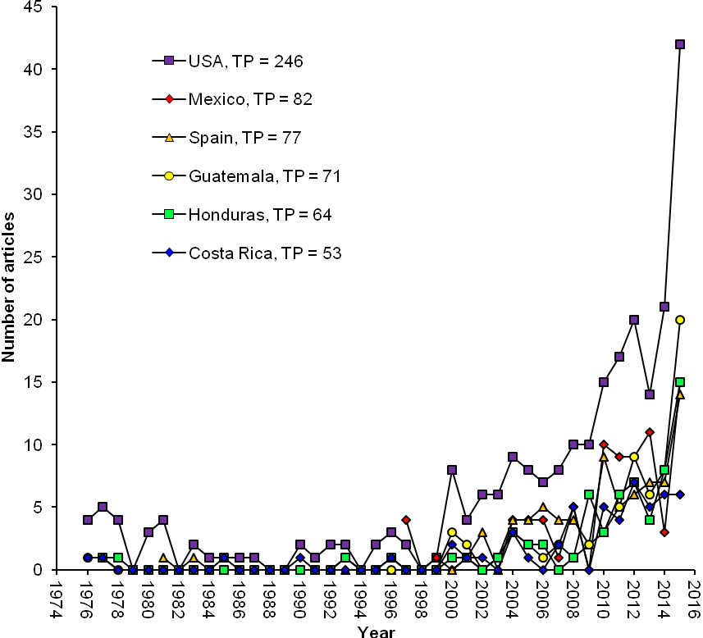
Fig. 5. Historical collaboration pattern for the top six collaborative countries with El Salvador (1972-2015; TP > 50).

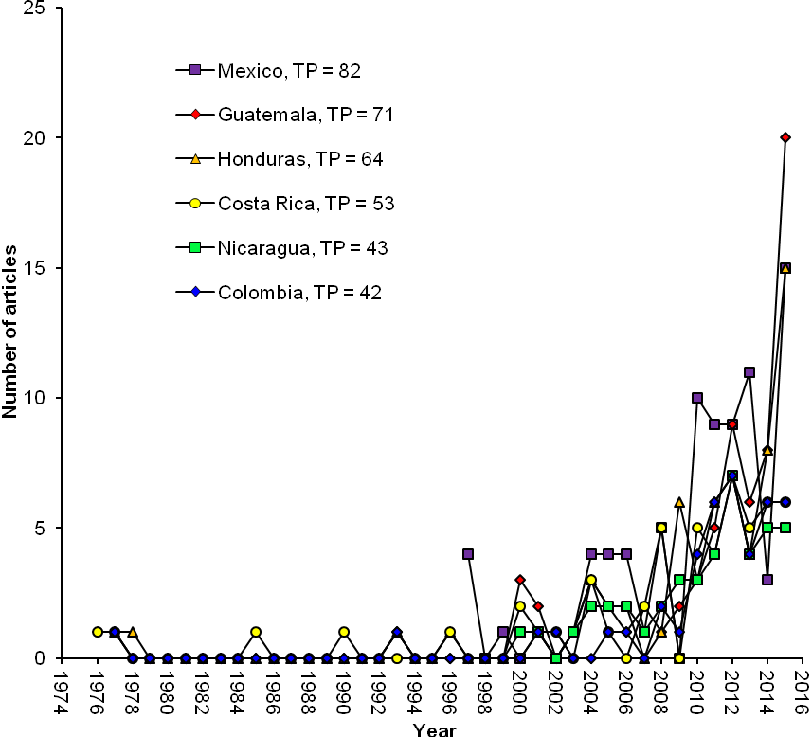
Fig. 6. Historical collaboration pattern for El Salvador, by geographically closest countries (1972-2015).

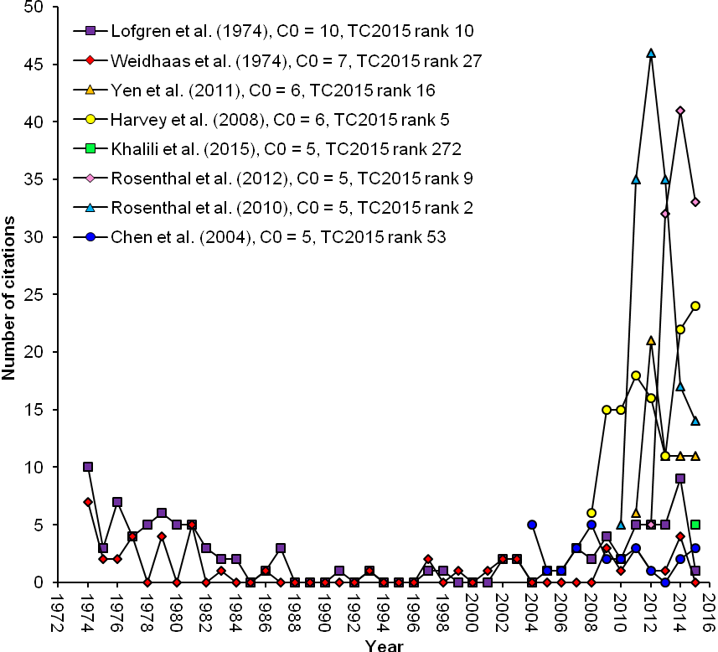
Fig. 7. Historical citation patterns for top cited articles, by publication year (C₀ ≥ 5; 1972-2015).

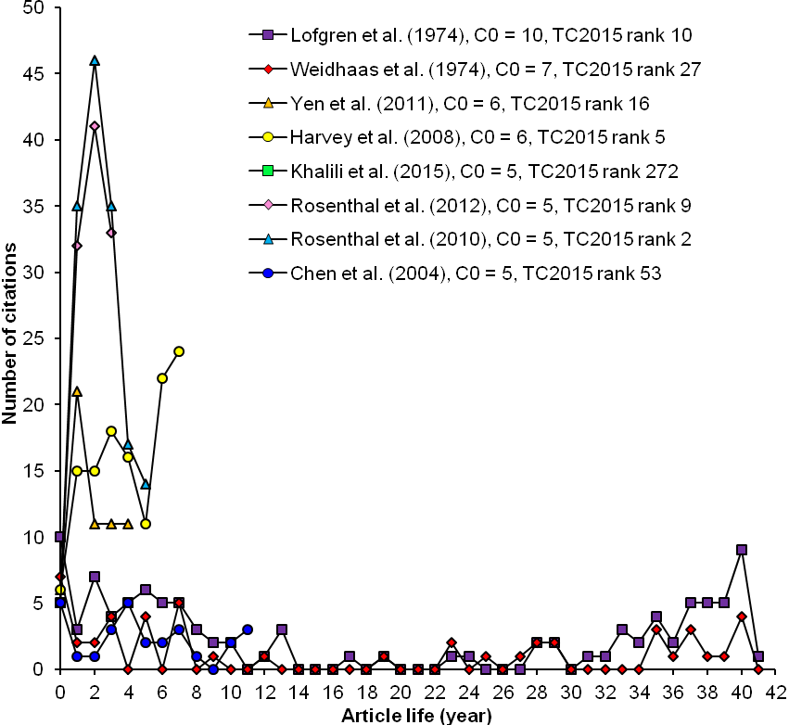
Fig. 8. Article lifespan for top cited articles, by publication year (C₀ ≥ 5; 1972-2015).

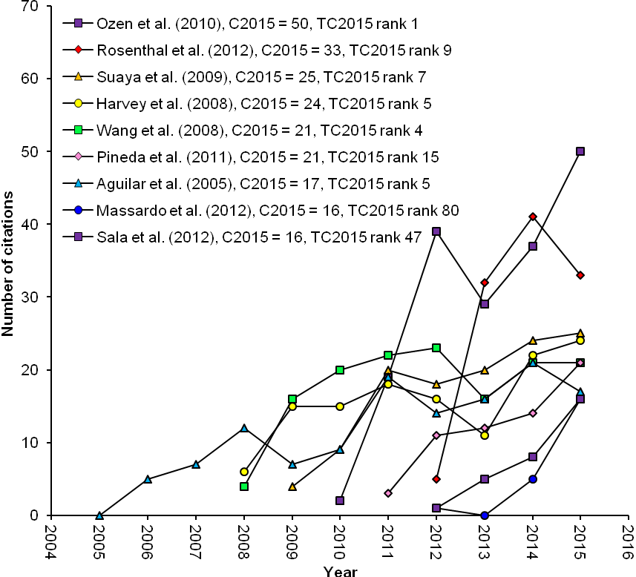
Fig. 9. Historical citation patterns for top cited articles in 2015 (recent year) only (C₂₀₁₅ > 15; 1972-2015).

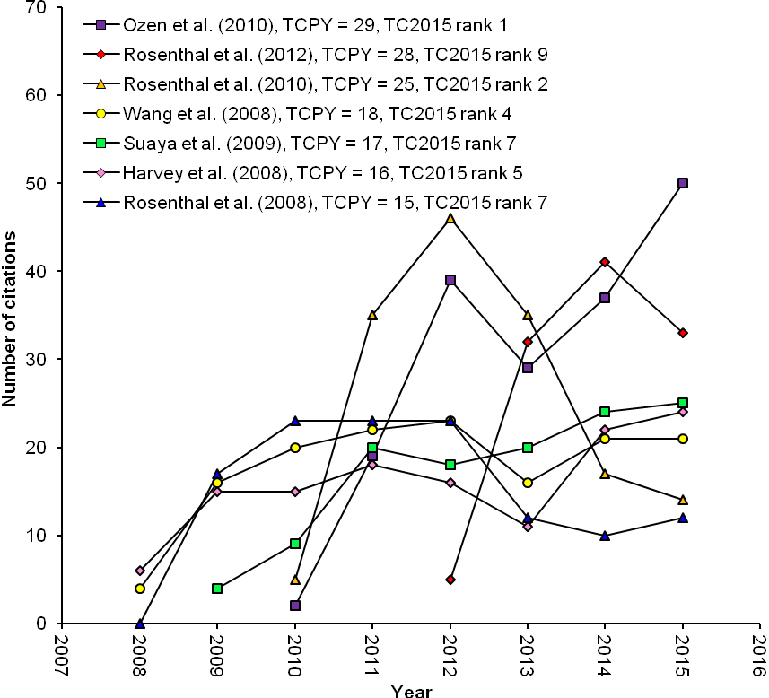
Fig. 10. Historical citation patterns for top cited articles by total citations per year (TCPY ≥ 15; 1972-2015).

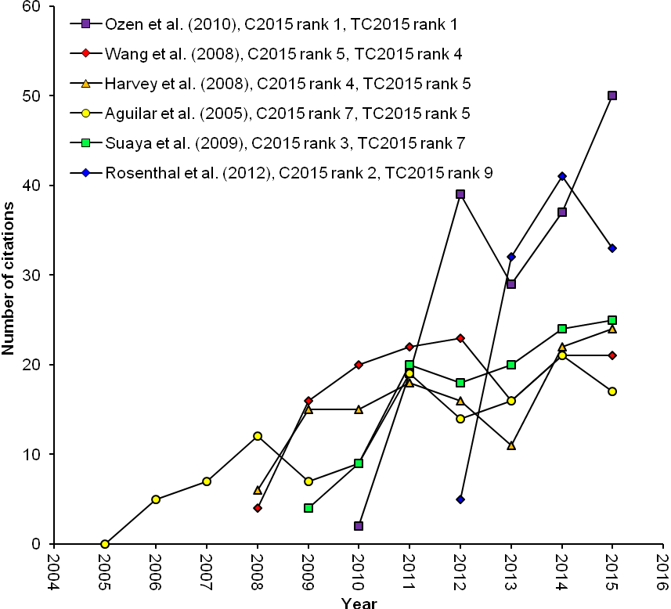
Fig. 11. Historical citation patterns for seven articles ranked on both the top ten TC₂₀₁₅ and C₂₀₁₅; (1972-2015).

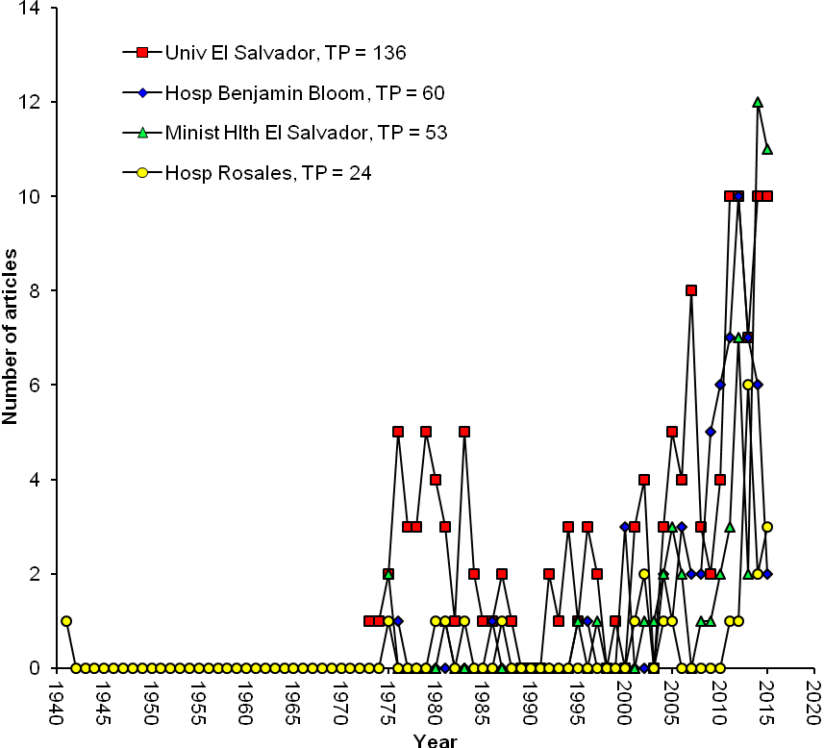
Fig. 12. Publication trends for the top four institutions, El Salvador publications (1972-2015).

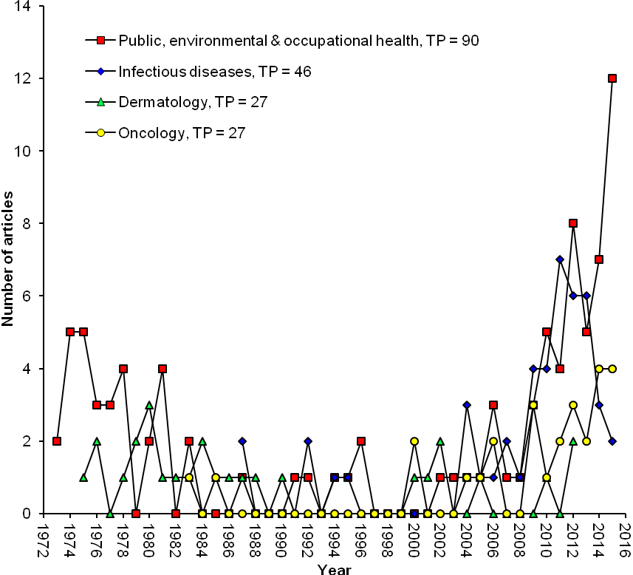
Fig. 13. Historical citation patterns for El Salvador articles, by the top four Web of Science subjects (1972-2015).

