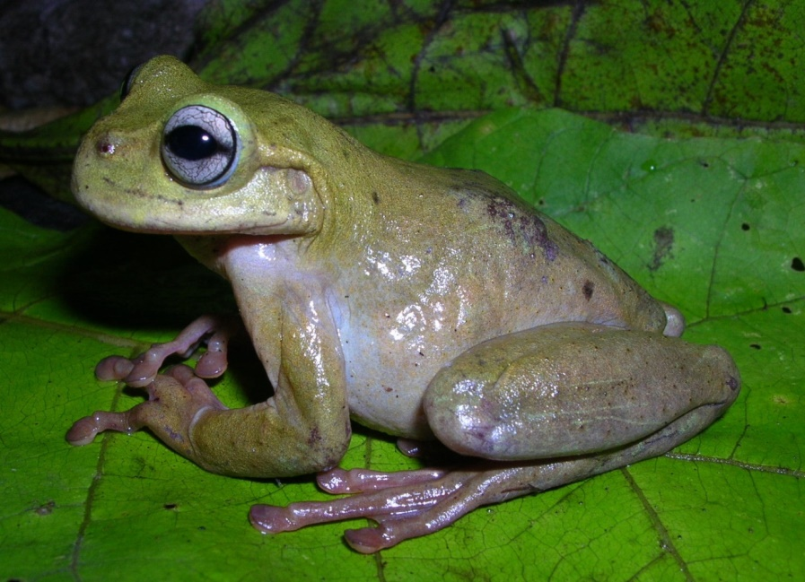
Fig. 5. Plectrohyla exquisita is endemic to the Jaguar Conservation Network. Its 131 km² distribution is limited to the Sierra de Omoa in northwest Honduras. Photo © F. Castañeda.

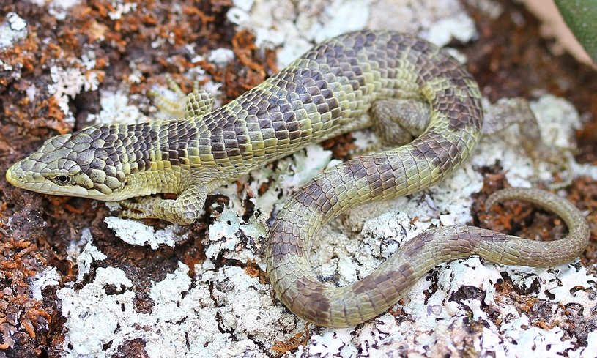
Fig. 6. Bogert's Arboreal Alligator Lizard Abronia bogerti is a Data Deficient reptile endemic to the Jaguar Conservation Network. It is only found in the Chimalapas in southeastern Mexico. Photo © A. Clause.

