APPENDIX 1
Frequency of detection of animal species recorded by photographic capture in the Santa Rosa National Park (SRNP), Costa Rica, between 2005 and 2015
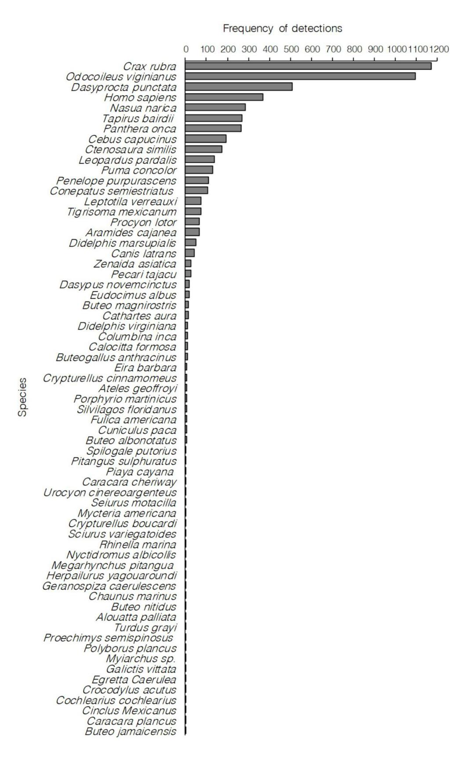

APPENDIX 2
Frequency of detection of animal species recorded by photographic capture in the Corcovado National Park (CNP), Costa Rica, between 2003 and 2015
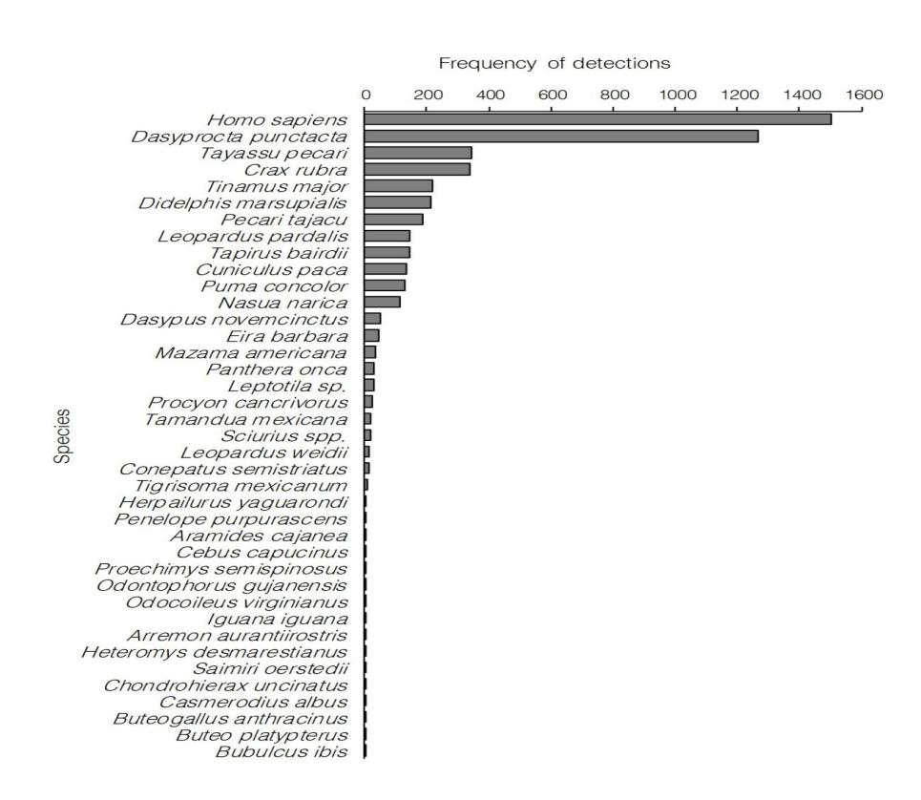

APPENDIX 3
Density estimates of the daily activity patterns of presumed prey species of jaguar, puma and ocelot in the Santa Rosa National Park (SRNP), Costa Rica
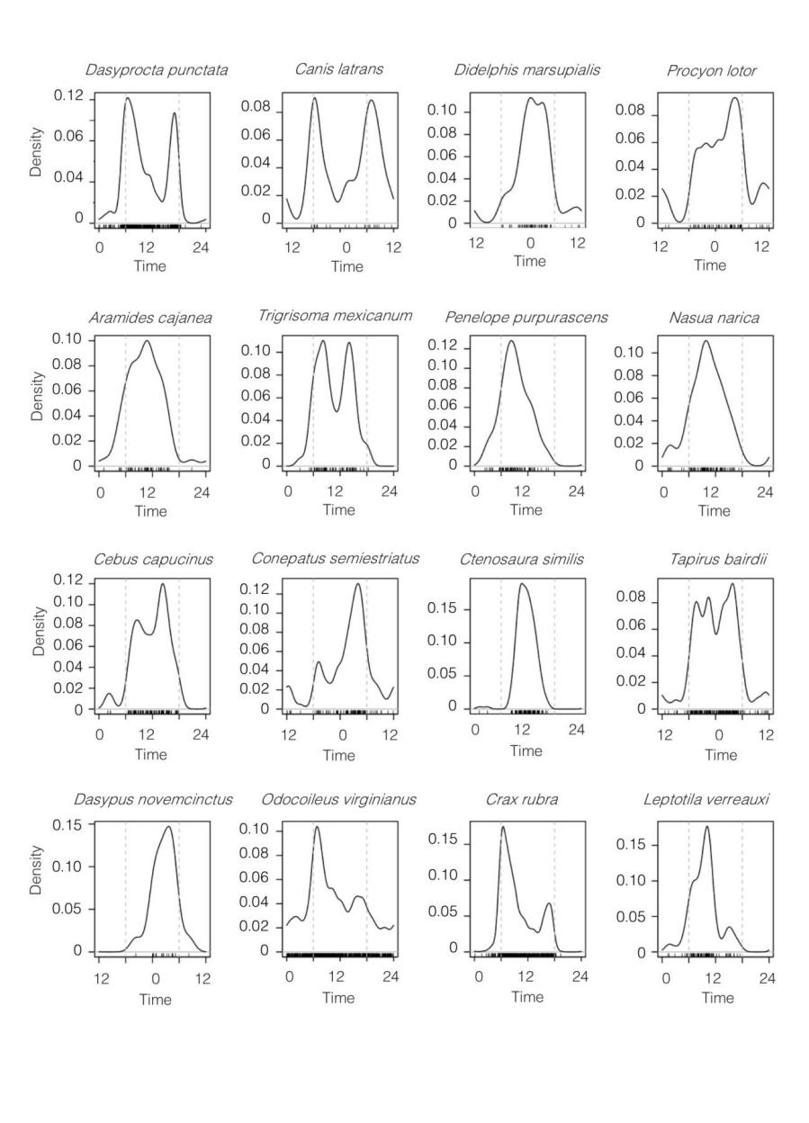
The short vertical lines above the x-axis indicate the times of individual photographs recorded between 2005 and 2015, and the grey dashed vertical lines indicate the approximate time of sunrise and sunset.

APPENDIX 4
Density estimates of the daily activity patterns of presumed prey species of jaguar, puma and ocelot in the Corcovado National Park (CNP), Costa Rica
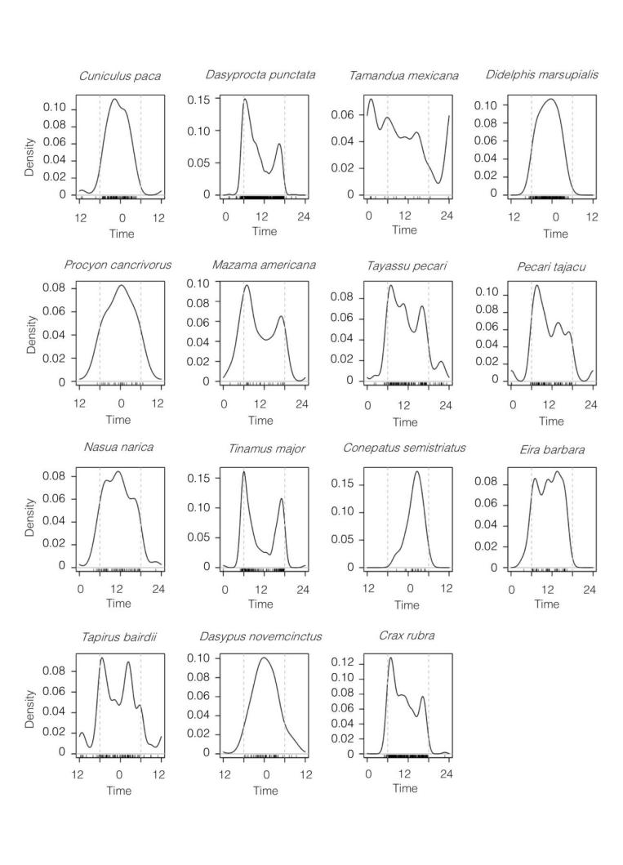
The short vertical lines above the x-axis indicate the times of individual photographs recorded between 2003 and 2015, and the grey dashed vertical lines indicate the approximate time of sunrise and sunset.

