Medellín (Colombia), April of 2018

Editorial Board

Please find attached the paper entitled: “Antimicrobial activity of Cymbopogon citratus essential oil on Streptococcus mutans and cytotoxic effect on keratinocytes and fibroblasts” authors, Mailen Ortega-Cuadros, Adriana Patricia Tofiño-Rivera, Luciano Jose Merini and María Cecilia Martínez-Pabón, so that it may be considered for evaluation and possible publication in Revista de Biología Tropical.

This study uses essential oil of Cymbopogon citratus and its main components citral and myrcene to control the viability of Streptococcus mutans in biofilms using the MBEC technique, because this microorganism is a good cariogenic model. Also, the cytotoxic effect of these substances on human keratinocytes and fibroblasts was evaluated by the MTT assay.
The findings of this study indicate that the substances evaluated control the growth of the microorganism in biofilms and do not present cytotoxicity on eukaryotic cells, supporting its possible use in oral hygiene product that includes in its formulation essential oils of C. citratus.

All the authors involved in this project declare that there is no conflict of interest and meet the relevant authorial criteria. The article is original and has not been sent to any other journal for publication. All the authors agree to pay for excess pages fee if required

Names and e-mail addresses of three possible objective reviewers:

Cristiane Yumi Koga Ito; cristiane@ict.unesp.br
Rosilene B. de Aguiar Almeida; rosileneaguiar@gmail.com
Ana Mesa-Arango amesa@medicina.udea.edu.co

Kind regards,

Mailen Ortega Cuadros

María Cecilia Martínez

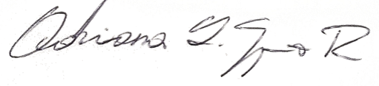
Adriana Tofiño Rivera

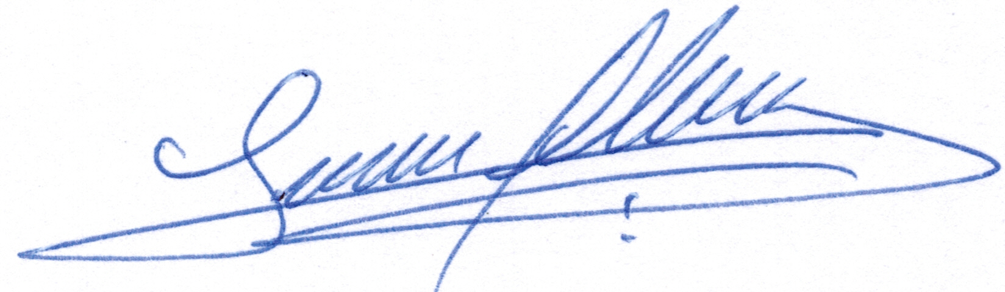

Luciano José Merini

Corresponding author: Mailen Ortega Cuadros
Email: mailen.ortega@udea.edu.co mailen.ortegac@gmail.com
Address: Corporación para investigaciones Biológicas-CIB, Cra 72A #78b-141, Medellín, Antioquia, Colombia
Phone: (+57) 3046095451

