Supplementary material

This PDF file includes:

Materials and Methods

- Propagation of AMF in trap cultures, monocultures and single spore cultures
- Molecular identification
- GPS location, vegetation and physical chararcteristics of the studied sites (table1)
- Values of mean and standard errors for different soil environment parameters. Letters indicate statistical difference according to Tukey’s HSD multiple comparison tests (table2).

Results

Figures
- S1: Sporocarpic fungi isolated from rhizosphere of Acacia nilotica (a-c Sclerocystis sinuosum b. Divrsispora aurentia and Glomus sp. ( where sp- spore, p-peridium, sw-sporewall, sh- subtending hyph,a shw1 and shw2 - subtending hyphae wall layers)
- S2: Maximum likelihood phylogenetic tree based on nuclear small subunit full (SSU)–5.8S–large subunit (LSU) rDNA of sequences isolated in present study and selected sequences of species from Glomeromycota. Bootstrap values are given for branches among different NCBI accession numbers. Acaulospora koskei sequences were used as outgroup. Multiple sequence alignment was done with Clustal w and phylogenetic tree was drawn with RaXml. The scale bar indicates the number of substitutions per site. Branches with < 60% bootstrap support were collapsed to polytomies, The scale bar indicates the number of substitutions per site. Treeview 1.6.6 is used for drawing the tree.
- S3 Effect of urban disturbance on spore density (A) and (MIP)of AM fungi isolated from nine sites located at Delhi Ridge
- S4 Venn diagram (plotted on the basis of presence absence of species) depicting distribution of Glomeromycotean species within three UD groups. 1-Glomus microaggregatum N. C. Schenck & G. S. Sm; 2- Glomus microcarpum Tul.& C. Tul {= Endogone microcarpa (Tul. &C. Tul.) Tul. & C. Tul. =Endogone neglacta Rodway}; 3- Glomus sp1; 4-Unidentified sp2; 5-Unidentified sp5; 6-unidentified sp.1; 7-Glomus invermianum R. Hall; 8-Diversispora aurantia (Blaszk., Blanke, Renker & Buscot) C. Walker & A. Shussler (= Glomus auronatium Blaszk., Blanke, Ranker & Buscot); 9-Rhizophagus aggregates (N.C. Schenck & G.S. Sm.) C. Walker; 10-Glomus ambisporum (G.S. Sm. & N.C. Schenck); 11-Glomus sp2; 12-Glomus tenebrossum S.M. Berch (=Endogone tenebrosa Thaxt.); 13-Rhizophagus intraradices (N.C. Schenck& G.S. Smith) C. Walker & A. Schüßler); 14-Unidentified sp3; 15-Unidentified sp4;16-Rhizophagus fasciculatus (C. Walker & A. Schüßler); 17-Glomus macrocarpum Tul.& C. Tul; 18-Enterophospora sp. (R. N. Ames & R.W. Schneid); 19-Entrophospora infrequens (I.R. Hall ) R.N. Ames & R.W. Schneid.(= Glomus infrequens I.R. Hall); 20-Glomus albidum C. Walker & L.H. Rhodes; 21-Glomus austral Berk.) S.M. Berch (= Endogon eaustralis Berk.); 22-Funneliformis geosporum T.H. Nicolson & Gerd.) C. Walker & A. Schüßler; 23-Funneliformis mosseae T.H. Nicolson & Gerd.) C. Walker & A. Schüßler; 24-Acaulospora sp.; 25-Acaulospora laevis Gerd & Trappe; 26-Scutellospora calospora (T.H. Nicolson & Gerd) C. Walker & F. E.; 27-Glomus constrictum (Trappe); 28-Gigaspora sp.; 29-Gigaspora gigantean (T.H. Nicolson &Gerd.)

Methods

Propagation of AMF in trap cultures, monocultures and single spore cultures

The method used for pot culturing was the same as developed by Dr. L. K. Abbott at University of Western Australia (Brundrett et al. 1996) using coarse textured soils with moderate nutrient level in non-draining pots. The soil was pasteurised by steaming for 1 hour at 90 ⁰ C for two consecutive days and watered to field capacity with minimal nutrient solution. Trap cultures were initiated using all spores separated from 50 g of soil samples by wet sieving and decanting (Daniels and Skipper 1982) using Trigonella foenum-graecum as host plants. Monospore cultures were raised by multiplying about 20 healthy spores of uniform appearance in sterile soil with Trigonella as host plant, picked using dissecting microscope (Olympus Magnus MSZ-BI). Single spore cultures were raised from a single spore already grown in trap or monospore culture in culture room using Zea mays cultivar narmada as host plants.

Molecular identification

Genomic DNA was extracted from 20 spores each from single spore cultures. Clean spores were collected in 0.5 ml tube and crushed thoroughly using a sterile pipette under dissecting microscope. To each sample 100 µl of PCR buffer (Biorad) was added and mixed thoroughly. Genes encoding small subunit (SSU) rRNA was amplified using SSU-ITS-LSU primers (Kruger et al. 2009). PCR was performed in final volume of 50ul containing 1µl of DNA complex, forward primer 200ng, reverse primer 200ng, dNTPs (2.5mM each) 2 μl, 10x aq pol assay buffer 10 μl, taq polymerase (3µ/μl) 0.5 μl and water 34.5μl. Amplification was performed as follows: 1x5 mins 90⁰C, 35x30 sec 94⁰C, 35x 30 sec 55⁰C, 35x180 sec 72⁰C, 1x10 min 72⁰C (final extension) on Biorad T100 thermal cycler. Cloning and sequencing was done at Chromus Biotech Pvt. Ltd. Control contained no template DNA for visualisation of PCR product, 10 µl of the amplification product were separated electrophoretically in 0.8% agarose gel and stained with ethidium bromide. The sequence data as *.ab1 file was processed with bioedit software and sequences were identified by similarity searches in NCBI blast. Identification was also confirmed by their location in phylogenetic tree drawn with selected preidentified sequences

Tab. 1- GPS location, vegetation and physical chararcteristics of the studied sites

HI | Site no. | Location name | GPS location | Vegetation (Dominant trees) | Site characteristics
 |  |  |  |  | U | G | R | F
gp1 | 1 | Civil lines, Kamla Nehru Ridge | 28.68227, 77.21711 | Acacia karoo, Capparis decidua, Azadiracta indica, Acacia nilotica,Ziziphus mauritiana, Eucalyptus sp. | nil | nil | nil | yes
gp1 | 2 | Central Delhi Ridge | 28.60194, 77.18018 | Acacia nilotica ,Cassia fistula, prosopis juliflora, Leucaena leucocepala | nil | nil | nil | yes
gp1 | 3 | Sanjay Van, South Delhi Ridge | 28.54129, 77.17927 | Prosopis juliflora, Anogeissus pendula, Acacia nilotica, Capparis decidua, Butea monosperma | nil | nil | nil | yes
gp2 | 4 | Buddha Jayanti Park, Central Delhi ridge | 28.61682, 77.17627 | Syzygium cumini, Acacia karoo, Acacia nilotica, Delonix regia, Cassia fistula, Capparis deciduas | nil | yes | yes | yes
gp2 | 5 | Hauz Rani Forest Stand, south Delhi Ridge | 28.51720, 77.20749 | Syzygium cumini, Morus alba, Acacia nilotica, Eucalyptus sp., Mangifera indica, Ficus religiosa | nil | yes | yes | yes
gp2 | 6 | Kamala Nehru Ridge ( behind HRC DU) | 28.68009, 77.21329 | Acacia karoo, Capparis decidua , Azadiracta indica, Acacia nilotica, Ziziphus mauritiana , Eucalyptus sp. | nil | yes | yes | yes
gp3 | 7 | Police wireless station Karol Bagh, cental delhi ridge | 28.65341, 77.19538 | Acacia karoo, Capparis decidua, Azadiracta indica, Acacia nilotica,Ziziphus mauritiana, Eucalyptus sp. | nil | nil | nil | yes
gp3 | 8 | Anand Vihar | 28.58691, 77.25904 | Acacia nilotica ,Cassia fistula, prosopis juliflora, Leucaena leucocepala | nil | nil | nil | yes
gp3 | 9 | Adjoin Okhla Bird Century | 28.54647, 77.30671 | Prosopis juliflora, Anogeissus pendula, Acacia nilotica, Capparis decidua, Butea monosperma | nil | nil | nil | yes

Tab. 2 – Values of mean and standard errors for different soil environment parameters.
Letters indicate statistical difference according to Tukey’s HSD multiple comparison tests.

UD group |  | pH | soil moisture | temp | % C | % N | P (PPM)
gp1 | Mean | 8.17a | 11.16a | 13.33 | 37.29a | 0.06a | 26.70a
 | SEM | 0.06 | 0.14 | 0.12 | 36.22 | 0.00 | 1.04
gp2 | Mean | 8.01b | 10.04b | 13.33 | 0.78a | 0.05b | 20.37b
 | SEM | 0.02 | 0.22 | 0.05 | 0.02 | 0.00 | 1.70
gp3 | Mean | 6.35c | 18.94c | 16.00 | 0.47a | 0.05b | 9.34c
 | SEM | 0.09 | 1.39 | 0.00 | 0.02 | 0.00 | 0.42

Results
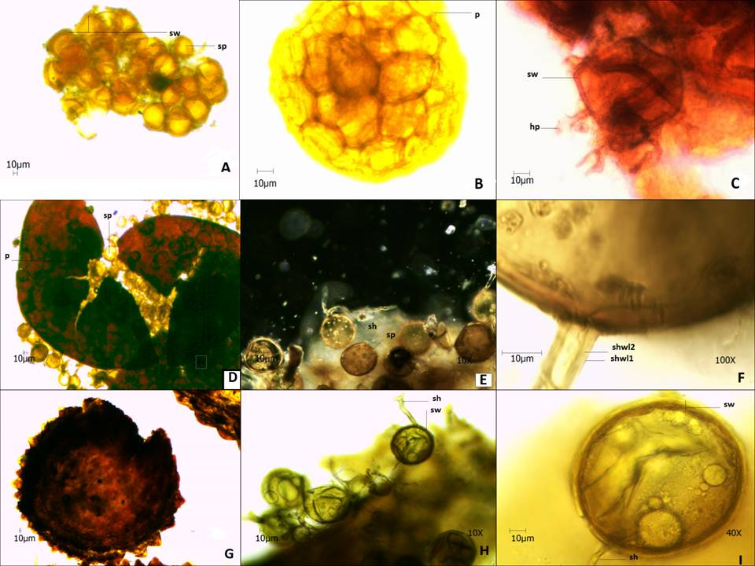
Figure S1
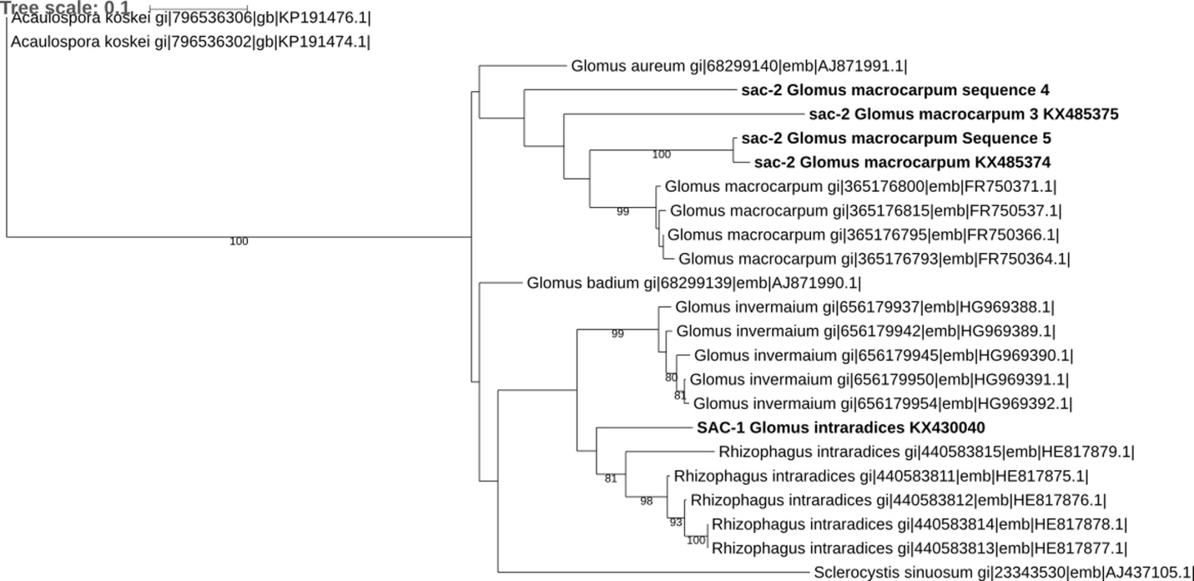
Figure S2

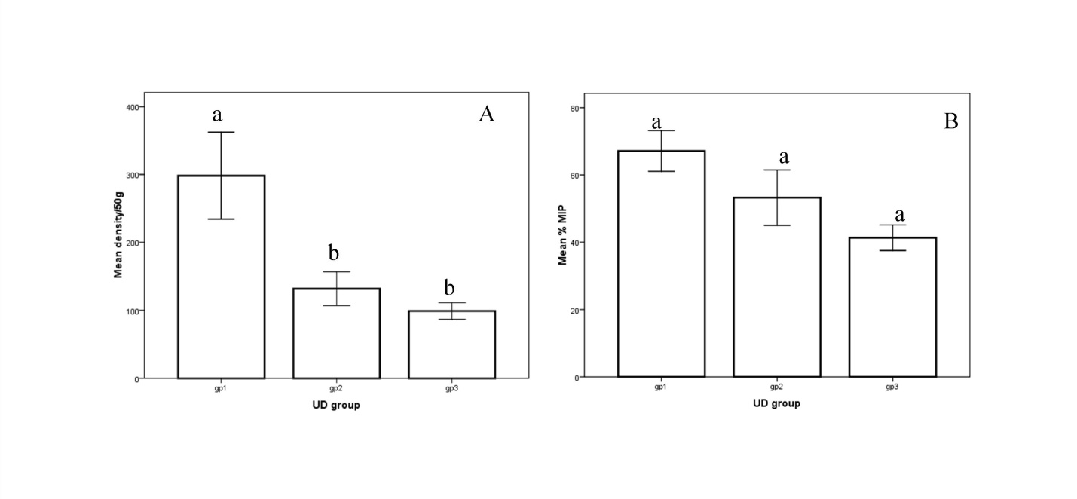
Figure S3
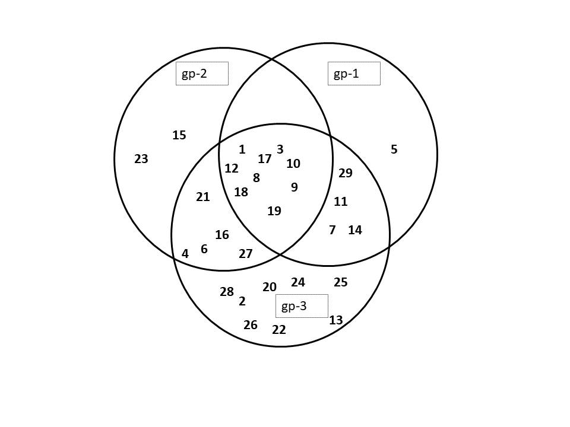
Figure S4

