APÉNDICE 1
Área de estudio en el oeste del Amazonas brasilero
APPENDIX 1
Study area located west in the Brazilian Amazon
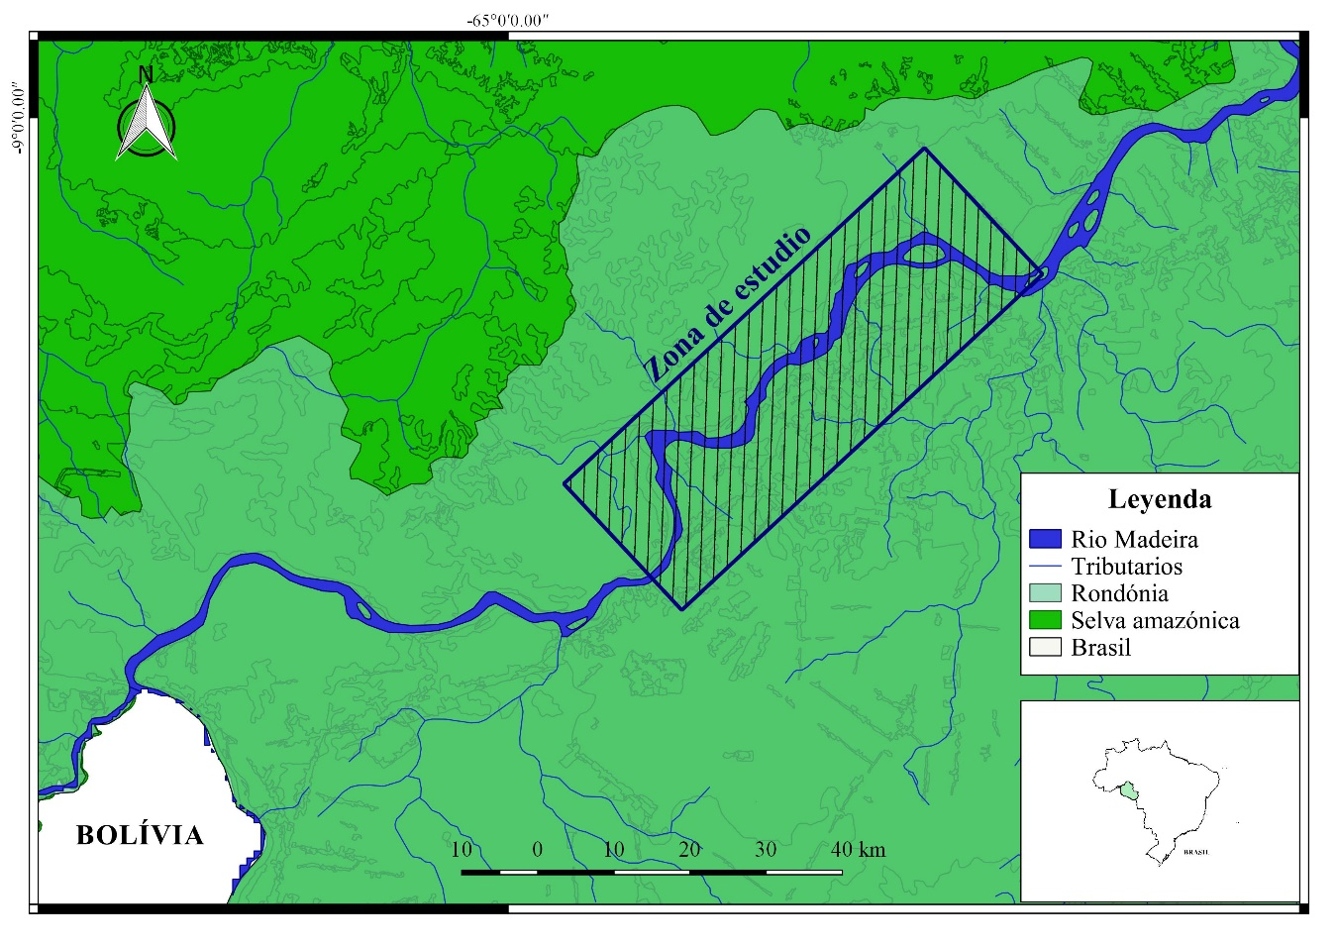

APÉNDICE 2
Valores de correlación entre la abundancia por especie de murciélago y la fase iluminada de la luna
APPENDIX 2
Correlation values between abundance by bat species and the illuminated phase of the moon

Especie | Gremio | Coef. de correlación | p-value
Artibeus concolor Peters 1865 | FEAC | 0.04 | 0.73
Artibeus lituratus (Olfers 1818) | FEAC | 0.15 | 0.25
Artibeus obscurus Schinz 1821 | FEAC | 0.00 | 0.99
Artibeus planirostris (Spix 1823) | FEAC | 0.16 | 0.23
Carollia benkeithi Solari y Baker 2006 | FEAC | -0.03 | 0.80
Carollia brevicauda (Schinz 1821) | FEAC | -0.25 | 0.06
Carollia perspicillata (Linnaeus 1758) | FEAC | -0.26 | 0.05*
Chiroderma villosum Peters 1860 | FEAC | 0.04 | 0.74
Choeroniscus minor (Peters 1868) | NEAC | -0.22 | 0.10
Chrotopterus auritus (Peters 1856) | CEAC | -0.05 | 0.71
Dermanura anderseni (Osgood 1926) | FEAC | -0.08 | 0.54
Dermanura cinerea Gervais 1856 | FEAC | 0.28 | 0.03*
Dermanura gnoma (Handley 1987) | FEAC | 0.33 | 0.01*
Desmodus rotundus (É. Geoffroy 1810) | S | 0.00 | 0.94
Diphylla ecaudata Spix 1823 | S | 0.03 | 0.82
Glossophaga longirostris Miller 1898 | O | -0.17 | 0.21
Glossophaga soricina (Pallas 1776) | O | -0.22 | 0.10
Glyphonycteris daviesi (Hill 1964) | IAEAC | 0.25 | 0.06
Glyphonycteris silvestris Thomas 1896 | IAEAC | -0.09 | 0.48
Lampronycteris brachyotis (Dobson 1879) | CEAC | 0.25 | 0.06
Lichonycteris degener (Miller 1831) | NEAC | 0.15 | 0.28
Lonchophylla thomasi Allen 1904 | NEAC | -0.16 | 0.24
Lophostoma brasiliense (Peters 1866) | CEAC | -0.14 | 0.28
Lophostoma silvicolum d´Orbigny 1836 | CEAC | 0.05 | 0.67
Lyonycteris spurrelli Thomas 1913 | NEAC | -0.16 | 0.23
Mesophylla macconnellii Thomas 1901 | FEAC | 0.32 | 0.01*
Micronycteris hirsuta (Peters 1869) | CEAC | -0.23 | 0.09
Micronycteris megalotis (Gray 1842) | CEAC | 0.18 | 0.17
Micronycteris microstis Miller 1898 | IPEAC | -0.07 | 0.60
Micronycteris schmidtorum Sanborn 1935 | IPEAC | 0.21 | 0.11
Mimon bennettii (Gray 1838) | CEAC | 0.01 | 0.92
Mimon crenulatum (É. Geoffroy 1810) | CEAC | 0.00 | 0.95
Myotis nigricans (Schinz 1821) | IAEC | 0.22 | 0.10
Myotis riparius Handley 1960 | IAEC | 0.04 | 0.73
Natalus spiritosantensis Ruschi 1951 | IAEC | -0.10 | 0.43
Phylloderma stenops Peters 1865 | FEAC | 0.03 | 0.82
Phyllostomus discolor Wagner 1843 | O | -0.16 | 0.23
Phyllostomus elongatus (É. Geoffroy 1810) | O | 0.02 | 0.83
Phyllostomus hastatus (Pallas 1767) | CEAC | -0.08 | 0.53
Platyrrhinus brachycephalus (Rouk y Carter 1972) | FEAC | -0.05 | 0.67
Platyrrhinus incarum (Thomas 1912) | FEAC | 0.23 | 0.09
Pteronotus parnellii Gray 1843 | IAEAC | -0.11 | 0.40
Rhynchonycteris naso (Wied-Neuwied 1820) | IAEC | -0.17 | 0.21
Rhynophylla fischerae Carter 1966 | FEAC | 0.05 | 0.67
Rhynophylla pumilio Peters 1865 | FEAC | 0.27 | 0.05*
Saccopteryx bilineata (Temminck 1838) | IAEC | -0.15 | 0.26
Saccopteryx leptura (Schreber 1774) | IAEC | 0.07 | 0.57
Sturnira lilium (É. Geoffroy 1810) | FEAC | 0.14 | 0.29
Sturnira tildae de la Torre 1959 | FEAC | 0.00 | 0.97
Thyroptera discifera (Lichtenstein y Peters 1855) | IAEC | 0.08 | 0.53
Thyroptera tricolor Spix 1823 | IEC | -0.06 | 0.62
Tonatia saurophila Koopman y Williams 1951 | IPEAC | -0.13 | 0.34
Trachops cirrhosus (Spix 1823) | CEAC | -0.07 | 0.58
Trinycteris nicefori Sanborn 1949 | FEAC | 0.18 | 0.18
Uroderma bilobatum Peters 1866 | FEAC | 0.18 | 0.18
Uroderma magnirostrum Davis 1968 | FEAC | 0.16 | 0.24
Vampyressa thyone Thomas 1909 | FEAC | 0.21 | 0.11
Vampyriscus bidens (Dobson 1878) | FEAC | 0.26 | 0.05*
FEAC= frugívoros aéreos de espacio altamente cerrado, NEAC = nectarívoros de espacios altamente cerrado, C = carnívoros de espacio altamente cerrado, S = sanguinívoro, IPEAC = insectívoros de presas posadas en espacio altamente cerrado, IAEC = insectívoros aéreos de espacio cerrado. * = valores significativos con un p ≤ 0.05.
FEAC = Highly cluttered space/gleaning frugivore, NEAC = Highly cluttered space/gleaning nectarivore, C = Highly cluttered space/gleaning carnivore, S = Sanguinivore, IPEAC = Highly cluttered space/gleaning insectivore, IAEC = Cluttered space/aerial insectivore. * = significant values with a p ≤ 0.05.

APÉNDICE 3
Coeficientes del modelo 1: M1 = Abundancia ~ Temperatura mínima + Humedad relativa
APPENDIX 3
Model 1 Coefficients: M1 = Abundance ~ Minimum temperature + Relative humidity
 | Estimado | Error estándar | z-value | p-value
Intercepto | 3.71 | 0.37 | 9.87 | 0.00
Temperatura mínima (°C) | -0.02 | 0.01 | -2.05 | 0.04
Humedad relativa (%) | 0.01 | 0.00 | 2.61 | 0.00

APÉNDICE 4
Relación entre las abundancias para cada especie de murciélago y el porcentaje de fase iluminada de la luna
APPENDIX 4
Relationship between the abundances of each bat species and the percentage of illuminated phase of the moon
