DIGITAL APPENDIX 1
APÉNDICE DIGITAL 1
The confirmation of the genre was based on the opinion of Dr. Diego Fontaneto (e-mail: diego.fontaneto@cnr.it). We concluded that the Bdelloidea rotifer, initially identified as Rotaria sp., is actually Philodina cf roseola. The following characteristics confirm the genus and the species (Appendix 2): the rotifer has a long and thin body (B and C), has a long foot, ends with two rigid conical appendices (E) and has four long toes which are visible when the rotifer is displaced (F, black arrow; previously we noticed 3 feet). It swims with the crown extended (D). Eyes commonly located in the brain (J, black arrow) at the same level of the trophi (A); the uncus has two teeth (A, black arrow), highlighting the conspicuous projection called Apophysis of Ramus. The genus Philodina is between 100-800 μm long, lives in freshwater environments.

DIGITAL APPENDIX 2
Anatomical description of the rotifer Philodina cf roseola: A) trophi, B) female, C) foot; black arrow, E) toes, F) three toes), G and H) female in anhydrobiopsis, I) parthenogenetic eggs, and J) Eyespot.
APÉNDICE DIGITAL 2
Descripción anatómica del rotífero Philodina cf roseola: A) trofi, B) hembra, C) pie; fleche negra, E) dedos, F) tres dedos, G and H) hembra en anhidrobiosis, I) huevo partenogenético, and J) ocelo.
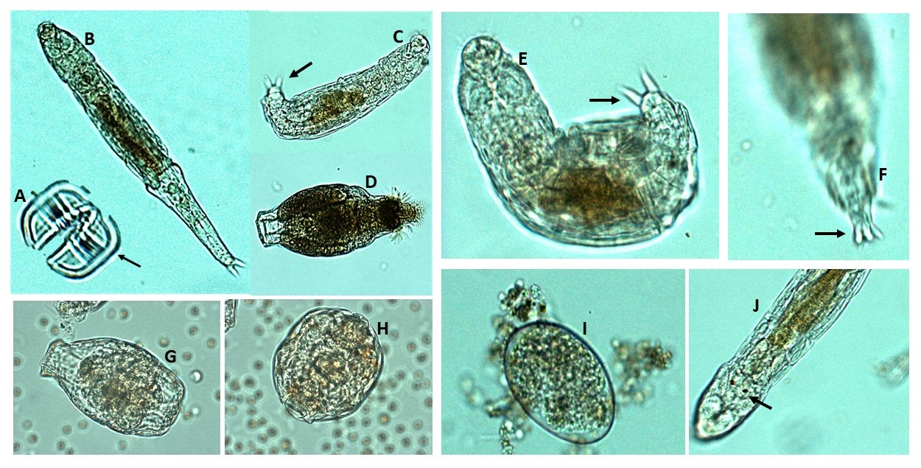

DIGITAL APPENDIX 3
Morphometric data of the female, male, eggs and trophi found in Philodina cf roseola
APÉNDICE DIGITAL 3
Datos morfométricos de hembras, machos, huevos y trofi encontrados en Philodina cf roseola
 | Length (μm) | Width (μm)
Female | 286.35 | 52.48
Trophi | 18.57 | 23.20
Parthenogenetic eggs | 73.04 | 49.17

