DIGITAL APPENDIX 1
Partition for each studied gene
APÉNDICE DIGITAL 1
Partición de cada gen estudiado
Gene | Partition
12S | GTR + I + G
16S | TPM3uf+G
18S | GTR + I + G
COI | TPM1uf+I+G

** Partitions were found for the four studied genes using Jmodeltest 2.1.10.
DIGITAL APPENDIX 2
Leg count and sex of analyzed specimens.
APÉNDICE DIGITAL 2
Conteo de patas y sexo de los especímenes analizados
Individual | Number of legs | Sex
1 | 37 | Female
2 | 33 | Male
3 | 32 | Male
4 | 37 | Female
5 | 37 | Female
6 | 38 | Female
7 | 39 | Female
** Details on analyzed specimens.

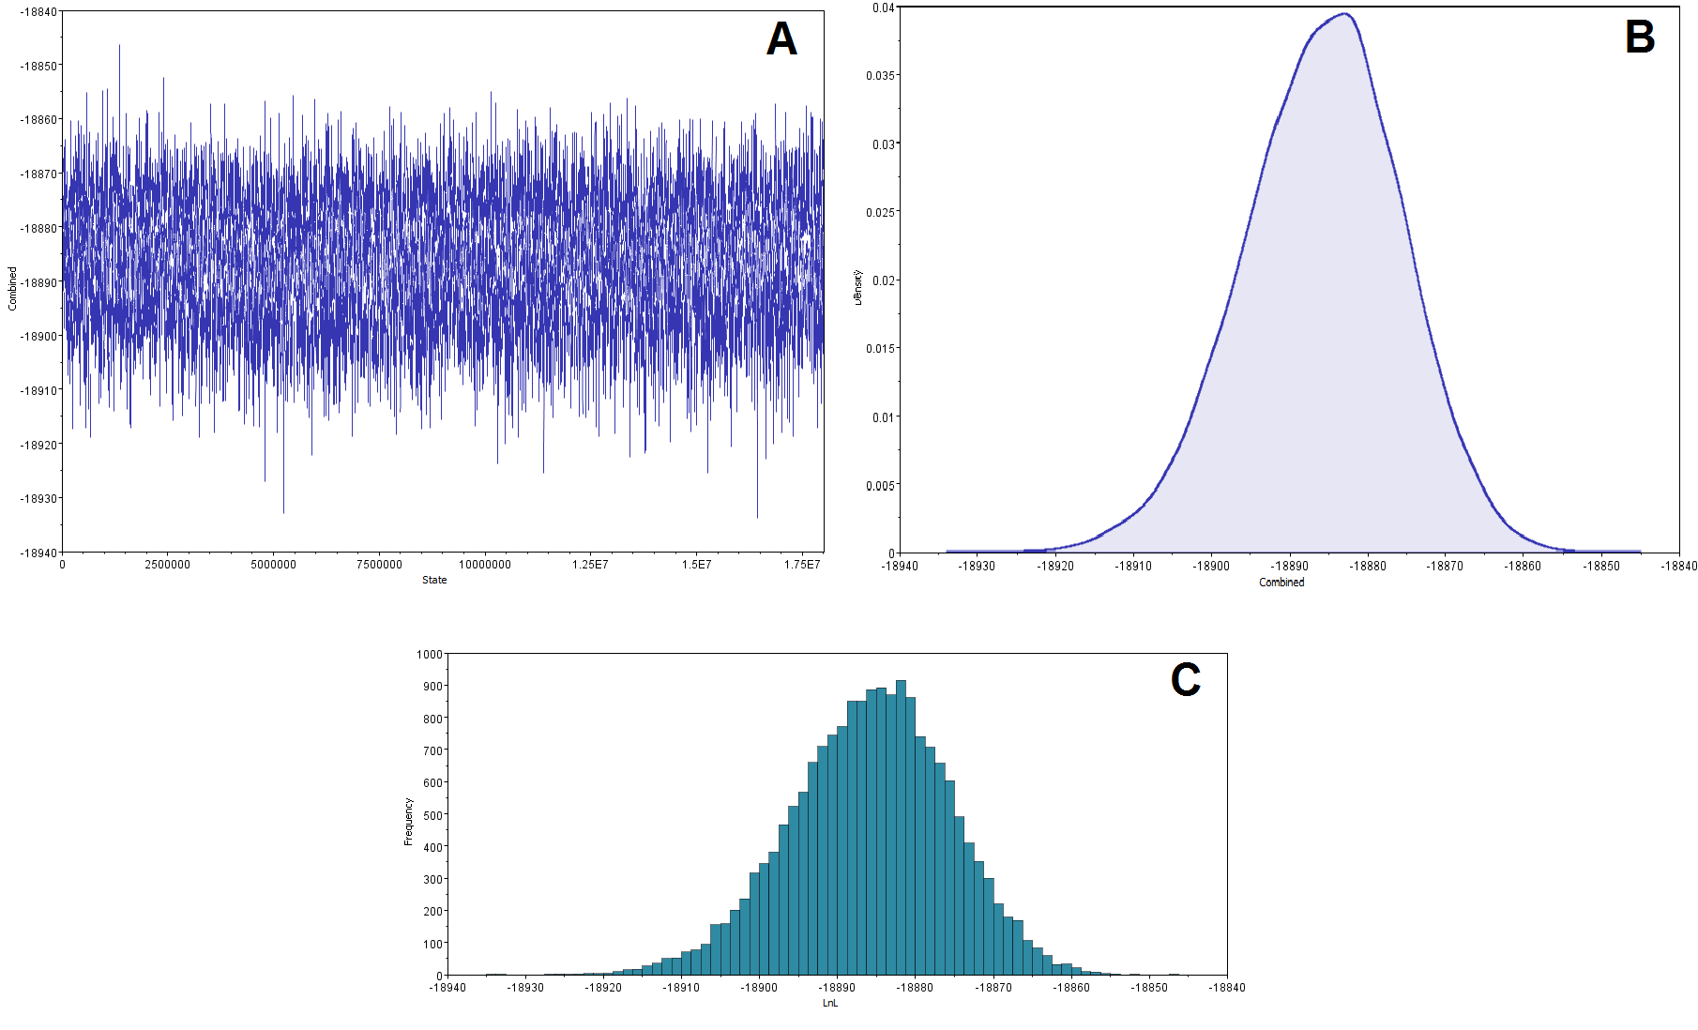
Digital Appendix 3. Convergence graphic representation of combined runs results: (a) trace; (b) marginal density’s KDE; (c) estimated parameters.
Apéndice Digital 3. Representación gráfica de los resultados de convergencia de las corridas combinadas: (a) señal; (b) KDE de densidad marginal; (c) parámetros estimados.

DIGITAL APPENDIX 4
95 % highest posterior density interval estimators of the Bayesian analysis

APÉNDICE DIGITAL 4

Estimadores al 95 % de los intervalos de mayor densidad posterior del análisis bayesiano

Parameter | Mean | Variance | Lower | Upper | Median | min ESS* | avg ESS | PSRF+
TL{all} | 3.326.108 | 0.029130 | 3.010.732 | 3.681.204 | 3.319.578 | 243.08 | 280.04 | 1.002
r(A<->C){1} | 0.141069 | 0.000246 | 0.108502 | 0.171006 | 0.141476 | 869.72 | 924.49 | 1.000
r(A<->G){1} | 0.140594 | 0.000436 | 0.099540 | 0.176391 | 0.140787 | 346.24 | 540.30 | 1.000
r(A<->T){1} | 0.143516 | 0.000227 | 0.116100 | 0.176247 | 0.143203 | 618.48 | 733.48 | 1.000
r(C<->G){1} | 0.019600 | 0.000213 | 0.000022 | 0.041824 | 0.017374 | 421.38 | 422.21 | 1.001
r(C<->T){1} | 0.535305 | 0.001632 | 0.459042 | 0.612549 | 0.535542 | 413.28 | 553.88 | 1.000
r(G<->T){1} | 0.019916 | 0.000080 | 0.004668 | 0.039009 | 0.018821 | 976.15 | 1073.07 | 1.000
k_revmat{1} | 3.838.865 | 0.532529 | 3.000.000 | 5.000.000 | 4.000.000 | 699.67 | 737.97 | 1.000
r(A<->C){2} | 0.030747 | 0.000461 | 0.000091 | 0.074355 | 0.024352 | 180.75 | 238.59 | 1.004
r(A<->G){2} | 0.387674 | 0.004324 | 0.280047 | 0.572301 | 0.372173 | 28.45 | 33.65 | 1.000
r(A<->T){2} | 0.092772 | 0.000444 | 0.058579 | 0.138327 | 0.088440 | 37.68 | 48.60 | 1.003
r(C<->G){2} | 0.055675 | 0.001152 | 0.000953 | 0.099408 | 0.060348 | 87.87 | 137.76 | 1.000
r(C<->T){2} | 0.347473 | 0.005623 | 0.116348 | 0.428641 | 0.367055 | 26.41 | 34.02 | 1.000
r(G<->T){2} | 0.085660 | 0.000485 | 0.043748 | 0.134391 | 0.083437 | 70.28 | 71.13 | 1.001
k_revmat{2} | 3.729.390 | 0.621530 | 3.000.000 | 5.000.000 | 4.000.000 | 122.51 | 362.38 | 1.002
r(A<->C){3} | 0.034500 | 0.000130 | 0.010453 | 0.056556 | 0.033964 | 312.28 | 327.12 | 1.006
r(A<->G){3} | 0.042466 | 0.000084 | 0.026696 | 0.060420 | 0.041252 | 502.58 | 555.93 | 1.003
r(A<->T){3} | 0.065600 | 0.000378 | 0.033510 | 0.102419 | 0.063884 | 341.72 | 370.21 | 1.000
r(C<->G){3} | 0.005740 | 0.000007 | 0.001058 | 0.010610 | 0.005470 | 893.19 | 998.14 | 1.000
r(C<->T){3} | 0.817946 | 0.000583 | 0.771904 | 0.865589 | 0.819341 | 492.85 | 492.88 | 1.006
r(G<->T){3} | 0.033749 | 0.000050 | 0.020479 | 0.047505 | 0.033209 | 418.14 | 737.27 | 1.000
k_revmat{3} | 4.617.505 | 0.535051 | 4.000.000 | 6.000.000 | 5.000.000 | 607.86 | 653.74 | 1.000
r(A<->C){4} | 0.002271 | 0.000006 | 0.000001 | 0.007108 | 0.001458 | 369.39 | 392.69 | 1.000
r(A<->G){4} | 0.530597 | 0.002260 | 0.446568 | 0.648308 | 0.531705 | 101.02 | 161.83 | 1.003
r(A<->T){4} | 0.073805 | 0.000063 | 0.059044 | 0.089682 | 0.073157 | 129.57 | 242.49 | 1.000
r(C<->G){4} | 0.055912 | 0.000431 | 0.013814 | 0.082560 | 0.065023 | 106.67 | 126.48 | 1.000
r(C<->T){4} | 0.261738 | 0.002175 | 0.161915 | 0.355874 | 0.257799 | 107.93 | 183.00 | 1.004
r(G<->T){4} | 0.075678 | 0.000112 | 0.056525 | 0.096002 | 0.074113 | 118.44 | 285.32 | 1.000
k_revmat{4} | 4.637.045 | 0.433155 | 4.000.000 | 6.000.000 | 5.000.000 | 177.44 | 281.79 | 1.000
pi(A){1} | 0.426240 | 0.000521 | 0.386751 | 0.477108 | 0.425903 | 579.43 | 646.10 | 1.000
pi(C){1} | 0.099000 | 0.000099 | 0.080057 | 0.118977 | 0.098667 | 564.62 | 596.47 | 1.000
pi(G){1} | 0.084358 | 0.000134 | 0.062509 | 0.107317 | 0.083455 | 823.89 | 878.40 | 1.000
pi(T){1} | 0.390403 | 0.000414 | 0.354413 | 0.434034 | 0.390239 | 661.55 | 741.66 | 1.000
pi(A){2} | 0.438575 | 0.000550 | 0.391984 | 0.483297 | 0.438909 | 217.66 | 271.61 | 1.000
pi(C){2} | 0.050986 | 0.000311 | 0.026891 | 0.096104 | 0.046054 | 25.60 | 33.62 | 1.000
pi(G){2} | 0.117847 | 0.000153 | 0.094954 | 0.142514 | 0.116944 | 360.45 | 414.70 | 1.002
pi(T){2} | 0.392592 | 0.000588 | 0.343170 | 0.436425 | 0.392367 | 342.92 | 390.60 | 1.001
pi(A){3} | 0.178978 | 0.000100 | 0.160062 | 0.198270 | 0.178705 | 724.30 | 814.51 | 1.000
pi(C){3} | 0.253744 | 0.000130 | 0.232323 | 0.276937 | 0.253327 | 730.19 | 734.69 | 1.000
pi(G){3} | 0.349767 | 0.000142 | 0.325815 | 0.372363 | 0.349817 | 771.00 | 926.93 | 1.001
pi(T){3} | 0.217512 | 0.000111 | 0.197682 | 0.237267 | 0.217582 | 509.11 | 674.46 | 1.002
pi(A){4} | 0.343957 | 0.000190 | 0.316939 | 0.370388 | 0.344038 | 374.79 | 530.59 | 1.000
pi(C){4} | 0.087862 | 0.000163 | 0.063895 | 0.113142 | 0.086796 | 81.10 | 167.86 | 1.001
pi(G){4} | 0.135033 | 0.000056 | 0.119424 | 0.148605 | 0.134899 | 536.50 | 620.44 | 1.001
pi(T){4} | 0.433147 | 0.000257 | 0.403738 | 0.464928 | 0.433040 | 299.93 | 470.32 | 1.000
alpha{1} | 0.415016 | 0.001919 | 0.337013 | 0.505028 | 0.412838 | 1561.04 | 1660.72 | 1.000
alpha{2} | 0.312961 | 0.000901 | 0.252802 | 0.369357 | 0.311505 | 1073.70 | 1122.90 | 1.000
alpha{3} | 0.147773 | 0.000060 | 0.132695 | 0.162949 | 0.147421 | 686.98 | 689.17 | 1.001
alpha{4} | 0.164601 | 0.000133 | 0.143569 | 0.188281 | 0.164091 | 712.87 | 776.94 | 1.000
pinvar{1} | 0.071758 | 0.000449 | 0.031912 | 0.113070 | 0.070377 | 1659.11 | 1763.56 | 1.000
pinvar{2} | 0.094146 | 0.000494 | 0.052575 | 0.138845 | 0.093334 | 690.53 | 1110.76 | 1.000
pinvar{3} | 0.226939 | 0.000466 | 0.183578 | 0.268769 | 0.226758 | 1225.03 | 1375.73 | 1.001
pinvar{4} | 0.069156 | 0.000129 | 0.047459 | 0.092087 | 0.068708 | 1523.32 | 1564.09 | 1.000
** Convergence diagnostic minimum and average values for parameter sampled in both runs for our dataset with 95% confidence interval.
DIGITAL APPENDIX 5
Summary of the statistics of partitions

APÉNDICE DIGITAL 5
Resumen de las estadísticas de las particiones

Average standard deviation of split frequencies | 0.005540
Maximum standard deviation of split frequencies | 0.027996
Average PSRF for parameter values (excluding NA and >10.0) | 1.000
Maximum PSRF for parameter values | 1.008
** Summary statistics in combined chains of both datasets for partitions with frequency ≥ 0.05 in at least one run.

DIGITAL APPENDIX 6
Summary of statistics

APÉNDICE DIGITAL 6
Resumen de las estadísticas

Mean | -18885.8095
Standard error of mean | 0.1122
Standard deviation | 10.08
Variance | 101.606
Median | -18885.3843
Value range | [-18933.8061, -18846.4037]
Geometric mean | n/a
95% HPD interval | [-18905.7091, -18866.4142]
Auto-correlation time (ACT) | 2231.0986
Effective sample size (ESS) | 8068.7
Number of samples | 18002

** Bayesian analysis summary statistics in combined chains of used dataset.

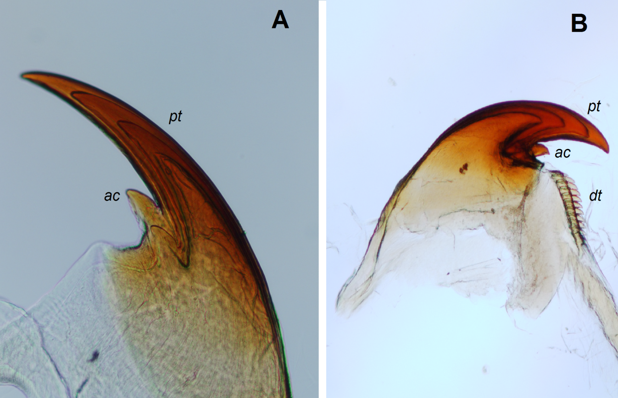
Digital Appendix 7. A. Shape of the outer jaw blade principal tooth (pt) and accessory tooth (ac); B. inner blade with its denticles (dt).
Apéndice Digital 7. A. Forma del diente principal de la mandíbula exterior (pt) y su diente accesorio (ac); B. Mandíbula interna con sus dentículos (dt).

