Table 1
Results of the statistical tests applied to the data of the restoration trial, Isla del Coco National Park, Costa Rica, 2018.

Test | p value | Chi² | Chi², tie corrected
Shapiro | <0.05
Levene | 0.2442 (>0,05)
Kruskal-Wallis | 0.1146 | 4.106 | 4.333
Friedman | 0.34673 | 2.625 | 2.8

TABLE 2
Values of SIMPER for the treatments Control outside the exclusion fence (CoEx) and Vegetation uprooting within the exclusion (VUwEx), applied in the restoration trial, Isla del Coco National Park, Costa Rica, 2018.
Taxon | Origen | Form | Average. dissimilarity | Contribution% | Cumulative% | Mean CoEx | Mean VUwEx
Paspalum cojugatum | Native | Grass | 31.94 | 39.6 | 39.6 | 0.4 | 61.7
Entada gigas | Native | Vine | 22.74 | 28.19 | 67.79 | 50.8 | 6.49
Clidemia strigillosa | Native | Shrub | 10.03 | 12.44 | 80.24 | 23.3 | 13.3
Hypolytrum amplum | Native | Grass | 5.44 | 6.745 | 86.98 | 10.2 | 3.54
Pterium feei | Native | Fern | 1.917 | 2.377 | 89.36 | 1.72 | 3.88
Litter | --- | --- | 1.909 | 2.367 | 91.73 | 4.19 | 1.02
Soil | --- | --- | 1.345 | 1.668 | 93.39 | 2.55 | 0.45
Paspalum nutans | Introduced* | Grass | 0.9316 | 1.155 | 94.55 | 1.45 | 0.45
Dicranopteris pectinata | Native | Fern | 0.9266 | 1.149 | 95.7 | 1.74 | 0
Cecropia pittieri | Endemic | Tree | 0.8242 | 1.022 | 96.72 | 0 | 1.65
Nephrolepis cocosensis | Endemic | Fern | 0.7658 | 0.9495 | 97.67 | 0.075 | 1.39
Rolandra fruticosa | Native | Herb | 0.5402 | 0.6698 | 98.34 | 0 | 1.02
Urena lobata | Introduced | Shrub | 0.3403 | 0.422 | 98.76 | 0.463 | 0.45
Phytolacca rivinoides | Native | Shrub | 0.264 | 0.3273 | 99.09 | 0 | 0.525
Coffea arabiga | Introduced* | Shrub | 0.2092 | 0.2594 | 99.35 | 0.388 | 0
Pityrogramma calomelanos | Native | Fern | 0.1766 | 0.2189 | 99.57 | 0 | 0.338
Rugoloa polygonata | Introduced* | Grass | 0.1565 | 0.194 | 99.76 | 0.338 | 0.025
Miconia appendiculata | Native | Shrub | 0.1247 | 0.1546 | 99.92 | 0.225 | 0
Rock | --- | --- | 0.03561 | 0.04416 | 99.96 | 0.0625 | 0
Panicum maximum | Introduced* | Grass | 0.03292 | 0.04082 | 100 | 0.075 | 0
Cyathea nesiotica | Endemic | Tree fern | 0 | 0 | 100 | 0 | 0
* Reported by Estrada-Chavarría et al. (2020).

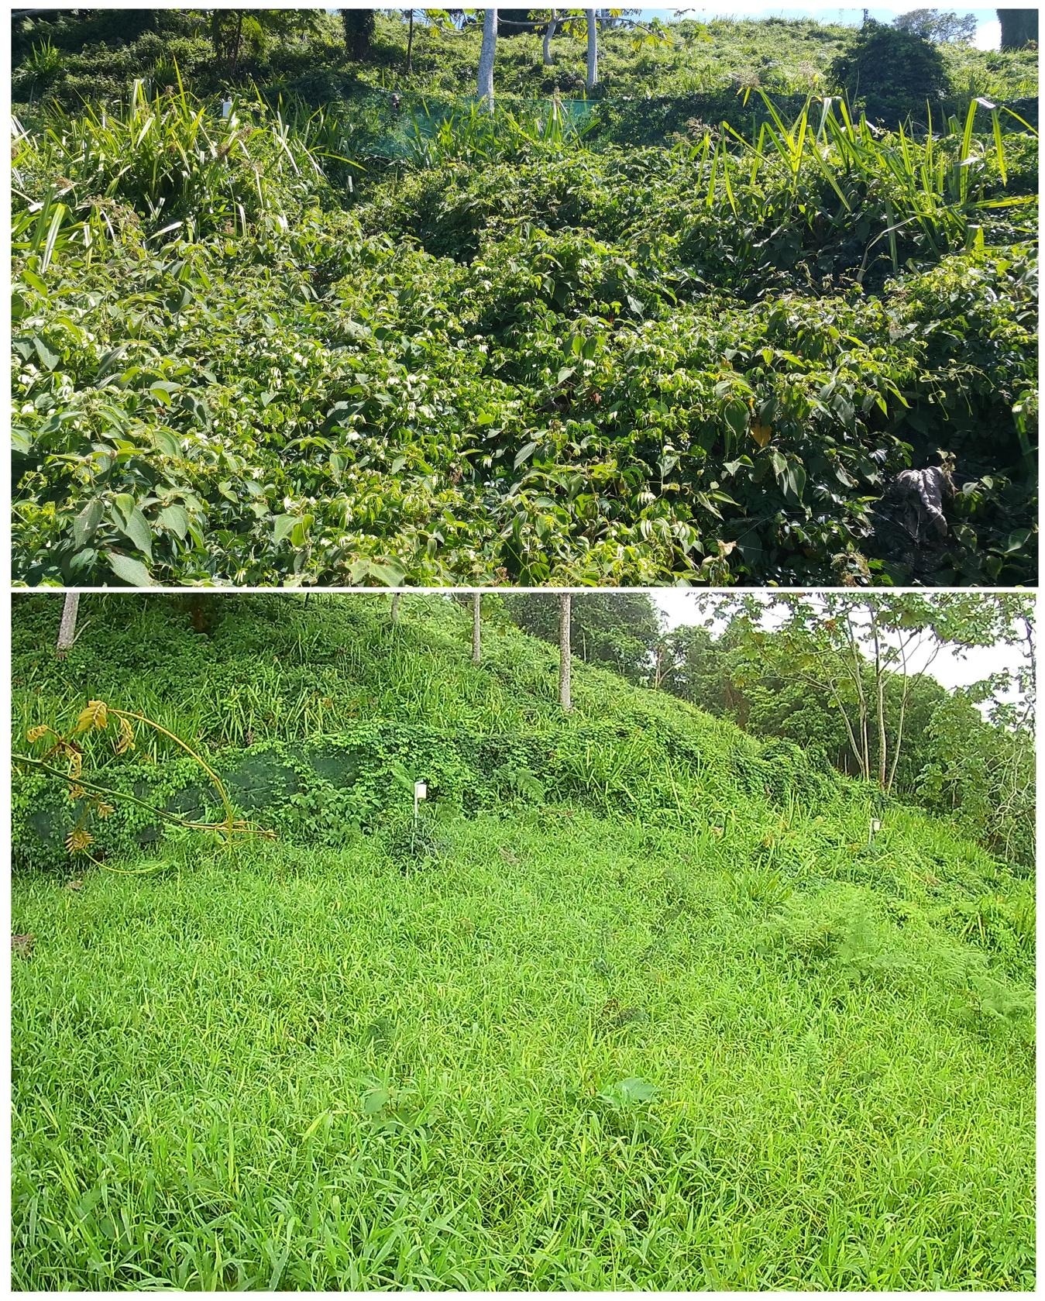
S1. Changes in the vegetation cover in the restoration site: A. Original vegetation cover in the Excluded Witness comprised by Entada gigas, Hypolytrum amplum and Clidemia strigillosa. B. New vegetation cover dominated by Paspalum conjugatum. Isla del Coco National Park, Costa Rica, 2018. Image: Luis Acosta.

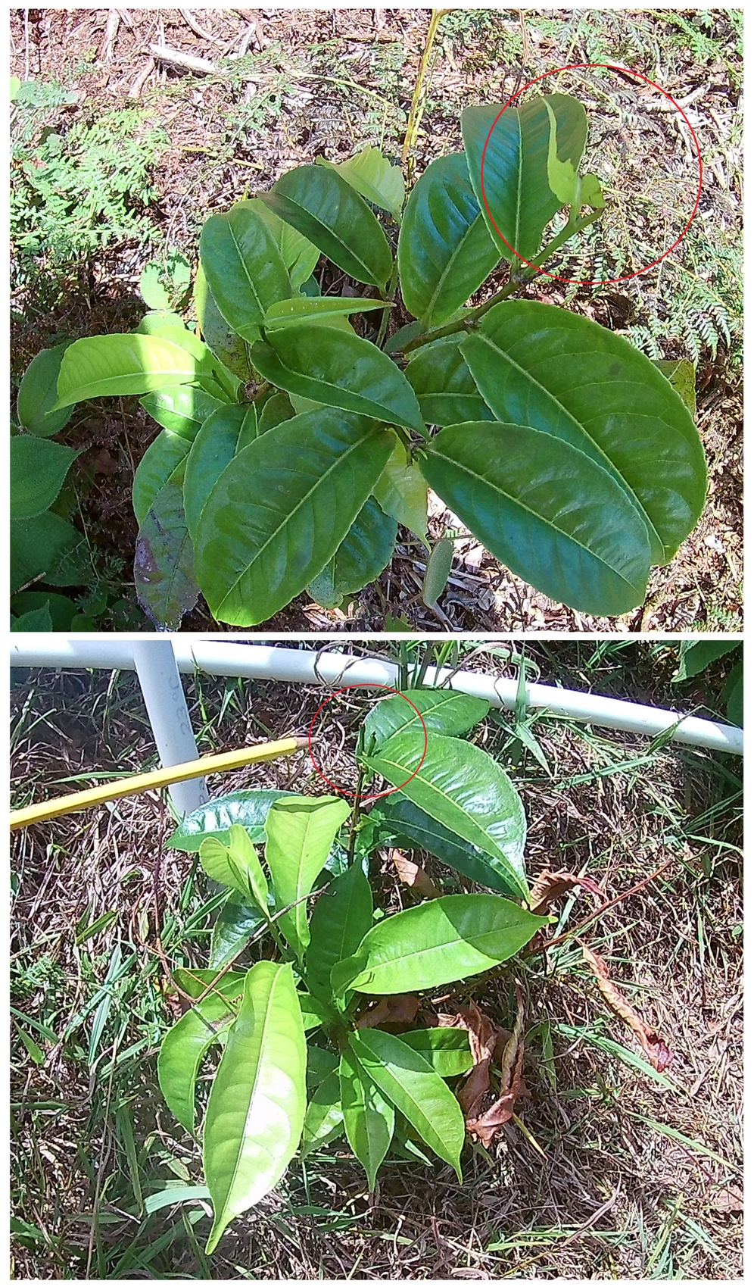
S2. Regeneration of Sacoglottis holdridgei branch-grazed by white-tailed deer (Odocoileus virginianus) in the restoration site. Notice that this herbivore consumes tender sprouts, which in the case of seedlings means death for the individual. Isla del Coco National Park, Costa Rica, 2018. Image: Luis Acosta.

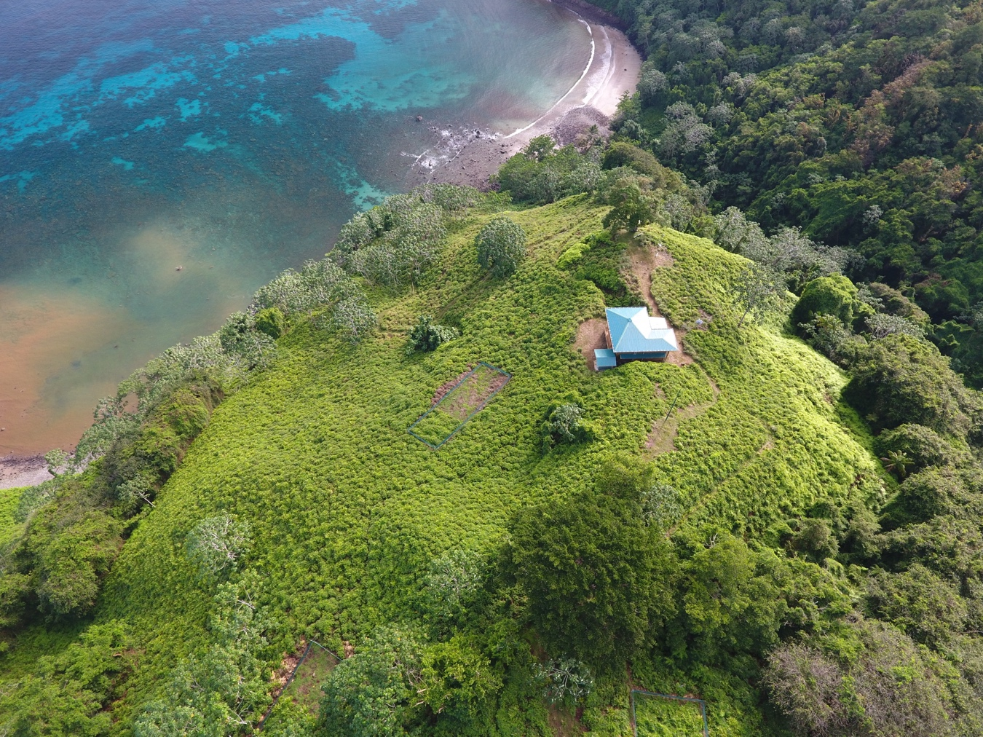
S3. Location of the site of the restoration trial. Notice the gradient of the site and the deforestation from the summit down to the mountain base. Isla del Coco National Park, Costa Rica, 2018. Image: Felipe Chacón.

