DIGITAL APPENDIX 1
Bibliographic review for species that prey on Cryphiops caementarius in the study area (see Fig. 1)

Rivers systems / abbreviations | Hydrographic zones | Bibliographic references
Peru
Peruvian rivers * (Pe) | CRPP | Hartmann (1958); Hernández (1974); Viacava et al. (1978); Morales (2019)
Cañete River (Ca) | CRPP | Valle (2010)
Majes-Camaná River (M-C) | CRPP | Elías (1960)
Tambo River (Ta) | CRPP | Bocardo, Morales, & Yipita (2007); Apaza (2018); Concha (2018)
Chile
Chilean rivers ** (Chi) | SRAZ-RMSZ | Busse & Schlatter (1965); Castro (1966);  Bahamonde & Vila (1971); Morales & Meruane (2013a, 2013b)
Loa River (Lo) | SRAZ | Alfaro et al. (1980); López, Segovia, & Alfaro (1986); De los Ríos-Escalante et al. (2010)
El Culebrón estuary (Cu) | RMSZ | Norambuena (1977); Avilés et al. (2018)
Limarí River (Li) | RMSZ | Tello et al. (2007); this study
Illapel and Choapa rivers (I-C) | RMSZ | Cortés (1999); this study
* = Pativilca, Pisco, Ocoña, Majes-Camaná and Tambo rivers.
** = Lluta, Camarones, Loa, Copiapó, Huasco, Elqui, Limarí, Illapel, Choapa, La Ligua and Aconcagua rivers.

DIGITAL APPENDIX 2
Taxonomic composition of the predator’s species of Cryphiops caementarius

Guild of predators / family / species | Zoogeographic origin |  | Trophic functional group | Phenotypic  attribute | River  zones
 | Perú | Chile
Macroinvertebrates
Leeches
Glossiphonidae
Helobdella spp. | - | Native | Omnivore | Opportunistic | R
Prawns
Palaemonidae
Cryphiops caementarius (Molina, 1782) * | Native | Native | Omnivore | Opportunistic | E, P, R
Number species = 2
Vertebrates
Fish
Cichlidae
Australoheros facetus (Jenyns, 1842) | - | Exotic | Omnivore | Opportunistic | E, P
Cyprinidae
Cyprinus carpio (Linnaeus, 1758) | Exotic | Exotic | Omnivore | Opportunistic | E, P, R
Poeciliidae
Gambusia affinis (Baird & Girard, 1853) | Exotic | Exotic | Omnivore | Opportunistic | E, P
Salmonidae
Oncorhynchus mykiss (Walbaum, 1792) | Exotic | Exotic | Carnivore | Opportunistic | E, P, R
Salmo trutta (Linnaeus, 1758) | Exotic | Exotic | Carnivore | Opportunistic | E, P, R
Atherinidae
Silversides | Native | Native | Omnivore | Opportunistic | E, P, R
Frogs
Calyptocephalellidae
Calyptocephalella gayi (Duméril & Bibron, 1841) | - | Native | Carnivore | Opportunistic | E, P, R
Pipidae
Xenopus laevis (Daudin, 1802) | - | Exotic | Carnivore | Opportunistic | E, P, R
Waterfowls
Ardeidae
Ardea alba (Linnaeus, 1758) | Native | Native | Carnivore | Opportunistic | E, P, R
Ardea cocoi (Linnaeus, 1766) | Native | Native | Carnivore | Opportunistic | E, P, R
Egretta thula (Molina, 1782) | Native | Native | Carnivore | Opportunistic | E, P, R
Nycticorax nycticorax (Linnaeus, 1758) | Native | Native | Carnivore | Opportunistic | E, P, R
Laridae
Larus dominicanus (Lichtenstein, 1823) | Native | Native | Carnivore | Opportunistic | E, P, R
Leucophaeus modestus (Tschudi, 1843) | Native | Native | Carnivore | Opportunistic | E, P, R
Phalacrocoracidae
Phalacrocorax brasilianus (Gmelin, 1789) | Native | Native | Carnivore | Opportunistic | E, P
Phoenicopteridae
Phoenicopterus chilensis (Molina, 1782) | Native | Native | Omnivore | Selective | E
Anatidae
Anas cyanoptera (Vieillot, 1816) | Native | Native | Herbivore | Opportunistic | E, P
Mammals
Hominidae
Homo sapiens (Linnaeus, 1758) | Cosmopolitan | Cosmopolitan | Omnivore | Selective | E, P, R
Mustelidae
Lontra felina (Molina, 1782) | Native | Native | Carnivore | Selective | E
Number species = 19
Total number species = 21
* = intraespecific predation / River zones = Estuary (E), Potamon (P), Rhithron (R).

DIGITAL APPENDIX 3
Taxonomic composition of the predator’s species of Cryphiops caementarius

Species | OF | RF | Study area
 |  |  | CRPP |  |  |  |  | * |  | SRAZ |  | RMSZ
 |  |  | Pe | Ca | M-C | Ta |  | Chi |  | Lo |  | Cu | Li | I-C
Helobdella spp. | 11.1 | 1.6 |  |  |  |  |  |  |  |  |  |  | X
Cryphiops caementarius | 55.6 | 8.2 | X |  |  |  |  | X |  | X |  | X |  | X
Australoheros facetus | 11.1 | 1.6 |  |  |  |  |  |  |  |  |  | X
Cyprinus carpio | 22.2 | 3.3 |  |  |  |  |  | X |  |  |  |  |  | X
Gambusia affinis | 44.4 | 6.6 |  |  |  | X |  | X |  | X |  | X
Oncorhynchus mykiss | 44.4 | 6.6 | X |  |  |  |  | X |  | X |  |  |  | X
Salmo trutta | 11.1 | 1.6 |  |  |  |  |  |  |  | X
Silversides | 22.2 | 3.3 | X | X
Calyptocephalella gayi | 22.2 | 3.3 |  |  |  |  |  | X |  |  |  |  |  | X
Xenopus laevis | 11.1 | 1.6 |  |  |  |  |  |  |  |  |  |  | X
Ardea alba | 66.7 | 9.8 | X |  | X | X |  | X |  |  |  | X |  | X
Ardea cocoi | 11.1 | 1.6 |  |  |  |  |  |  |  |  |  |  |  | X
Egretta thula | 55.6 | 8.2 |  |  | X | X |  | X |  |  |  | X |  | X
Nycticorax nycticorax | 55.6 | 8.2 | X |  | X |  |  | X |  |  |  | X |  | X
Larus dominicanus | 11.1 | 1.6 |  |  | X
Leucophaeus modestus | 11.1 | 1.6 | X
Phalacrocorax brasilianus | 44.4 | 6.6 |  |  |  | X |  | X |  |  |  | X |  | X
Phoenicopterus chilensis | 11.1 | 1.6 | X
Anas cyanoptera | 33.3 | 4.9 |  |  | X | X |  | X
Homo sapiens | 100.0 | 14.8 | X | X | X | X |  | X |  | X |  | X | X | X
Lontra felina | 22.2 | 3.3 | X |  |  | X
Total number species = 21 |  |  | 9 | 2 | 6 | 7 |  | 11 |  | 5 |  | 8 | 3 | 10
For each species is indicated occurrence frequency (OF; %) and relative frequency (RF; %). Rivers names abbreviations in the column header are the same as in Table 1 and are grouped by hydrographic zone (see Fig. 1).
* = includes two hydrographic zones (SRAZ-RMSZ).

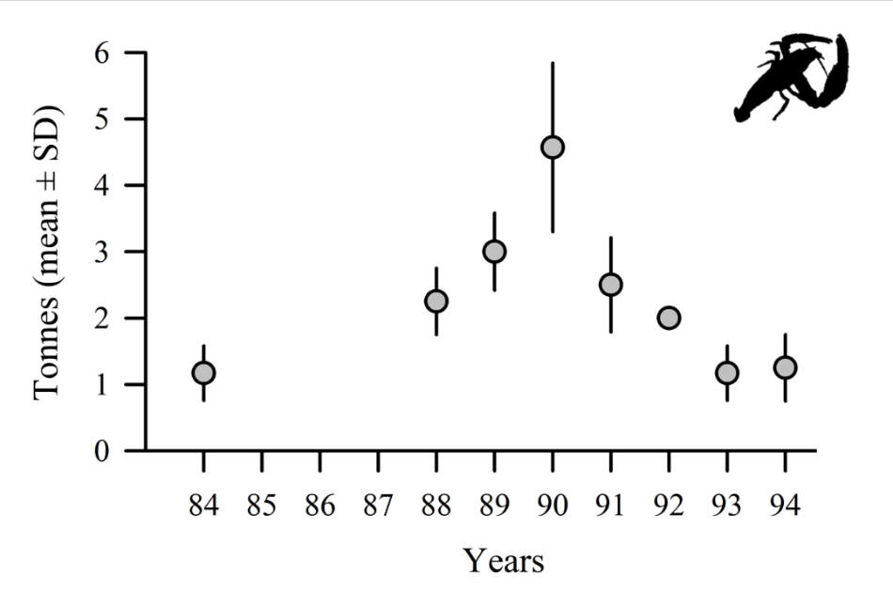

Digital Appendix 4. Historical landing of Cryphiops caementarius in central-Northern Chile. Data correspond to official records of the National Service for Fisheries and Aquaculture (Sernapesca; https://www.sernapesca.cl) between 1984-1994. Since 1994, there is no official updating in landings data.

