DIGITAL APPENDIX 1
Study area: Northeastern region of Venezuela

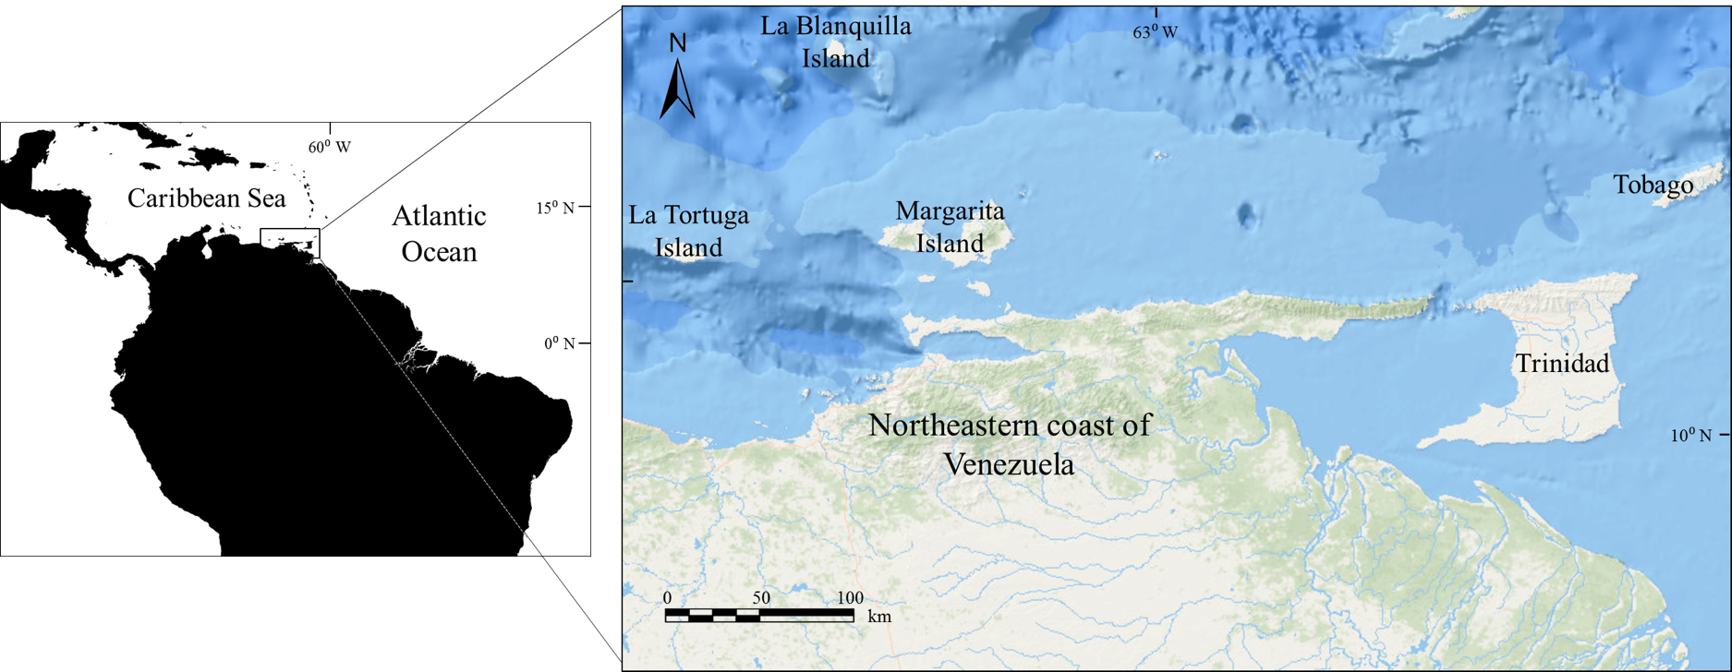

DIGITAL APPENDIX 2
Comparative information of growth parameters estimated for species of the genus Mustelus

Species | Sex | Max. size | Growth parameters |  |  | Study area | Authors
 |  | (cm TL) | L∞ | k | t₀
Mustelus californicus | Males | 93.0 | 101.8 | 0.35 | -1.00 | West coast, USA | Yudin & Cailliet (1990)
 | Females | 125.0 | 142.4 | 0.22 | -1.03
Mustelus henlei | Males | 79.5 | 86.1 | 0.29 | -1.09
 | Females | 100.0 | 97.6 | 0.23 | -1.38
Mustelus mustelus | Males | 112.0 | 105.2 | 0.44 | -1.52 | Northwestern Atlantic | Conrath et al. (2002)
 | Females | 132.0 | 123.6 | 0.29 | -1.94
Mustelus asterias | Males | 104.0 | 103.7 | 0.20 | ⎯ | Northeastern Atlantic | Farrell et al. (2010)
 | Females | 112.0 | 123.5 | 0.15 | ⎯
Mustelus higmani | Males | 61.0 | 60.4 | 0.53 | -1.02 | Caribbean, Vzla. | Present study
 | Females | 71.6 | 71.1 | 0.38 | -1.17

