SMT1

Geographic information and general characteristics of the sampling stations in the Colombian Caribbean. ARCO, Coralline Archipelagos Ecoregion; MAG, Magdalena Ecoregion; MOR, Gulf of Morrosquillo Ecoregion

| **Ecoregion** | **Station** | **Department** | **Municipality** | **Locality** | **Latitude** | **Longitude** | **Characteristics** |
| --- | --- | --- | --- | --- | --- | --- | --- |
| ARCO | E1 | Bolívar | Cartagena de Indias | Península de Barú | 10.184666 | -75.643253 | Rocky and sandy coastline with few interventions. Mangroves near the coastline. Leaf litter, coral remains, and logs. Calcareous sand. |
| E2 | Isla Tintipán | 9.789974 | -75.840315 | Rocky coastline in some cases intervened. The only existing sandy coastline is used as a tourist beach. Mangroves along the entire edge of the Island's coastline. Logs and coral remains. Calcareous sand. |
| E3 | Isla Fuerte | 9.396457 | -76.183658 | Rocky and sandy coastline with few interventions. Herbaceous plants and mangrove near the coastline. Leaf litter, coral remains, logs and decomposing plant material. Calcareous sand. |
| MAG | E1 | Atlántico | Puerto Colombia | Punta Sabanilla | 11.042941 | -74.89002 | Sandy coastline with few interventions. Highly influenced by the discharges of the Magdalena River. Mangroves removed from the coastline. Logs. Sand of continental origin. |
| E2 | Juan de Acosta | Santa Verónica | 10.854117 | -75.134841 | Sandy coastline with few interventions. Mangroves near the coastline. Logs and decomposing plant material. Mixed, calcareous sand of continental origin. |
| E3 | Bolívar | Cartagena de Indias | Arroyo de Piedra, Condominio Bahía del Sol | 10.64223 | -75.422951 | Sandy coastline intervened for tourist purposes in some sectors. Few herbaceous plants and tree vegetation removed from the coastline. Logs and decomposing plant material. Sand of continental origin. |
| MOR | E1 | Sucre | San Onofre | Rincón del Mar | 9.776012 | -75.643443 | Sandy coastline with few interventions. Herbaceous plants and mangroves near the coastline. Logs and decomposing plant material. Mixed, calcareous sand of continental origin. |
| E2 | Tolú | Tolú | 9.61284 | -75.572868 | Sandy coastline with few interventions. Herbaceous plants and mangroves near the coastline. Logs and decomposing plant material. Mixed, calcareous sand of continental origin. |
| E3 | Córdoba | San Bernardo del Viento | Tinajones, Vereda Boca Negra | 9.379197 | -75.974898 | Sandy coastline with few interventions. Highly influenced by the discharges of the Sinú River. Few herbaceous plants and tree vegetation removed from the coastline. Decomposing plant material and logs. Sand of continental origin. |

SMF1

Photographic record in the sampling stations

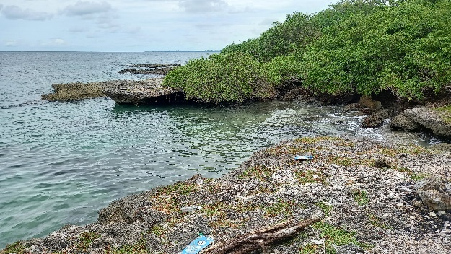 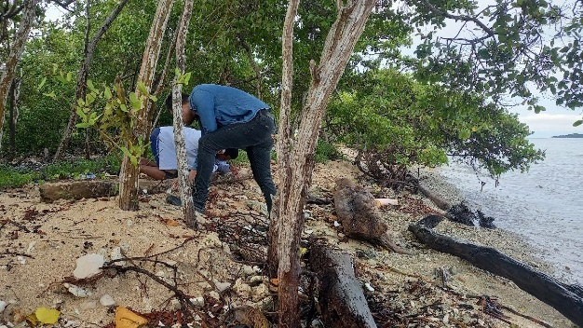

Rocky and sandy coastline in ARCO-E1, Península de Barú.

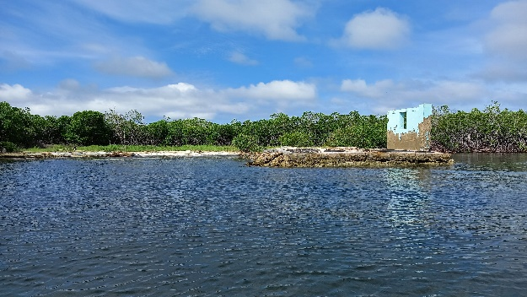 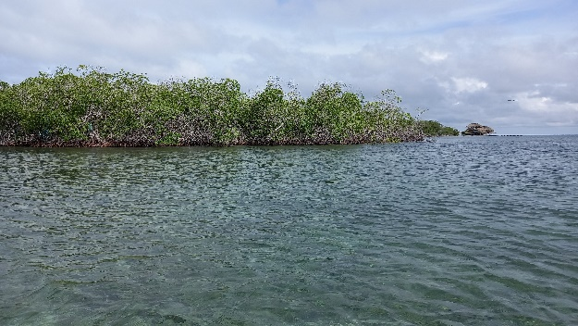

Coastal edge in ARCO-E2, Isla Tintipán.

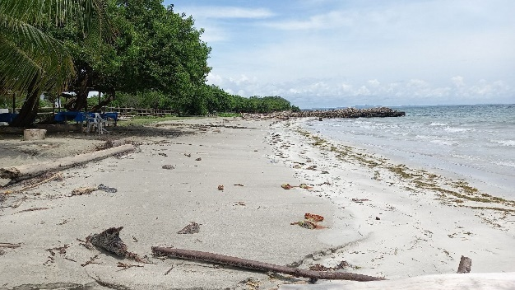 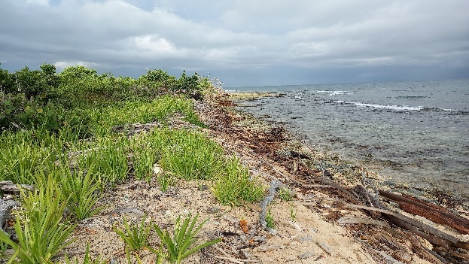

Rocky and sandy coastline in ARCO-E3, Isla Fuerte.

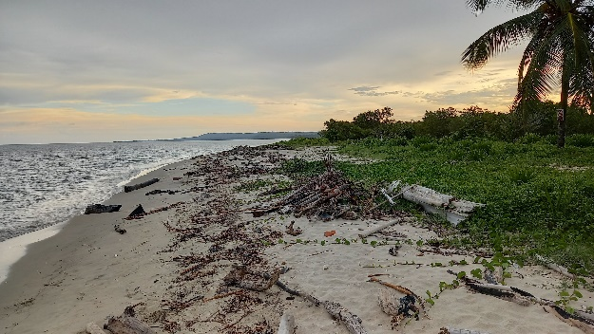 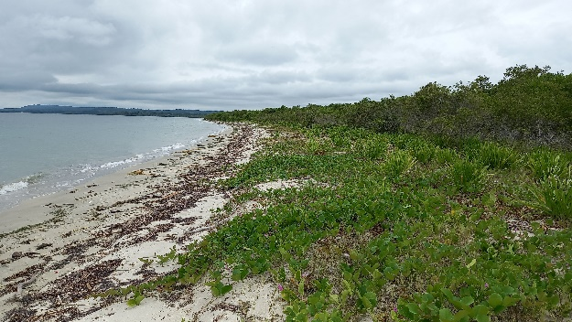

Sandy coastline in MOR-E1, Rincón del Mar.

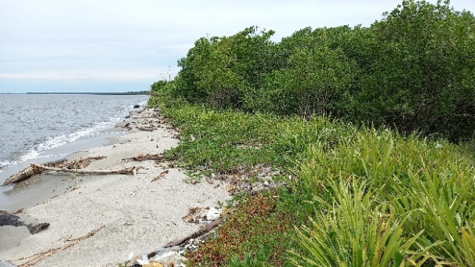 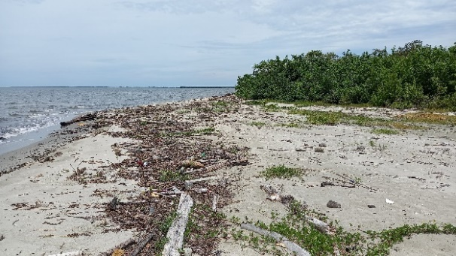

Sandy coastline in MOR-E2, Tolú.

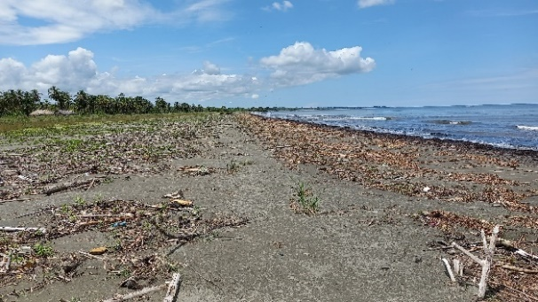 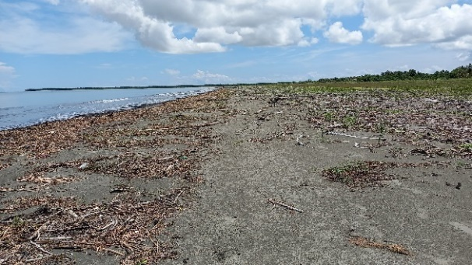

Sandy coastline in MOR-E3, Tinajones.

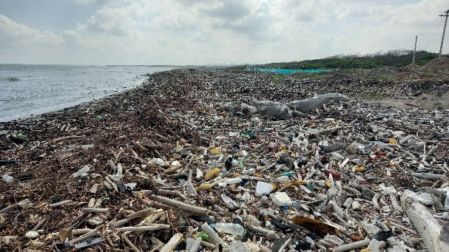 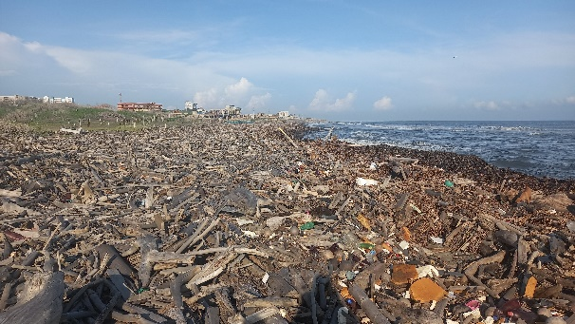

Sandy coastline covered with logs in MAG-E1, Puerto Colombia-Punta Sabanilla.

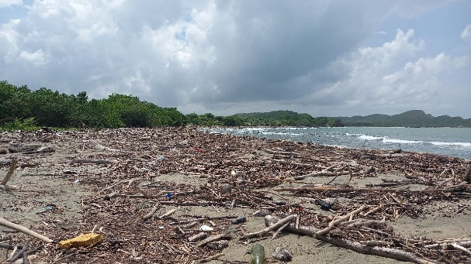 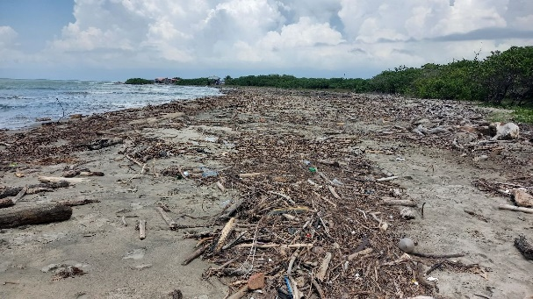

Sandy coastline in MAG-E2, Santa Verónica.

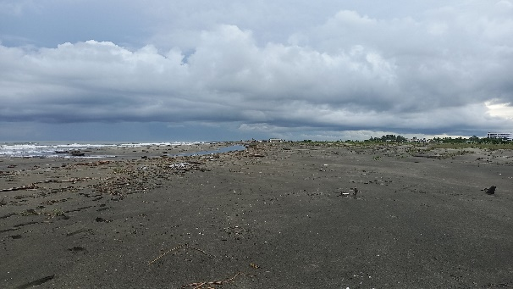 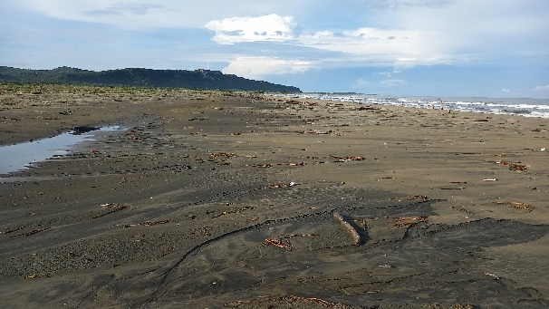

Sandy coastline in MAG-E3, Condominio Bahía del Sol.