MATERIAL SUPLEMENTARIO

MST1

Promedio y desviación estándar de las especies *Corollia perspicillata, Corollia castanea* *y* *Corollia brevicauda* con las variables (cola, pata, antebrazo, pata, tibia, calcar, trago y tamaño corporal) de las hembras y machos

SMT1

Mean and standard deviation of the species *Corollia perspicillata*, *Corollia castanea* and *Corollia brevicauda* with the variables (tail, leg, forearm, paw, tibia, calcar, tragus and body size) of females and males

|  |  |  |  |  |  |  |  |  |  |  |  |  |  |
| --- | --- | --- | --- | --- | --- | --- | --- | --- | --- | --- | --- | --- | --- |
| Variables | | ***Carollia brevicauda*** | | | | 1. ***castanea*** | | | | 1. ***perspicillata*** | | | |
| Hembra | | Macho | | Hembra | | Macho | | Hembra | | Macho | |
| Media | SD | Media | SD | Media | SD | Media | SD | Media | SD | Media | SD |
| Adultos | Calcar | 6.52 | 1.47 | 6.39 | 1.22 | 4.94 | 1.58 | 5.42 | 1.26 | 6.07 | 1.48 | 6.34 | 1.42 |
| Cuerpo | 60.00 | 5.67 | 58.67 | 4.00 | 53.36 | 6.25 | 54.23 | 5.27 | 58.36 | 6.87 | 59.51 | 5.38 |
| Antebrazo | 40.78 | 3.45 | 41.42 | 2.14 | 37.67 | 3.59 | 38.06 | 2.63 | 41.27 | 2.08 | 42.16 | 1.70 |
| Cola | 7.66 | 0.73 | 7.48 | 0.57 | 7.39 | 0.70 | 7.35 | 0.61 | 9.23 | 0.72 | 9.26 | 0.71 |
| Oreja | 16.18 | 2.05 | 15.67 | 2.03 | 15.09 | 2.21 | 15.21 | 2.47 | 15.11 | 2.75 | 14.55 | 2.65 |
| Pata | 10.48 | 1.36 | 10.51 | 1.64 | 10.72 | 2.12 | 10.44 | 1.66 | 10.96 | 2.34 | 11.44 | 2.44 |
| Tibia | 18.22 | 1.39 | 18.42 | 1.17 | 15.72 | 2.00 | 16.21 | 2.09 | 17.87 | 2.12 | 18.20 | 2.29 |
| Trago | 4.70 | 0.89 | 4.82 | 1.04 | 4.72 | 0.98 | 4.81 | 0.96 | 4.23 | 1.12 | 4.51 | 1.02 |
| Juveniles | Calcar | 5.67 | 1.53 | 8.33 | 0.58 | 3.00 | 0.00 | 4.25 | 1.26 | 5.75 | 1.49 | 6.00 | 1.53 |
| Cuerpo | 53.00 | 5.29 | 59.33 | 1.53 | 45.00 | 0.00 | 46.00 | 3.56 | 58.62 | 5.60 | 57.29 | 5.19 |
| Antebrazo | 37.67 | 3.51 | 43.33 | 3.21 | 34.00 | 0.00 | 35.25 | 4.72 | 42.00 | 1.60 | 41.43 | 1.28 |
| Cola | 8.00 | 1.00 | 7.67 | 0.58 | 7.00 | 0.00 | 8.00 | 1.15 | 9.87 | 1.55 | 9.00 | 0.00 |
| Oreja | 13.33 | 1.53 | 14.67 | 2.31 | 19.00 | 0.00 | 14.00 | 2.45 | 14.25 | 3.10 | 14.00 | 2.31 |
| Pata | 11.33 | 0.58 | 10.33 | 2.89 | 11.00 | 0.00 | 10.5 | 1.91 | 13.24 | 2.05 | 11.14 | 2.03 |
| Tibia | 17.33 | 0.58 | 18.00 | 0.00 | 12.00 | 0.00 | 14.75 | 1.71 | 18.12 | 3.64 | 18.00 | 2.94 |
| Trago | 3.33 | 1.53 | 4.67 | 0.58 | 5.00 | 0.00 | 4.75 | 0.50 | 4.37 | 1.06 | 4.00 | 1.15 |

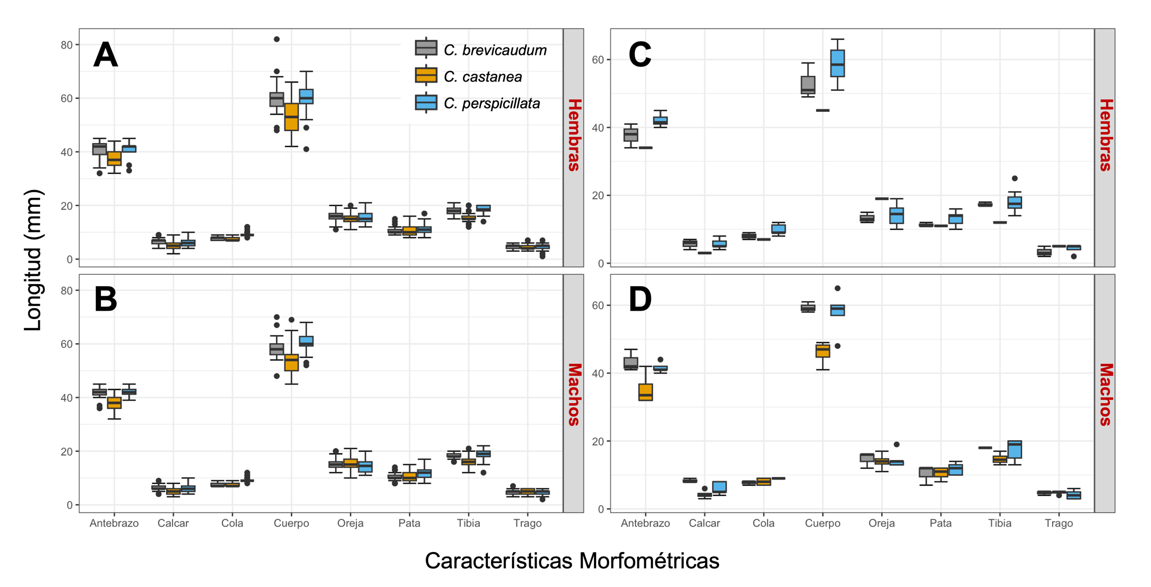

**MSF1.** Comparación de variables morfométricas externas de adultos. **A.-B.** Jóvenes. **C.-D.** Entre *Carollia perspicillata*, *Corollia castanea* y *Corollia brevicauda.*

**SMF1.** Comparison of external morphometric variables of adults **A.-B.** Juveniles. **C.-D.** Between *Carollia perspicillata, Corollia castanea and Corollia brevicauda.*

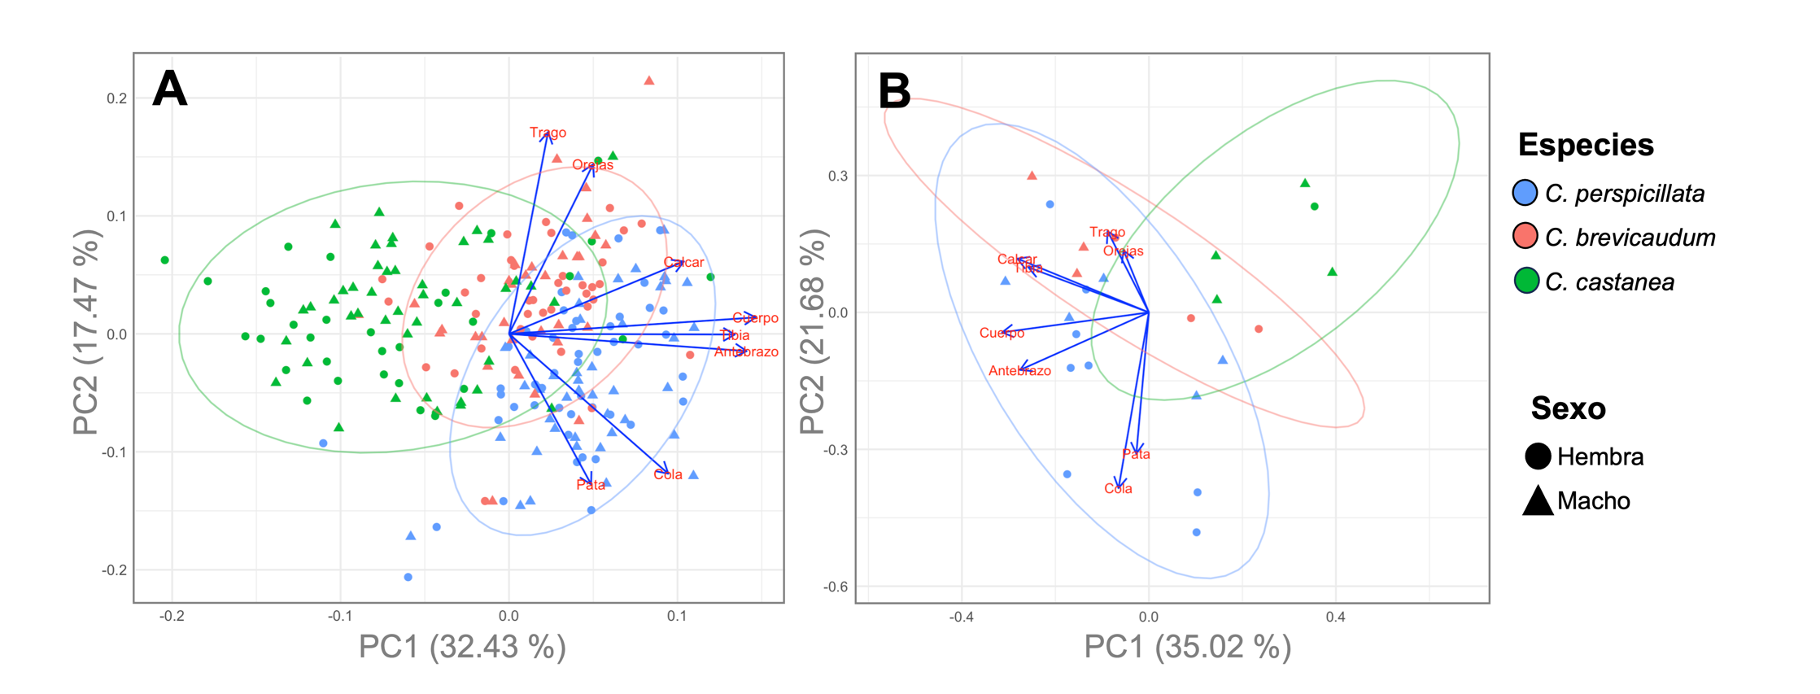

**MSF2.** Análisis de componentes principales de las características morfométricas externas con agrupación mediante clústeres por especies. **A.** Adultos. **B.** Juveniles.

**SMF2.** Principal component analysis of external morphometric characteristics with clustering by species. **A.** Adults. **B.** Juveniles.