SUPPLEMENTARY MATERIAL

APPENDIX TABLE 1. List of families, genera, species and morphospecies of insect floral visitors of the order Diptera collected on ruderal plants in San Gerardo de Dota, Costa Rica. The number of individuals collected during the dry and rainy seasons are indicated.

|  |  |  |  |  |
| --- | --- | --- | --- | --- |
| Family | Genus/Species | Morphospecies | Abundance Dry Season | Abundance rainy season |
| Agromyzidae |  | 1 | 1 | 0 |
| Anisopodidae |  | 1 | 0 | 1 |
| Anthomyiidae | *Hydrophoria* | 1 | 0 | 2 |
| Bibionidae |  | 1 | 1 | 0 |
| Bombyliidae | *Dipalta* | 1 | 5 | 0 |
| Bombyliidae | *Exoprosopa* | 1 | 1 | 0 |
| Bombyliidae | *Paravilla* | 1 | 1 | 0 |
| Calliphoridae | *Chrysomyia* | 2 | 3 | 0 |
| Ceratopogonidae |  | 7 | 0 | 7 |
| Chironomidae |  | 1 | 0 | 1 |
| Chloropidae | *Biorbitella* | 4 | 3 | 1 |
| Chloropidae | *Malloewia* | 1 | 1 | 0 |
| Chloropidae | *Olcella* | 1 | 1 | 18 |
| Chloropidae | *Thaumatomyia* | 1 | 0 | 9 |
| Conopidae |  | 1 | 2 | 0 |
| Dolichopodidae |  | 1 | 0 | 1 |
| Drosophilidae | *Cladochaeta* | 1 | 2 | 0 |
| Drosophilidae | *Drosophila* | 4 | 25 | 61 |
| Drosophilidae | *Scaptomyza* | 1 | 1 | 8 |
| Drosophilidae | *Zygothrica* | 1 | 0 | 4 |
| Empididae | *Porphyrochroa* | 1 | 0 | 2 |
| Empididae | *Rhamphomyia* | 1 | 0 | 1 |
| Fanniidae | *Fannia* | 1 | 1 | 0 |
| Lauxaniidae |  | 1 | 0 | 2 |
| Lonchaeidae |  | 1 | 3 | 1 |
| Muscidae | *Coenosia* | 2 | 0 | 2 |
| Muscidae | *Helina* | 4 | 0 | 3 |
| Muscidae | *Limnophora* | 4 | 2 | 42 |
| Muscidae | *Mydaea* | 1 | 0 | 2 |
| Muscidae | *Neodexiopsis* | 6 | 0 | 9 |
| Muscidae | *Pilispina* | 1 | 0 | 1 |
| Phoridae |  | 1 | 0 | 1 |
| Sarcophagidae |  | 1 | 3 | 7 |
| Sciaridae |  | 1 | 0 | 1 |
| Sphaeroceridae |  | 1 | 0 | 1 |
| Stratiomyidae |  | 1 | 1 | 0 |
| Syrphidae | *Allograpta neotropica* | NA | 3 | 9 |
| Syrphidae | *Allograpta spp.* | 7 | 11 | 20 |
| gSyrphidae | *Argentinomyia* | 1 | 0 | 1 |
| Syrphidae | *Leucopodella* | 1 | 1 | 0 |
| Syrphidae | *Ocyptamus* | 3 | 0 | 3 |
| Syrphidae | *Palpada furcata* | NA | 1 | 14 |
| Syrphidae | *Palpada flavoscutellata* | NA | 0 | 4 |
| Syrphidae | *Platycheirus* | 1 | 15 | 37 |
| Syrphidae | *Quichuana* | 1 | 1 | 0 |
| Syrphidae | *Toxomerus* | 3 | 57 | 108 |
| Tachinidae | *Chaetogaedia* | 1 | 1 | 0 |
| Tachinidae | *Clausicella* | 1 | 0 | 1 |
| Tachinidae | *Dolichotarsus* | 1 | 0 | 1 |
| Tachinidae | *Epalpus* | 2 | 0 | 2 |
| Tachinidae | *Gaediopsis* | 2 | 0 | 9 |
| Tachinidae | *Ginglymyia* | 1 | 0 | 5 |
| Tachinidae | *Jurinella* | 1 | 0 | 1 |
| Tachinidae | *Leskia* | 1 | 0 | 1 |
| Tachinidae | *Neosolieria* | 1 | 0 | 1 |
| Tachinidae | *Parepalpus* | 2 | 2 | 5 |
| Tachinidae | *Peleteria* | 3 | 3 | 3 |
| Tachinidae | *Periscepsia* | 1 | 0 | 1 |
| Tachinidae | *Phytomyptera* | 2 | 1 | 1 |
| Tachinidae | *Protodejeania* | 2 | 0 | 9 |
| Tachinidae | *Pseudosiphona* | 4 | 2 | 3 |
| Tachinidae | *Ptylodexia* | 1 | 0 | 1 |
| Tachinidae | *Siphona* | 3 | 1 | 12 |
| Tachinidae | *Thelyoxynops* | 1 | 0 | 1 |
| Tachinidae | *Trafoia* | 2 | 0 | 6 |
| Tachinidae | *Trichophora* | 2 | 0 | 3 |
| Ulidiidae |  | 1 | 1 | 0 |

APPENDIX TABLE 2. List of families, genera, species, and morphospecies of floral visitors from the order Hymenoptera collected on ruderal plants in San Gerardo de Dota.

|  |  |  |  |  |
| --- | --- | --- | --- | --- |
| Family | Genus/Species | Morphospecies | Abundance Dry Season | Abundance Rainy Season |
| Apidae | *Apis mellifera* |  | 58 | 116 |
|  | *Bombus ephippiatus* |  | 39 | 46 |
|  | *Bombus pullatus* |  | 0 | 6 |
|  | *Bombus vollucelloides* |  | 5 | 5 |
|  | *Ceratina* | 5 | 4 | 7 |
|  | *Exomalopsis* | 1 | 9 | 0 |
|  | *Meliwillea bivea* |  | 24 | 15 |
|  | *Partamona grandipennis* |  | 0 | 8 |
|  | *Thygater* | 1 | 1 | 5 |
| Braconidae |  |  | 2 | 9 |
|  | *Opius* | 1 | 0 | 3 |
| Colletidae | *Colletes* | 1 | 1 | 0 |
| Crabronidae | *Ectemnius* | 1 | 0 | 1 |
|  | *Solierella* | 1 | 1 | 0 |
| Diapriidae |  |  | 0 | 1 |
| Encyrtidae |  |  | 0 | 1 |
| Figitidae | *Anacharis* | 1 | 3 | 0 |
| Halictidae | *Habralictus* | 1 | 0 | 2 |
|  | *Lasioglossum* | 10 | 60 | 73 |
| Ichneumonidae | *Dreisbachia* | 1 | 0 | 3 |
|  |  |  | 0 | 3 |
| Megachilidae | *Megachile* | 1 | 0 | 1 |
| Pteromalidae |  |  | 2 | 3 |
| Sphecidae | *Podalonia* | 1 | 0 | 1 |
| Vespidae | *Agelaia yepocapa* |  | 0 | 3 |
|  | *Ancistrocerus* | 1 | 1 | 0 |
|  | c.f. *Ancistrocerus* | 1 | 1 | 0 |
|  | c.f. *Zeta* | 1 | 2 | 0 |
|  | *Epipona guerini* |  | 3 | 7 |

APPENDIX TABLE 3. List of families and genera, species, and morphospecies of floral visitors from other Orders collected on ruderal plants in San Gerardo de Dota.

|  |  |  |  |  |  |
| --- | --- | --- | --- | --- | --- |
| Order | Family | Genus/Species | Morphospecies | Abundance Dry Season | Abundance Rainy Season |
| Coleoptera | Cantharidae | *Chauliognathus* | 2 | 0 | 3 |
|  | Cerambycidae | *Scatopyrodes trichostethus* |  | 0 | 2 |
|  | Chrysomelidae |  |  | 0 | 2 |
|  | Coccinellidae |  |  | 1 | 0 |
|  | Curculionidae |  |  | 1 | 2 |
|  | Melyridae | *Astylus indentatus* |  | 18 | 14 |
|  | Mycteridae |  |  | 9 | 13 |
|  | Nitidulidae | *Conotelus* | 1 | 5 | 19 |
| Lepidoptera | Hesperiidae | *Hylephila* | 1 | 0 | 2 |
|  | Lycaenidae | *Celastrina echo* |  | 0 | 1 |
|  | Notodontidae | *Josia gigantea* |  | 0 | 1 |
|  | Nymphalidae | *Actinote* | 1 | 0 | 1 |
|  |  | *Dione moneta* |  | 1 | 1 |
|  | Pterophoridae |  |  | 1 | 0 |
| Hemiptera | Anthocoridae |  |  | 0 | 1 |
|  | Aphididae |  |  | 12 | 0 |
|  | Cicadellidae |  |  | 4 | 2 |
|  | Delphacidae |  |  | 1 | 0 |
|  | Lygaeidae |  |  | 1 | 0 |
|  | Miridae |  |  | 2 | 0 |
|  | NA |  |  | 1 | 1 |
|  | Rhyparochromidae |  |  | 1 | 0 |
|  | Triozidae |  |  | 0 | 1 |

APPENDIX TABLE 4. Observed and estimated species richness based on Chao richness index estimator for the different plant groups. Standard error (SE) and lower (L) and upper (U) 95 % confidence intervals are included.

|  |  |  |  |  |  |
| --- | --- | --- | --- | --- | --- |
| Plant Group | Observed | Estimated | SE | L95 % | U95 % |
| Asteraceae-1 | 32 | 69.3 | 29.5 | 41.5 | 178.5 |
| Asteraceae-2 | 53 | 85.9 | 17.1 | 65.6 | 138.8 |
| Asteraceae-3 | 52 | 129.2 | 40.6 | 81.3 | 255.6 |
| Cucurbit-vines | 41 | 88.6 | 28.3 | 57.2 | 181 |
| *Lopezia miniata* | 28 | 82 | 36.6 | 44.2 | 208.1 |
| Open-flowers | 20 | 35 | 12.3 | 23.6 | 81.4 |
| Small-flower-vines | 45 | 112 | 40.6 | 67.3 | 245.9 |
| Herbs-1 | 18 | 53.2 | 32.7 | 25.5 | 183.3 |
| Herbs-2 | 25 | 32 | 5.8 | 26.7 | 54 |
| Herbs-3 | 28 | 53.3 | 17.7 | 35.3 | 115.2 |
| Tubular-flowers | 28 | 108.5 | 68.9 | 46.8 | 372.7 |

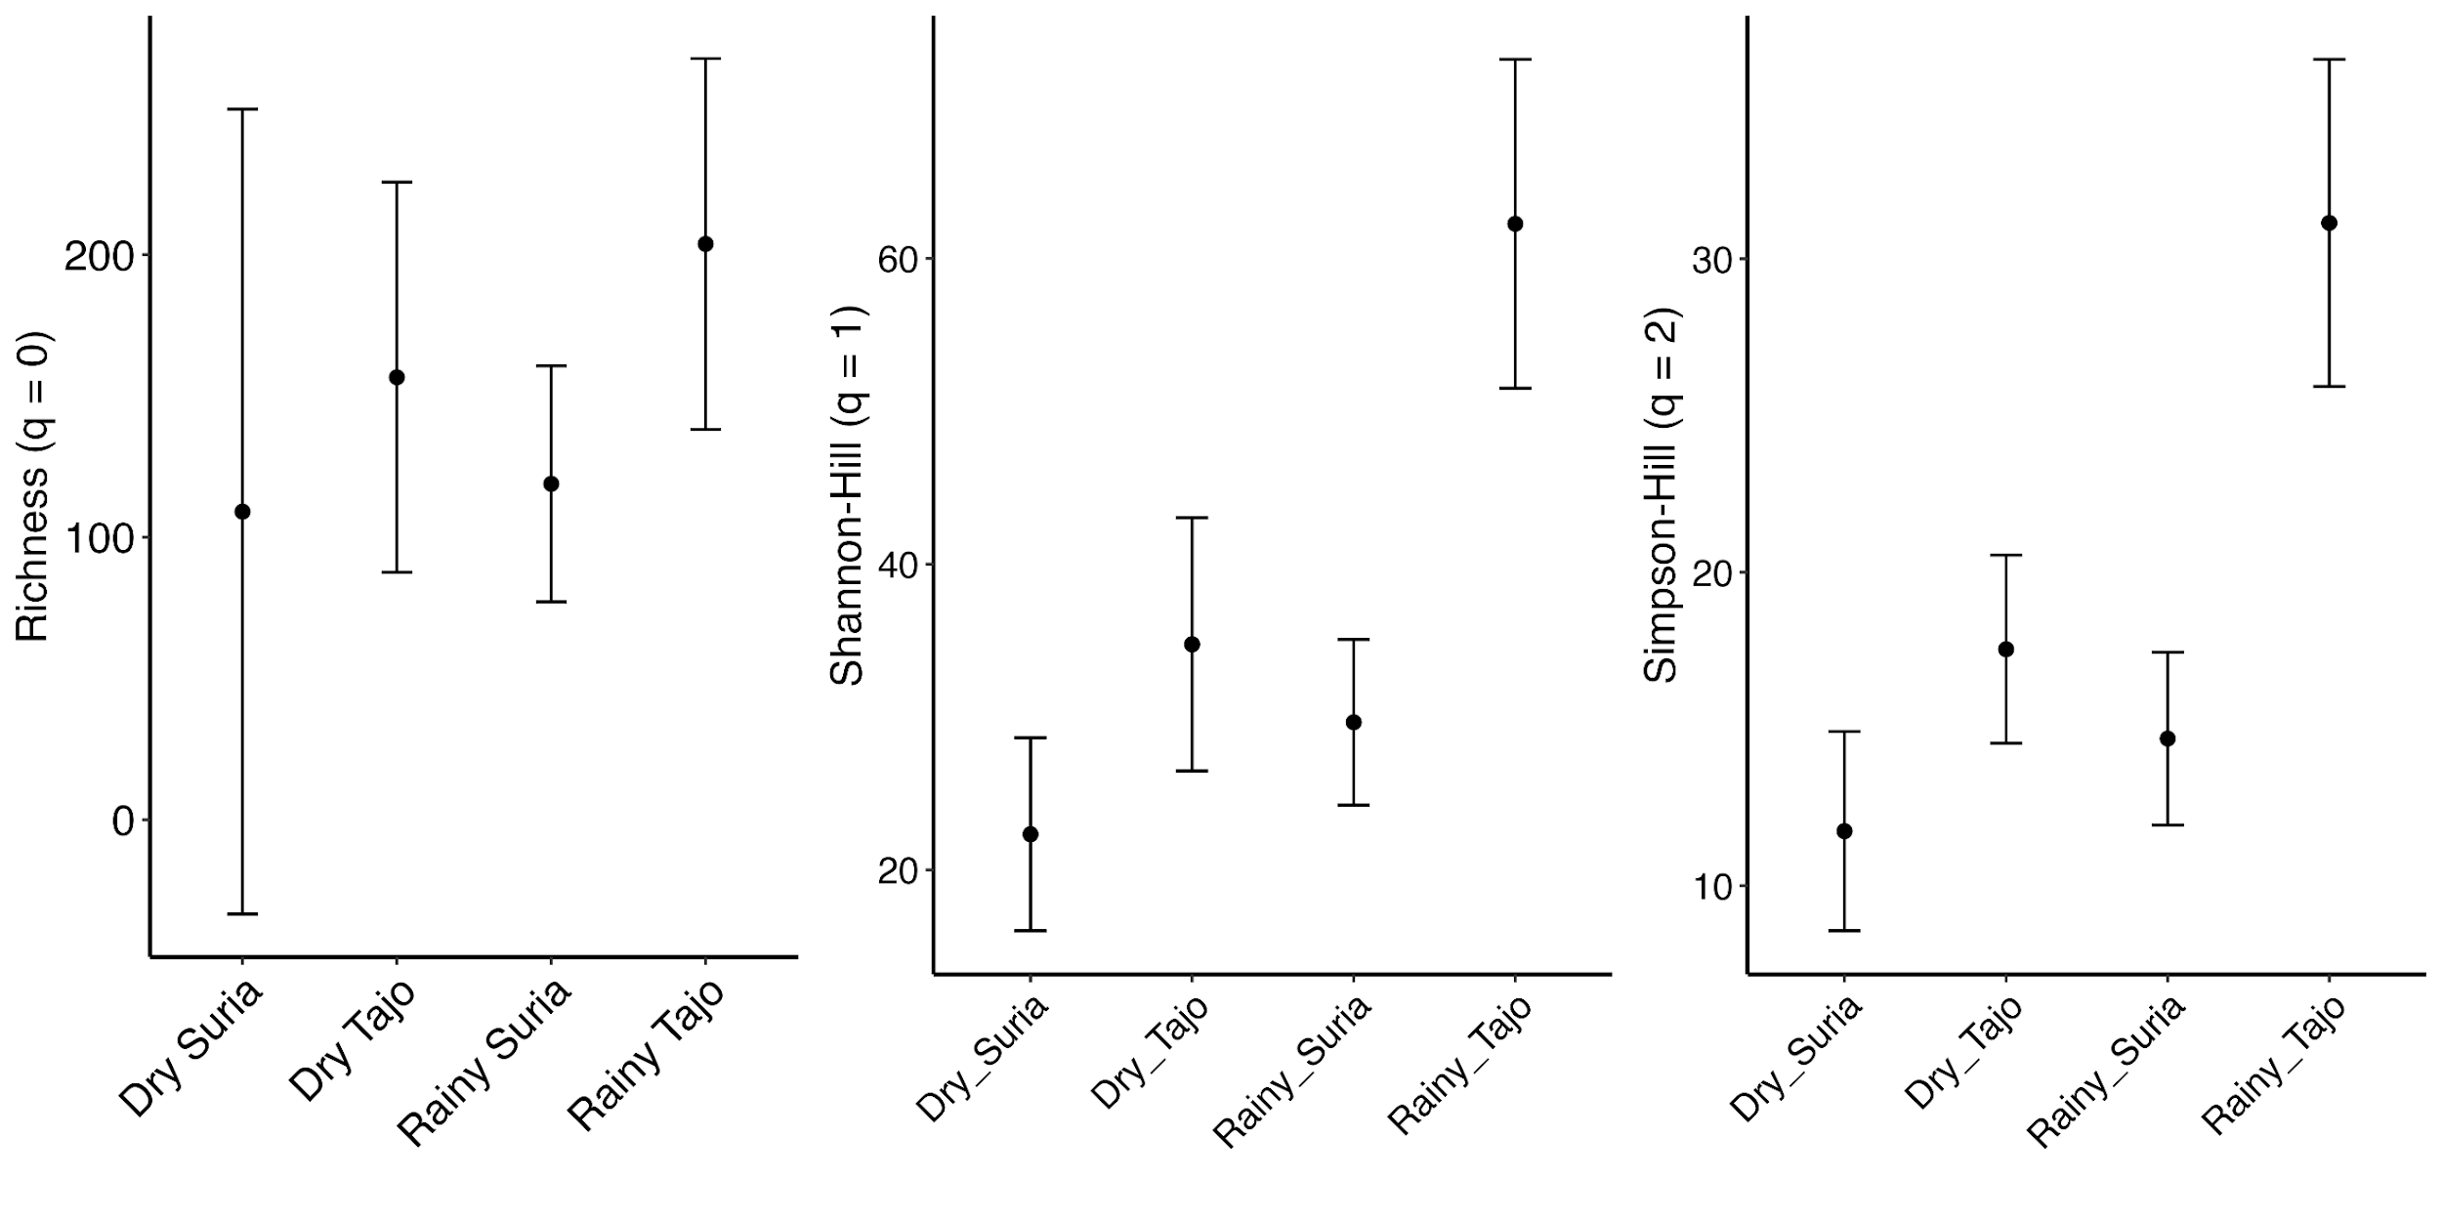

**Fig. A1.** Comparison of the three Hill-diversity estimates of insect visitors for each site-season combination. Error bars depict 95 % CI.

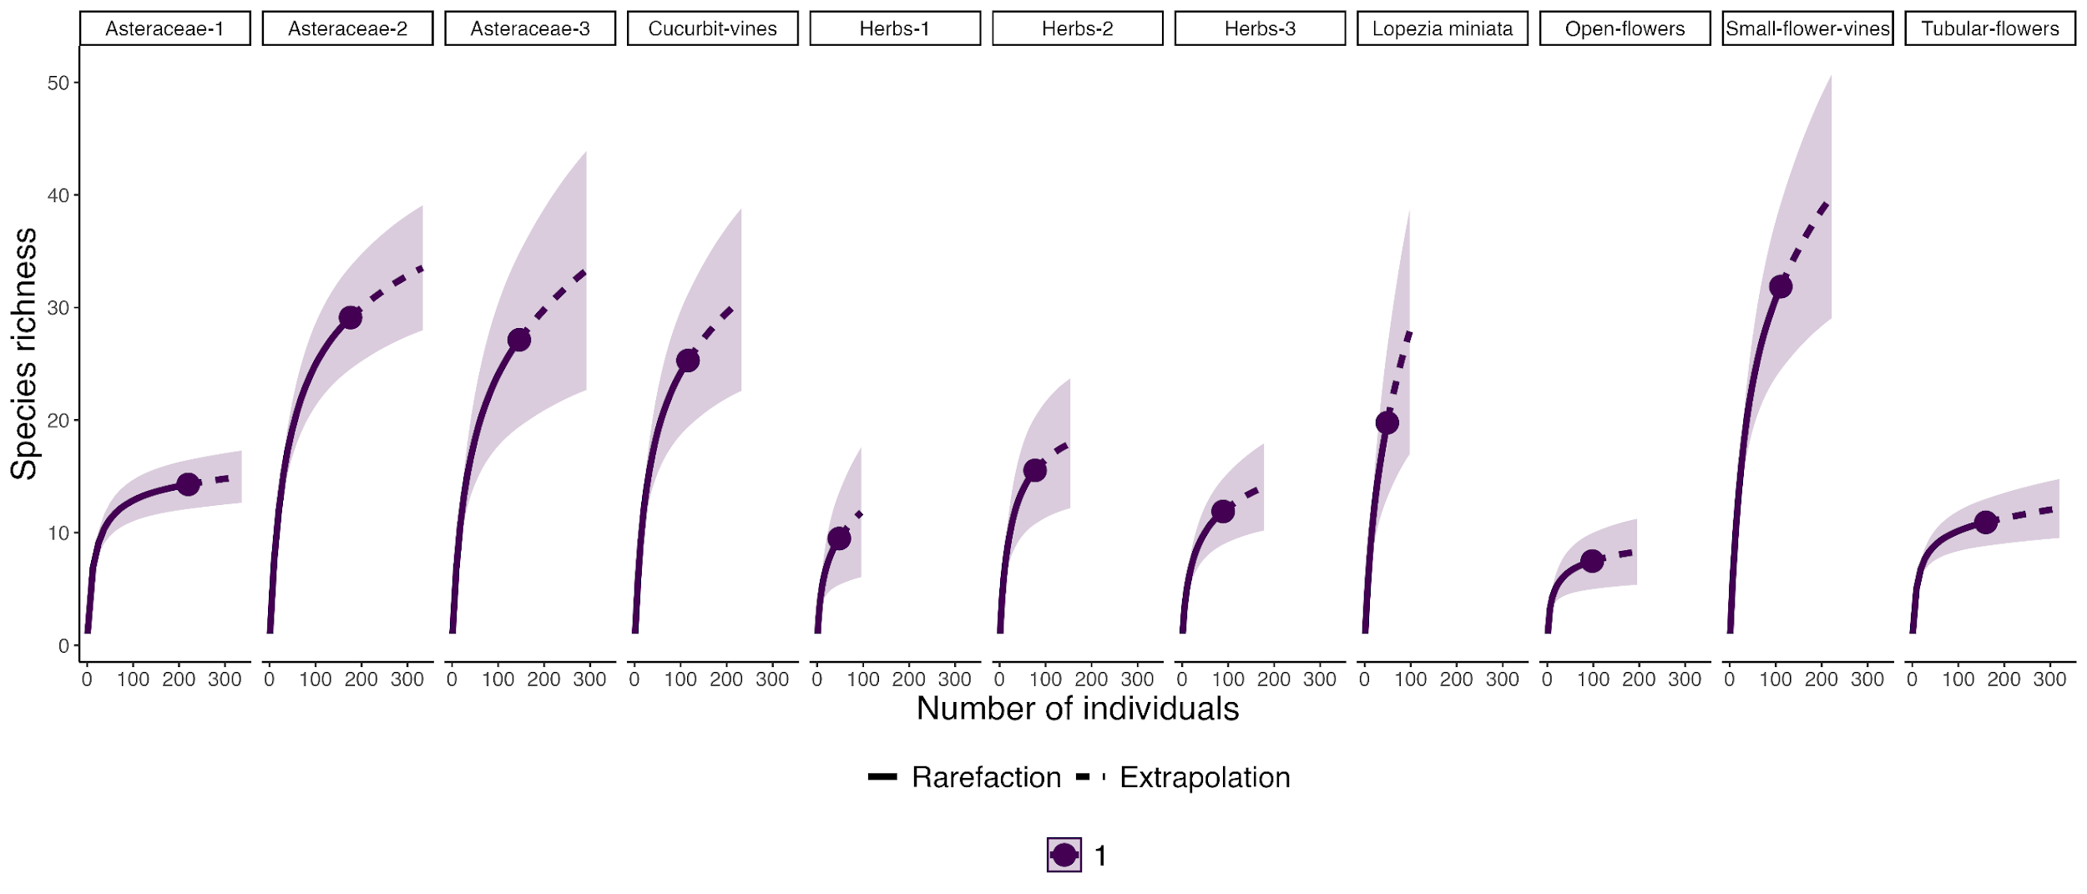

**Fig. A2.** Species accumulation curves using Hill-Shannon (q1) for each of the plant groups studied.

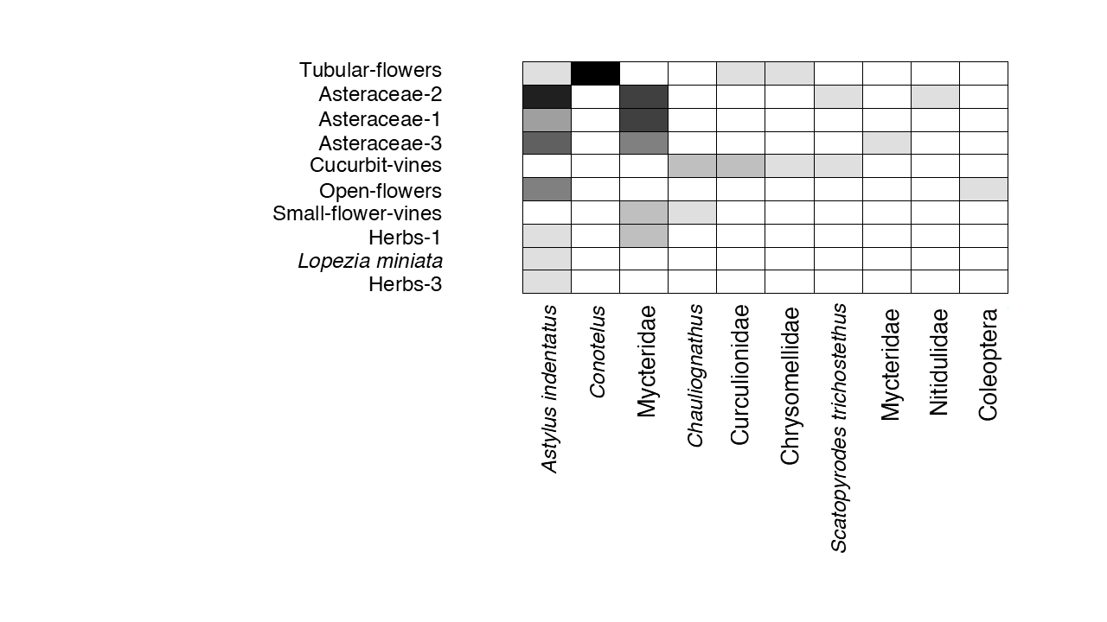

**Fig. A3.** Floral visiting insect communities of the order Coleoptera recorded for each group of plants. Darker colors in the gray-scale indicate greater abundance of collected insects.

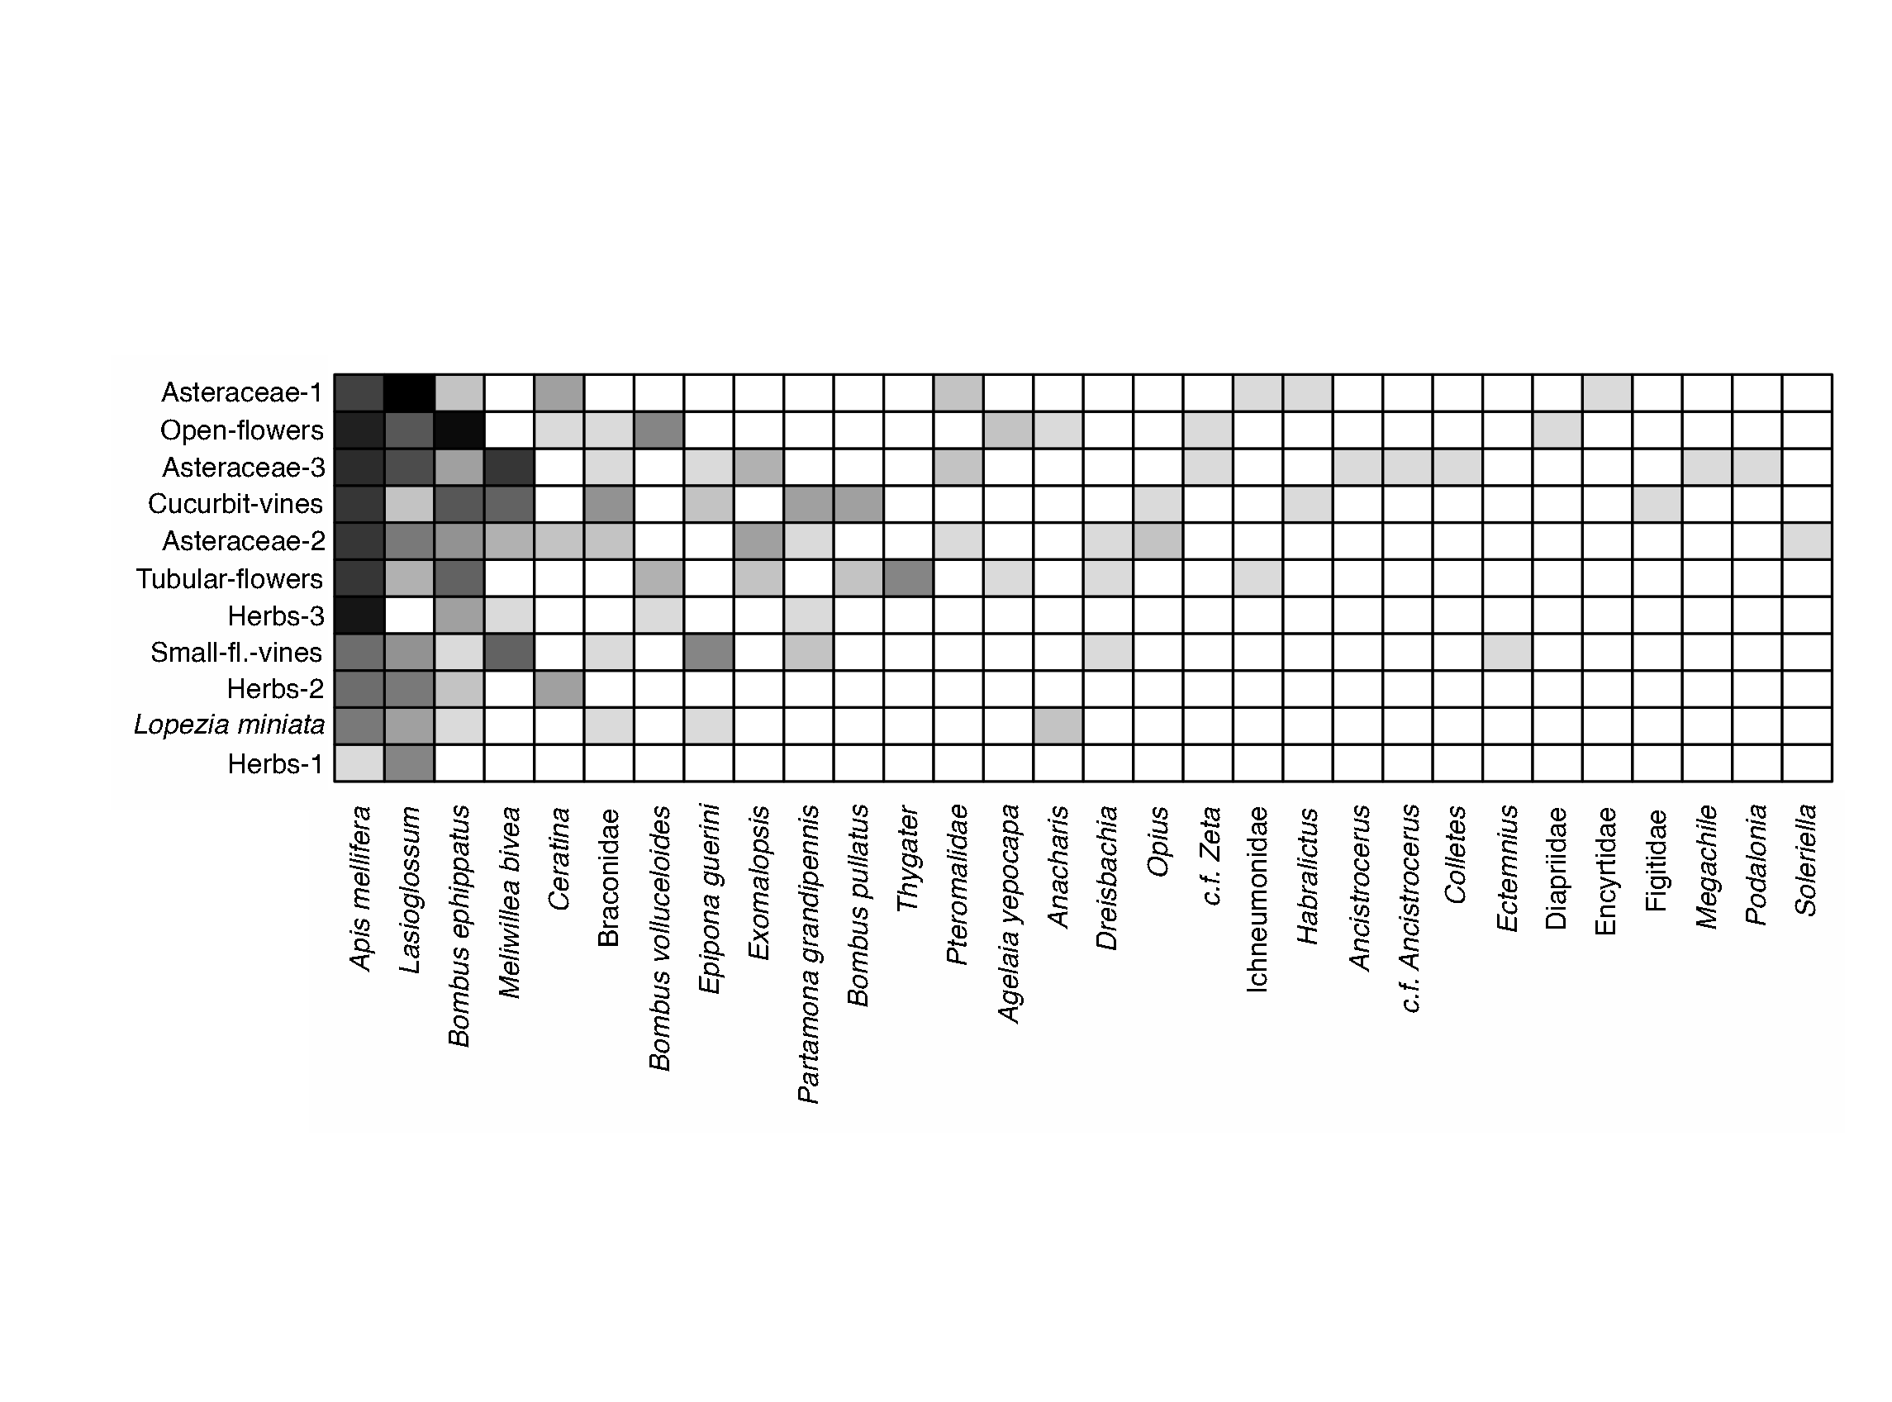

**Fig. A4.** Communities of floral visiting insects of the order Hymenoptera recorded for each group of plants. The color tone gives an estimate of the number of insects found, with lighter shades being few individuals and darker shades many individuals.

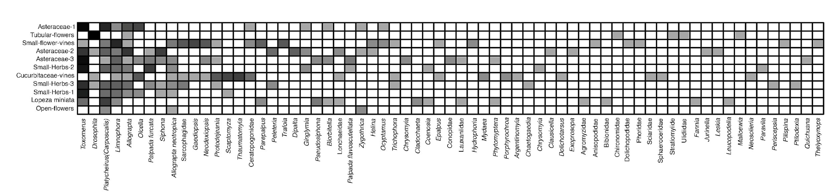

**Fig. A5.** Communities of visiting insects of the order Diptera recorded for each group of plants. The color tone gives an estimate of the number of insects found, with lighter shades being few individuals and darker shades many individuals.