**Appendix 1.** Study area (327.16 Km2) and sites selected for surveys of medium and large-sized mammals using camera traps in Sarapiquí, Heredia, Costa Rica during 2013-2014.

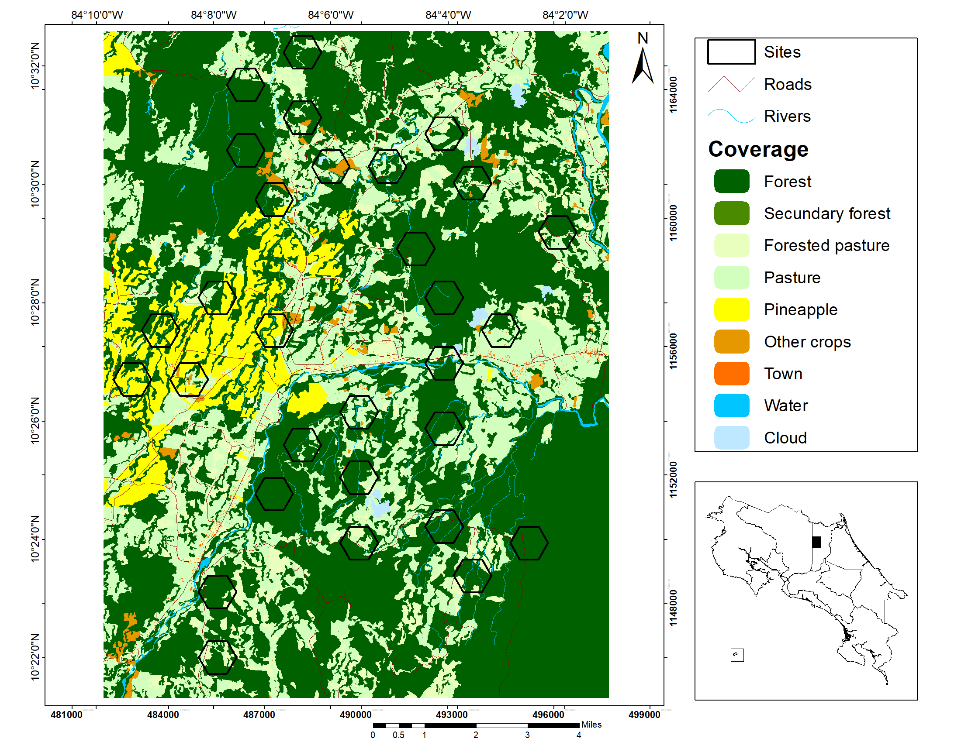

aElaborated by M. Runnebaum

bImage sources: Mosaic generated in SIG OTS from aerial photographies issued by the Costa Rica Airborne Research and Technology Applications (CARTA 2005), Centro Nacional de Alta Tecnología (CENAT) and Nasa Johnson Space Center (2014).

**Appendix 2.** Information of each location surveyed in the Sarapiquí region, Heredia, Costa Rica during 2013-2014. Sites wit with**⁑** indicate more than 75% of forest, sites with **~** indicate more than 30% of pineapple, and sites with **\*** indicate more than 30% pastures

|  |  |  |  |  |  |  |  |  |  |  |  |
| --- | --- | --- | --- | --- | --- | --- | --- | --- | --- | --- | --- |
| **Site** | **Owner's name** | **Abbreviation** | **UTM**  **Coordinates** | | **#cameras in site** | **# Species Found** | **Distance (m)** | **Land cover** | | | |
| **Forest** | **Pineapple** | **Pasture** | **Other** |
| 1 | Finca Corsicana | FC1~ | 483753 | 1156500 | 1 | 6 | 2415.70 | 0.57 | 0.41 | 0.02 | 0.00 |
| 2 | Finca Corsicana | FC2~ | 485510 | 1157527 | 1 | 10 | 1655.93 | 0.45 | 0.32 | 0.23 | 0.00 |
| 3 | Finca Corsicana | FC3~ | 484631 | 1154981 | 1 | 7 | 2881.75 | 0.19 | 0.46 | 0.26 | 0.09 |
| 4 | Finca Corsicana | FC4~ | 487283 | 1156502 | 1 | 8 | 2053.61 | 0.31 | 0.50 | 0.14 | 0.06 |
| 5 | Finca Corsicana | FC5~ | 482868 | 1154985 | 2 | 9 | 4134.01 | 0.34 | 0.66 | 0.00 | 0.00 |
| 6 | Selva Verde S.A. | SV | 492584 | 1155475 | 2 | 8 | 240.00 | 0.60 | 0.00 | 0.30 | 0.09 |
| 7 | Hacienda Agroindustrial Pozo Azul S.A. | PA⁑ | 485505 | 1148347 | 2 | 6 | 2437.42 | 0.88 | 0.00 | 0.12 | 0.00 |
| 8 | Reserva Biologica La Tirimbina Ltda | RT⁑ | 487283 | 1151408 | 2 | 9 | 0.00 | 1.00 | 0.00 | 0.00 | 0.00 |
| 9 | Spring Farm de Sarapiqui S.A. | SF* | 485520 | 1146309 | 1 | 4 | 2836.48 | 0.60 | 0.00 | 0.39 | 0.00 |
| 10 | Zoila Rosa Mora Bustamante | ZB⁑ | 492580 | 1150388 | 1 | 4 | 1115.17 | 0.89 | 0.00 | 0.11 | 0.00 |
| 11 | Familia Ovialfa S.A. | FO⁑ | 493458 | 1148859 | 1 | 5 | 0.00 | 0.78 | 0.00 | 0.22 | 0.00 |
| 12 | Magsasay | MG⁑ | 495223 | 1149875 | 2 | 9 | 0.00 | 1.00 | 0.00 | 0.00 | 0.00 |
| 13 | Miguel Oconitrillo Madrigal | MO1* | 492567 | 1153443 | 1 | 5 | 1406.02 | 0.74 | 0.00 | 0.26 | 0.00 |
| 14 | Eida Molina y Edgar Umana | EM* | 489914 | 1153960 | 1 | 4 | 317.80 | 0.40 | 0.00 | 0.59 | 0.01 |
| 15 | Teresa Acuna y Jose Munoz | TA⁑ | 489927 | 1151903 | 2 | 7 | 541.48 | 0.77 | 0.00 | 0.23 | 0.00 |
| 16 | Emilia Carmona y Rosibel Rodriguez | EC⁑ | 488164 | 1152932 | 1 | 8 | 0.00 | 0.85 | 0.00 | 0.15 | 0.00 |
| 17 | Ganadera Rio Peje S.A. | GP* | 490812 | 1161594 | 1 | 8 | 777.82 | 0.59 | 0.00 | 0.39 | 0.02 |
| 18 | Miguel Oconitrillo Madrigal | MO2* | 492581 | 1162617 | 1 | 3 | 1412.83 | 0.44 | 0.00 | 0.54 | 0.01 |
| 19 | Ecovida Inmobiliaria S.A. | EV1* | 494346 | 1156512 | 2 | 16 | 512.64 | 0.41 | 0.00 | 0.58 | 0.01 |
| 20 | Ecovida Inmobiliaria S.A. | EV2⁑ | 491699 | 1159053 | 1 | 8 | 0.00 | 0.97 | 0.00 | 0.03 | 0.00 |
| 21 | Ecovida Inmobiliaria S.A. | EV3⁑ | 492584 | 1157531 | 1 | 7 | 0.00 | 1.00 | 0.00 | 0.00 | 0.00 |
| 22 | Alfa Industrias Forestales | AI1* | 487283 | 1160579 | 2 | 10 | 0.00 | 0.65 | 0.11 | 0.17 | 0.06 |
| 23 | Alfa Industrias Forestales | AI2⁑ | 486403 | 1162105 | 2 | 10 | 0.00 | 1.00 | 0.00 | 0.00 | 0.00 |
| 24 | Forestal Santa Ines de Sarapiqui S.A. | SI⁑ | 486396 | 1164158 | 2 | 8 | 0.00 | 0.79 | 0.00 | 0.21 | 0.00 |
| 25 | Juan Luis Quiros Huertas | LQ⁑ | 488168 | 1165170 | 2 | 6 | 0.00 | 0.84 | 0.00 | 0.16 | 0.00 |
| 26 | Jesus Eduardo Zuniga Brenes | JZ* | 488160 | 1163135 | 1 | 7 | 196.98 | 0.69 | 0.00 | 0.26 | 0.05 |
| 27 | Rosa Picado Chacon | RP* | 489046 | 1161594 | 2 | 5 | 785.49 | 0.36 | 0.00 | 0.38 | 0.26 |
| 28 | Vanilla Export Company | VE* | 493466 | 1161097 | 2 | 10 | 44.72 | 0.70 | 0.00 | 0.28 | 0.02 |
| 29 | Ecosistemas El Pilon | EP* | 496125 | 1159560 | 2 | 7 | 403.11 | 0.70 | 0.00 | 0.30 | 0.00 |
| 30 | Trovador | TV* | 489925 | 1149877 | 1 | 3 | 72.11 | 0.64 | 0.00 | 0.36 | 0.00 |

**Appendix 3.** Terrestrial and semi-terrestrial medium and large sized mammals registered in Sarapiquí and Braulio Carrillo National Park

|  |  |  |  |  |  |  |  |
| --- | --- | --- | --- | --- | --- | --- | --- |
| **Order** | | **Common name** | **Functional group 1** | **Size2** | **Forest dependance3** | **Rarity/Hunted4** | **IUCN Red list status5** |
|  | **Species** |
| **ORDER DIDELPHIMORPHIA** | |  |  |  |  |  |  |
|  | *Didelphis marsupialis (*Linnaeus, 1758)* | Common Opossum | omnivore | M | low | C | LC |
|  | *Philander melanurus* (Linnaeus, 1758) **\*** | Grey Four-eyed Opossum | omnivore | M | medium | C | LC |
|  |  |  |  |  |  |  |  |
| **ORDEN PILOSA** | |  |  |  |  |  |  |
|  | *Myrmecophaga tridactyla* (Linnaeus, 1758) | Giant anteater | insectivore | L | low | HU | VU |
|  | *Tamandua mexicana* (Saussure, 1860) **\*** | Northern Tamandua | insectivore | M | low | U | LC |
|  |  |  |  |  |  |  |  |
| **ORDEN CINGULATA** | |  |  |  |  |  |  |
|  | *Dasypus novemcinctus* (Linnaeus, 1758) **\*** | Nine-banded Armadillo | omnivore | M | low | C | LC |
|  | *Cabassous centralis* (Miller, 1899) | Northern Naked Tailed Armadillo | omnivore | M | low | HU | DD |
|  |  |  |  |  |  |  |  |
| **ORDEN RODENTIA** | |  |  |  |  |  |  |
|  | *Coendou mexicanus* (Kerr, 1792) **\*** | Mexican Hary Dwarf Porcupine | herbivore | M | medium | C | LC |
|  | *Dasyprocta punctata* Gray, 1842 **\*** | Central American Agouti | herbivore | M | low | C/H | LC |
|  | *Cuniculus paca* (Linnaeus, 1766) **\*** | Spotted Paca | herbivore | M | medium | U/H | LC |
|  |  |  |  |  |  |  |  |
| **ORDEN LAGOMORPHA** | |  |  |  |  |  |  |
|  | *Sylvilagus gabbii* (J. A. Allen, 1877) **\*** | Forest rabbit | herbivore | M | medium | C/H | LC |
|  |  |  |  |  |  |  |  |
| **ORDEN CARNIVORA** | |  |  |  |  |  |  |
|  | *Canis latrans* (Say, 1823) **\*** | Coyote | omnivore | L | low | C | LC |
|  | *Panthera onca* (Linnaeus, 1758) | Jaguar | carnivore | L | medium | U/H | NT |
|  | *Leopardus pardalis* (Linnaeus, 1758) **\*** | Ocelot | carnivore | L | low | U | LC |
|  | *Leopardus tigrinus* (Schreber, 1775*)* **\*** | Oncilla | carnivore | M | high | HU | VU |
|  | *Leopardus wiedii* (Schinz, 1821) **\*** | Margay | carnivore | M | high | HU | NT |
|  | *Puma concolor* (Linnaeus, 1771) | Puma | carnivore | L | medium | U/H | LC |
|  | *Herpailurus yagouaroundi* (E. Geoffroy, 1803) **\*** | Jaguarundi | carnivore | M | medium | C | LC |
|  | *Nasua narica* (Linnaeus, 1766) **\*** | White-nosed Coati | omnivore | M | low | C | LC |
|  | *Procyon lotor* (Linnaeus, 1758) **\*** | Northern raccoon | omnivore | M | low | C | LC |
|  | *Eira barbara* (Linnaeus, 1758) **\*** | Tayra | omnivore | M | medium | U | LC |
|  | *Galictis vittata* (Schreber, 1776) **\*** | Lesser Grison | carnivore | M | medium | HU | LC |
|  | *Lontra longicaudis* (Olfers, 1818) | Neotropical River otter | carnivore | M | high | U | NT |
|  | *Conepatus semistriatus* (Boddaert, 1785) **\*** | Striped Hog-nosed Skunk | omnivore | M | medium | U | LC |
|  |  |  |  |  |  |  |  |
| **ORDEN PERISSODACTYLA** | |  |  |  |  |  |  |
|  | *Tapirus bairdii* (Gill, 1865) **\*** | Baird's Tapir | herbivore | L | medium | U | E |
|  |  |  |  |  |  |  |  |
| **ORDEN ARTIODACTYLA** | |  |  |  |  |  |  |
|  | *Tayassu pecari* (Link, 1795) | White-lipped Peccary | omnivore | L | high | HU/H | VU |
|  | *Dicotyles tajacu* (Linnaeus, 1758) **\*** | Collared Peccary | omnivore | L | medium | C/H | LC |
|  | *Mazama temama* (Kerr, 1792) **\*** | Central American Red Brocket | herbivore | L | medium | C | DD |
|  | *Odocoileus virginianus* (Zimmermann1780) **\*** | White-tailed Deer | herbivore | L | low | C | LC |

**\* Species found in this study**

**1Functional group**

**2Size: M=Medium, L=Large**

**3Forest dependance: H=High, M=Medium, L=low**

**4Rarity/Hunted: C=Common, U=Uncommon, HU=Highly Uncommon, H=Hunted**

**5IUCN Red list status: DD=Data deficient, E=Endangerd, VU=Vulnerable, NT=Near threatened, LC=Least concerned**