Supplementary material

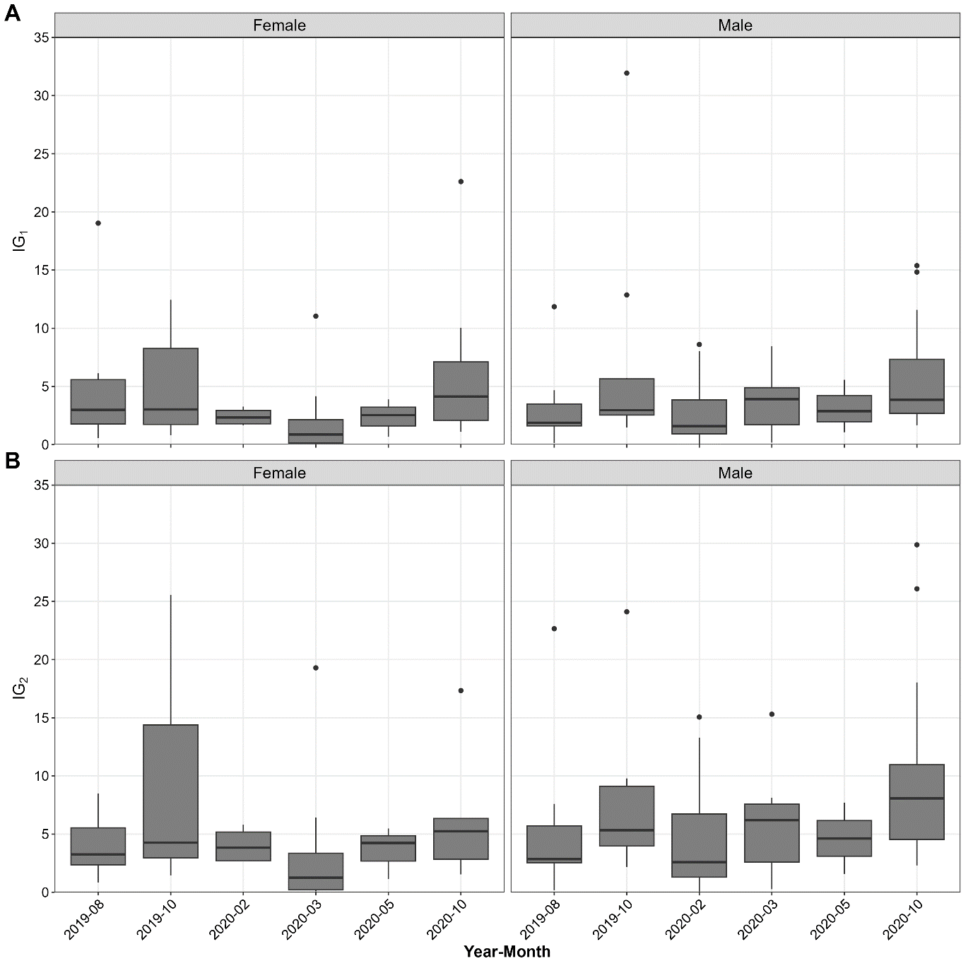
SMF1. Gonad indexes of the H. (H.) grisea from Armação do Itapocoroy (Santa Catarina, Brazil). A. GI₁. B. GI₂.

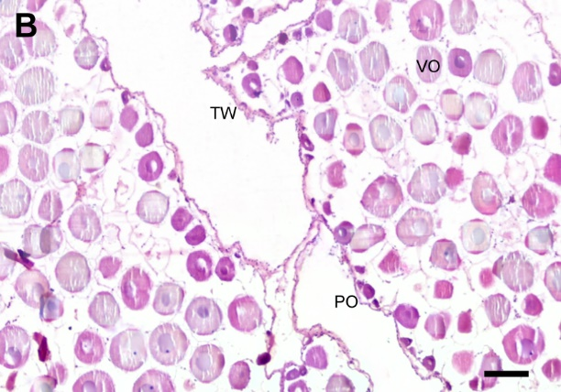
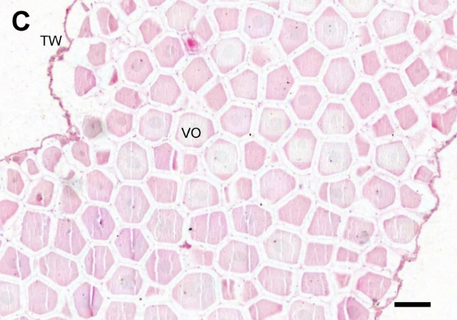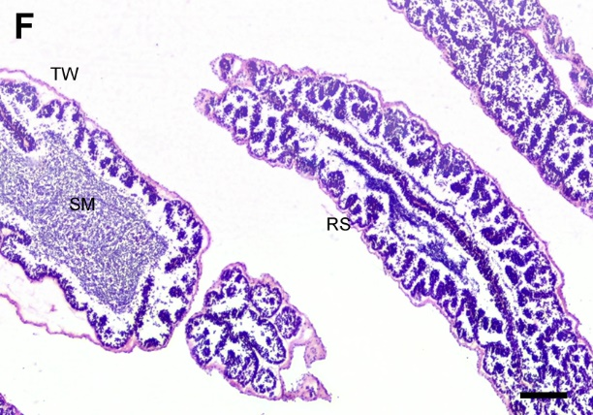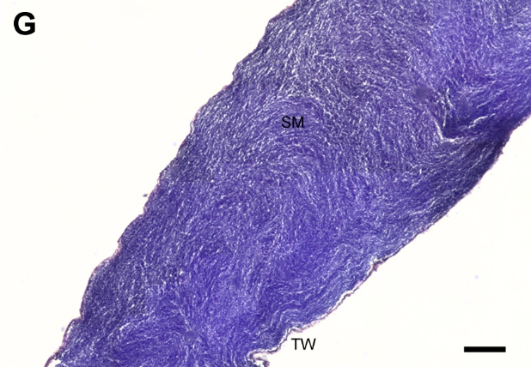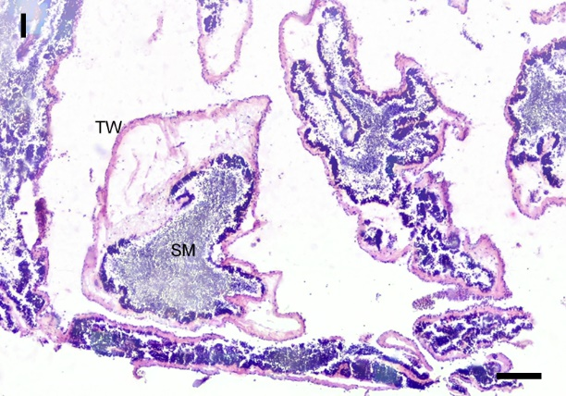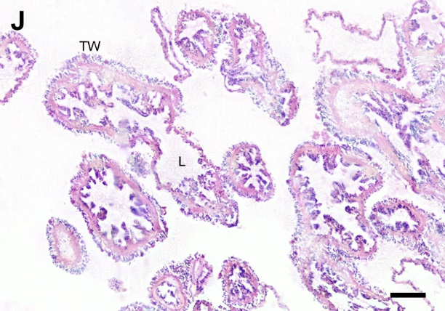
SMF2. Tubules development of the H. (H.) grisea from Armação do Itapocoroy (Santa Catarina, Brazil). Female: A. Growing stage. B. Premature stage. C. Mature stage. D. Spawning stage (total spawning). E. Spawning stage (spawning with growing). Male: F. Growing and premature stage. G. Mature stage. H. Beginning of spawning stage. I. Spawning stage (spawning with growing). J. Post-spawning stage. TW: tubular wall. NP: nutritive phagocyte. L: lumen. PO: previtellogenic oocyte. VO: vitellogenic oocyte. RS: radial series. SM: Spermatozoa mass. Scale bar: 50 μm.

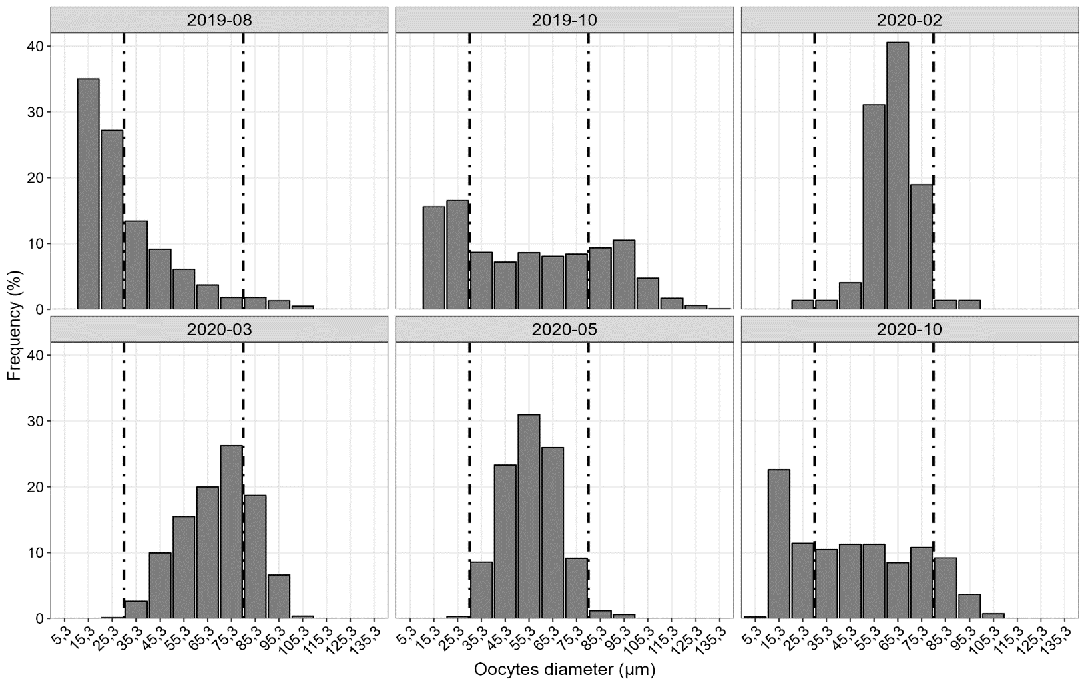
SMF3. Monthly distribution of H. (H.) grisea frequency of oocytes diameter average from Armação do Itapocoroy (Santa Catarina, Brazil). The dotted lines represent the cohorts based on Bhattacharya's method.

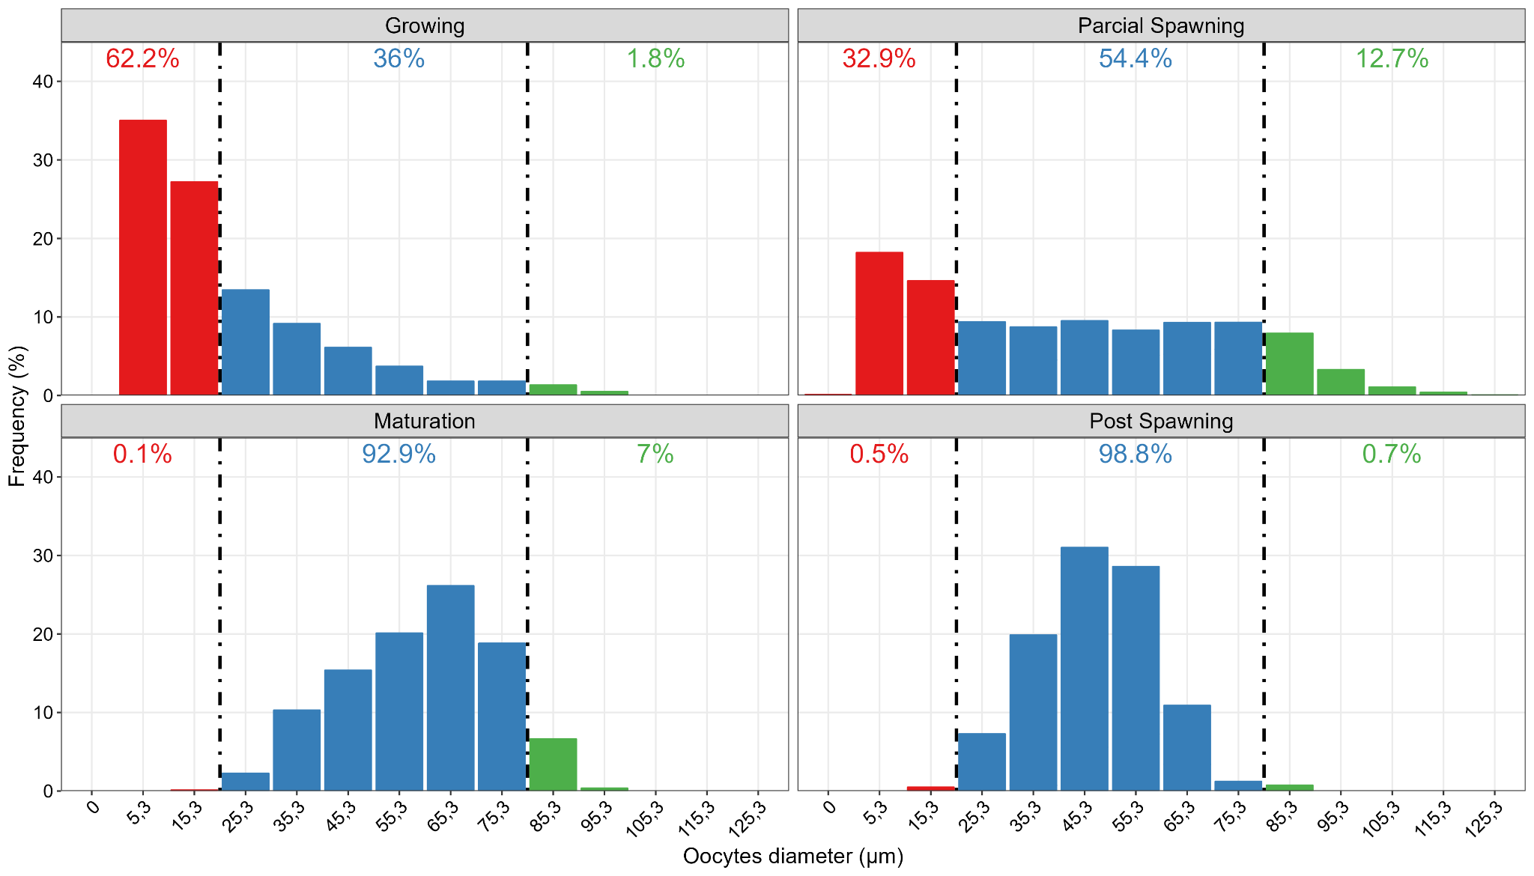
SMF4. Female GDS based on oocyte diameter intervals of the H. (H.) grisea from Armação do Itapocoroy (Santa Catarina, Brazil). The dotted lines represent the cohorts based on Bhattacharya's method.
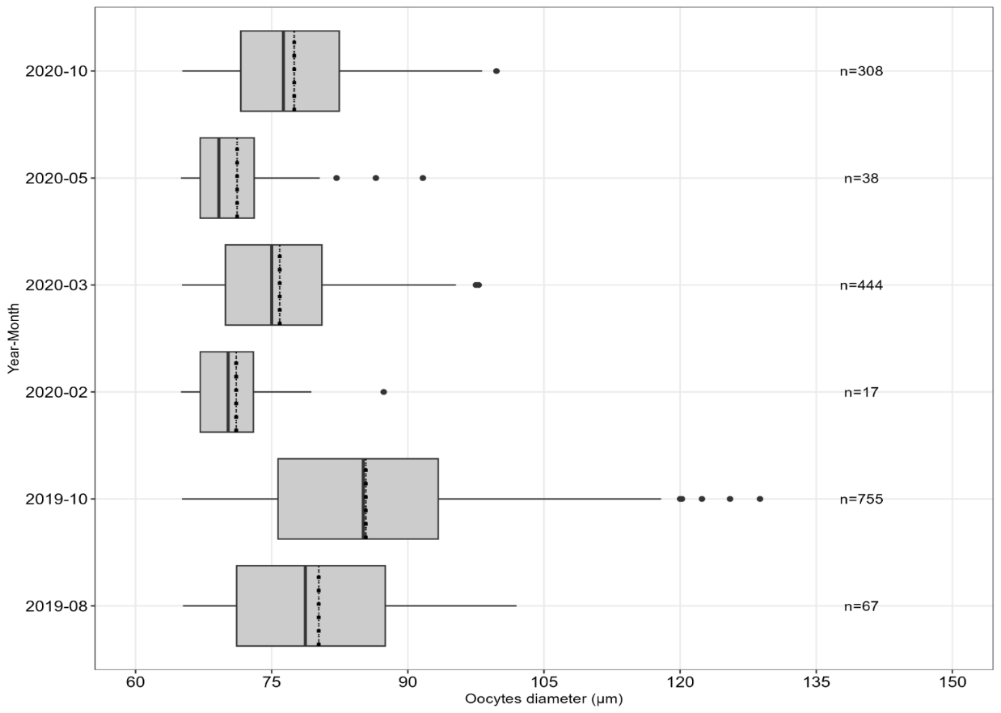
SMF5. Mean and standard error of oocyte diameter (μm) of H. (H.) grisea from Armação do Itapocoroy (Santa Catarina, Brazil). n = number of oocytes.
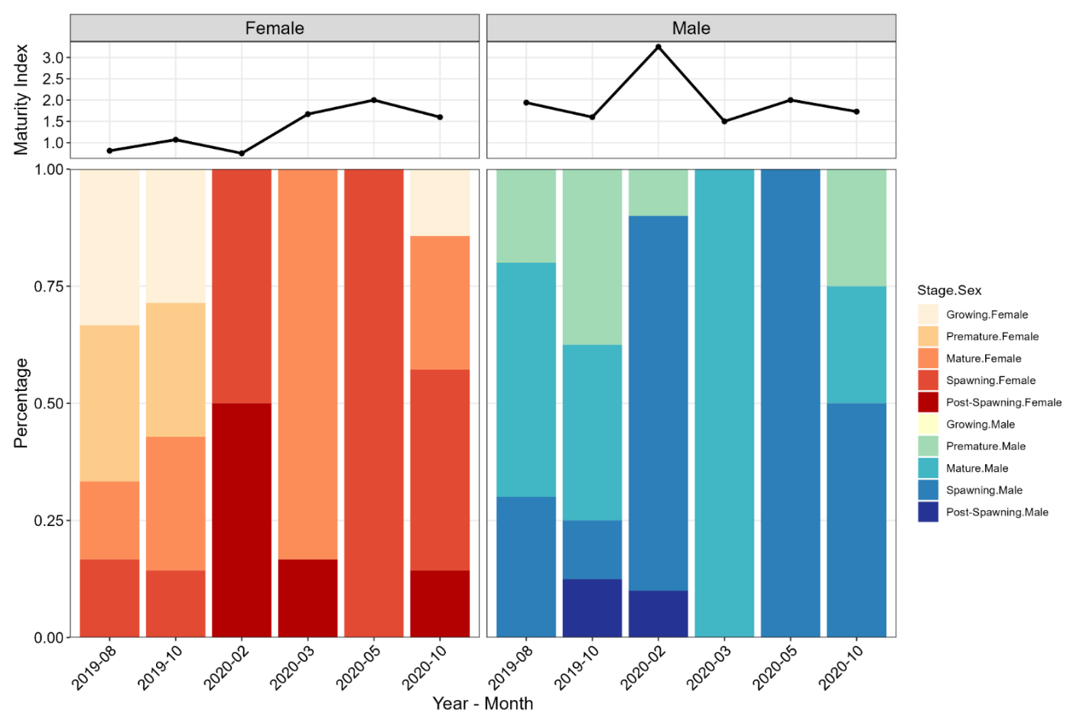
SMF6. Frequency of tubule development stages (GDS) and Maturity Index (MI) of H. (H.) grisea from Armação do Itapocoroy (Santa Catarina, Brazil).

SMT1
Gametogenic events for tubules in females and males of the H. (H.) grisea from Armação do Itapocoroy (Santa Catarina, Brazil)
Event | Tubule wall | Lumen | Germinative cells | Accessory cells
Growing | Female tubules are thick with | Rather empty | Small oocytes (Da < 25 µm) arranged in a single layer in a thin the germinal epithelium (grow zone). | Rare or non-existent
Growing | Male tubules with a large amount of connective tissue; extremely convoluted | Rather empty | Ridges of connective tissue develop towards the center of the lumen where primary cells (spermatogonia and spermatocytes) are present. Few spermatozoa mass later started to invade the tubule lumen. | Rare or non-existent
Premature | Increase of wall distension | Empty space still visible | As vitellogenesis progressed (25-65 µm) fully-grown oocytes began to take up a central position in the lumen. Accessory (follicle) cells surround the growing oocytes. | Rare and close to germinal epithelium
Premature | Increase of wall distension | Empty space still visible | Spermatozoa mass increase to the center of the tubule. Spermatocyte areas can be observed. Ridges of connective tissue remain at the tubule periphery. | Rare and close to germinal epithelium
Mature | Maximum distension | Filled with mature gametes | Few numbers of previtellogenic oocytes close to the ovarian tubule wall. Large vitellogenic oocytes (up to 75 µm) fill almost completely the tubule lumen. Mature oocytes have a polyhedral outline and the presence of cortical granules on the cell surface indicates the maximum degree of maturation). | Rare and close to germinal epithelium
Mature | Maximum distension | Filled with mature gametes | Spermatocytes can still form a well distinct peripheral layer. Spermatozoa mass in their maximum development. | Rare and close to germinal epithelium
Spawning | Tubules very flaccid and wrinkled | Rather empty due to the release of gametes | Remarkable decrease in the abundance of rounded oocytes number. Atresia signs (visible reduction in size and shape) and progressive disappearance of gametes (resorption process) by phagocytic cells (total spawning). Grow zone (small gametes along the germinal epithelium) can be observed in the germinal epithelium (spawning with growing). | Few number
Spawning | Tubules very flaccid and wrinkled | Rather empty due to the release of gametes | Detachment of the radial series from the germinal epithelium and decreased of spermatozoa mass. In some males grow zone can still observe (spawning with growing). | Few number
Post-spawning | Maximum thickness with a large amount of connective tissue | Empty but in restricted areas with traces of follicular epithelium and nutritive phagocytes | End of resorption process. A little grow zone can be observed. | Rare or non-existent

SMT2
Macro-microscopic diagnosis (sex, GDS, tubules colors) for females and males of the H. (H.) grisea from Armação do Itapocoroy
Tubule development stages | Males | Females
Growing | - | transparent  transparent-pink
Premature | white | Pink
Premature | creamy-white | Pink
Mature | transparent-pink
Mature | white | pink
Spawning | creamy-white  transparent-white | transparent-pink  pink
Spawning | transparent-pink
Depletion | transparent
Depletion | - | creamy

SMT3
Literature review on the biological and reproductive characteristics of some tropical species (exploited or not) in Holothuria (special remarks to maturity and release of gametes periods in grey frames with details for H. H. grisea)
Species | Ecorregion | Latitude | Authors |  | L_{t(cm)} | W_{w(g)} | GI | O_{m(μ)} | M:F | DJF | MAM | JJA | SON
Holothuria tubulosa | Temperate N Atlantic | 39-41°N & 8°-10ºE | Pasquini et al. (2022) |  | 9-37 | 52- 989 | 7^{M} -12^{F} | 110 | 1:1
Holothuria tubulosa | Temperate N Atlantic | 36°0’N & 03°0’W | Bahida et al. (2022) |  | 19 | 260 | 11^{Max} | - | 1:1
Holothuria tubulosa | Temperate N Atlantic | 35°46’N & 0°49’W | Tahri et al. (2019) |  | - | - | 11-23^{Max} | - | 0.8:1.2
Holothuria forskali | Temperate N Atlantic | 39°21’N & 09°22’W | Santos et al. (2015) |  | - | 40-120 | 13^{F}-15^{M} | 112-130 | 1.6:1
Holothuria forskali | Temperate N Atlantic | 36°0’N & 03°00’W | Bahida et al. (2022) |  | 16 | 213 | 15^{Max} |  | 1:2
Holothuria mammata | Temperate N Atlantic | 38°26’N & 09º01’W | Venâncio et al. (2022) |  | 23 | 345 | 29^{M} - 43^{F} | 125 | 1.2:1
Holothuria mammata | Temperate N Atlantic | 37°24’N & 01º37’W | Marquet et al. (2017) |  | 15-40 | - | 60^{Max} | 136* | 1:1
Holothuria arguinensis | Temperate N Atlantic | 37°00’-37°05’N & 07°59’-08°55’W |  |  | 10-50 | - | 74-88^{Max} | 136* | 1:1
Holothuria sanctori | Temperate N Atlantic | 27°51’-28°9’N & 15°23’-15°41’W | Navarro et al. (2012) |  | 11-30 | 34-175 | 4^{M} - 8^{F} | 140-160 | 1:1
Holothuria sanctori | Temperate N Atlantic | 36°0’N & 03°0’W | Bahida et al. (2022) |  | 19 | 261 | 23^{Max} | - | 1:1
Holothuria polii | Temperate N Atlantic | 38°21’N & 26°46’E | Tolon & Engin (2019) |  | 14 | 120 | 16^{F}-19^{M} | - | 1:1
Holothuria scabra | W Indo-Pacific | 04°39’S & 39°13’E | Muthiga et al. (2009) |  | - | 12-598 | 5^{Av} | - | 1:1
Holothuria scabra | W Indo-Pacific | 23°20’-23°30’S & 43°40’-43°45’E | Rasolofonirina et al. (2005) |  | - | - | 5 ^{Max} | 140 | 1:1
Holothuria atra | W Indo-Pacific | 08°04’-08°22’N & 80°43’-80°47’E | Dissanayake & Stefansson (2010) |  | - | 419-1125 | 14^{M} -16^{F} | - | 1:1
Holothuria leucospilota | Central  Indo-Pacific | 22°35’N & 114°31’W | Huang et al. (2018) |  | >20 | >400 | 39^{M} -79^{F} | 141 | 1:1
Holothuria leucospilota | Central  Indo-Pacific | 21°07’S & 55°32’E | Gaudron et al. (2008) |  | - | 84-861 | 42 ^{Max} | >200 | 1:11
Holothuria scabra | Central  Indo-Pacific | 4°39’-6°49’N & 116°51’-118°15’E | Arsad et al. (2017) |  | 5-27 | 48-529 | 1,7 ^{Max} | - | 1.14:1
Holothuria  fuscocinerea | Tropical E Pacific | 15°44’N & 96°07’W | Benítez-Villalobos et al. (2013) |  | - | - | 11^{M} -20^{F} | 121^{Md} | 1:1
Holothuria mexicana | Tropical  NW Atlantic | 16°47’-16°05’N & 88°42’-88°04’W | Rogers et al. (2018) |  | 24 | - | 10^{M} - 19^{F} | 163* | 1:1
Holothuria (Halodeima) grisea | Tropical  SW Atlantic | 02°47’S & 41°14’W | Leite-Castro et al. (2016) |  | 20 | 90 | 42^{M} -45^{F} | 90-116 | 1:1
Holothuria (Halodeima) grisea | Temperate  SW Atlantic | 22°45’S & 41°54’W | Martins & Rezende-Ventura (2013) |  | - | - | 17 ^{Av} | - | 1,2:1
Holothuria (Halodeima) grisea | Temperate  SW Atlantic | 25°53’S & 48°33’W | de Lima-Bueno et al. (2015) |  | - | 115 | 7^{F}-12^{M} | 75 ^{Av} | 1:1
Holothuria (Halodeima) grisea | Temperate  SW Atlantic | 26°47’S & 48º36’W | Present study | ♀ | 9-20^{r} | 30-200^{r} | 6-12 ^{Max} | 78-129 | 1:1 | mat/spa | mat/spa | gro/pre | pre/mat/spa
 |  |  |  | ♂ | 9-20^{r} | 30-200^{r} | 7-16 ^{Max} | - | - | mat/spa | spa | mat/spa | pre/mat/spa

Lt: total length average. Ww: total wet weight average. Om: mature average oocyte diameter. F:M: female and male sex ratio. GI: gonad indexes (GI₂ in bold). gro: growing. pre: premature. mat: maturation. spa: spawning. Av: average. *Approximate value.

