APPENDIX 1
Identity, abundance and size of hermatypic coral colonies recorded during the baseline survey conducted in November 2021 at Puerto Villamil, Isabela Island, Galápagos Archipelago.

Taxa | n | Rel. Abundance | Depth (m) |  | Diameter (cm) |  | Height (cm)
Taxa | n | Rel. Abundance | min | max | min | max | min | max
Pocillopora | 2626 | 73.6 % | 0.5 | 6.0 | 4.0 | 210.0 | 2.0 | 60.0
Pavona clavus | 785 | 22.0 % | 1.0 | 7.0 | 10.0 | 450.0 | 5.0 | 300.0
Pavona gigantea | 81 | 2.3 % | 3.0 | 7.0 | 13.0 | 400.0 | 10.0 | 240.0
Porites lobata | 65 | 1.8 % | 1.0 | 4.5 | 10.0 | 410.0 | 5.0 | 130.0
Pavona chiriquiensis | 12 | 0.3 % | 0.5 | 4.0 | 48.0 | 150.0 | 34.0 | 140.0

APPENDIX 2
Fitness status of hermatypic coral colonies recorded during the baseline survey of November 2021 at Puerto Villamil, Isabela Island, Galápagos Archipelago.
Taxa | Average* of Bleaching (%) | Average* of Disease (%) | Average* Parasites (%) | Average* of Predation (%) | Average* of Fragmentation (%)
Pocillopora | 16.0 | 10.8 | 0.0 | 2.2 | 29.0
Pavona clavus | 1.6 | 29.8 | 4.1 | 0.5 | 0.0
Pavona gigantea | 0.6 | 21.5 | 6.4 | 1.2 | 2.4
Porites lobata | 20.6 | 15.4 | 16.1 | 5.4 | 0.0
Pavona chiriquiensis | 0.0 | 0.0 | 8.0 | 0.0 | 0.0
*Averages were calculated on the upper range limits of scores; see text.
APPENDIX 3
El Niño 1+2 SST Anomaly data from National Oceanic and Atmospheric Administration Climate Prediction Center (n.d).
Date | Index | Phase
2022-01-05 | -0.7 | La Niña
2022-01-12 | -0.3 | Neutral
2022-01-19 | -0.5 | Neutral
2022-01-26 | -0.8 | La Niña
2022-02-02 | -1.2 | La Niña
2022-02-09 | -1.5 | La Niña
2022-02-16 | -1.5 | La Niña
2022-02-23 | -1.4 | La Niña
2022-03-02 | -1.1 | La Niña
2022-03-09 | -0.5 | Neutral
2022-03-16 | 0.0 | Neutral
2022-03-23 | -0.5 | Neutral
2022-03-30 | -0.8 | La Niña
2022-04-06 | -1.0 | La Niña
2022-04-13 | -1.7 | La Niña
2022-04-20 | -1.9 | La Niña
2022-04-27 | -1.9 | La Niña
2022-05-04 | -1.5 | La Niña
2022-05-11 | -1.4 | La Niña
2022-05-18 | -1.5 | La Niña
2022-05-25 | -1.1 | La Niña
2022-06-01 | -0.6 | La Niña
2022-06-08 | -1.6 | La Niña
2022-06-15 | -1.6 | La Niña
2022-06-22 | -1.4 | La Niña
2022-06-29 | -1.4 | La Niña
2022-07-06 | -1.2 | La Niña
2022-07-13 | -1.2 | La Niña
2022-07-20 | -1.0 | La Niña
2022-07-27 | -0.9 | La Niña
2022-08-03 | -0.6 | La Niña
2022-08-10 | -0.5 | Neutral
2022-08-17 | -0.8 | La Niña
2022-08-24 | -0.5 | Neutral
2022-08-31 | -0.4 | Neutral
2022-09-07 | -0.9 | La Niña
2022-09-14 | -0.8 | La Niña
2022-09-21 | -1.0 | La Niña
2022-09-28 | -1.7 | La Niña
2022-10-05 | -1.6 | La Niña
2022-10-12 | -2.0 | La Niña
2022-10-19 | -1.4 | La Niña
2022-10-26 | -1.8 | La Niña
2022-11-02 | -1.8 | La Niña
2022-11-09 | -1.4 | La Niña
2022-11-16 | -1.3 | La Niña
2022-11-23 | -1.7 | La Niña
2022-11-30 | -0.5 | Neutral
2022-12-07 | -0.7 | La Niña
2022-12-14 | -0.1 | Neutral
2022-12-21 | -0.1 | Neutral
2022-12-28 | -0.3 | Neutral
2023-01-04 | -0.8 | La Niña
2023-01-11 | -0.2 | Neutral
2023-01-18 | -0.3 | Neutral
2023-01-25 | -0.2 | Neutral

APPENDIX 4
Comparison of absolute growth rates between warm and cold seasons for each Pocillopora morphotype coral cultivated in the pilot nursery. The warm season ran from January to May 2022, and the cold season from June to December 2022.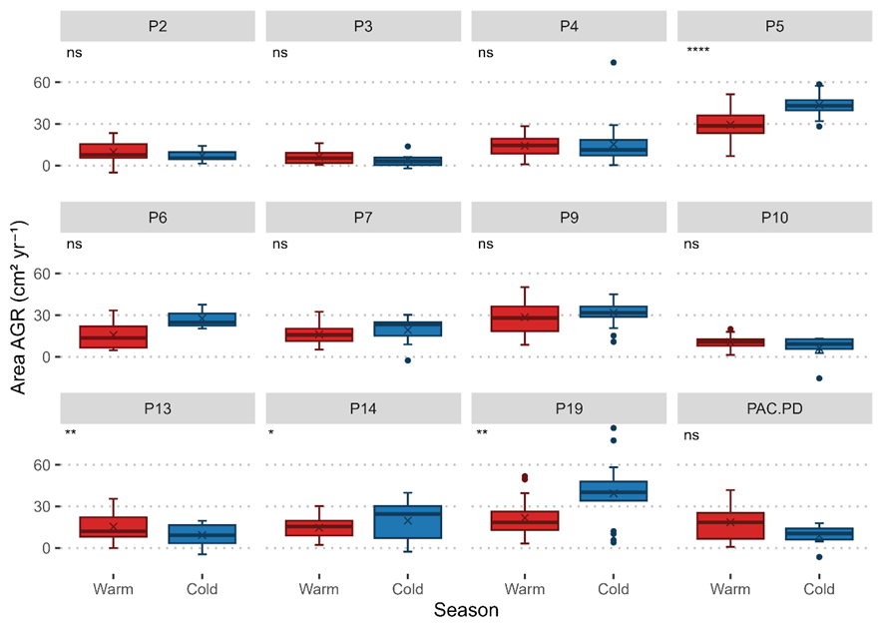
Boxplots illustrate differences in absolute growth rates (AGR) based on coral planar area. See the main text for details on this growth rate. Statistical comparisons were conducted using paired t-tests, with significance levels indicated as follows: p > 0.05 = ns, p < 0.05 = *, p <0.01 = **, p < 0.001 = ***, p < 0.0001 = ****.
APPENDIX 5
Comparison of relative growth rates between warm and cold seasons for each Pocillopora coral morphotype cultivated in the pilot nursery. The warm season ran from January to May 2022, and the cold season from June to December 2022.
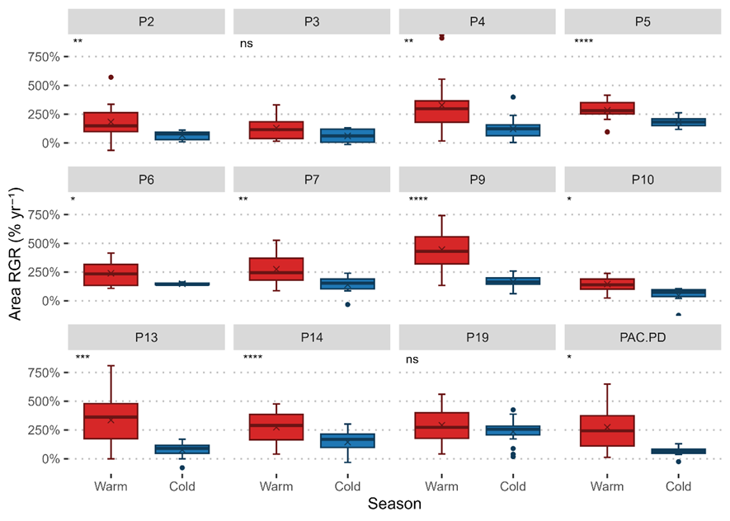
Boxplots illustrate differences in relative growth rates (RGR) based on coral planar area. See text the main text for details on this growth rate. Statistical comparisons were performed using paired t-tests, with significance levels indicated as follows: p > 0.05 = ns, p < 0.05 = *, p <0.01 = **, p < 0.001 = ***, p < 0.0001 = ****.
APPENDIX 6
Comparison of specific growth rates between warm and cold seasons for each Pocillopora morphotype coral cultivated in the pilot nursery. The warm season ran from January to May 2022, and the cold season from June to December 2022.
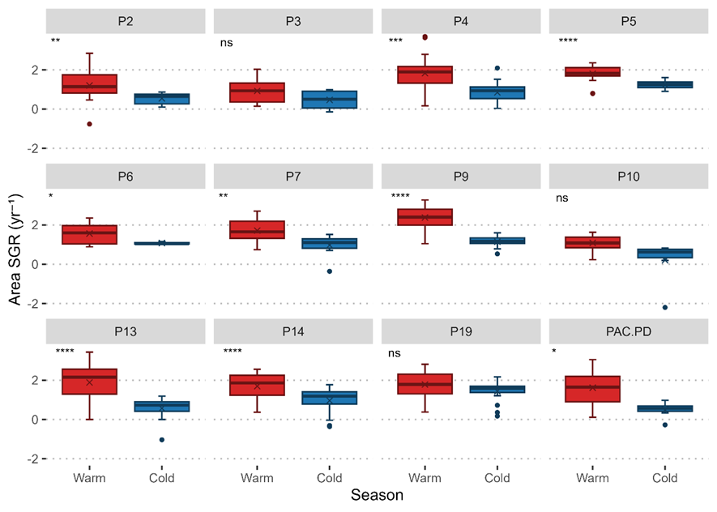
Boxplots illustrate differences in specific growth rates (SGR) based on coral planar area. See the main text for details on this growth rate. Statistical comparisons were performed using paired t-tests, with significance levels indicated as follows: p > 0.05 = ns, p < 0.05 = *, p <0.01 = **, p < 0.001 = ***, p < 0.0001 = ****.
APPENDIX 7
Comparison of absolute, relative and specific coral growth rates based on maximum length (ML) between warm and cold seasons for all Pocillopora corals cultivated in the pilot nursery. The warm season ran from January to May 2022, and the cold season from June to December 2022.
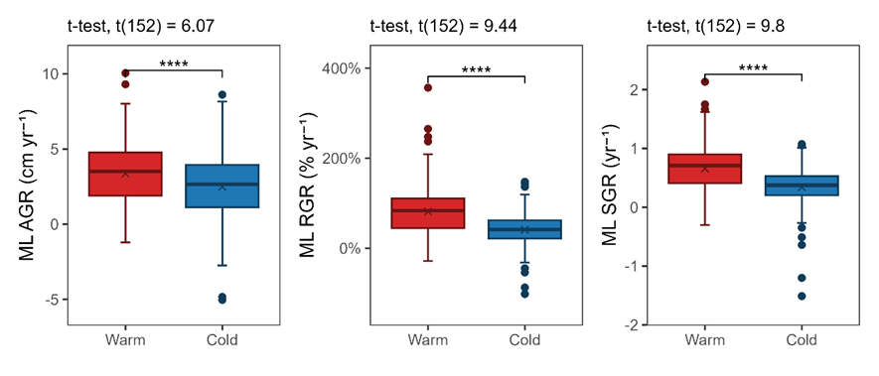
Boxplots illustrate differences in absolute growth rate (AGR), relative growth rate (RGR), and specific growth rate (SGR) based on coral maximum length (ML). See text for detailed descriptions on these rates. Statistical comparisons were conducted using paired t-tests, with significance levels indicated as follows: p < 0.05 = *, p < 0.0001 = ****.
APPENDIX 8
Cohen’s d effect sizes for differences in coral growth rates between warm and cold seasons in Pocillopora morphotypes cultivated in the pilot nursery. The warm season ran from January to May 2022, and the cold season from June to December 2022.
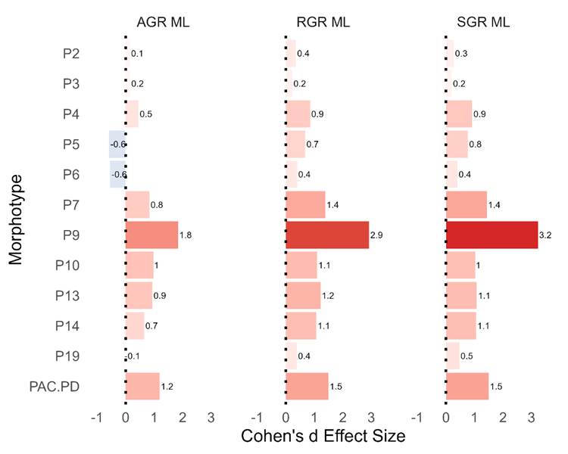
Positive (red) values indicate higher growth rates during the warm season, whereas negative (blue) values indicate higher growth during the cold season. Effect sizes are shown for absolute growth rate (AGR), relative growth rate (RGR), and specific growth rate (SGR) based on coral maximum length (ML). See text for detailed descriptions on these rates. According to standard thresholds, d ≈ 0.2 indicates a small effect, 0.5 a moderate effect, and ≥ 0.8 a strong effect.

