Supplementary Material 1
The survey conducted online to obtain a baseline of information about the recreational tarpon fishery.

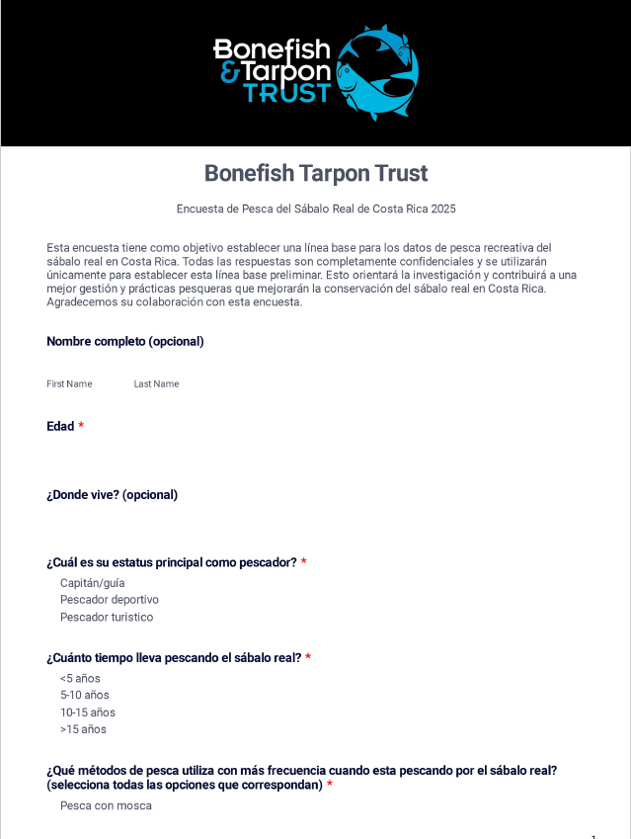

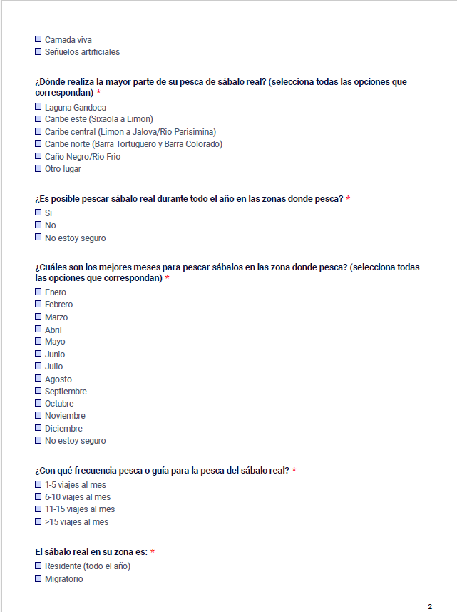

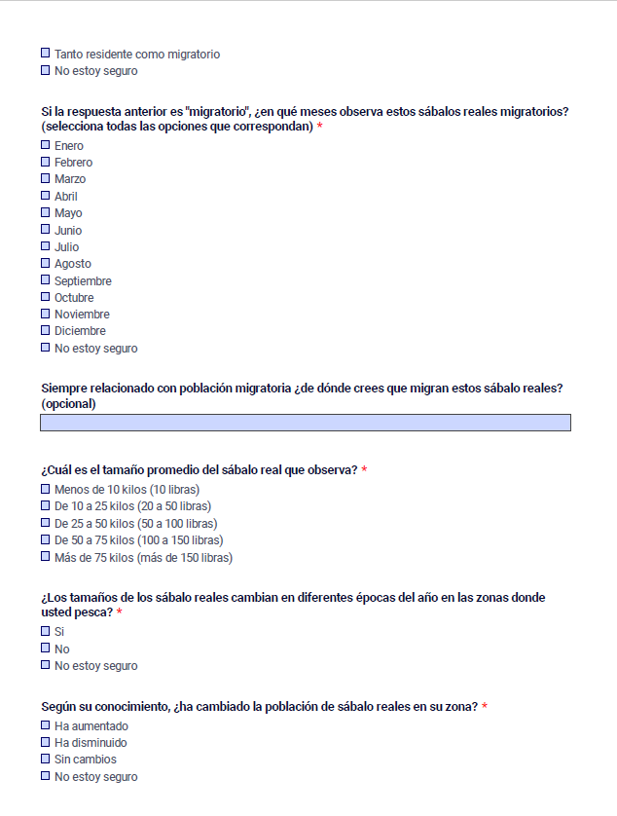
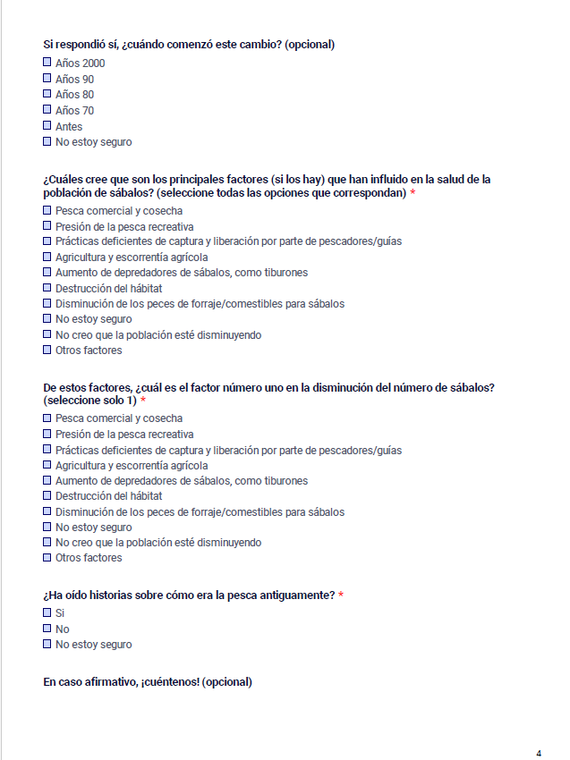

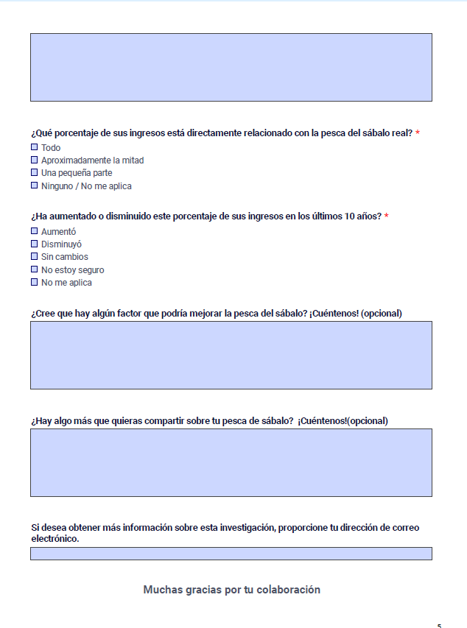

Supplementary Material 2

Below is an outline of a stepwise approach to addressing research and conservation needs for tarpon in Costa Rica.
- Establish a baseline of knowledge
  - Tarpon biology (identifies and prioritizes habitats, areas, and seasons for protection, the need for international/regional collaboration)
    - Adult movements, spawning places and seasons, diet
    - Larval transport
    - Juvenile locations
    - Ontogenetic habitat shifts
    - Population connectivity assessment - regional and Costa Rica genetics
  - Tarpon fisheries (historic trend, current status, needs)
    - Conduct a Best Catch Assessment (BECAA) (Sáenz–Arroyo et al. 2005; Jones et al. In Review) to establish recreational fishery trends over time
      - This should be a recurring survey
    - Estimate Fishery Capacity (Palomo & Perez 2025)
    - Catch and Release
      - Estimate mortality rates
      - Assess fish handling practices
      - Formulate and distribute handling practices education
    - Assess other fisheries
      - Spatial, seasonality, history, harvest,
    - Economic assessments
      - Recreational fishery
      - Other fisheries
  - Threat assessment
    - Fishery related
      - Post-release mortality
      - Harvest by other fisheries
      - Population connectivity (are Costa Rica fish harvested in other countries?)
    - Habitat
      - Especially juvenile and subadult, since in other regions those are most under threat
      - Watershed development (agriculture, residential commercial)
        - Land use maps, changes over time, priority areas
    - Water quality
      - Point and non-point pollution sources
        - Agricultural, commercial, residential

Research Area | Main Objectives | Specific Actions
1. Biology and Ecology | Identify critical habitats, seasonality, and connectivity of the species. | - Track adult movements, spawning, diet, and larval transport. - Identify juvenile habitats and ontogenetic shifts. - Assess regional and local genetic structure.
2. Fisheries Assessment | Determine the status, capacity, and economic value of the fishery. | - Implement recurring BECAA surveys to assess historical trends. - Evaluate mortality rates and catch-and-release practices. - Conduct economic valuation of the recreational fishery and related sectors.
3. Threat Mitigation | Quantify and mitigate anthropogenic impacts on the population and its habitat. | - Evaluate impacts of transboundary harvest and other fisheries. - Analyze habitat loss due to development (e.g., land-use mapping). - Monitor sources of water pollution (agricultural and urban).

- Develop a Conservation Priority Schedule
This schedule must integrate ecological research, fisheries assessments, and socioeconomic considerations, ensuring alignment with Costa Rica’s National Fisheries and Aquaculture Development Plan (PNDPA) and the National Tourism Plan 2022–2027. This is especially important since sportfishing and tourism fishing are not adequately addressed.
  - Combine scientific needs, fishery status, threats to create a priority list
    - Short term
      - Develop and disseminate national best-practice guidelines for tarpon catch-and-release, embedded in fisheries management training (INCOPESCA) and sustainable tourism certifications (e.g., CST, Blue Flag).
      - Integrate tarpon explicitly into the PNDPA research agenda as a priority species of ecological and economic value.
      - Position tarpon fishing within the tourism development strategy, highlighting it as a flagship product of sustainable marine tourism.
      - Introduction of conservation programs for sportfishing species, including tarpon, that reduce/mitigate mortalities from bycatch in commercial fishing operations.
    - Long term
      - Secure formal recognition of tarpon as a priority species within fisheries management frameworks (PNDPA) and incorporate protective measures into marine spatial planning and marine protected area (MPA) zoning
      - Establish regional cooperation agreements with Nicaragua, Panama, and Caribbean nations for joint research and management, consistent with PNDPA’s international management pillar.
      - Promote tarpon as a world-class ecotourism product, ensuring that coastal communities benefit economically while the species is safeguarded.
      - Link tarpon nursery habitat conservation, RAMSAR´s sites to blue carbon initiatives and Payment for Environmental Services (PES) schemes, aligning with Costa Rica’s climate and biodiversity commitments.
  - Iterative process
    - Evaluated every five years, adjusted as new information is gained, threats are addressed, new threats arise
Timeframe | Strategic Objective | Priority Actions
Short-term | Integrate tarpon into national fisheries and tourism frameworks while reducing immediate threats. | - Develop and disseminate national best-practice guidelines for tarpon catch-and-release, integrated into fisheries management training (INCOPESCA) and sustainable tourism certifications (e.g., CST, Blue Flag).  - Incorporate tarpon explicitly into the National Fisheries and Aquaculture Development Plan (PNDPA) as a priority species of ecological and economic importance.  - Position tarpon fishing within national tourism strategies as a flagship product of sustainable marine tourism.  - Implement conservation programs for sportfishing species (including tarpon) to reduce mortality from bycatch in commercial fisheries.
Long-term | Establish formal protection, regional coordination, and sustainable economic integration of tarpon fisheries. | - Secure formal recognition of tarpon as a priority species within fisheries management frameworks (PNDPA) and incorporate protective measures into marine spatial planning and marine protected area (MPA) zoning.  - Establish regional cooperation agreements with Nicaragua, Panama, and Caribbean nations for joint research and management, aligned with PNDPA’s international management objectives.  - Promote tarpon as a world-class ecotourism resource, ensuring economic benefits for coastal communities while maintaining conservation goals.  - Link conservation of tarpon nursery habitats (e.g., RAMSAR sites) to blue carbon initiatives and Payment for Environmental Services (PES) schemes, aligning with national climate and biodiversity commitments.
Adaptive management | Ensure long-term effectiveness through continuous evaluation and adjustment. | - Evaluate and update conservation priorities every five years. - Adjust strategies based on new scientific information, emerging threats, and management outcomes.

