SUPPLEMENTARY MATERIALS
Variable | KW χ² | df | KW p | ε²
Years targeting billfish | 6.703 | 2 | 0.035 | 0.081
% trips targeting billfish | 23.741 | 2 | <0.001 | 0.410
Number of months fishing annually | 7.530 | 2 | 0.023 | 0.094
Table S1. Demographics: Kruskal-Wallis results to compare across regions.

Variable | Region A | Region B | Dunn Z | Dunn p (raw) | Dunn p (adj)
Years targeting billfish | Central | Northern | 2.550 | 0.011 | 0.032
Years targeting billfish | Central | Southern | 1.152 | 0.249 | 0.747
Years targeting billfish | Northern | Southern | -1.209 | 0.227 | 0.680
% trips targeting billfish | Central | Northern | 4.501 | <0.001 | <0.001
% trips targeting billfish | Central | Southern | 2.875 | 0.004 | 0.012
% trips targeting billfish | Northern | Southern | -0.676 | 0.499 | 1.000
Number of months fishing annually | Central | Northern | -0.595 | 0.552 | 1.000
Number of months fishing annually | Central | Southern | 2.389 | 0.017 | 0.051
Number of months fishing annually | Northern | Southern | 2.507 | 0.012 | 0.037
Table S2. Demographics: Dunn pairwise comparisons.

Variable | Test used | p value | Cramér's V
Charter or Private | Fisher (MC) | 0.226 | 0.210
Overnight | Fisher (MC) | 0.003 | 0.417
Table S3. Demographics: Fisher test across regions (categorical variables).

Region A | Region B | p (raw) | Pairwise p (adj) | propA | propB | diff
Northern | Central | 0.001 | 0.003 | 0.071 | 0.588 | -0.517
Northern | Southern | 0.077 | 0.230 | 0.071 | 0.429 | -0.358
Central | Southern | 0.355 | 1.000 | 0.588 | 0.429 | 0.159
Table S4. Demographics: Pairwise region proportion tests for overnight variable (categorical binary variable).

Variable | Region | n | Mean | SD | Median
MRT_Distance | Northern | 13 | 13.385 | 9.927 | 12.000
MRT_Distance | Central | 34 | 49.353 | 35.052 | 35.000
MRT_Distance | Southern | 11 | 30.364 | 15.100 | 30.000
MRT_TotalTime | Northern | 13 | 6.865 | 2.717 | 6.500
MRT_TotalTime | Central | 34 | 7.380 | 2.172 | 6.875
MRT_TotalTime | Southern | 12 | 6.604 | 2.411 | 5.750
Table S5. Most-recent trips (distance and time): Summary statistics by region.

Variable | KW χ² | df | KW p | ε²
MRT_Distance | 19.693 | 2 | <0.001 | 0.322
MRT_TotalTime | 2.285 | 2 | 0.319 | 0.005
Table S6. Most-recent trip (distance and time): Kruskal-Wallis results to compare across regions.

Variable | Region A | Region B | Dunn Z | Dunn p (raw) | Dunn p (adj)
MRT_Distance | Central | Northern | 4.437 | <0.001 | <0.001
MRT_Distance | Central | Southern | 1.221 | 0.222 | 0.666
MRT_Distance | Northern | Southern | -2.498 | 0.012 | 0.037
Table S7. Most-recent trip (distance): Dunn pairwise comparisons.

Species | Region | n | Mean | SD | Median
Sailfish | Northern | 13 | 1.654 | 1.345 | 1
Sailfish | Central | 34 | 2.118 | 2.508 | 2
Sailfish | Southern | 13 | 0.538 | 0.967 | 0
Blue marlin | Northern | 13 | 0.615 | 1.121 | 0
Blue marlin | Central | 34 | 2.333 | 3.553 | 1
Blue marlin | Southern | 13 | 1.462 | 1.808 | 1
Black marlin | Northern | 13 | 0.000 | 0.000 | 0
Black marlin | Central | 34 | 0.029 | 0.171 | 0
Black marlin | Southern | 13 | 0.000 | 0.000 | 0
Striped marlin | Northern | 13 | 0.000 | 0.000 | 0
Striped marlin | Central | 34 | 0.029 | 0.171 | 0
Striped marlin | Southern | 13 | 0.000 | 0.000 | 0
Mahi-mahi | Northern | 13 | 0.538 | 0.967 | 0
Mahi-mahi | Central | 34 | 0.882 | 2.027 | 0
Mahi-mahi | Southern | 13 | 0.462 | 1.198 | 0
Yellowfin tuna | Northern | 13 | 1.000 | 1.528 | 0
Yellowfin tuna | Central | 34 | 0.515 | 1.384 | 0
Yellowfin tuna | Southern | 13 | 2.154 | 4.598 | 0
Wahoo | Northern | 13 | 0.000 | 0.000 | 0
Wahoo | Central | 34 | 0.039 | 0.179 | 0
Wahoo | Southern | 13 | 0.000 | 0.000 | 0
Rooster | Northern | 13 | 0.308 | 0.751 | 0
Rooster | Central | 34 | 0.059 | 0.343 | 0
Rooster | Southern | 13 | 0.000 | 0.000 | 0
Snook | Northern | 13 | 0.308 | 1.109 | 0
Snook | Central | 34 | 0.000 | 0.000 | 0
Snook | Southern | 13 | 0.000 | 0.000 | 0
Table S8. Most-recent trip (catch): Summary statistics.

Species | KW χ² | df | KW p | ε²
Sailfish | 7.067 | 2 | 0.029 | 0.089
Blue marlin | 3.474 | 2 | 0.176 | 0.026
Black marlin | 0.765 | 2 | 0.682 | 0.000
Striped marlin | 0.765 | 2 | 0.682 | 0.000
Mahi-mahi | 0.650 | 2 | 0.722 | 0.000
Yellowfin tuna | 2.543 | 2 | 0.280 | 0.010
Wahoo | 1.555 | 2 | 0.459 | 0.000
Rooster | 3.873 | 2 | 0.144 | 0.033
Snook | 3.615 | 2 | 0.164 | 0.028
Table S9. Most-recent trip (catch): Kruskal-Wallis results to compare across regions.

Species | Region A | Region B | Dunn Z | Dunn p (raw) | Dunn p (adj)
Sailfish | Central | Northern | 0.020 | 0.984 | 1.000
Sailfish | Central | Southern | 2.560 | 0.010 | 0.031
Sailfish | Northern | Southern | 2.112 | 0.035 | 0.104
Table S10. Most-recent trip (catch): Dunn pairwise comparisons for sailfish.

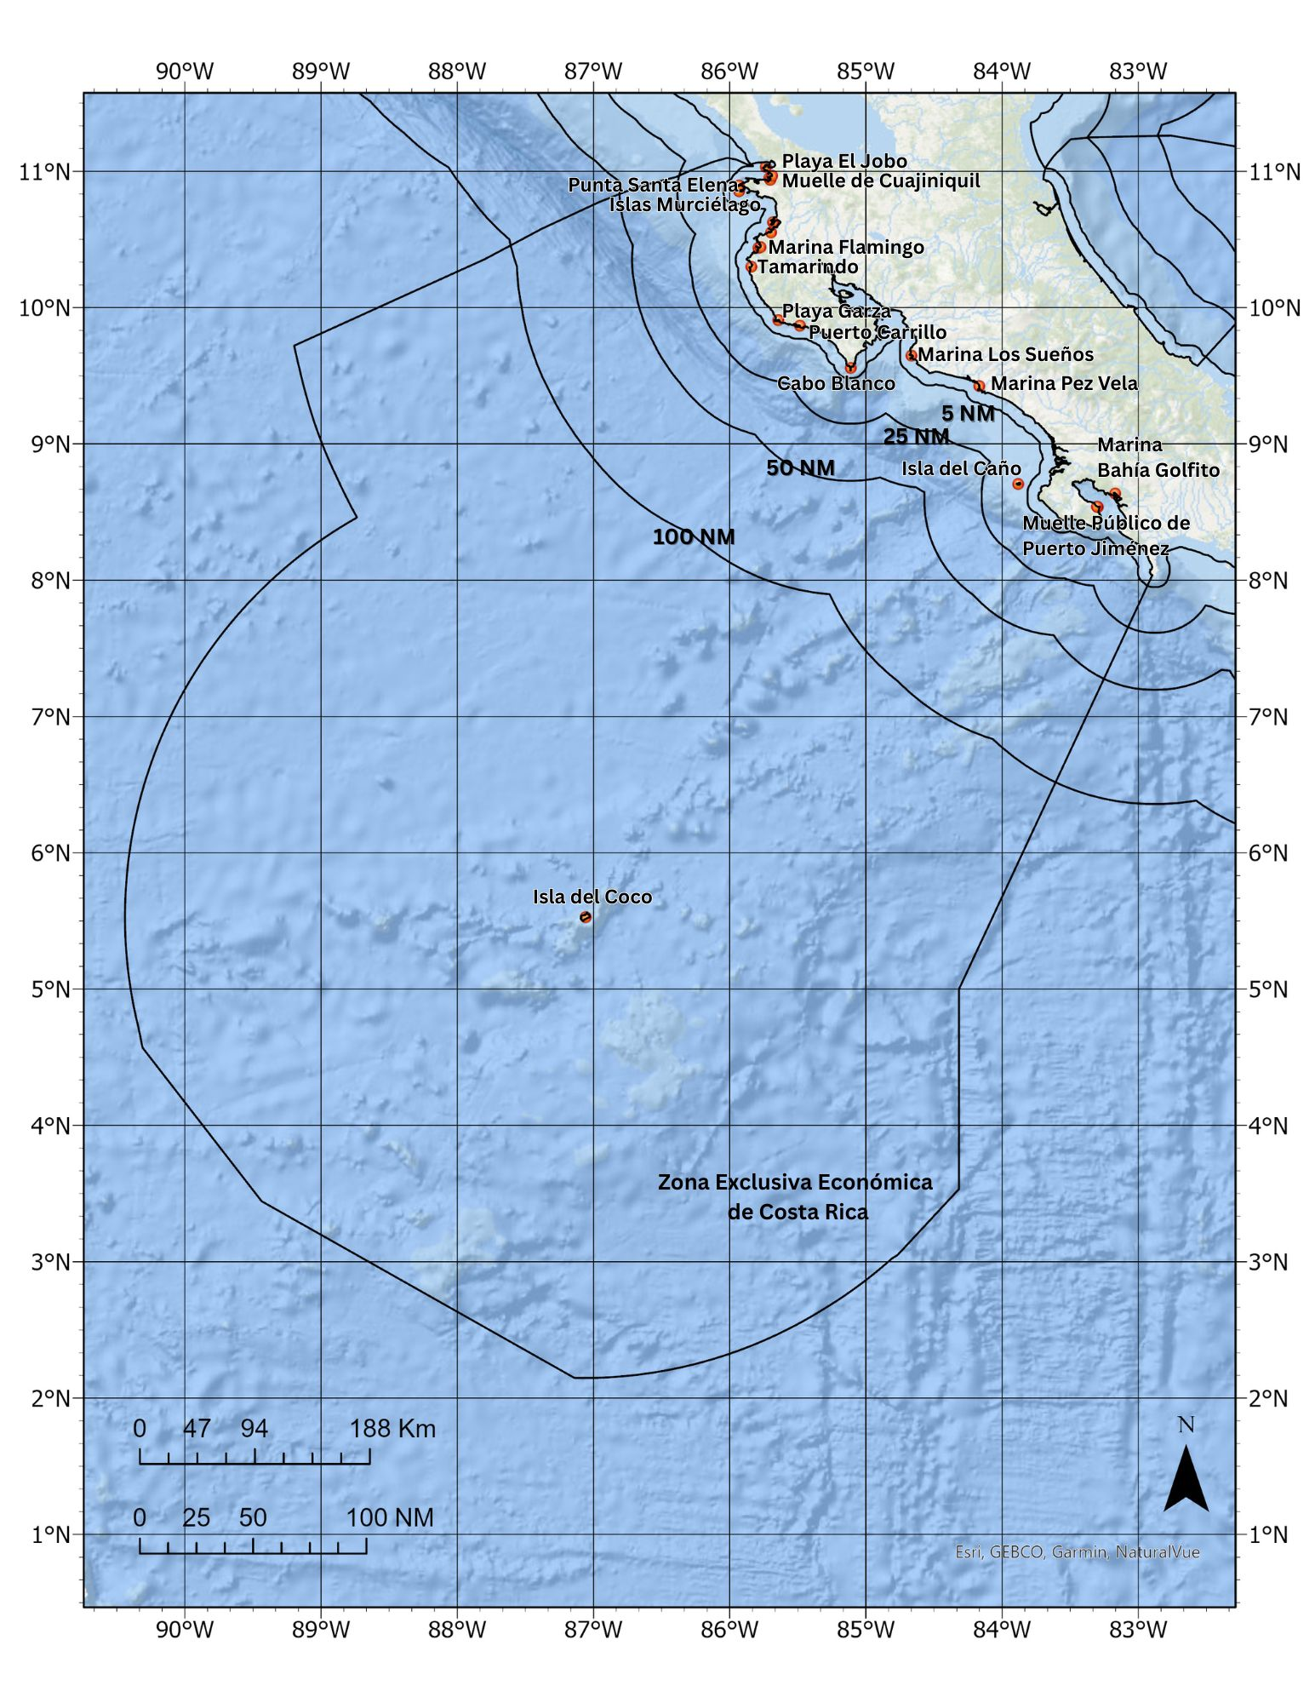
Fig S1. Static reference image of the map used in ArcGIS Field Maps for participatory mapping interviews. During interviews, participants interacted with a digital map that allowed zooming and dynamically displayed labels based on zoom level. The static image presented here is included for reference and does not capture all interactive features of the interview map. The map shows longitude and latitude graticules (degree scale), major ports, coastal towns, and islands, the Costa Rica exclusive economic zone (EEZ), and distance bands of 5, 25, 50, and 100 nautical miles from the coastline. Bathymetric context is provided by the ArcGIS Oceans Basemap.

