SUPPLEMENTARY MATERIAL
TABLE S1.Table S1. Results of the General Linear Model two-way ANOVA of coral growth parameters of Pocillopora fragments in IMNP and Cuastecomate.
Source of Variation | DF | MS | F | P
Height
Location | 1 | 10709.241 | 16.977 | <0.001
Colony(Location) | 108 | 630.812
Time | 4 | 27231.508 | 117.424 | <0.001
Location x Time | 4 | 1208.498 | 5.211 | <0.001
Residual | 432 | 231.908
Length
Location | 1 | 69691.289 | 28.383 | <0.001
Colony(Location) | 108 | 2455.423
Time | 4 | 63241.974 | 130.699 | <0.001
Location x Time | 4 | 9604.608 | 19.849 | <0.001
Residual | 432 | 483.875
Width
Location | 1 | 7.913 | 126.367 | <0.001
Colony(Location) | 108 | 6712.575
Time | 4 | 20.218 | 80.718 | <0.001
Location x Time | 4 | 5.831 | 23.278 | <0.001
Residual | 432 | 33.815
Ecological Volume
Location | 1 | 70211.719 | 50.630 | <0.001
Colony(Location) | 108 | 1386,750
Time | 4 | 80026.152 | 261.880 | <0.001
Location x Time | 4 | 18487.917 | 60.500 | <0.001
Residual | 432 | 305.584

TABLE S2. All pairwise multiple comparison procedures (Holm-Sidak method)
Comparison for factor time (Height) | Diff of Means | t | Unadjusted P
335 vs. 56 | 0.763 | 22.001 | <0.001
335 vs. 260 | 0.573 | 16.519 | <0.001
335 vs. 119 | 0.565 | 16.294 | <0.001
335 vs. 196 | 0.519 | 14.955 | <0.001
196 vs. 56 | 0.244 | 7.046 | <0.001
119 vs. 56 | 0.198 | 5.708 | <0.001
260 vs. 56 | 0.19 | 5.483 | <0.001
196 vs. 260 | 0.0542 | 1.563 | 0.119
196 vs. 119 | 0.0464 | 1.338 | 0.182
119 vs. 260 | 0.0078 | 0.225 | 0.822
Comparisons for factor: Time within Cuastecomate
335 vs. 56 | 1.032 | 21.232 | <0.001
335 vs. 260 | 0.7 | 14.397 | <0.001
335 vs. 196 | 0.679 | 13.956 | <0.001
335 vs. 119 | 0.671 | 13.809 | <0.001
119 vs. 56 | 0.361 | 7.423 | <0.001
196 vs. 56 | 0.354 | 7.276 | <0.001
260 vs. 56 | 0.332 | 6.835 | <0.001
119 vs. 260 | 0.0286 | 0.588 | 0.557
196 vs. 260 | 0.0214 | 0.441 | 0.66
119 vs. 196 | 0.00714 | 0.147 | 0.883
Comparisons for factor: Time within Islas Marietas
335 vs.56 | 0.494 | 9.986 | <0.001
335 vs. 119 | 0.459 | 9.275 | <0.001
335 vs. 260 | 0.446 | 9.014 | <0.001
335 vs. 196 | 0.359 | 7.256 | <0.001
196 vs. 56 | 0.135 | 2.73 | 0.007
196vs. 119 | 0.1 | 2.02 | 0.044
196 vs. 260 | 0.087 | 1.758 | 0.079
260 vs. 56 | 0.0481 | 0.972 | 0.331
119 vs. 56 | 0.0352 | 0.711 | 0.478
260 vs. 119 | 0.013 | 0.262 | 0.794
Comparison for factor time (Length)
335 vs. 56 | 0.622 | 17.24 | <0.001
335 vs. 119 | 0.515 | 14.273 | <0.001
335 vs. 260 | 0.5 | 13.844 | <0.001
335 vs. 196 | 0.483 | 13.392 | <0.001
196 vs. 56 | 0.139 | 3.848 | <0.001
260 vs. 56 | 0.123 | 3.396 | <0.001
119 vs. 56 | 0.107 | 2.967 | 0.003
196 vs. 119 | 0.0318 | 0.881 | 0.379
196 vs. 260 | 0.0163 | 0.452 | 0.652
260 vs. 119 | 0.0155 | 0.428 | 0.668
Comparisons for factor: Time within Cuastecomate
335 vs. 56 | 0.905 | 17.904 | <0.001
335 vs. 196 | 0.654 | 12.925 | <0.001
335 vs. 119 | 0.638 | 12.607 | <0.001
335 vs. 260 | 0.573 | 11.336 | <0.001
4.000 vs. 56 | 0.332 | 6.568 | <0.001
119 vs. 56 | 0.268 | 5.297 | <0.001
196 vs. 56 | 0.252 | 4.979 | <0.001
260 vs. 196 | 0.0804 | 1.589 | 0.113
260 vs. 119 | 0.0643 | 1.271 | 0.204
119 vs. 196 | 0.0161 | 0.310 | 0.751
Comparisons for factor: Time within Islas Marietas
335 vs. 260 | 0.426 | 8.271 | <0.001
335 vs. 119 | 0.393 | 7.624 | <0.001
335 vs. 56 | 0.339 | 6.581 | <0.001
335 vs. 196 | 0.313 | 6.078 | <0.001
196 vs. 260 | 0.113 | 2.194 | 0.029
56 vs. 260 | 0.087 | 1.69 | 0.092
196 vs. 119 | 0.0796 | 1.546 | 0.123
56 vs. 119 | 0.0537 | 1.043 | 0.298
119 vs. 260 | 0.0333 | 0.647 | 0.518
196 vs. 56 | 0.259 | 0.503 | 0.615
Comparison for factor time (Width)
335 vs. 56 | 0.578 | 17.313 | <0.001
335 vs. 119 | 0.423 | 12.669 | <0.001
335 vs. 260 | 0.412 | 12.329 | <0.001
335 vs. 196 | 0.369 | 11.041 | <0.001
196 vs. 56 | 0.209 | 6..272 | <0.001
260 vs. 56 | 0.166 | 4.985 | <0.001
119 vs. 56 | 0.155 | 4.644 | <0.001
196 vs. 119 | 0.0544 | 1.628 | 0.104
196 vs. 260 | 0.043 | 1.287 | 0.199
260 vs. 119 | 0.0114 | 0.341 | 0.734
Comparisons for factor: Time within Cuastecomate
335 vs. 56 | 0.879 | 18.775 | <0.001
335 vs. 119 | 0.554 | 11.83 | <0.001
335 vs. 196 | 0.539 | 11.524 | <0.001
335 vs. 260 | 0.468 | 9.998 | <0.001
260 vs. 56 | 0.411 | 8.777 | <0.001
196 vs. 56 | 0.339 | 7.25 | <0.001
119 vs. 56 | 0.325 | 6.945 | <0.001
260 vs. 119 | 0.0857 | 1.832 | 0.068
260 vs. 196 | 0.0714 | 1.526 | 0.128
196vs. 119 | 0.0143 | 0.305 | 0.76
Comparisons for factor: Time within Islas Marietas
335 vs. 260 | 0.356 | 7.461 | <0.001
335 vs. 119 | 0.293 | 6.14 | <0.001
335 vs. 56 | 0.278 | 5.829 | <0.001
335 vs. 196 | 0.198 | 4.158 | <0.001
196 vs. 260 | 0.157 | 3.303 | 0.001
196 vs. 119 | 0.0944 | 1.982 | 0.048
196 vs. 56 | 0.0796 | 1.671 | 0.095
56 vs. 260 | 0.0778 | 1.632 | 0.103
119 vs. 260 | 0.063 | 1.321 | 0.187
56 vs. 119 | 0.0148 | 0.311 | 0.756
Comparison for factor time (EV)
335 vs. 56 | 66.778 | 28.841 | <0.001
335 vs. 119 | 59.652 | 25.763 | <0.001
335 vs. 196 | 53.998 | 23.321 | <0.001
335 vs. 260 | 49.145 | 21.225 | <0.001
260 vs. 56 | 17.633 | 7.616 | <0.001
196 vs. 56 | 12.780 | 5.520 | <0.001
260 vs. 119 | 10.507 | 4.538 | <0.001
119 vs. 56 | 7.126 | 3.078 | n.s
196 vs. 119 | 5.654 | 2.442 | n.s
260 vs. 196 | 4.853 | 2.096 | n.s
Comparisons for factor: Time within Cuastecomate
335 vs. 56 | 99.701 | 39.448 | <0.001
335 vs. 119 | 85.791 | 26.200 | <0.001
335 vs. 196 | 80.970 | 24.728 | <0.001
335 vs. 260 | 68.282 | 20.853 | <0.001
260 vs. 56 | 31.419 | 9.595 | <0.001
196 vs. 56 | 18.731 | 5.720 | <0.001
260 vs. 119 | 17.509 | 5.347 | <0.001
119 vs. 56 | 13.910 | 4.248 | <0.001
260 vs. 196 | 12.688 | 3.875 | <0.001
196 vs. 119 | 4.821 | 1.472 | n.s
Comparisons for factor: Time within Islas Marietas
335 vs. 56 | 33.855 | 10.339 | <0.001
335 vs. 119 | 33.513 | 10.235 | <0.001
335 vs. 260 | 30.008 | 9.164 | <0.001
335 vs. 196 | 27.026 | 8.254 | <0.001
196 vs. 56 | 6.829 | 2.085 | n.s
196 vs. 119 | 6.486 | 1.981 | n.s
260 vs. 56 | 3.847 | 1.175 | n.s
260 vs. 119 | 3.505 | 1.070 | n.s
196 vs. 260 | 2.982 | 911 | n.s
119 vs. 56 | 342 | 105 | n.s

SUPPLEMENTARY MATERIAL- FIGURES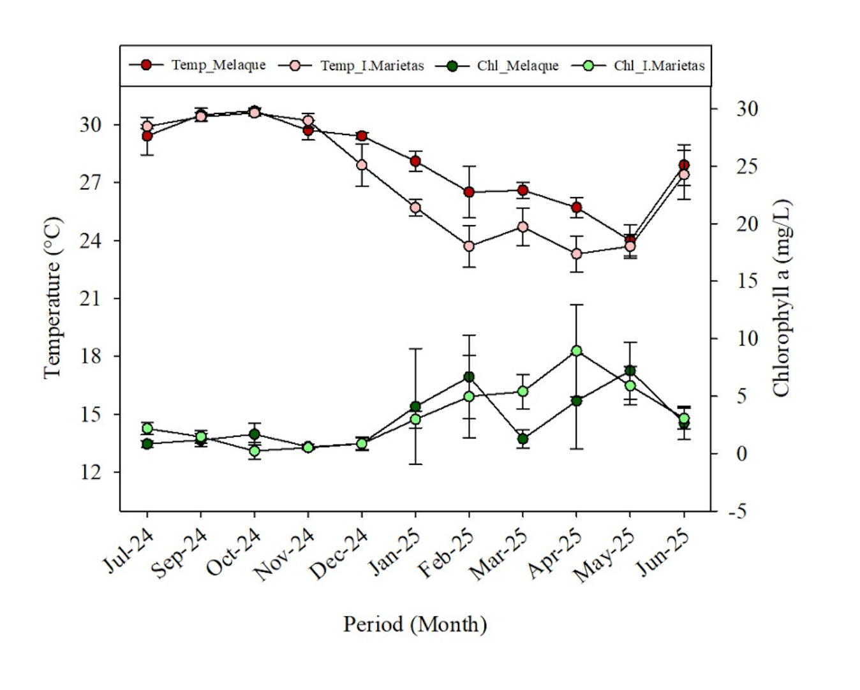
Fig. S1. Mean monthly values of chlorophyll a (mg L⁻¹ ± SD) and mean monthly SWT (°C ± standard error) recorded in Islas Marietas National Park and Cuastecomate throughout the study period. Between locations, no differences were revealed either in SWT (t-test = -0.824; P = 0.419) nor in chl-a (Mann-Whitney = 52; P = 0.599).

