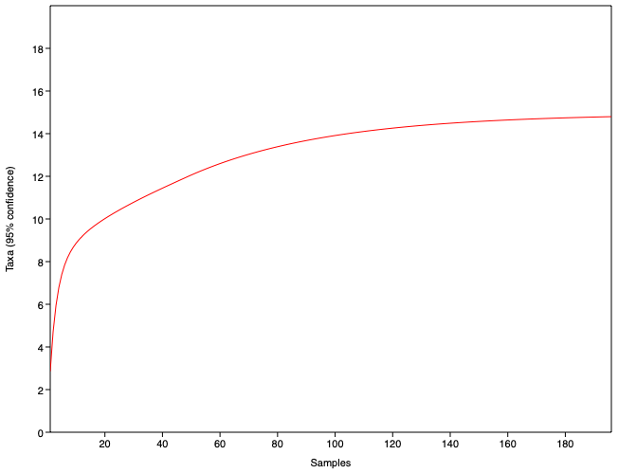
SMF 1. Food item accumulation curve for stomach contents of P. bimaculatus from San Sebastián Spring, Mexico. The red line represents the cumulative number of prey taxa detected with increasing sample size. The curve showed a rapid initial increase followed by progressive stabilization, approaching an asymptote at approximately 15 prey taxa, and indicating adequate sampling effort.

SMF 2. Costello feeding strategy diagrams of P. bimaculatus from San Sebastián Spring, Mexico, showing monthly variation in trophic strategy between A, C, E, G, I, K females and B, D, F, H, J, L males. Months: M1: February, M2: April, M3: June, M4: August, M5: October and M6: December. Labels represent prey items with more than 25 % of % FO or % PA, as follows: UI, unidentified insect parts; DET, unidentified organic matter; TI, terrestrial insect remains; AI, aquatic insects; FORM, Formicidae (ants); FRT, fish remains; CHIR, Chironomidae; EGG, unidentified eggs.

