Supplementary Material
SMT 1
Geographic coordinates associated with the 30 sampling stations characterized in the Andean-Amazonian region during the bimonthly sampling campaigns from October 2021 to April 2022
Region | Station | Altitude | XCoord | YCoord
Andean | E1 | 2 205 | -75.6796 | 1.8781
Andean | E2 | 2 202 | -75.6786 | 1.8773
Andean | E3 | 2 070 | -75.6700 | 1.8690
Andean | E4 | 1 540 | -75.6618 | 1.8404
Andean | E5 | 1 000 | -75.6470 | 1.7951
Andean | E6 | 957 | -75.6394 | 1.7708
Andean | E7 | 2 168 | -75.7663 | 1.7627
Andean | E8 | 2 041 | -75.7496 | 1.7562
Andean | E9 | 1 697 | -75.7231 | 1.7359
Andean | E10 | 581 | -75.6456 | 1.7294
Transition | E11 | 396 | -75.6723 | 1.6236
Transition | E12 | 492 | -75.9832 | 1.2977
Transition | E13 | 321 | -75.9538 | 1.3350
Transition | E14 | 300 | -75.9181 | 1.3622
Transition | E15 | 308 | -75.8866 | 1.4083
Transition | E16 | 285 | -75.2284 | 1.7665
Transition | E17 | 285 | -75.2361 | 1.7539
Transition | E18 | 378 | -75.3017 | 1.6362
Transition | E19 | 293 | -75.3363 | 1.5427
Transition | E20 | 276 | -75.3426 | 1.5205
Amazonian | E21 | 247 | -75.3594 | 1.4283
Amazonian | E22 | 252 | -75.3582 | 1.4253
Amazonian | E23 | 231 | -75.3448 | 1.3754
Amazonian | E24 | 237 | -75.3853 | 1.3572
Amazonian | E25 | 245 | -75.4162 | 1.3358
Amazonian | E26 | 243 | -75.4346 | 1.2999
Amazonian | E27 | 233 | -75.4300 | 1.3052
Amazonian | E28 | 235 | -75.4356 | 1.2954
Amazonian | E29 | 266 | -75.4396 | 1.2821
Amazonian | E30 | 234 | -75.4295 | 1.2973

SMT 2
Recorded of average values of the different riverscape components associated with the 30 sampling stations characterized in the Andean-Amazonian region during the bimonthly field campaigns from October 2021 to April 2022
Station | Altitude | Ve. | DO | pH | Co. | TDS | Te. | Wi. | Dep. | C.V | Tre. | Shr. | Pas. | Her. | Boul. | Cobb. | Grav. | Sand. | O.Veg.
E1 | 2 205 | 0.22 | 7.5 | 7.363 | 28.85 | 14.4 | 14.4 | 2.6 | 0.05 | 0.95 | 0.7 | 0.3 | 0 | 0 | 0.7 | 0.1 | 0.05 | 0.1 | 0.05
E2 | 2 202 | 0.31 | 7.65 | 7.423 | 18.2 | 13.5 | 13.5 | 1.08 | 0.1 | 1 | 0.7 | 0.3 | 0 | 0 | 0.75 | 0.1 | 0.05 | 0.05 | 0.05
E3 | 2 070 | 0.29 | 7.775 | 7.393 | 14.875 | 13.875 | 13.875 | 8 | 0.2 | 0.9 | 0.2 | 0.4 | 0 | 0.4 | 0.65 | 0.1 | 0.1 | 0.1 | 0.05
E4 | 1 540 | 0.44 | 7.2 | 7.363 | 15.975 | 16.75 | 16.75 | 12 | 0.26 | 0.9 | 0.4 | 0.6 | 0.1 | 0.1 | 0.7 | 0.1 | 0.1 | 0.1 | 0
E5 | 1 000 | 0.41 | 7.075 | 7.273 | 20.475 | 19.7 | 19.7 | 15 | 0.26 | 0.6 | 0.4 | 0.2 | 0.2 | 0.2 | 0.6 | 0.2 | 0.1 | 0.1 | 0
E6 | 957 | 0.24 | 6.45 | 7.295 | 24.975 | 20.7 | 20.7 | 5.8 | 0.28 | 0.6 | 0.4 | 0.2 | 0.3 | 0.1 | 0.55 | 0.1 | 0.1 | 0.2 | 0.05
E7 | 2 168 | 0.36 | 7.08 | 8.998 | 12.475 | 13.225 | 13.225 | 2.5 | 0.07 | 0.9 | 0.6 | 0.3 | 0 | 0.1 | 0.2 | 0.35 | 0.2 | 0.2 | 0.05
E8 | 2 041 | 0.19 | 7.863 | 8.638 | 11.125 | 14.45 | 14.45 | 4 | 0.22 | 0.6 | 0.4 | 0.6 | 0 | 0 | 0.5 | 0.25 | 0.1 | 0.1 | 0.05
E9 | 1 697 | 0.23 | 7.693 | 7.325 | 23.975 | 17 | 17 | 1.2 | 0.04 | 0.7 | 0.2 | 0.6 | 0 | 0.2 | 0.1 | 0.55 | 0.2 | 0.1 | 0.05
E10 | 581 | 0.32 | 6.885 | 7.98 | 30.475 | 23.3 | 23.3 | 24 | 0.37 | 0.8 | 0.7 | 0.1 | 0.1 | 0.1 | 0.3 | 0.4 | 0.05 | 0.2 | 0.05
E11 | 396 | 0.21 | 6.425 | 7.72 | 36.5 | 24.1 | 24.1 | 7 | 0.28 | 0.5 | 0.3 | 0.1 | 0.4 | 0.2 | 0.4 | 0.2 | 0.1 | 0.3 | 0
E12 | 492 | 0.53 | 6.25 | 7.378 | 39.65 | 24.2 | 24.2 | 22 | 0.3 | 0.6 | 0.4 | 0.3 | 0.1 | 0.2 | 0.2 | 0.4 | 0.1 | 0.2 | 0.05
E13 | 321 | 0.39 | 6.3 | 7.26 | 28.7 | 24.375 | 24.375 | 16 | 0.37 | 0.6 | 0.4 | 0.2 | 0.2 | 0.2 | 0.2 | 0.4 | 0.2 | 0.2 | 0
E14 | 300 | 0.85 | 6.45 | 7.135 | 29.925 | 24.325 | 24.325 | 5 | 0.23 | 0.4 | 0.2 | 0.2 | 0.6 | 0 | 0.1 | 0.6 | 0.1 | 0.2 | 0
E15 | 308 | 0.71 | 6.6 | 7.505 | 32.775 | 23.55 | 23.55 | 13.5 | 0.35 | 0.5 | 0.3 | 0.2 | 0.5 | 0 | 0.2 | 0.4 | 0.3 | 0.1 | 0
E16 | 285 | 1.11 | 5.875 | 7.615 | 33.875 | 28.75 | 28.75 | 9 | 0.29 | 0.3 | 0.1 | 0 | 0.8 | 0.1 | 0.1 | 0.4 | 0.2 | 0.3 | 0
E17 | 285 | 0.44 | 5.175 | 7.26 | 30.625 | 29.368 | 29.368 | 18 | 0.14 | 0.8 | 0.6 | 0.2 | 0.1 | 0.1 | 0 | 0.5 | 0.2 | 0.3 | 0
E18 | 378 | 0.29 | 6.05 | 7.498 | 29.025 | 25.65 | 25.65 | 9 | 0.36 | 0.3 | 0.2 | 0 | 0.8 | 0 | 0.6 | 0.2 | 0.1 | 0.1 | 0
E19 | 293 | 0.45 | 5.825 | 7.223 | 19.025 | 25.675 | 25.675 | 9.5 | 0.15 | 0.3 | 0.2 | 0 | 0.8 | 0 | 0.1 | 0.4 | 0.2 | 0.3 | 0
E20 | 276 | 0.35 | 5.875 | 7.485 | 21.2 | 25.95 | 25.95 | 4.5 | 0.18 | 0.4 | 0.1 | 0 | 0.8 | 0.1 | 0.1 | 0.5 | 0.1 | 0.3 | 0
E21 | 247 | 0.72 | 5.925 | 7.07 | 18.9 | 25.775 | 25.775 | 22 | 0.36 | 0.4 | 0.4 | 0.2 | 0.4 | 0 | 0 | 0 | 0.2 | 0.6 | 0.2
E22 | 252 | 0.08 | 4.2 | 6.235 | 15.85 | 25.8 | 25.8 | 20 | 0.77 | 0.4 | 0.1 | 0.4 | 0.4 | 0.1 | 0 | 0 | 0 | 0.3 | 0.4
E23 | 231 | 0.08 | 3.95 | 6.115 | 18.75 | 24.975 | 24.975 | 5 | 0.84 | 0.4 | 0.2 | 0.4 | 0.4 | 0 | 0 | 0 | 0 | 0 | 0.3
E24 | 237 | 0.06 | 4.5 | 6.128 | 13.975 | 25.4 | 25.4 | 4 | 0.67 | 0.3 | 0.3 | 0.4 | 0.3 | 0 | 0 | 0 | 0 | 0 | 0.3
E25 | 245 | 0.06 | 3.25 | 6.108 | 13.6 | 25.2 | 25.2 | 3 | 0.58 | 0.5 | 0.1 | 0.4 | 0.4 | 0.1 | 0 | 0 | 0 | 0 | 0.3
E26 | 243 | 0.02 | 3.3 | 5.713 | 22.15 | 26.575 | 26.575 | 3.5 | 1.3 | 0 | 0 | 0 | 0.5 | 0.5 | 0 | 0 | 0 | 0 | 0.3
E27 | 233 | 0.02 | 1.875 | 6.06 | 25.15 | 27.575 | 27.575 | 25 | 0.22 | 0 | 0 | 0 | 0.5 | 0.5 | 0 | 0 | 0 | 0 | 0.3
E28 | 235 | 0.09 | 4.685 | 5.798 | 15.75 | 27.475 | 27.475 | 2 | 0.6 | 0.4 | 0.1 | 0.2 | 0.5 | 0.2 | 0 | 0 | 0 | 0 | 0.3
E29 | 266 | 0.06 | 3.45 | 6.098 | 13.675 | 26.5 | 26.5 | 10 | 0.91 | 0.5 | 0.5 | 0.1 | 0.3 | 0.1 | 0 | 0 | 0 | 0 | 0.3
E30 | 234 | 0.003 | 0.525 | 5.743 | 31.1 | 25.775 | 25.775 | 4 | 0.13 | 0.6 | 0.3 | 0.2 | 0 | 0.5 | 0 | 0 | 0 | 0 | 0.6
Physical and chemical variables: current velocity (Ve.), dissolved oxygen (DO.), hydrogen ion potential (pH), conductivity (Co.), total dissolved solids (TDS), water temperature (Te.), width (Wi.), depth (De.), vegetation cover and type: vegetation cover (C.V), trees (Tre.), shrubs (Shr.), pastures (Pas.), herbaceous plants (Her.). Riverbed substrate composition: boulders (Boul.), cobbles (Cobb.), gravel (Grav.), sand (Sand.), vegetal origin (O.Veg.).

SMT 3
Composition of the Chironomidae family present in different ecosystems of the Andean-Amazonian region. collected during the bimonthly field campaigns from October 2021 to April 2022
Taxon | Code | E1 | E2 | E3 | E4 | E5 | E6 | E7 | E8 | E9 | E10 | E11 | E12 | E13 | E14 | E15 | E16 | E17 | E18 | E19 | E20 | E21 | E22 | E23 | E24 | E25 | E26 | E27 | E28 | E29 | E30
Chironominae
Caladomyia | Ca | 0 | 0 | 0 | 0 | 0 | 0 | 0 | 0 | 0 | 0 | 0 | 0 | 0 | 0 | 0 | 0 | 0 | 0 | 0 | 0 | 0 | 0 | 0 | 0 | 9 | 45 | 72 | 0 | 0 | 0
Chironomini | Chirono | 1 | 0 | 0 | 0 | 0 | 0 | 0 | 1 | 0 | 0 | 0 | 0 | 10 | 0 | 0 | 0 | 0 | 0 | 0 | 0 | 0 | 0 | 0 | 0 | 0 | 0 | 0 | 0 | 0 | 0
Chironomus | Chironomus | 0 | 0 | 0 | 0 | 0 | 10 | 4 | 1 | 2 | 0 | 0 | 12 | 12 | 11 | 10 | 12 | 0 | 12 | 23 | 2 | 12 | 122 | 0 | 12 | 0 | 34 | 243 | 55 | 1 | 91
Chironomus spp2. | Chironom | 0 | 0 | 0 | 0 | 0 | 0 | 0 | 0 | 0 | 0 | 0 | 0 | 0 | 0 | 0 | 0 | 0 | 0 | 0 | 1 | 0 | 0 | 0 | 0 | 0 | 14 | 12 | 0 | 0 | 0
Endotribelos | En | 22 | 7 | 0 | 0 | 9 | 0 | 0 | 0 | 0 | 0 | 0 | 0 | 0 | 0 | 0 | 0 | 0 | 0 | 0 | 0 | 0 | 0 | 16 | 0 | 0 | 0 | 0 | 0 | 0 | 0
Oukuriella | Ou | 0 | 0 | 0 | 0 | 0 | 0 | 0 | 0 | 0 | 0 | 0 | 0 | 0 | 0 | 0 | 0 | 0 | 2 | 0 | 0 | 0 | 5 | 0 | 0 | 0 | 0 | 0 | 14 | 4 | 4
Parachironomus | Pa | 0 | 0 | 0 | 0 | 0 | 0 | 0 | 0 | 0 | 0 | 0 | 0 | 0 | 0 | 0 | 0 | 1 | 5 | 0 | 4 | 0 | 0 | 0 | 0 | 7 | 0 | 0 | 0 | 0 | 0
Polypedilum | Po | 0 | 12 | 0 | 7 | 0 | 12 | 1 | 1 | 1 | 7 | 8 | 2 | 1 | 1 | 0 | 0 | 12 | 3 | 21 | 5 | 4 | 89 | 0 | 3 | 21 | 45 | 129 | 0 | 3 | 42
Rheotanytarsus | Rh | 10 | 0 | 0 | 0 | 0 | 0 | 0 | 0 | 0 | 0 | 0 | 0 | 0 | 0 | 0 | 0 | 0 | 0 | 0 | 0 | 0 | 0 | 0 | 0 | 0 | 0 | 0 | 0 | 0 | 0
Riethia | Ri | 0 | 0 | 0 | 0 | 0 | 0 | 0 | 0 | 0 | 1 | 0 | 0 | 0 | 0 | 0 | 0 | 5 | 4 | 0 | 0 | 0 | 5 | 5 | 3 | 0 | 0 | 24 | 35 | 0 | 0
Saetheria | Sa | 0 | 0 | 0 | 0 | 0 | 0 | 0 | 0 | 0 | 0 | 0 | 0 | 0 | 0 | 0 | 0 | 0 | 0 | 0 | 0 | 0 | 0 | 0 | 0 | 0 | 0 | 0 | 21 | 3 | 0
Tanytarsus | Ta | 0 | 1 | 8 | 0 | 0 | 0 | 0 | 0 | 0 | 0 | 22 | 14 | 0 | 0 | 0 | 0 | 0 | 7 | 12 | 0 | 0 | 0 | 19 | 7 | 0 | 0 | 0 | 0 | 0 | 0
Xestochironomus | Xe | 0 | 0 | 0 | 0 | 0 | 0 | 0 | 1 | 0 | 0 | 0 | 0 | 12 | 0 | 0 | 0 | 0 | 0 | 0 | 0 | 0 | 0 | 0 | 0 | 0 | 0 | 0 | 0 | 1 | 12
Zavreliella | Za | 0 | 0 | 0 | 0 | 0 | 0 | 0 | 0 | 0 | 0 | 0 | 0 | 0 | 0 | 0 | 0 | 0 | 0 | 0 | 0 | 0 | 2 | 8 | 0 | 6 | 0 | 0 | 0 | 0 | 0
Ge_x1 | Ge.1 | 0 | 0 | 0 | 0 | 0 | 0 | 0 | 0 | 0 | 0 | 0 | 0 | 0 | 0 | 12 | 0 | 0 | 0 | 0 | 0 | 0 | 0 | 0 | 0 | 0 | 0 | 0 | 0 | 1 | 6
Ge_x2 | Ge.2 | 0 | 0 | 0 | 0 | 0 | 0 | 0 | 0 | 0 | 4 | 5 | 0 | 10 | 0 | 0 | 12 | 0 | 0 | 0 | 0 | 0 | 0 | 0 | 0 | 0 | 0 | 0 | 0 | 0 | 0
Ge_x3 | Ge.3 | 0 | 0 | 0 | 0 | 0 | 0 | 0 | 0 | 0 | 0 | 0 | 0 | 0 | 0 | 0 | 0 | 0 | 0 | 0 | 0 | 0 | 0 | 0 | 0 | 0 | 0 | 0 | 0 | 12 | 0
Orthocladiinae
Antillocladius | Ant | 0 | 0 | 0 | 21 | 0 | 0 | 0 | 0 | 0 | 0 | 0 | 0 | 0 | 0 | 0 | 0 | 0 | 0 | 0 | 0 | 0 | 0 | 0 | 0 | 0 | 0 | 0 | 0 | 0 | 0
cf. Cardiocladius | Car | 0 | 0 | 0 | 0 | 0 | 0 | 0 | 0 | 5 | 2 | 3 | 0 | 0 | 0 | 0 | 0 | 0 | 0 | 0 | 0 | 0 | 0 | 0 | 0 | 0 | 0 | 0 | 0 | 0 | 0
Corynoneura | Co | 0 | 0 | 0 | 0 | 5 | 12 | 0 | 16 | 22 | 2 | 24 | 1 | 3 | 0 | 1 | 0 | 0 | 0 | 0 | 3 | 0 | 5 | 3 | 0 | 3 | 22 | 0 | 0 | 0 | 0
Cricotopus | Cr | 225 | 113 | 76 | 51 | 35 | 7 | 23 | 12 | 12 | 1 | 18 | 1 | 14 | 12 | 8 | 2 | 1 | 12 | 0 | 5 | 3 | 0 | 9 | 4 | 30 | 45 | 16 | 0 | 0 | 0
Onconeura | On | 0 | 0 | 0 | 0 | 0 | 0 | 0 | 0 | 1 | 14 | 0 | 1 | 1 | 0 | 1 | 0 | 0 | 0 | 4 | 1 | 0 | 0 | 3 | 0 | 4 | 37 | 0 | 2 | 0 | 0
Orthocladius | Ort | 0 | 0 | 0 | 0 | 0 | 0 | 0 | 0 | 0 | 0 | 0 | 0 | 0 | 3 | 0 | 0 | 0 | 0 | 0 | 0 | 0 | 0 | 0 | 0 | 0 | 0 | 0 | 0 | 0 | 0
Parametriocnemus | Para | 0 | 0 | 65 | 12 | 0 | 0 | 0 | 22 | 0 | 1 | 0 | 1 | 9 | 0 | 2 | 0 | 0 | 0 | 0 | 0 | 0 | 0 | 0 | 0 | 0 | 0 | 0 | 0 | 0 | 0
Thienemanniella | Thi | 0 | 12 | 0 | 0 | 25 | 0 | 0 | 0 | 0 | 0 | 0 | 0 | 0 | 0 | 0 | 0 | 0 | 0 | 0 | 0 | 0 | 0 | 0 | 0 | 0 | 0 | 0 | 0 | 0 | 0
Ge_x4 | Ge.4 | 0 | 0 | 0 | 0 | 0 | 0 | 10 | 0 | 0 | 0 | 0 | 0 | 0 | 0 | 0 | 0 | 0 | 0 | 0 | 0 | 0 | 0 | 0 | 0 | 0 | 0 | 0 | 0 | 0 | 0
Ge_x5 | Ge | 0 | 0 | 0 | 0 | 0 | 0 | 0 | 5 | 0 | 0 | 0 | 0 | 0 | 0 | 0 | 0 | 0 | 0 | 0 | 0 | 0 | 0 | 0 | 0 | 0 | 0 | 0 | 0 | 0 | 0
Tanypodinae
Ablabesmyia | Abl | 3 | 8 | 5 | 5 | 3 | 4 | 1 | 18 | 1 | 1 | 0 | 0 | 0 | 0 | 0 | 0 | 4 | 0 | 0 | 0 | 0 | 0 | 0 | 0 | 0 | 0 | 0 | 0 | 0 | 0
Coelotanypus | Coe | 0 | 0 | 0 | 0 | 0 | 0 | 0 | 0 | 0 | 0 | 0 | 0 | 0 | 0 | 0 | 0 | 0 | 0 | 0 | 0 | 0 | 0 | 0 | 15 | 0 | 0 | 34 | 0 | 2 | 0
Denopelopia | De | 0 | 0 | 0 | 0 | 0 | 0 | 1 | 0 | 0 | 0 | 0 | 0 | 0 | 3 | 0 | 0 | 0 | 0 | 0 | 0 | 0 | 18 | 12 | 0 | 21 | 34 | 55 | 55 | 1 | 0
Labrundinia | Lab | 0 | 0 | 0 | 0 | 0 | 0 | 0 | 0 | 0 | 0 | 0 | 0 | 0 | 0 | 0 | 0 | 0 | 0 | 3 | 0 | 0 | 0 | 9 | 12 | 12 | 12 | 23 | 22 | 1 | 0
Larsia | La | 0 | 0 | 0 | 0 | 0 | 0 | 0 | 0 | 0 | 0 | 0 | 0 | 5 | 12 | 0 | 0 | 0 | 4 | 0 | 0 | 0 | 4 | 52 | 55 | 43 | 45 | 234 | 12 | 2 | 4
cf. Macropelopia | Macro | 0 | 0 | 0 | 0 | 0 | 0 | 0 | 0 | 0 | 0 | 0 | 0 | 0 | 0 | 0 | 0 | 4 | 0 | 0 | 0 | 0 | 0 | 0 | 0 | 0 | 0 | 0 | 0 | 0 | 0
Nilotanypus | Ni | 6 | 4 | 0 | 0 | 0 | 0 | 0 | 0 | 0 | 0 | 0 | 0 | 0 | 0 | 0 | 0 | 0 | 0 | 0 | 0 | 0 | 0 | 0 | 0 | 0 | 0 | 0 | 0 | 0 | 0
Pentaneura | Pe | 0 | 0 | 0 | 0 | 0 | 8 | 0 | 8 | 0 | 0 | 0 | 0 | 5 | 2 | 0 | 3 | 0 | 0 | 0 | 0 | 0 | 0 | 0 | 0 | 0 | 0 | 0 | 0 | 0 | 0
cf. Zavrelimyia | Za | 0 | 0 | 0 | 0 | 0 | 0 | 0 | 0 | 0 | 0 | 12 | 22 | 0 | 0 | 12 | 0 | 0 | 0 | 0 | 0 | 0 | 0 | 0 | 0 | 0 | 0 | 0 | 0 | 0 | 0
Unidentified gender morphs (Ge_x1, Ge_x2, Ge_x3, Ge_x4, Ge_x5). Total abundances are related at each sampling station.

SMF 1
Photographic record of some genera identified in the area of interest

Chironominae
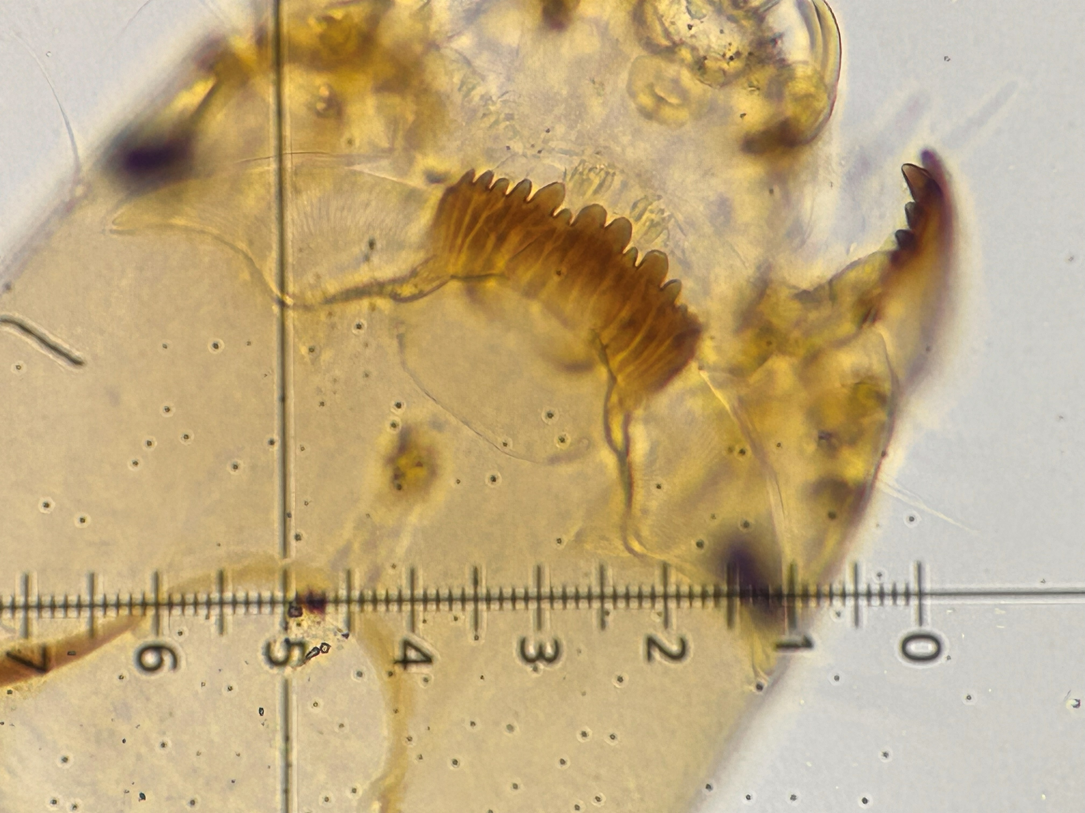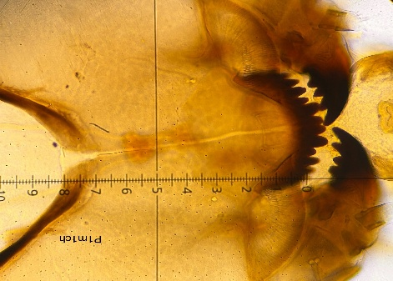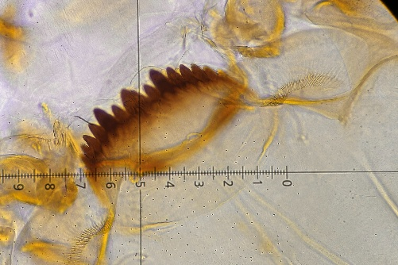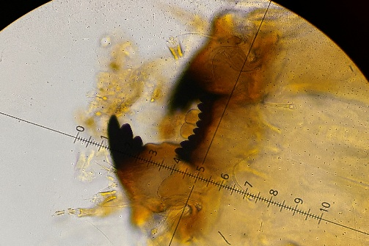
Polypedilium Endotribelos Chironomus Xestochironomus
Orthocladiinae
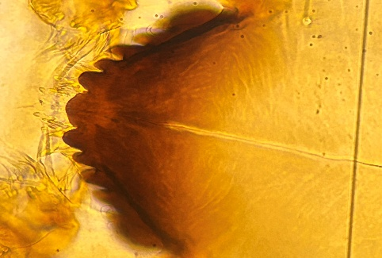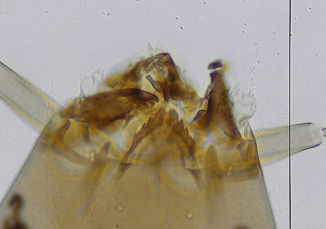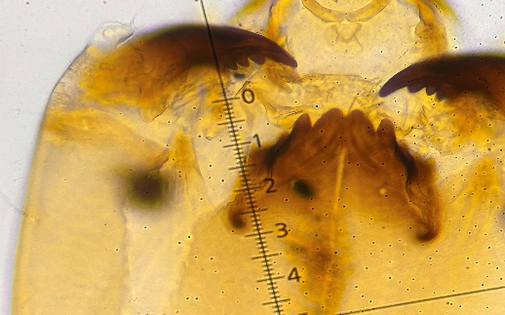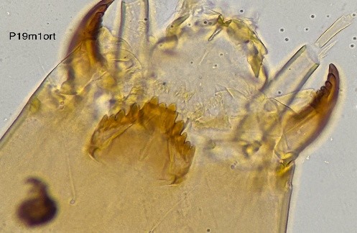
Cricotopus Corynoneura Parametriocnemus Onconeura
Tanypodinae
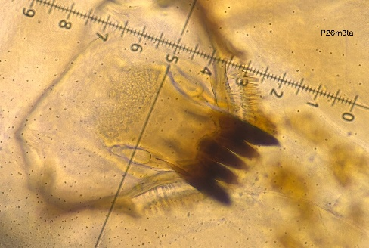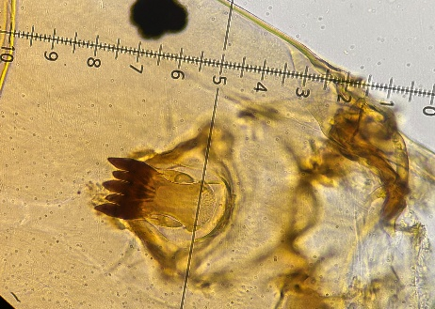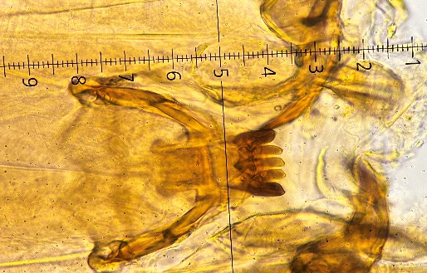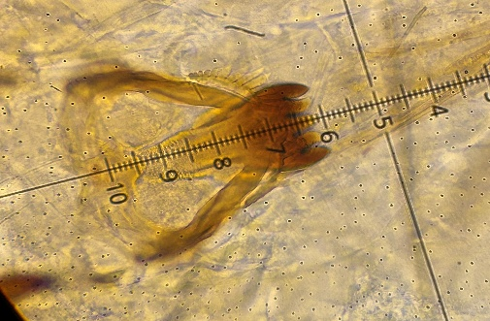
Larsia Labrundinia Denopelopia Pentaneura

