SUPPLEMENTARY MATERIAL
SMT 1
Sampling transects established to study Psittacidae species in urban areas of Medellín (Colombia)
Sampling transects | Reference coordinate | Urbanization levels (%)
La Playa | 6°14’53.17’’ N & 75°33’41.37’’W | 84
Estadio | 6°15’13.03’’ N & 75°35’17.72’’ W | 61
Jardín Botánico-Parque Norte | 6°16’13.87’’ N & 75°33’48.91’’ W | 51
La Asomadera | 6°14’13.25’’ N & 75°33’51.46’’ W | 35 (A)*
La Ayurá | 6°10’54.86’’ N & 75°34’54.34’’ W | 35 (B)*
La Presidenta | 6°12’27.99’’ N & 75°34’12.98’’ W | 33
El Rodeo | 6°12’11.3’’ N & 75°36’9.414’’ W | 19
El Volador | 6°15’53.44’’ N & 75°34’57.09’’ W | 5
Cerro Quitasol | 6°22’21.63’’ N 75°33’29.48’’ W | 4
El Salado | 6°8’22.099’’ N & 75°34’9.577’’ W | 2
Detailing the common name of each sample site, geographic coordinates, and corresponding levels of urbanization (percentage of built-up area at 50 m distance buffer). *For these transects with equivalent urbanization levels, “A” indicate a site within an established urban protected park, whereas “B” denotes a site at the edge of an urban stream.
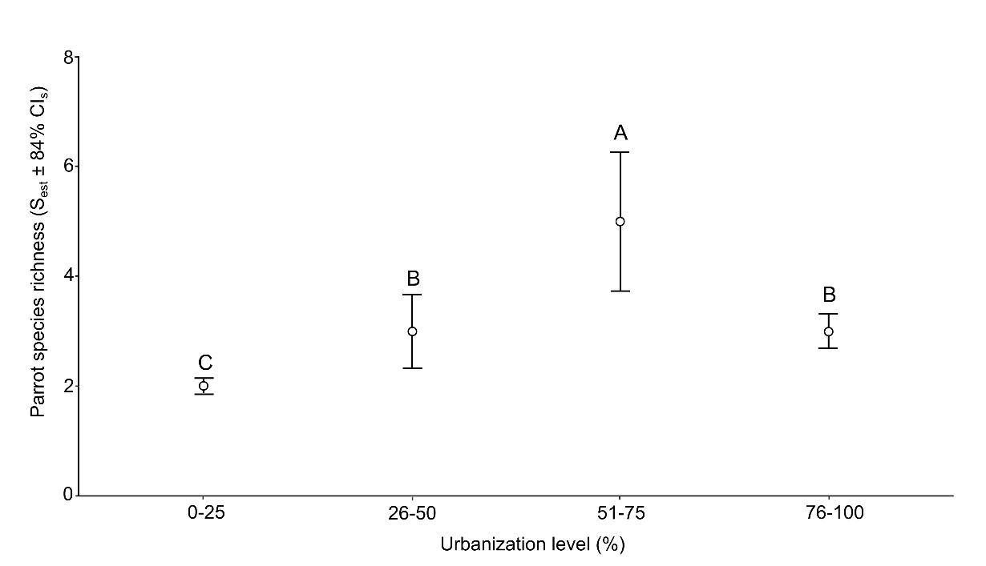
SMF 1. Analysis of parrot species richness across urbanization levels in Medellín.
We estimated the cumulative parrot species richness across urbanization levels based on rarefaction methods with 1 000 bootstrap replications (Gotelli & Colwell, 2001), using the iNEXT R package (Hsieh et al., 2016). Statistical significance for pairwise differences between urbanization levels was determined by examining the non-overlapping 84 % confidence intervals (CI; see MacGregor-Fors & Payton, 2013). Capital letters represent significant differences between urbanization levels (different letters = statistical difference), displayed from the highest to the lowest values.
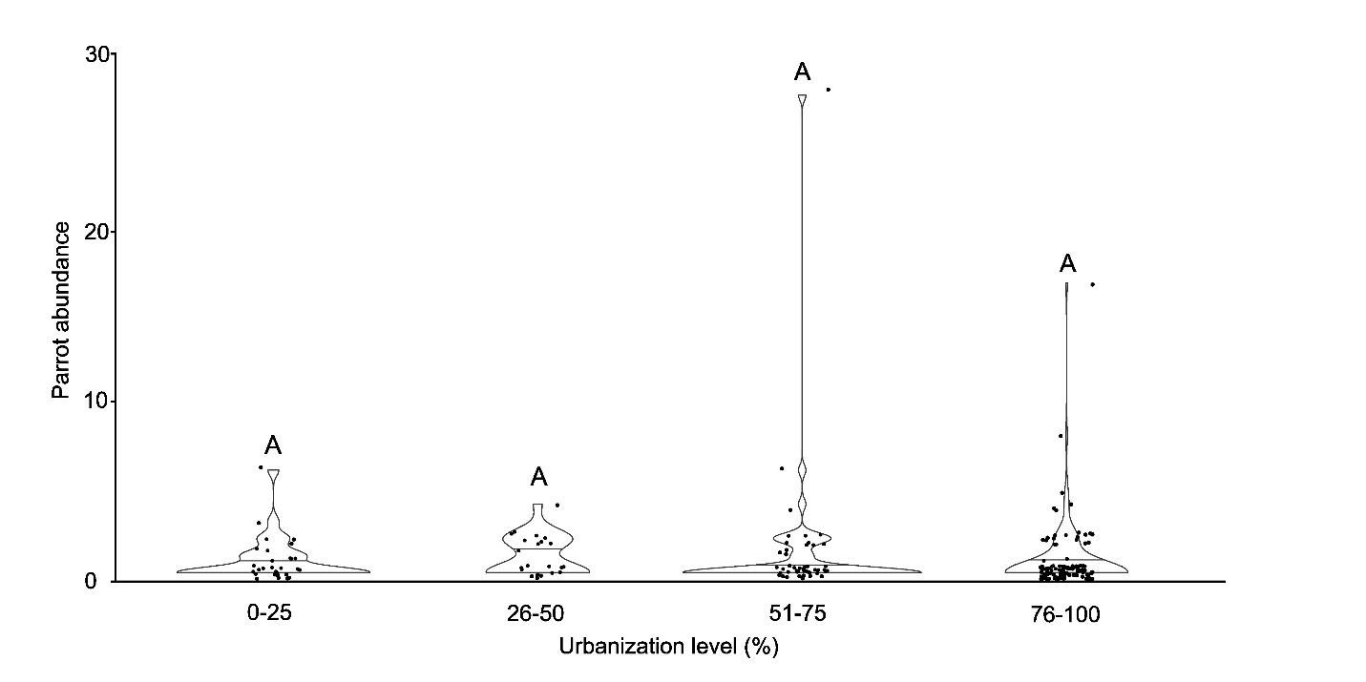
SMF 2. Analysis of parrot abundance across urbanization levels in Medellín.
We compared parrot abundance (number of individuals) across urbanization levels in Medellín using violin plots and the General Linear Hypothesis Tests to assess statistical significance (p < 0.05). Horizontal bars inside the violin plots indicate the median values and capital letters above them represent significant differences between urbanization levels (different letters = statistical difference), displayed from the highest to the lowest values. In this case, we found no significant differences in parrot abundance across urbanization levels.
SMT 2
Analysis of the parrot and related species assemblage (i.e., species composition)
Spatial scale | R² | F | p-value
Built-up area at 50 m | 0.031 | 1.957 | 0.126
Built-up area at 500 m | 0.005 | 0.298 | 0.762
Built-up area at 1 000 m | 0.078 | 5.028 | 0.014

To determine if the species composition of parrots and related species varied across spatial scales, we performed a Permutational Multivariate Analysis of Variance (PERMANOVA). The results are summarized in the following table, where a statistically significant relationship is shown only between species composition and the percentage of built-up area measured at the 1 000 m scale. However, the explained variance was very low across scales (R2 < 0.1).
SMT 3
Analysis of the parrot and related species assemblage (i.e., species composition)
Spatial scale | R² | F | p-value
Built-up area at 1 000 m | 0.080 | 2.439 | 0.065

To evaluate the relationship across urbanization levels based on categories, we performed a second PERMANOVA. For this analysis, we grouped the percentage of built-up area at 1000 m into four categories: 0-25 %, 26-50 %, 51-75 %, and 76-100 %. This approach allows us to evaluate if there were significant differences in species composition across urbanization levels, as a complement analysis based on specific values of built-up cover.
The analysis suggests that the parrot species assemblage composition exhibits a changing trend along this categorical gradient, although the result was only marginally significant.
REFERENCES
Gotelli, N. J., & Colwell, R. K. (2001). Quantifying biodiversity: Procedures and pitfalls in the measurement and comparison of species richness. Ecology Letters, 4(4), 379–391. https://doi.org/10.1046/j.1461-0248.2001.00230.x
Hsieh, T. C., Ma, K. H., & Chao, A. (2016). iNEXT: An R package for rarefaction and extrapolation of species diversity (Hill numbers). Methods in Ecology and Evolution, 7(12), 1451–1456. https://doi.org/10.1111/2041-210X.12613
MacGregor-Fors, I., & Payton, M. E. (2013). Contrasting diversity values: Statistical inferences based on overlapping confidence intervals. PLoS ONE, 8(2), e56794. https://doi.org/10.1371/journal.pone.0056794

