MST 1
Características de las áreas de estudio
SMT 1
Characteristics of the study areas
Localidades | Elevación | Zonas de vida | Coordenadas
Localidades | Elevación | Zonas de vida | N | W
Agua Fría | 1 200 | bh-PM | 4.423 | -75.239
Entre Aguas | 1 300 | bh-PM | 4.409 | -75.292
Gaia | 1 330 | bh-PM | 4.462 | -75.216
Kenisha | 1 300 | bh-PM | 4.416 | -75.221
La Carpintería | 1 550 | bh-PM | 4.496 | -75.293
Los Alpes | 1 000 | bh-PM | 4.384 | -75.185
La Lucia | 1 300 | bh-PM | 4.373 | -75.215
Primavera | 1 080 | bh-PM | 4.481 | -75.107
Orquídeas | 1 300 | bh-PM | 4.423 | -75.258
Paraíso Cocora | 1 300 | bh-PM | 4.389 | -75.322
El Palmar | 2 000 | bh-MB' | 4.580 | -75.327
Bella Vista | 1 800 | bh-MB | 4.488 | -75.196
Doima | 603 | bs-T | 4.398 | -75.027
Potrerillo | 440 | bs-T | 4.251 | -74.976
Unibagué | 1 134 | bh-PM | 4.451 | -75.198
MST 2
Esfuerzo de muestreo
SMT 2
Sampling effort
Localidades | Periódo de muestreo | Esfuerzo total |  | Listas de eBird
 |  | Puntos de conteo (h) | Redes de niebla (h)
Agua Fría | 2018, 2019 | 120 | 300 | 2018: 2  2022: 2
Entre Aguas | 2018, 2019 | 192 | 300 | -
Gaia | 2018, 2019, 2022 | 192 | 490 | -
Kenisha | 2018, 2019 | 192 | 300 | -
La Carpintería | 2018, 2019 | 192 | 300 | -
Los Alpes | 2018, 2019 | 120 | 300 | 2018: 2  2022: 2
La Lucia | 2018, 2019 | 120 | 300 | 2018: 2  2022: 2
La Primavera | 2019, 2022 | 120 | 490 | 2018: 2
Orquídeas del Tolima | 2018, 2019 | 192 | 300 | -
Paraíso de Cocora | 2018, 2019, 2022 | 120 | 300 | 2022: 2
El Palmar | 2018, 2019 | 120 | 300 | 2018: 2  2022: 2
Bella Vista | 2018, 2019 | 120 | 300 | 2018: 2  2022: 2
Doima | 2022 | - | 490 | 2018: 2  2019: 3
Potrerillo | 2022 | - | 490 | 2018: 2  2019: 3
Universidad de Ibagué | 2018, 2019 | 72 | 300 | 2019: 2  2022: 2
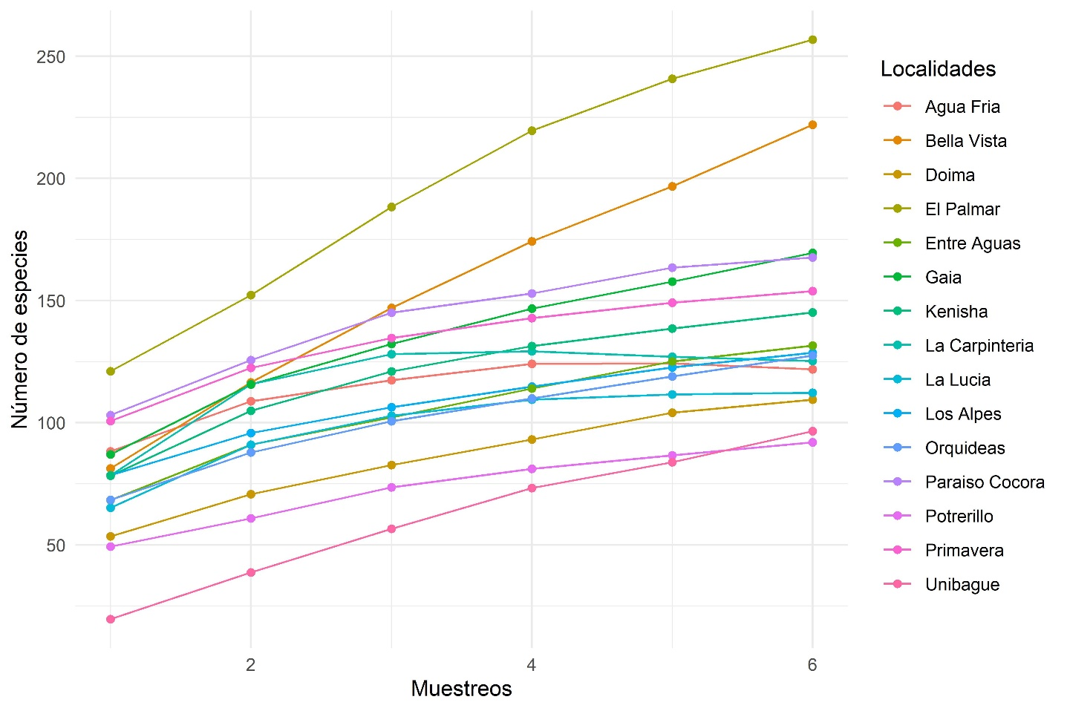
MSF 3. Curvas de rarefacción según el estimador de riqueza Chao1 para las áreas de estudio.
SMF 3. Rarefaction curves according to the Chao1 richness estimator for the study areas.
MST 4
Resultados de las métricas a nivel de parche, clase y paisaje
SMT 4
Results of patch, class, and landscape-level metrics
Métricas de parche
 |  | Área del parche |  |  |  |  |  |  | Perímetro del parche
 |  | B |  | TU |  |  | VS |  | B |  | TU |  |  |  | VS
Agua Fría |  | 3.01 |  | 5.71 |  |  | 0.44 |  | 40 |  | 2 |  |  |  | 17
Bella Vista |  | 10.72 |  | 1.01 |  |  | 1.28 |  | 62 |  | 1 |  |  |  | 12
Doima |  | 3.18 |  | 3.16 |  |  | 5.20 |  | 10 |  | 6 |  |  |  | 26
El Palmar |  | 13.69 |  | 1.04 |  |  | 1.24 |  | 68 |  | 3 |  |  |  | 9
Entre Aguas |  | 3.47 |  | 4.17 |  |  | 1.73 |  | 86 |  | 80 |  |  |  | 41
Gaia |  | 11.40 |  | 3.27 |  |  | 1.04 |  | 21 |  | 8 |  |  |  | 36
Kenisha |  | 7.05 |  | 1.18 |  |  | 3.12 |  | 15 |  | 2 |  |  |  | 48
La Carpintería |  | 4.06 |  | 1.74 |  |  | 1.20 |  | 53 |  | 9 |  |  |  | 67
La Lucia |  | 2.87 |  | 1.61 |  |  | 5.14 |  | 73 |  | 5 |  |  |  | 90
Los Alpes |  | 3.05 |  | 1.39 |  |  | 2.51 |  | 67 |  | 11 |  |  |  | 60
Orquídeas |  | 1.24 |  | 2.35 |  |  | 2.15 |  | 23 |  | 43 |  |  |  | 65
Paraíso Cocora |  | 2.46 |  | 2.03 |  |  | 1.51 |  | 39 |  | 3 |  |  |  | 38
Potrerillo |  | 1.22 |  | 4.04 |  |  | 6.58 |  | 50 |  | 5 |  |  |  | 39
Primavera |  | 3.24 |  | 1.05 |  |  | 1.51 |  | 84 |  | 4 |  |  |  | 53
Unibagué |  | 2.70 |  | 12.19 |  |  | 1.49 |  | 44 |  | 31 |  |  |  | 13
Métricas de clase
 | Porcentaje de la clase |  |  |  |  |  |  | Número de parches |  |  |  | Índice de forma
 | B |  | TU |  |  | VS |  | B | TU | VS |  | B |  | TU |  | VS
Agua Fría | 33 |  | 23 |  |  | 14 |  | 6 | 22 | 13 |  | 2.04 |  | 3.52 |  | 1.66
Bella Vista | 97 |  | 0.4 |  |  | 2 |  | 2 | 1 | 3 |  | 1.49 |  | 1.37 |  | 1.71
Doima | 18 |  | 8 |  |  | 32 |  | 7 | 7 | 10 |  | 2.58 |  | 1.39 |  | 1.87
El Palmar | 79 |  | 1 |  |  | 1 |  | 3 | 4 | 1 |  | 2.21 |  | 1.47 |  | 2.02
Entre Aguas | 36 |  | 4 |  |  | 49 |  | 8 | 28 | 17 |  | 2.56 |  | 1.54 |  | 1.90
Gaia | 73 |  | 3 |  |  | 17 |  | 2 | 27 | 13 |  | 2.98 |  | 1.65 |  | 2.37
Kenisha | 59 |  | 2 |  |  | 34 |  | 1 | 27 | 9 |  | 3.99 |  | 1.47 |  | 1.83
La Carpintería | 70 |  | 5 |  |  | 5 |  | 3 | 8 | 5 |  | 2.06 |  | 1.64 |  | 1.57
La Lucia | 46 |  | 2 |  |  | 3 |  | 3 | 14 | 3 |  | 2.87 |  | 1.45 |  | 1.63
Los Alpes | 24 |  | 11 |  |  | 49 |  | 9 | 52 | 15 |  | 1.87 |  | 1.38 |  | 2.03
Orquídeas | 15 |  | 23 |  |  | 33 |  | 2 | 10 | 7 |  | 1.82 |  | 3.94 |  | 2.72
Paraíso Cocora | 40 |  | 1 |  |  | 0.4 |  | 7 | 8 | 1 |  | 1.73 |  | 1.33 |  | 1.36
Potrerillo | 17 |  | 7 |  |  | 36 |  | 4 | 7 | 5 |  | 2.52 |  | 1.34 |  | 1.64
Primavera | 50 |  | 3 |  |  | 30 |  | 3 | 29 | 11 |  | 2.49 |  | 1.42 |  | 2.00
Unibagué | 25 |  | 57 |  |  | 5 |  | 2 | 31 | 3 |  | 2.06 |  | 1.53 |  | 7.41
Métricas de paisaje
 |  | Número de parches |  |  | Diversidad de Shannon |  |  |  | Uniformidad de Shannon |  |  |  | Riqueza del parche
Agua Fría |  | 63 |  |  | 1.87 |  |  |  | 0.81 |  |  |  | 8
Bella Vista |  | 12 |  |  | 0.15 |  |  |  | 0.10 |  |  |  | 5
Doima |  | 55 |  |  | 1.61 |  |  |  | 0.73 |  |  |  | 8
El Palmar |  | 17 |  |  | 0.74 |  |  |  | 0.42 |  |  |  | 5
Entre Aguas |  | 74 |  |  | 1.24 |  |  |  | 0.64 |  |  |  | 6
Gaia |  | 62 |  |  | 0.70 |  |  |  | 0.36 |  |  |  | 6
Kenisha |  | 53 |  |  | 0.95 |  |  |  | 0.53 |  |  |  | 5
La Carpintería |  | 30 |  |  | 1.08 |  |  |  | 0.49 |  |  |  | 8
La Lucia |  | 40 |  |  | 1.05 |  |  |  | 0.51 |  |  |  | 7
Los Alpes |  | 102 |  |  | 1.44 |  |  |  | 0.69 |  |  |  | 7
Orquídeas |  | 22 |  |  | 1.36 |  |  |  | 0.76 |  |  |  | 5
Paraíso Cocora |  | 39 |  |  | 1.32 |  |  |  | 0.60 |  |  |  | 8
Potrerillo |  | 33 |  |  | 1.63 |  |  |  | 0.78 |  |  |  | 7
Primavera |  | 71 |  |  | 1.27 |  |  |  | 0.65 |  |  |  | 6
Unibagué |  | 42 |  |  | 1.38 |  |  |  | 0.66 |  |  |  | 6
B = bosque, TU = tejido urbano, VS = vegetación secundaria.
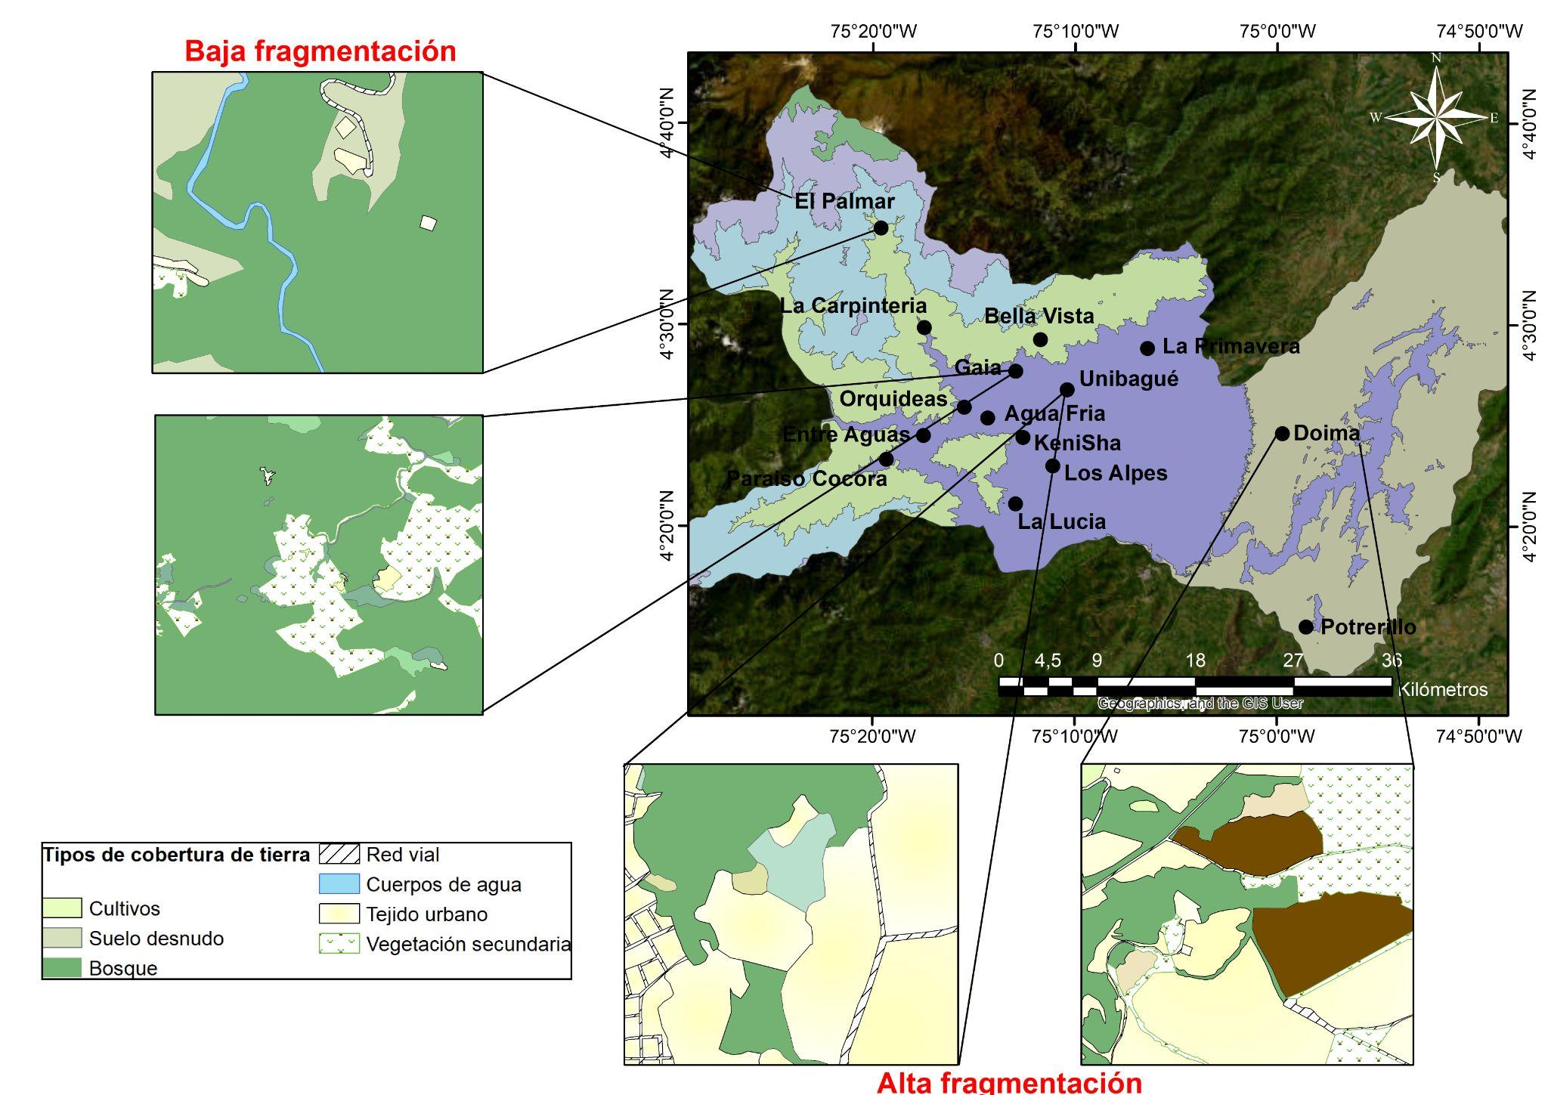
MSF 5. Coberturas de la tierra identificadas en los paisajes evaluados, según la clasificación establecida por la Leyenda Nacional de Coberturas de la Tierra ‘Corine Land Cover’.
SMF 5. Land covers identified in the assessed landscapes, according to the classification established by the National Land Cover Legend ‘Corine Land Cover’.
MST 6
Estructura y composición de los ensamblajes de aves evaluados en el Valle Alto de Magdalena
SMT 6
Structure and composition of the bird assemblages evaluated in the Upper Magdalena Valley
Filo | Clase | Orden | Familia | Especie
Chordata | Aves | Tinamiformes | Tinamidae | Tinamus major
 |  |  |  | Crypturellus soui
 |  | Anseriformes | Anatidae | Dendrocygna autumnalis
 |  | Galliformes | Cracidae | Chamaepetes goudotii
 |  |  |  | Penelope montagnii
 |  |  |  | Ortalis columbiana
 |  |  | Odontophoridae | Colinus cristatus
 |  |  |  | Odontophorus hyperythrus
 |  | Columbiformes | Columbidae | Columba livia
 |  |  |  | Patagioenas fasciata
 |  |  |  | Patagioenas cayennensis
 |  |  |  | Patagioenas subvinacea
 |  |  |  | Geotrygon montana
 |  |  |  | Leptotila verreauxi
 |  |  |  | Leptotila conoveri
 |  |  |  | Zenaida auriculata
 |  |  |  | Claravis pretiosa
 |  |  |  | Columbina passerina
 |  |  |  | Columbina minuta
 |  |  |  | Columbina talpacoti
 |  | Cuculiformes | Cuculidae | Crotophaga major
 |  |  |  | Crotophaga ani
 |  |  |  | Crotophaga sulcirostris
 |  |  |  | Tapera naevia
 |  |  |  | Coccycua minuta
 |  |  |  | Coccycua pumila
 |  |  |  | Piaya cayana
 |  |  |  | Coccyzus americanus
 |  | Steatornithiformes | Steatornithidae | Steatornis caripensis
 |  | Caprimulgiformes | Caprimulgidae | Nyctidromus albicollis
 |  | Apodiformes | Apodidae | Streptoprocne rutila
 |  |  |  | Streptoprocne zonaris
 |  |  |  | Aeronautes montivagus
 |  |  | Trochilidae | Florisuga mellivora
 |  |  |  | Eutoxeres aquila
 |  |  |  | Glaucis hirsutus
 |  |  |  | Phaethornis anthophilus
 |  |  |  | Phaethornis guy
 |  |  |  | Phaethornis syrmatophorus
 |  |  |  | Doryfera ludovicae
 |  |  |  | Colibri delphinae
 |  |  |  | Colibri cyanotus
 |  |  |  | Colibri coruscans
 |  |  |  | Chrysolampis mosquitus
 |  |  |  | Anthracothorax nigricollis
 |  |  |  | Heliangelus exortis
 |  |  |  | Adelomyia melanogenys
 |  |  |  | Aglaiocercus kingii
 |  |  |  | Haplophaedia aureliae
 |  |  |  | Coeligena coeligena
 |  |  |  | Coeligena torquata
 |  |  |  | Lafresnaya lafresnayi
 |  |  |  | Ensifera ensifera
 |  |  |  | Boissonneaua flavescens
 |  |  |  | Ocreatus underwoodii
 |  |  |  | Heliomaster longirostris
 |  |  |  | Chaetocercus mulsant
 |  |  |  | Philodice mitchellii
 |  |  |  | Chlorostilbon melanorhynchus
 |  |  |  | Chlorostilbon gibsoni
 |  |  |  | Anthocephala berlepschi
 |  |  |  | Campylopterus falcatus
 |  |  |  | Chalybura buffonii
 |  |  |  | Thalurania colombica
 |  |  |  | Saucerottia saucerottei
 |  |  |  | Saucerottia cyanifrons
 |  |  |  | Amazilia tzacatl
 |  |  |  | Uranomitra franciae
 |  |  |  | Chrysuronia goudoti
 |  |  |  | Chlorestes julie
 |  | Gruiformes | Rallidae | Aramides cajaneus
 |  | Charadriiformes | Charadriidae | Vanellus chilensis
 |  |  | Jacanidae | Jacana jacana
 |  | Suliformes | Phalacrocoracidae | Nannopterum brasilianum
 |  | Pelecaniformes | Ardeidae | Butorides striata
 |  |  |  | Bubulcus ibis
 |  |  |  | Ardea cocoi
 |  |  |  | Ardea alba
 |  |  |  | Syrigma sibilatrix
 |  |  |  | Pilherodius pileatus
 |  |  |  | Egretta thula
 |  |  |  | Egretta caerulea
 |  |  | Threskiornithidae | Phimosus infuscatus
 |  | Cathartiformes | Cathartidae | Sarcoramphus papa
 |  |  |  | Coragyps atratus
 |  |  |  | Cathartes aura
 |  |  |  | Cathartes burrovianus
 |  | Accipitriformes | Accipitridae | Chondrohierax uncinatus
 |  |  |  | Ictinia plumbea
 |  |  |  | Buteogallus meridionalis
 |  |  |  | Rupornis magnirostris
 |  |  |  | Buteo nitidus
 |  |  |  | Buteo platypterus
 |  |  |  | Buteo brachyurus
 |  |  |  | Buteo swainsoni
 |  | Strigiformes | Strigidae | Strix virgata
 |  |  |  | Asio stygius
 |  | Trogoniformes | Trogonidae | Trogon collaris
 |  |  |  | Trogon personatus
 |  | Coraciiformes | Momotidae | Momotus subrufescens
 |  |  |  | Momotus aequatorialis
 |  |  | Alcedinidae | Megaceryle torquata
 |  |  |  | Chloroceryle amazona
 |  |  |  | Chloroceryle americana
 |  | Galbuliformes | Galbulidae | Galbula ruficauda
 |  |  | Bucconidae | Nystalus radiatus
 |  |  |  | Malacoptila mystacalis
 |  | Piciformes | Ramphastidae | Aulacorhynchus albivitta
 |  |  |  | Aulacorhynchus haematopygus
 |  |  |  | Andigena nigrirostris
 |  |  | Picidae | Picumnus olivaceus
 |  |  |  | Melanerpes rubricapillus
 |  |  |  | Dryobates fumigatus
 |  |  |  | Dryobates kirkii
 |  |  |  | Dryocopus lineatus
 |  |  |  | Colaptes rivolii
 |  |  |  | Colaptes punctigula
 |  | Falconiformes | Falconidae | Herpetotheres cachinnans
 |  |  |  | Micrastur semitorquatus
 |  |  |  | Caracara plancus
 |  |  |  | Milvago chimachima
 |  |  |  | Falco sparverius
 |  |  |  | Falco rufigularis
 |  |  |  | Falco femoralis
 |  | Psittaciformes | Psittacidae | Brotogeris jugularis
 |  |  |  | Pionus menstruus
 |  |  |  | Pionus chalcopterus
 |  |  |  | Amazona ochrocephala
 |  |  |  | Amazona amazonica
 |  |  |  | Forpus conspicillatus
 |  |  |  | Ara militaris
 |  |  |  | Leptosittaca branickii
 |  |  |  | Psittacara wagleri
 |  | Passeriformes | Thamnophilidae | Thamnophilus doliatus
 |  |  |  | Thamnophilus multistriatus
 |  |  |  | Thamnophilus atrinucha
 |  |  |  | Dysithamnus mentalis
 |  |  |  | Myrmotherula schisticolor
 |  |  |  | Formicivora grisea
 |  |  |  | Cercomacroides tyrannina
 |  |  |  | Cercomacra nigricans
 |  |  |  | Myrmeciza longipes
 |  |  |  | Hafferia immaculata
 |  |  | Grallariidae | Grallaria ruficapilla
 |  |  |  | Grallaria nuchalis
 |  |  |  | Grallaria milleri
 |  |  |  | Grallaricula nana
 |  |  | Rhinocryptidae | Myornis senilis
 |  |  |  | Scytalopus atratus
 |  |  |  | Scytalopus latrans
 |  |  |  | Scytalopus spillmanni
 |  |  | Furnariidae | Dendrocincla tyrannina
 |  |  |  | Dendrocincla fuliginosa
 |  |  |  | Dendrocolaptes picumnus
 |  |  |  | Xiphorhynchus susurrans
 |  |  |  | Xiphorhynchus triangularis
 |  |  |  | Dendroplex picus
 |  |  |  | Campylorhamphus trochilirostris
 |  |  |  | Campylorhamphus pusillus
 |  |  |  | Lepidocolaptes souleyetii
 |  |  |  | Lepidocolaptes lacrymiger
 |  |  |  | Xenops minutus
 |  |  |  | Xenops rutilans
 |  |  |  | Pseudocolaptes boissonneautii
 |  |  |  | Anabacerthia striaticollis
 |  |  |  | Thripadectes holostictus
 |  |  |  | Thripadectes virgaticeps
 |  |  |  | Automolus ochrolaemus
 |  |  |  | Margarornis squamiger
 |  |  |  | Synallaxis brachyura
 |  |  |  | Synallaxis albescens
 |  |  |  | Synallaxis azarae
 |  |  | Pipridae | Chiroxiphia lanceolata
 |  |  |  | Masius chrysopterus
 |  |  |  | Manacus manacus
 |  |  | Cotingidae | Pipreola riefferii
 |  |  |  | Lipaugus fuscocinereus
 |  |  | Tityridae | Tityra inquisitor
 |  |  |  | Pachyramphus versicolor
 |  |  |  | Pachyramphus rufus
 |  |  |  | Pachyramphus polychopterus
 |  |  | Tyrannidae | Platyrinchus mystaceus
 |  |  |  | Pogonotriccus ophthalmicus
 |  |  |  | Pogonotriccus poecilotis
 |  |  |  | Mionectes striaticollis
 |  |  |  | Mionectes olivaceus
 |  |  |  | Mionectes oleagineus
 |  |  |  | Mionectes galbinus
 |  |  |  | Leptopogon amaurocephalus
 |  |  |  | Leptopogon superciliaris
 |  |  |  | Tolmomyias sulphurescens
 |  |  |  | Lophotriccus pileatus
 |  |  |  | Atalotriccus pilaris
 |  |  |  | Hemitriccus margaritaceiventer
 |  |  |  | Poecilotriccus ruficeps
 |  |  |  | Poecilotriccus sylvia
 |  |  |  | Todirostrum cinereum
 |  |  |  | Pyrrhomyias cinnamomeus
 |  |  |  | Zimmerius chrysops
 |  |  |  | Euscarthmus meloryphus
 |  |  |  | Camptostoma obsoletum
 |  |  |  | Elaenia flavogaster
 |  |  |  | Elaenia chiriquensis
 |  |  |  | Elaenia frantzii
 |  |  |  | Tyrannulus elatus
 |  |  |  | Myiopagis gaimardii
 |  |  |  | Myiopagis viridicata
 |  |  |  | Capsiempis flaveola
 |  |  |  | Phyllomyias griseiceps
 |  |  |  | Phyllomyias nigrocapillus
 |  |  |  | Phaeomyias murina
 |  |  |  | Mecocerculus leucophrys
 |  |  |  | Serpophaga cinerea
 |  |  |  | Legatus leucophaius
 |  |  |  | Pitangus sulphuratus
 |  |  |  | Machetornis rixosa
 |  |  |  | Megarynchus pitangua
 |  |  |  | Myiodynastes chrysocephalus
 |  |  |  | Myiodynastes luteiventris
 |  |  |  | Myiodynastes hemichrysus
 |  |  |  | Myiodynastes maculatus
 |  |  |  | Myiozetetes cayanensis
 |  |  |  | Myiozetetes similis
 |  |  |  | Tyrannus melancholicus
 |  |  |  | Tyrannus savana
 |  |  |  | Myiarchus tuberculifer
 |  |  |  | Myiarchus panamensis
 |  |  |  | Myiarchus apicalis
 |  |  |  | Myiarchus cephalotes
 |  |  |  | Myiarchus crinitus
 |  |  |  | Myiophobus flavicans
 |  |  |  | Myiophobus fasciatus
 |  |  |  | Ochthoeca diadema
 |  |  |  | Ochthoeca cinnamomeiventris
 |  |  |  | Pyrocephalus rubinus
 |  |  |  | Fluvicola pica
 |  |  |  | Knipolegus poecilurus
 |  |  |  | Myiotheretes striaticollis
 |  |  |  | Cnemotriccus fuscatus
 |  |  |  | Sayornis nigricans
 |  |  |  | Empidonax virescens
 |  |  |  | Empidonax traillii
 |  |  |  | Empidonax alnorum
 |  |  |  | Contopus cooperi
 |  |  |  | Contopus fumigatus
 |  |  |  | Contopus sordidulus
 |  |  |  | Contopus virens
 |  |  |  | Contopus bogotensis
 |  |  | Vireonidae | Cyclarhis gujanensis
 |  |  |  | Cyclarhis nigrirostris
 |  |  |  | Hylophilus flavipes
 |  |  |  | Pachysylvia semibrunnea
 |  |  |  | Vireo leucophrys
 |  |  |  | Vireo olivaceus
 |  |  |  | Vireo flavoviridis
 |  |  | Corvidae | Cyanolyca armillata
 |  |  |  | Cyanocorax affinis
 |  |  |  | Cyanocorax yncas
 |  |  | Hirundinidae | Pygochelidon cyanoleuca
 |  |  |  | Orochelidon murina
 |  |  |  | Stelgidopteryx ruficollis
 |  |  |  | Progne tapera
 |  |  | Troglodytidae | Troglodytes aedon
 |  |  |  | Troglodytes solstitialis
 |  |  |  | Campylorhynchus griseus
 |  |  |  | Pheugopedius fasciatoventris
 |  |  |  | Pheugopedius mystacalis
 |  |  |  | Cantorchilus leucotis
 |  |  |  | Cinnycerthia olivascens
 |  |  |  | Henicorhina leucosticta
 |  |  |  | Henicorhina leucophrys
 |  |  |  | Cyphorhinus thoracicus
 |  |  | Polioptilidae | Polioptila plumbea
 |  |  | Turdidae | Myadestes ralloides
 |  |  |  | Catharus aurantiirostris
 |  |  |  | Catharus fuscater
 |  |  |  | Catharus minimus
 |  |  |  | Catharus ustulatus
 |  |  |  | Turdus leucomelas
 |  |  |  | Turdus ignobilis
 |  |  |  | Turdus fuscater
 |  |  |  | Turdus serranus
 |  |  | Mimidae | Mimus gilvus
 |  |  | Estrildidae | Lonchura malacca
 |  |  | Fringillidae | Spinus xanthogastrus
 |  |  |  | Spinus psaltria
 |  |  |  | Chlorophonia cyanocephala
 |  |  |  | Chlorophonia cyanea
 |  |  |  | Chlorophonia pyrrhophrys
 |  |  |  | Euphonia concinna
 |  |  |  | Euphonia laniirostris
 |  |  |  | Euphonia xanthogaster
 |  |  | Rhodinocichlidae | Rhodinocichla rosea
 |  |  | Passerellidae | Chlorospingus flavopectus
 |  |  |  | Arremonops conirostris
 |  |  |  | Arremon assimilis
 |  |  |  | Arremon aurantiirostris
 |  |  |  | Arremon brunneinucha
 |  |  |  | Zonotrichia capensis
 |  |  |  | Atlapetes albinucha
 |  |  |  | Atlapetes flaviceps
 |  |  |  | Atlapetes schistaceus
 |  |  |  | Atlapetes pallidinucha
 |  |  | Icteridae | Leistes militaris
 |  |  |  | Amblycercus holosericeus
 |  |  |  | Psarocolius angustifrons
 |  |  |  | Psarocolius decumanus
 |  |  |  | Cacicus chrysonotus
 |  |  |  | Icterus auricapillus
 |  |  |  | Icterus chrysater
 |  |  |  | Icterus galbula
 |  |  |  | Icterus nigrogularis
 |  |  |  | Molothrus oryzivorus
 |  |  |  | Molothrus bonariensis
 |  |  |  | Quiscalus lugubris
 |  |  |  | Chrysomus icterocephalus
 |  |  | Parulidae | Parkesia noveboracensis
 |  |  |  | Mniotilta varia
 |  |  |  | Leiothlypis peregrina
 |  |  |  | Geothlypis philadelphia
 |  |  |  | Setophaga ruticilla
 |  |  |  | Setophaga cerulea
 |  |  |  | Setophaga pitiayumi
 |  |  |  | Setophaga castanea
 |  |  |  | Setophaga fusca
 |  |  |  | Setophaga petechia
 |  |  |  | Myiothlypis nigrocristata
 |  |  |  | Myiothlypis fulvicauda
 |  |  |  | Myiothlypis coronata
 |  |  |  | Basileuterus delattrii
 |  |  |  | Basileuterus tristriatus
 |  |  |  | Cardellina canadensis
 |  |  |  | Myioborus miniatus
 |  |  |  | Myioborus ornatus
 |  |  | Cardinalidae | Piranga flava
 |  |  |  | Piranga rubra
 |  |  |  | Piranga olivacea
 |  |  |  | Habia cristata
 |  |  |  | Pheucticus ludovicianus
 |  |  |  | Cyanoloxia cyanoides
 |  |  | Thraupidae | Sericossypha albocristata
 |  |  |  | Catamblyrhynchus diadema
 |  |  |  | Chlorophanes spiza
 |  |  |  | Hemithraupis guira
 |  |  |  | Conirostrum leucogenys
 |  |  |  | Conirostrum albifrons
 |  |  |  | Sicalis flaveola
 |  |  |  | Diglossa albilatera
 |  |  |  | Diglossa sittoides
 |  |  |  | Diglossa caerulescens
 |  |  |  | Diglossa cyanea
 |  |  |  | Haplospiza rustica
 |  |  |  | Volatinia jacarina
 |  |  |  | Loriotus luctuosus
 |  |  |  | Tachyphonus rufus
 |  |  |  | Eucometis penicillata
 |  |  |  | Coryphospingus pileatus
 |  |  |  | Ramphocelus dimidiatus
 |  |  |  | Tersina viridis
 |  |  |  | Dacnis lineata
 |  |  |  | Dacnis cayana
 |  |  |  | Sporophila minuta
 |  |  |  | Sporophila funerea
 |  |  |  | Sporophila angolensis
 |  |  |  | Sporophila crassirostris
 |  |  |  | Sporophila intermedia
 |  |  |  | Sporophila luctuosa
 |  |  |  | Sporophila nigricollis
 |  |  |  | Sporophila schistacea
 |  |  |  | Saltator maximus
 |  |  |  | Saltator atripennis
 |  |  |  | Saltator coerulescens
 |  |  |  | Saltator striatipectus
 |  |  |  | Emberizoides herbicola
 |  |  |  | Cnemoscopus rubrirostris
 |  |  |  | Kleinothraupis atropileus
 |  |  |  | Sphenopsis frontalis
 |  |  |  | Sphenopsis melanotis
 |  |  |  | Coereba flaveola
 |  |  |  | Tiaris olivaceus
 |  |  |  | Asemospiza obscura
 |  |  |  | Melanospiza bicolor
 |  |  |  | Pipraeidea melanonota
 |  |  |  | Anisognathus lacrymosus
 |  |  |  | Anisognathus somptuosus
 |  |  |  | Buthraupis montana
 |  |  |  | Sporathraupis cyanocephala
 |  |  |  | Chlorornis riefferii
 |  |  |  | Chalcothraupis ruficervix
 |  |  |  | Stilpnia heinei
 |  |  |  | Stilpnia vitriolina
 |  |  |  | Stilpnia cyanicollis
 |  |  |  | Tangara vassorii
 |  |  |  | Tangara nigroviridis
 |  |  |  | Tangara labradorides
 |  |  |  | Tangara inornata
 |  |  |  | Tangara gyrola
 |  |  |  | Tangara xanthocephala
 |  |  |  | Tangara arthus
 |  |  |  | Thraupis episcopus
 |  |  |  | Thraupis palmarum
MST 7
Asociación de las variables del paisaje con los dos primeros componentes principales
SMT 7
Association of landscape variables with the first two principal components
Variables del paisaje | ACP1 | ACP2 | Contribución ACP1 (%) | Contribución ACP2 (%)
NPPA | 0.68342966 | 0.32746842 | 6.61102823 | 2.34852298
DIVP | 0.83021888 | - 0.3044992 | 9.75588295 | 2.03061817
UNIF | 0.87111758 | - 0.2827801 | 10.7407579 | 1.75127218
RIQP | 0.40034356 | - 0.2859039 | 2.26854325 | 1.79017761
PORB | - 0.77363412 | 0.32177514 | 8.47134943 | 2.26757122
NPB | 0.387745 | - 0.20088571 | 2.12801056 | 0.88380006
FORB | 0.15802936 | 0.64462336 | 0.35347354 | 9.1005581
PORTU | 0.62734418 | - 0.45934662 | 5.57048643 | 4.62101109
NPTU | 0.66513939 | 0.22309497 | 6.26190833 | 1.0900226
FORTU | 0.48777721 | - 0.32425556 | 3.36763002 | 2.30266523
PORVS | 0.72284852 | 0.59973762 | 7.3956433 | 7.87732097
NPVS | 0.68279636 | 0.58800412 | 6.59878176 | 7.57210599
FORVS | 0.33981568 | 0.49362713 | 1.63443707 | 5.33646908
AREB | - 0.60943606 | 0.66531393 | 5.25699617 | 9.69413765
PERB | - 0.10524478 | 0.89380538 | 0.15677704 | 17.4961252
ARETU | 0.59355468 | - 0.33562798 | 4.98658043 | 2.46701776
PERTU | 0.75906207 | - 0.26535173 | 8.15522503 | 1.54205481
AREVS | 0.61940782 | 0.65716373 | 5.43043654 | 9.45808302
PERVS | 0.58573474 | 0.68813107 | 4.85605206 | 10.3704663
Variables del paisaje = PORVS: Porcentaje de vegetación secundaria, UNIF: Uniformidad de Shannon, PERVS: Perímetro de los parches de vegetación secundaria, AREVS: Área de los parches de vegetación secundaria, AREB: Área de los parches de bosque, NPVS: Número de parches de vegetación secundaria, PERB: Perímetro de los parches de bosque, DIVP: Diversidad de Shannon, PORB: Porcentaje de bosque, PERTU: Perímetro de los parches de tejido urbano, PORTU: Porcentaje de tejido urbano, NPPA: Número de parches, NPTU: Número de parches de tejido urbano, ARETU: Área de los parches de tejido urbano, FORB: Índice de forma de los parches de bosque, FORVS: Índice de forma de los parches de vegetación secundaria, FORTU: Índice de forma de los parches de tejido urbano, RIQP: Riqueza del parche, NPB: Número de parches de bosque.
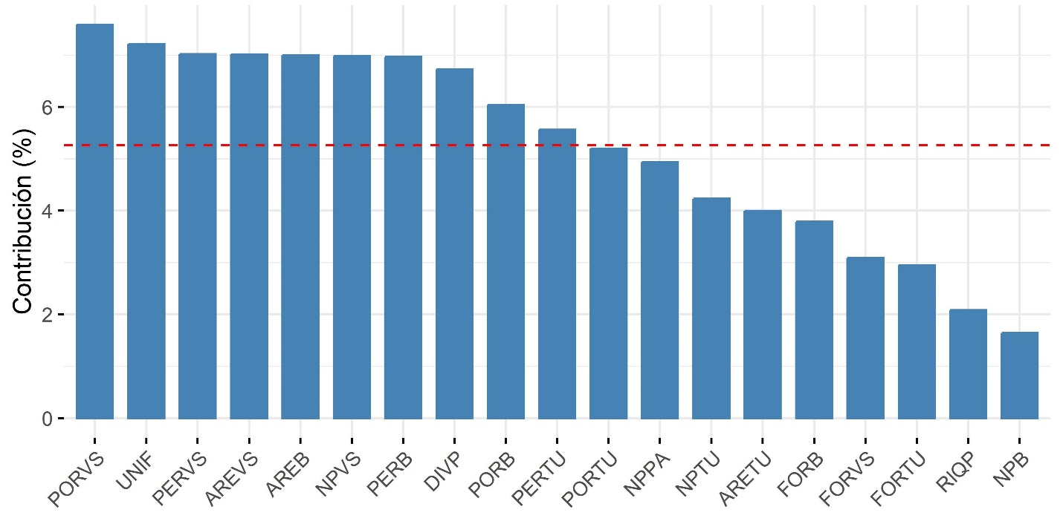
MSF 8. Contribución de las métricas de paisaje a los ejes 1 y 2 del Análisis de Componentes Principales (ACP). Se utiliza una línea discontinua roja para resaltar las variables que presentan coeficientes de correlación superiores a 0.5. Variables del paisaje = PORVS: Porcentaje de vegetación secundaria, UNIF: Uniformidad de Shannon, PERVS: Perímetro de los parches de vegetación secundaria, AREVS: Área de los parches de vegetación secundaria, AREB: Área de los parches de bosque, NPVS: Número de parches de vegetación secundaria, PERB: Perímetro de los parches de bosque, DIVP: Diversidad de Shannon, PORB: Porcentaje de bosque, PERTU: Perímetro de los parches de tejido urbano, PORTU: Porcentaje de tejido urbano, NPPA: Número de parches, NPTU: Número de parches de tejido urbano, ARETU: Área de los parches de tejido urbano, FORB: Índice de forma de los parches de bosque, FORVS: Índice de forma de los parches de vegetación secundaria, FORTU: Índice de forma de los parches de tejido urbano, RIQP: Riqueza del parche, NPB: Número de parches de bosque.
SMF 8. Contribution of landscape metrics to axes 1 and 2 of the Principal Component Analysis (PCA). A red dashed line is used to highlight variables with correlation coefficients greater than 0.5. Landscape variables = PORVS: Percentage of secondary vegetation, UNIF: Shannon evenness, PERVS: Perimeter of secondary vegetation patches, AREVS: Area of secondary vegetation patches, AREB: Area of forest patches, NPVS: Number of secondary vegetation patches, PERB: Perimeter of forest patches, DIVP: Shannon diversity, PORB: Percentage of forest, PERTU: Perimeter of urban fabric patches, PORTU: Percentage of urban fabric, NPPA: Number of patches, NPTU: Number of urban fabric patches, ARETU: Area of urban fabric patches, FORB: Shape index of forest patches, FORVS: Shape index of secondary vegetation patches, FORTU: Shape index of urban fabric patches, RIQP: Patch richness, NPB: Number of forest patches.
MST 9
Modelos lineales generalizados para la riqueza de especies (q=0). AIC = Criterio de información de Akaike, * = Valor p < 0.05. Variables del paisaje = DIVP: diversidad de Shannon, UNIF: uniformidad de Shannon, PORVS: porcentaje de vegetación secundaria,
NPVS: número de parches de vegetación secundaria, AREB: área de los parches de bosque, PERB: perímetro de los parches de bosque, PERVS: perímetro de los parches de vegetación secundaria, PORB: Porcentaje de bosque, AREVS: área de los parches de vegetación secundaria, PERTU: perímetro de los parches de tejido urbano
SMT 9
Generalized linear models for species richness (q=0). AIC = Akaike's information criterion, * = p-value < 0.05. Landscape variables = DIVP: Shannon diversity, UNIF: Shannon evenness, PORVS: percentage of secondary vegetation, NPVS: number of secondary vegetation patches, AREB: area of forest patches, PERB: perimeter of forest patches, PERVS: perimeter of secondary vegetation patches, PORB: Percentage of forest, AREVS: area of secondary vegetation patches, PERTU: perimeter of urban fabric patches
Modelos | Coeficientes | Valor p | AIC | wi
q=0 | (Intercepto)  DIVP  UNIF  PORVS  NPVS  AREB  PERB  PERVS  PORB  AREVS  PERTU | 0.134  0.754  0.745  0.754  0.883  0.893  0.780  0.641  0.689  0.854  0.644 | 320.8 | 0
q=0 | (Intercepto)  DIVP  PORVS  NPVS  AREB  PERB  PERVS  PORB  AREVS  UNIF | 0.093  0.991  0.956  0.783  0.789  0.995  0.777  0.234  0.968  0.880 | 251.7 | 0.001
q=0 | (Intercepto)  PORVS  NPVS  PERB  PERVS  PORB  AREVS | < 2e-16 ***  0.377  0.035 *  0.825  0.309  1.31e-13 ***  0.391 | 253.2 | 0
q=0 | (Intercepto)  DIVP  UNIF  PORVS  AREB  PORB | < 2e-16 ***  0.009 **  0.009 **  0.749  0.021*  4.44e-11 *** | 238.4 | 0.462
q=0 | (Intercepto)  DIVP  UNIF  PORVS  PERVS  PERTU | < 2e-16 ***  2.24e-05 ***  0.0003 ***  1.74e-05 ***  0.003 **  6.36e-11 *** | 238.1 | 0.537

