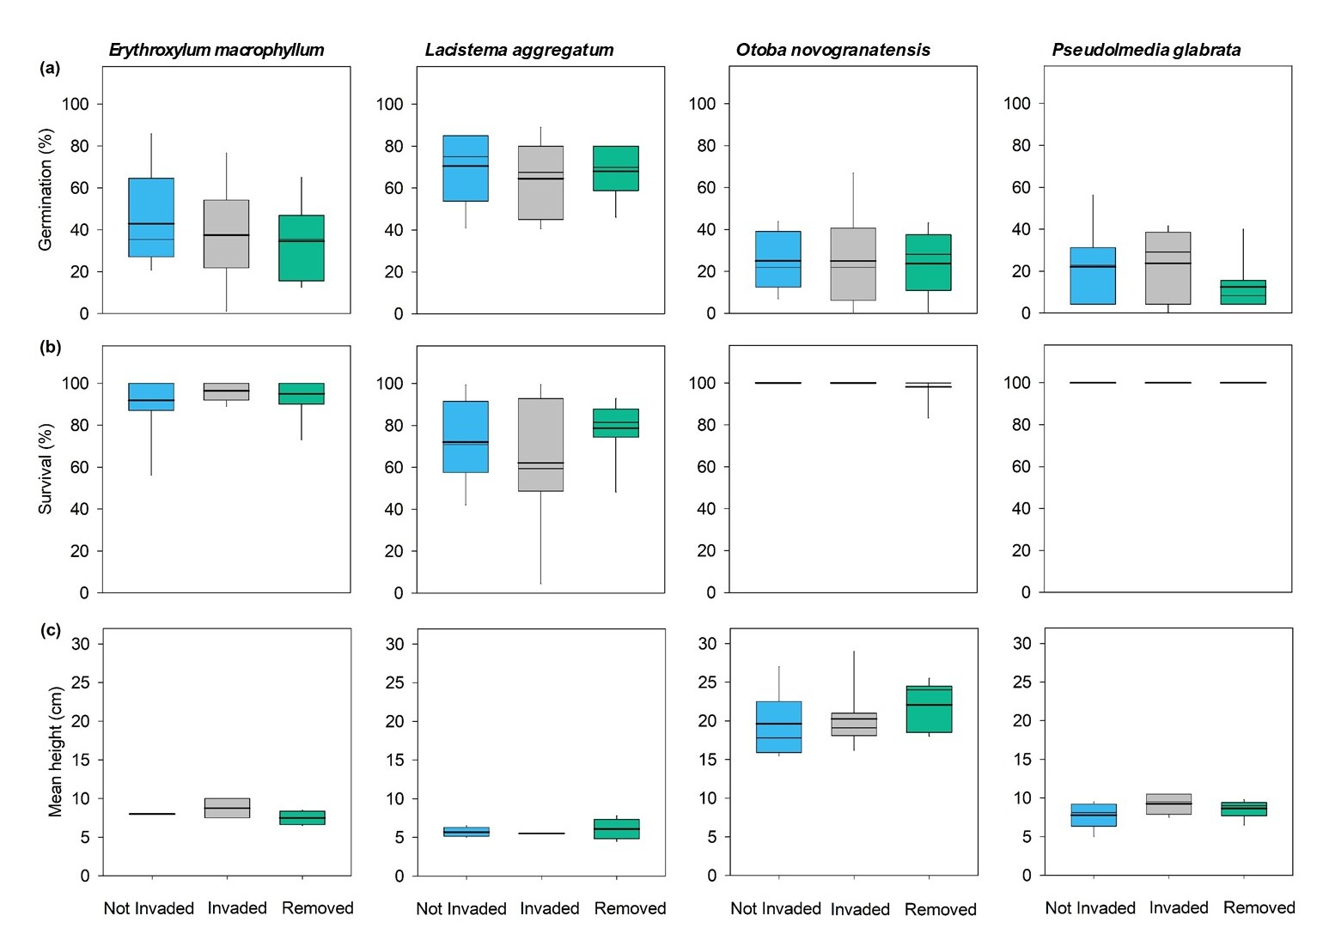
SMF 1. Outcomes of seed germination, seedling survival and growth (height) of four native species placed in each of three treatments (invaded, closed canopy forest). (a) Shows percent germination for each of the four species under each treatment. (b) Shows percent survival of each of the four species under each treatment. (c) Shows mean height of each of the four species under each treatment. Boxes show the median (bold line), mean (lighter lines). There were no significant differences across treatment for any variables after one year (p > 0.05 in all cases).

SMT 1
Pearson’s correlation coefficients for the relationship of Z. spectabile invasion level (aboveground biomass) with forest characteristics pooled across primary and secondary forest (n = 24)
Forest characteristic | r | p
Basal area (m²/ha) | 0.13 | 0.530
% Canopy openness | 0.34 | 0.112
% Volumetric water content (VWC) | -0.04 | 0.851

SMT 2
Statistical results of linear mixed-effects model for understory vegetation metrics (n = 6)

Understory vegetation metric |  |  | F | p
Primary forest | Z. spectabile aboveground biomass
Primary forest |  | Time | 1.0 | 0.333
Primary forest |  | Treatment | 4.2 | 0.066
Primary forest |  | Time * Treatment | 9.3 | 0.012
Primary forest | Woody saplings
Primary forest |  | Time | 0.7 | 0.430
Primary forest |  | Treatment | 0.6 | 0.447
Primary forest |  | Time * Treatment | 0.1 | 0.810
Primary forest | Herbs
Primary forest |  | Time | 3.8 | 0.079
Primary forest |  | Treatment | 0.9 | 0.356
Primary forest |  | Time * Treatment | 0.1 | 0.741
Primary forest | Woody seedlings
Primary forest |  | Time | 15.3 | 0.003
Primary forest |  | Treatment | 1.3 | 0.275
Primary forest |  | Time * Treatment | 0.3 | 0.617
Secondary Forest | Z. spectabile aboveground biomass
Secondary Forest |  | Time | 10.7 | 0.008
Secondary Forest |  | Treatment | 0.3 | 0.577
Secondary Forest |  | Time * Treatment | 13.2 | 0.005
Secondary Forest | Woody saplings
Secondary Forest |  | Time | 6.9 | 0.026
Secondary Forest |  | Treatment | 0.0 | 0.857
Secondary Forest |  | Time * Treatment | 0.7 | 0.419
Secondary Forest | Herbs
Secondary Forest |  | Time | 5.4 | 0.043
Secondary Forest |  | Treatment | 5.7 | 0.037
Secondary Forest |  | Time * Treatment | 2.6 | 0.138
Secondary Forest | Woody seedlings
Secondary Forest |  | Time | 0.2 | 0.649
Secondary Forest |  | Treatment | 0.1 | 0.753
Secondary Forest |  | Time * Treatment | 0.1 | 0.748
Significant p values are shown in bold text.

