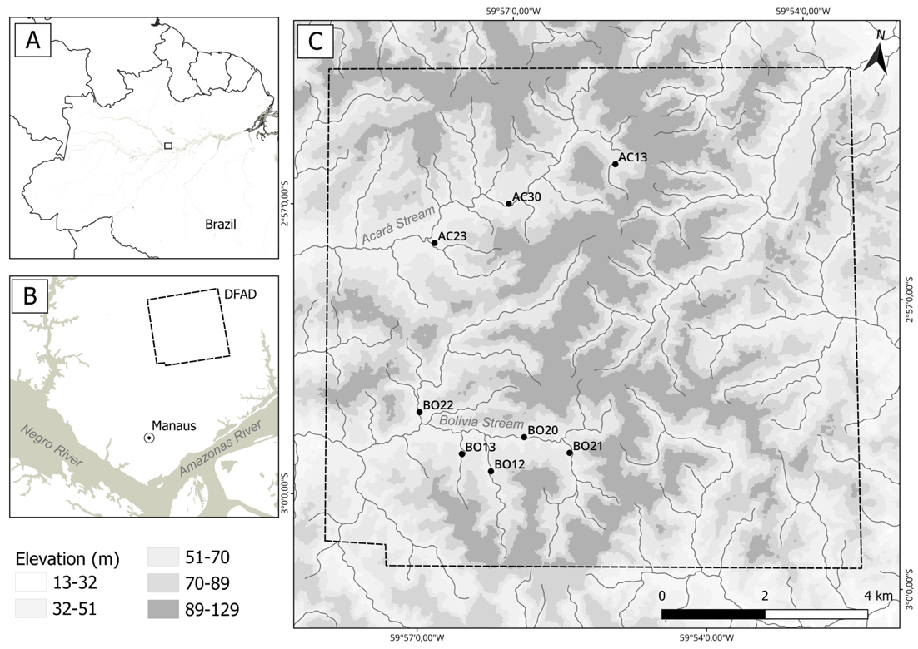

**SMF 1.** Geographic location of **A.** Brazil, **B.** Reserva Forestal Adolpho Ducke (RFAD) north of the city of Manaus, and **C.** sampling sites for specimen collection and underwater observations in the studied streams (●).

SMT 1

Co-occurrence situations in which the species were found in the studied streams

|  |  |  |  |  |  |  |  |  |
| --- | --- | --- | --- | --- | --- | --- | --- | --- |
| Species | AC30 | BO13 | AC23 | AC13 | BO20 | BO12 | BO21 | BO22 |
| *Bryconops giacopinii* | x |  | x |  | x | x | x | x |
| *Bryconops inpai* |  |  |  | x |  |  |  |  |
| *Hyphessobrycon* aff. *melazonatus* |  | x | x | x | x | x | x | x |
| *Iguanodectes geisleri* |  |  |  |  |  | x | x | x |

**SMF 2.** Frequency of Occurrence (FO %) for **A.** horizontal and **B.** vertical space use and **C.** foraging among the four species in the eight sampled streams. GEI = *Iguanodectes geisleri*; GIA = *Bryconops giacopinii*; INP = *Bryconops inpai*; MEL = *Hyphessobrycon* aff. *melazonatus*. Significant differences (p < 0.05) in comparisons within species (water column x surface) and between species (water column or surface among GEI, GIA, INP, and MEL) are indicated by different letters.

SMT 2

### Proportion of the Food Index (*FI*i) for each food category found in the stomach contents of the four stream fish species studied in the Amazon Rainforest

|  | *B. giacopinii*  (n = 60) | | | *B. inpai*  (n = 10) | | | *H.* aff. *melazonatus*  (n = 70) | | | 1. *geisleri*   (n =30) | | | |
| --- | --- | --- | --- | --- | --- | --- | --- | --- | --- | --- | --- | --- | --- |
|  | *F*i | *V*i | *FI*i | *F*i | *V*i | *FI*i | *F*i | *V*i | *FI*i | | *F*i | *V*i | *FI*i |
| **Allochthonous food items** |  |  |  |  |  |  |  |  |  | |  |  |  |
| Isoptera | 16.67 | 2.98 | 0.68 | 30 | 5.56 | 2.03 | 17.14 | 1.51 | 0.35 | | 43.33 | 4.71 | 2.43 |
| Hymenoptera | 98.33 | 13.14 | 17.81 | 100 | 18.54 | 22.56 | 87.14 | 18.64 | 21.93 | | 96.67 | 22.55 | 26.03 |
| Plant Fragments | 83.33 | 12.29 | 14.12 | 90 | 14.02 | 15.35 | 75.71 | 8.40 | 8.59 | | 86.67 | 8.22 | 8.50 |
| Insect Fragments | 96.67 | 32.22 | 42.94 | 100 | 39.92 | 48.59 | 94.29 | 28.14 | 35.81 | | 96.67 | 39.50 | 45.59 |
| Coleoptera | 28.33 | 3.60 | 1.41 | 50 | 3.36 | 2.04 | 17.14 | 1.96 | 0.45 | | 33.33 | 2.04 | 0.81 |
| Araneae | 33.33 | 4.52 | 2.08 | 0 | 0 | 0 | 10 | 1.45 | 0.20 | | 33.33 | 2.12 | 0.84 |
| **Autochthonous food items** |  |  |  |  |  |  |  |  |  | |  |  |  |
| Coleoptera Larvae | 16.67 | 0.84 | 0.19 | 10 | 1.42 | 0.17 | 22.86 | 3.36 | 1.04 | | 23.33 | 0.59 | 0.16 |
| Diptera Pupae | 50 | 2.28 | 1.57 | 0 | 0 | 0 | 45.71 | 2.98 | 1.84 | | 46.67 | 1.48 | 0.82 |
| Trichoptera Larvae | 36.67 | 2.07 | 1.05 | 0 | 0 | 0 | 18.57 | 1.05 | 0.26 | | 16.67 | 0.76 | 0.15 |
| Ephemeroptera Larvae | 90 | 11.80 | 14.64 | 80 | 8.40 | 8.18 | 90 | 20.59 | 25.01 | | 96.67 | 11.60 | 13.39 |
| Diptera Larvae | 58.33 | 2.83 | 2.28 | 10 | 0.13 | 0.02 | 64.29 | 4.71 | 4.09 | | 40 | 1.61 | 0.77 |

### The *FI*i reflects the contribution and importance of each food category in the diet of the specimens. *F*i is the frequency of occurrence and *V*i is the relative volume.

**SMF 3.**Proportion of the Food Index (*FI*i) for each food category found in the stomach contents of the four stream fish species studied in the Amazon Rainforest. The *FI*i reflects the contribution and importance of each food category in the diet of the specimens. Only food categories with an *FI*i value greater than 1 for at least one species are shown.

SMT 3

Results of the MANOVA test for differences in stomach content among species pairs with Holm-s correction (p < 0.006)

| Pairwise species | F | r² | p |
| --- | --- | --- | --- |
| MEL-GIA | 51.335 | 0.45 | <0.001 |
| MEL-INP | 33.465 | 0.41 | <0.001 |
| MEL-GEI | 42.316 | 0.43 | <0.001 |
| GIA-INP | 2.318 | 0.37 | 0.016 |
| GIA-GEI | 2.071 | 0.29 | 0.018 |
| INP-GEI | 2.412 | 0.52 | 0.007 |

GIA–*B. giacopinii*; MEL–*H.* aff. *melazonatus*; INP–*B. inpai*; GEI–*I. geisleri*.

**SMF 4.** Principal Component Analysis (PCA)-PC1 and PC2. Distribution of individuals of the four species in the ecomorphological space. OB–mouth orientation; IC–compression index; ALRC–relative body height; ICPC–caudal peduncle compression index; CRC–relative head length; TRO–relative eye size; LRB–relative mouth width; ARB–relative mouth height; RAB–mouth configuration ratio; CRPC–relative caudal peduncle length; ARD–relative dorsal fin area.

**SMF 5.** Principal Component Analysis (PCA)-PC1 and PC2. Distribution of individuals of the four species in the ecomorphological space. CRPC–relative lenght of caudal peduncle; ARD–relative dorsal fin area; ARB–relative mouth height; RAB–mouth configuration ratio; ARPt–relative area of pectoral fin; ARPv–relative area of pelvic fin.

SMT 4

Results of the MANOVA test for morphological differences among species pairs, with a corrected significance level of p < 0.006 (Holm, 1979)

| Pairwise species | F | r² | p |
| --- | --- | --- | --- |
| MEL-GIA | 29.022 | 0.40 | <0.001 |
| MEL-INP | 6.878 | 0.15 | <0.001 |
| MEL-GEI | 84.825 | 0.66 | <0.001 |
| GIA-INP | 24.264 | 0.36 | <0.001 |
| GIA-GEI | 56.223 | 0.57 | <0.001 |
| INP-GEI | 106.26 | 0.71 | <0.001 |

GIA–*B. giacopinii*; MEL–*H.* aff. *melazonatus*; INP–*B. inpai*; GEI–*I. geisleri*.