APPENDIX 1
Average live coral cover (LCC) and Reef Functional Index (RFI) values. Percent changes for each period are also included.
Year | PNIM | IL | IR | CM | ZRS | ZR | TA | PP | PA
2012 | RFI: 0.419 ± 0.193  LCC: 12.928 ± 12.450 | RFI: 0.501 ± 0.171  LCC: 17.400 ± 14.569 | RFI: 0.338 ± 0.183  LCC: 8.456 ± 8.279 | RFI: 0.478 ± 0.093  ∆% (1997* – 2012) = -19.05 %  LCC: 11.133 ± 7.025 ∆% (1997* – 2012) = 38.49 % | RFI: 0.376 ± 0.193  ∆% (1997* – 2012) = -36.40 %  LCC: 8.667 ± 8.308 ∆% (1997* – 2012) = -52.12 % | RFI: 0.648 ± 0.095 ∆% (1997* – 2012) = 9.64%  LCC: 32.400 ± 14.100 ∆% (1997* – 2012) = 79.00 % | RFI: 0.309 ± 0.203 ∆% (1997* – 2012) = -49.66 %  LCC: 7.000 ± 7.389 ∆% (1997* – 2012) = -67.59 % | RFI: 0.408 ± 0.129 ∆% (1997* – 2012) = -33.60 %  LCC: 10.367 ± 8.367 ∆% (1997* – 2012) = -52.01 % | RFI: 0.298 ± 0.224 ∆% (1997* – 2012) = -51-45 %  LCC: 8.000 ± 10.385 ∆% (1997* – 2012) = -62-96 %
2013 | RFI: 0.454 ± 0.193  LCC: 16.289 ± 15.523 | RFI: 0.548 ± 0.161  LCC: 22.956 ± 17.920 | RFI: 0.360 ± 0.180  LCC: 9.622± 9.097 | RFI: 0.494 ± 0.181  LCC: 15.933± 10.405 | RFI: 0.673 ± 0.133  LCC: 41.567 ± 17.805 | RFI: 0.475 ± 0.100  LCC: 11.367 ± 6.015 | RFI: 0.347 ± 0.164  LCC: 7.467 ± 7.536 | RFI: 0.390 ± 0.193  LCC: 11.800 ± 10.484 | RFI: 0.342 ± 0.219  LCC: 9.600 ± 10.545
2014 | RFI: 0.439 ± 0.166  LCC: 12.572 ± 11.505 | RFI: 0.535 ± 0.130  LCC: 18.000 ± 13.294 | RFI: 0.344 ± 0.143  LCC: 7.144 ± 5.860 | RFI: 0.496 ± 0.134  ∆% (2012 – 2014) = 3.73 %  LCC: 13.367 ± 9.492 ∆% (2012 – 2014) = 20.06 % | RFI: 0.495 ± 0.131  ∆% (2012 – 2014) = 31.70 %  LCC: 12.933 ± 7.627 ∆% (2012 – 2014) = 49.23 % | RFI: 0.613 ± 0.113  ∆% (2012 – 2014) = -5.32 %  LCC: 27.700 ± 17.140  ∆% (2012 – 2014) = -14.51 % | RFI: 0.338 ± 0.140 ∆% (2012 – 2014) = 9.48 %  LCC: 6.200 ± 4.938 ∆% (2012 – 2014) = -11.42 % | RFI: 0.369 ± 0.148 ∆% (2012 – 2014) = -9.46 %  LCC: 8.400 ± 5.566 ∆% (2012 – 2014) = -18.97 % | RFI: 0.323 ± 0.172  ∆% (2012 – 2014) = 8.51 %  LCC: 6.833 ± 7.849  ∆% (2012 – 2014) = -14.58 %
2015 | RFI: 0.467 ± 0.175  LCC: 14.097 ± 12.672 | RFI: 0.581 ± 0.101  LCC: 21.261 ± 13.844 | RFI: 0.354 ± 0.161  LCC: 6.933 ± 5.568 | RFI: 0.544 ± 0.117  LCC: 17.600 ± 13.585 | RFI: 0.548 ± 0.058  LCC: 15.667 ± 5.006 | RFI: 0.650 ± 0.099  LCC: 30.517 ± 17.269 | RFI: 0.310 ± 0.177  LCC: 5.567 ± 3.980 | RFI: 0.403 ± 0.166  LCC: 10.000 ± 6.999 | RFI: 0.347 ± 0.161  LCC: 5.233 ± 5.097
2016 | RFI: 0.453 ± 0.185  LCC: 13.339 ± 12.159 | RFI: 0.566 ± 0.129  LCC: 20.578 ± 12.172 | RFI: 0.340 ± 0.164  LCC: 6.100 ± 6.768 | RFI: 0.531 ± 0.154  LCC: 17.633 ± 14.175 | RFI: 0.525 ± 0.136  LCC: 15.767 ± 9.384 | RFI: 0.641 ± 0.070  LCC: 28.333 ± 10.707 | RFI: 0.308 ± 0.077  LCC: 2.833 ± 2.098 | RFI: 0.422 ± 0.141  LCC: 10.267 ± 9.342 | RFI: 0.291 ± 0.237  LCC: 5.200 ± 5.707
2017 | RFI: 0.482 ± 0.149  LCC: 13.672 ± 10.589 | RFI: 0.583 ± 0.092  LCC: 20.567 ± 9.901 | RFI: 0.381 ± 0.124  LCC: 6.778 ± 5.691 | RFI: 0.542 ± 0.081  LCC: 15.133 ± 7.991 | RFI: 0.583 ± 0.121  LCC: 21.067 ± 9.939 | RFI: 0.625 ± 0.063  LCC: 25.500 ± 10.623 | RFI: 0.337 ± 0.133  LCC: 4.900 ± 2.613 | RFI: 0.466 ± 0.073  LCC: 10.867 ± 5.620 | RFI: 0.340 ± 0.132  LCC: 4.567 ± 6.598
2018 | RFI: 0.489 ± 0.169  LCC: 16.217± 13.872 | RFI: 0.586 ± 0.126  LCC: 23.544 ± 14.755 | RFI: 0.392 ± 0.152  LCC: 8.889± 8.115 | RFI: 0.560 ± 0.122  LCC: 19.667 ± 14.957 | RFI: 0.539 ± 0.149  LCC: 17.800 ± 9.105 | RFI: 0.658 ± 0.090  LCC: 33.167 ± 16.721 | RFI: 0.321 ± 0.137  LCC: 4.867 ± 2.772 | RFI: 0.479 ± 0.102  LCC: 13.367 ± 8.754 | RFI: 0.374 ± 0.189  LCC: 8.433 ± 10.031
2019 | RFI: 0.524 ± 0.162  LCC: 19.339 ± 13.724 | RFI: 0.625 ± 0.101  LCC: 27.756 ± 12.458 | RFI: 0.423 ± 0.151  LCC: 10.922 ± 9.118 | RFI: 0.612 ± 0.077  LCC: 24.267 ± 10.568 | RFI: 0.581 ± 0.136  LCC: 22.567 ± 12.479 | RFI: 0.681 ± 0.068  LCC: 36.433 ± 11.523 | RFI: 0.355 ± 0.149  LCC: 4.867 ± 2.772 | RFI: 0.524 ± 0.064  LCC: 16.467 ± 7.837 | RFI: 0.391 ± 0.182  LCC: 9.200 ± 12.332
2020 | RFI: 0.544 ± 0.152  LCC: 20.872 ± 15.001 | RFI: 0.646 ± 0.094  LCC: 30.367 ± 12.758 | RFI: 0.442 ± 0.128  LCC: 11.378 ± 10.497 | RFI: 0.604 ± 0.124  LCC: 25.400 ± 17.249 | RFI: 0.643 ± 0.097  LCC: 29.400 ± 12.050 | RFI: 0.692 ± 0.038  LCC: 36.300 ± 7.137 | RFI: 0.362 ± 0.091  LCC: 5.367 ± 3.237 | RFI: 0.526 ± 0.061  LCC: 16.567 ± 7.521 | RFI: 0.439 ± 0.169  LCC: 12.200 ± 15.457
2021 | RFI: 0.549 ± 0.187  LCC: 23.661 ± 17.786 | RFI: 0.662 ± 0.112  LCC: 34.244 ± 16.642 | RFI: 0.436 ± 0.181  LCC: 13.078 ± 11.761 | RFI: 0.609 ± 0.097  LCC: 24.367 ± 13.370 | RFI: 0.624 ± 0.130  LCC: 27.767 ± 13.776 | RFI: 0.752 ± 0.045  LCC: 50.600 ± 9.589 | RFI: 0.293 ± 0.184  LCC: 5.733 ± 6.203 | RFI: 0.557 ± 0.044  LCC: 19.533 ± 5.877 | RFI: 0.459 ± 0.185  LCC: 13.967 ± 17.047
2022 | RFI: 0.569 ± 0.170  LCC: 25.267± 17.891 | RFI: 0.672 ± 0.106  LCC: 36.267 ± 16.544 | RFI: 0.465 ± 0.161  LCC: 14.267 ± 11.403 | RFI: 0.639 ± 0.098  LCC: 29.200 ± 16.170 | RFI: 0.628 ± 0.127  LCC: 28.700 ± 13.447 | RFI: 0.749 ± 0.052  LCC: 50.900 ± 10.679 | RFI: 0.347 ± 0.179  LCC: 7.533 ± 7.058 | RFI: 0.557 ± 0.061  LCC: 20.200 ± 7.259 | RFI: 0.492 ± 0.161  LCC: 15.067 ± 15.845
2023 | RFI: 0.538 ± 0.154  LCC: 20.689 ± 14.244 | RFI: 0.630 ± 0.116  LCC: 29.200 ± 13.730 | RFI: 0.447 ± 0.133  LCC: 12.178± 8.748 | RFI: 0.617 ± 0.118  ∆% (2014 – 2023) = 24.33 %  ∆% (1997* – 2023) = 4.41 %  LCC: 26.933 ± 15.664 ∆% (2014 – 2023) = 101.50 %  ∆% (1997* – 2023) = 48.80 % | RFI: 0.591 ± 0.153  ∆% (2014 – 2023) = 19.54 %  ∆% (1997* – 2023) = 0.12 %  LCC: 24.367 ± 13.198 ∆% (2014 – 2023) = 88.40 %  ∆% (1997* – 2023) = 34.62 % | RFI: 0.682 ± 0.065  ∆% (2014 – 2023) = 11.17 %  ∆% (1997* – 2023) = 15.40 %  LCC: 36.300 ± 11.899  ∆% (2014 – 2023) = 31.05 %  ∆% (1997* – 2023) = 100.55 % | RFI: 0.354 ± 0.117 ∆% (2014 – 2023) = 4.62 %  ∆% (1997* – 2023) = -42.34 %  LCC: 7.200 ± 4.332 ∆% (2014 – 2023) = 16.13 %  ∆% (1997* – 2023) = -66.67 % | RFI: 0.521 ± 0.041 ∆% (2014 – 2023) = 41.21 %  ∆% (1997* – 2023) = -15.11 %  LCC: 16.067 ± 4.672 ∆% (2014 – 2023) = 91.27 %  ∆% (1997* – 2023) = -25.62 % | RFI: 0.465 ± 0.169  ∆% (2014 – 2023) = 43.78 %  ∆% (1997* – 2023) = -24.26 %  LCC: 13.267 ± 13.262 ∆% (2014 – 2023) = 94.15 %  ∆% (1997* – 2023) = -38.58 %

∆% = Percentage of change. * The baseline data used to calculate the rate of change correspond to the island to which each site belongs. PNIM = Parque Nacional Islas Marietas, IL = Isla Larga, IR = Isla Redonda, ZR = Zona de Restauración, ZRS = Zona de Restauración Sur, CM = Cueva del Muerto, PP = Plataforma Pavonas, TA = Túnel Amarradero, PA = Playa del Amor

APPENDIX 2
Historical trends in live coral cover (LCC; a, b, c) and reef functional index (RFI; d, e, f) across different sites of Isla Larga. RP = beginning of the restoration program; CM = Cueva del Muerto; ZRS = Zona de Restauración Sur; ZR = Zona de Restauración.

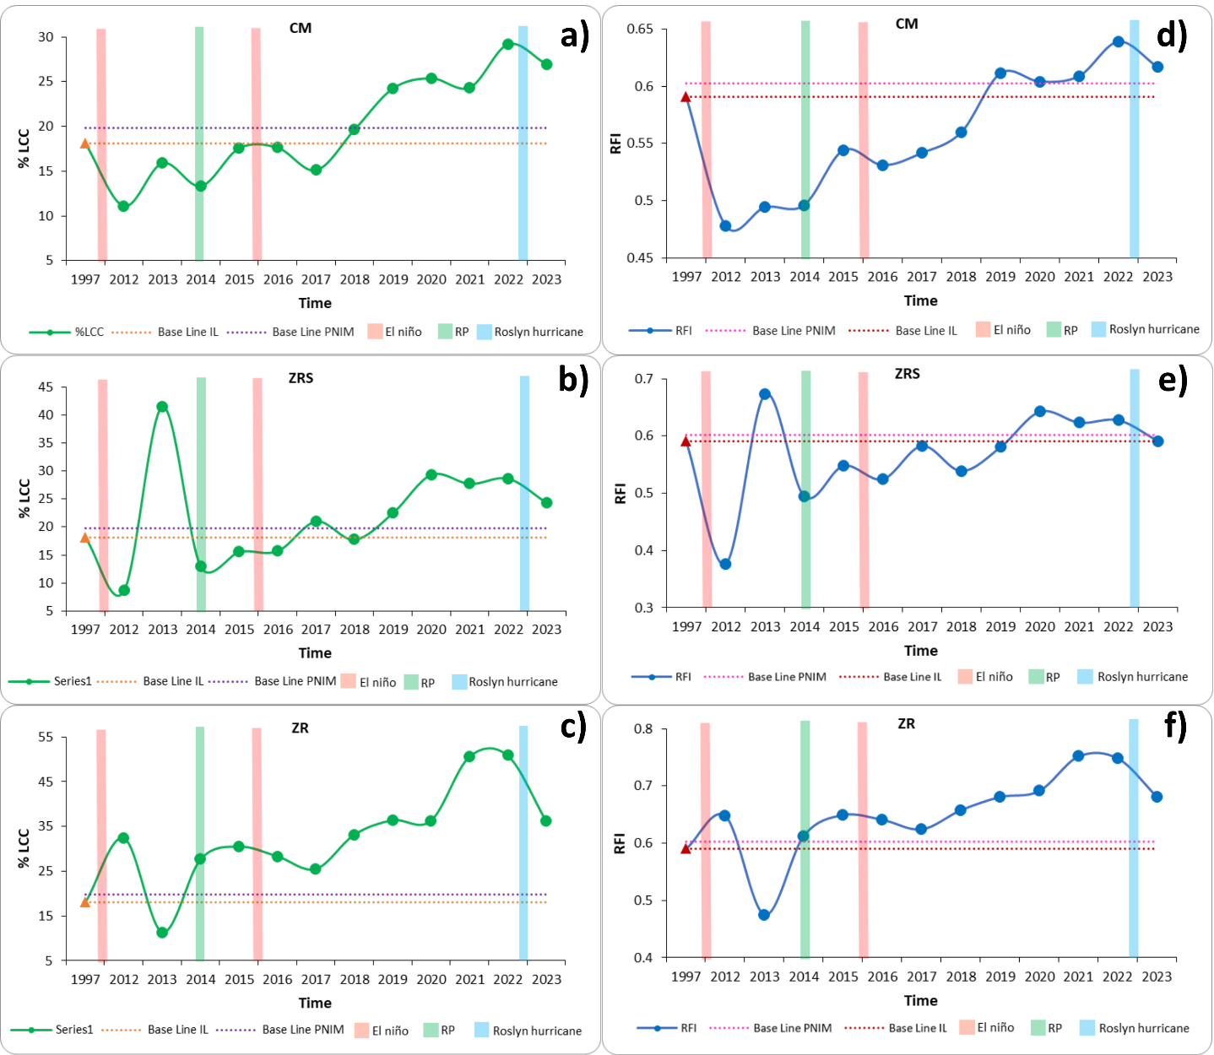

APPENDIX 3
Historical trends in live coral cover (LCC; a, b, c) and reef functional index (RFI; d, e, f) across different sites of Isla Redonda. RP = beginning of the restoration program; TA = Túnel Amarradero; PP = Plataforma Pavonas; PA = Playa del Amor.

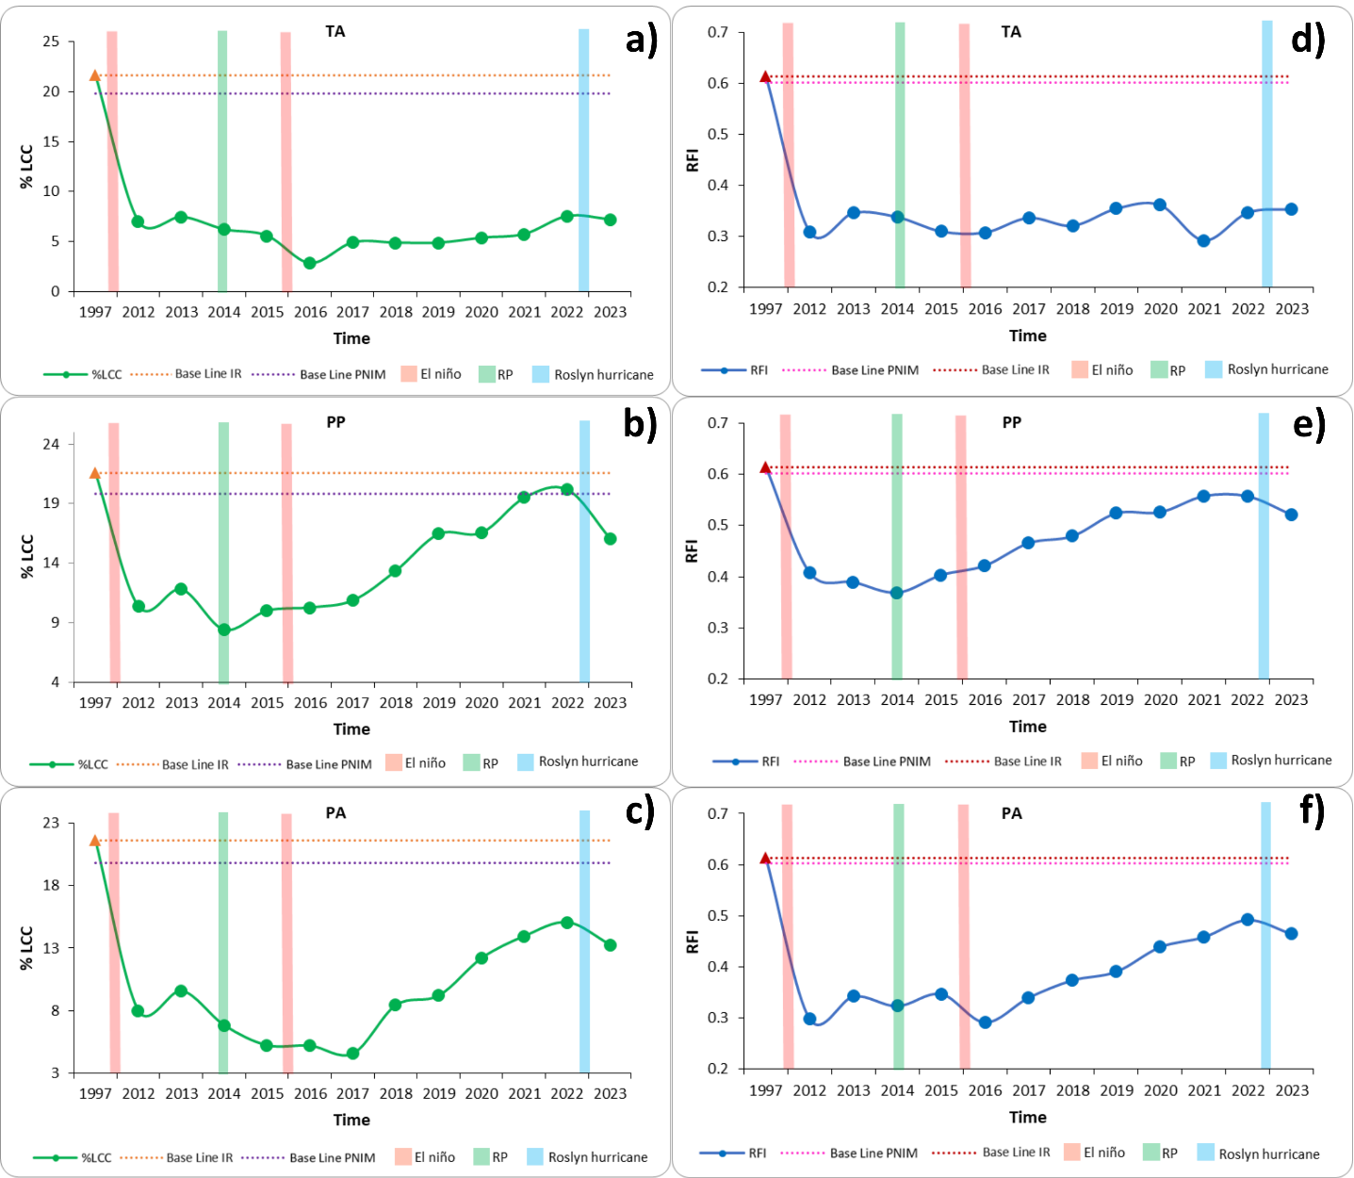

APPENDIX 4
Global LCC model
Term | Estimate | Std.Error | z | p
Intercept | -1.56300 | 0.05087 | -30.728 | <2e-16
Year_c | 0.06120 | 0.01359 | 4.505 | 6.65e-06

APPENDIX 5
Type III Wald Chi-Square Tests for the Global LCC Model
Effect | Chisq | Df | Pr(>Chisq)
(Intercept) | 944.182 | 1 | < 2.2 × 10⁻¹⁶
Year_c | 20.291 | 1 | 6.651 × 10⁻⁶

APPENDIX 6
LCC model – Island fixed
Term | Estimate | Std.Error | z | p
Intercept | -1.13273 | 0.05283 | -21.441 | <2e-16
Year_c | 0.08377 | 0.01520 | 5.512 | 3.54e-08
Island: Redonda | -1.02865 | 0.08509 | -12.089 | <2e-16
Year_c × Redonda | -0.03361 | 0.02457 | -1.368 | 0.171

APPENDIX 7
Type III Wald Chi-Square Tests for the LCC Model – Island fixed
Effect | Chisq | Df | Pr(>Chisq)
(Intercept) | 459.708 | 1 | < 2.2e-16
Year_c | 30.384 | 1 | 3.543e-08
Island | 146.136 | 1 | < 2.2e-16
Year-C:Island | 1.872 | 1 | 0.1712

APPENDIX 8
LCC model – Site fixed
Term | Estimate | Std.Error | z | p
Intercept | -1.422387 | 0.088805 | -16.017 | <2e-16
Year_c | 0.091191 | 0.025590 | 3.564 | 0.000366
Site: Plataforma Pavonas | -0.364149 | 0.130415 | -2.792 | 0.005235
Site: Playa del Amor | -0.965863 | 0.144905 | -6.666 | 2.64e-11
Site: Túnel Amarradero | -1.070445 | 0.145228 | -7.371 | 1.70e-13
Site: Zona de Restauración | 0.706999 | 0.117054 | 6.040 | 1.54e-09
Site: ZR Sur | 0.094442 | 0.123661 | 0.764 | 0.445035
Year_c × Pavonas | -0.006485 | 0.037843 | -0.171 | 0.863930
Year_c × Playa del Amor | -0.025706 | 0.042892 | -0.599 | 0.548960
Year_c × Túnel Amarradero | -0.079924 | 0.042347 | -1.887 | 0.059115
Year_c × ZR | 0.012533 | 0.034140 | 0.367 | 0.713541
Year_c × ZR Sur | -0.028750 | 0.035909 | -0.801 | 0.423331

APPENDIX 9
Type III Wald Chi-Square Tests for the LCC Model – Site fixed
Effect | Chisq | Df | Pr(>Chisq)
(Intercept) | 256.544 | 1 | < 2.2e-16
Year_c | 12.699 | 1 | 0.0003659
Site | 243.820 | 5 | < 2.2e-16
Year-C:Site | 6.013 | 5 | 0.3049593

APPENDIX 10
LCC model – by site
Term | Estimate | Std.Error | z | p
Cueva del Muerto
Intercept | -1.40683 | 0.09571 | -14.699 | <2e-16
Year_c | 0.08968 | 0.02669 | 3.361 | 0.000778
Plataforma Pavonas
Intercept | -1.87772 | 0.08198 | -22.905 | < 2e-16
Year_c | 0.09149 | 0.02303 | 3.972 | 7.13e-05
Playa del Amor
Intercept | -2.26895 | 0.14395 | -15.762 | <2e-16
Year_c | 0.05875 | 0.03661 | 1.605 | 0.109
Tunel Amarradero
Intercept | -2.73015 | 0.10042 | -27.187 | <2e-16
Year_c | 0.01377 | 0.02821 | 0.488 | 0.625
Zona de Restauración
Intercept | -0.71531 | 0.07748 | -9.233 | <2e-16
Year_c | 0.10371 | 0.02269 | 4.571 | 4.84e-06
Zona de Restauración sur
Intercept | -1.27474 | 0.10444 | -12.205 | <2e-16
Year_c | 0.05917 | 0.02906 | 2.036 | 0.0417

APPENDIX 11
Global RFI model
Term | Estimate | Std. Error | z | p
(Intercept) | 0.2319 | 0.0708 | 3.273 | 0.0010
Year_c | 0.0579 | 0.0206 | 2.809 | 0.0050
Site: Plataforma Pavonas | −0.3745 | 0.1001 | −3.740 | <.001
Site: Playa del Amor | −0.8279 | 0.1023 | −8.097 | <.001
Site: Túnel Amarradero | −0.9497 | 0.1025 | −9.263 | <.001
Site: Zona de Restauración | 0.3789 | 0.1019 | 3.720 | <.001
Site: Zona de Restauración Sur | 0.0186 | 0.1002 | 0.186 | 0.853
Year_c × Plataforma Pavonas | 0.0147 | 0.0292 | 0.503 | 0.615
Year_c × Playa del Amor | 0.0363 | 0.0300 | 1.210 | 0.226
Year_c × Túnel Amarradero | −0.0449 | 0.0297 | −1.512 | 0.131
Year_c × Zona de Restauración | 0.0008 | 0.0296 | 0.027 | 0.979
Year_c × Zona de Restauración Sur | −0.0080 | 0.0291 | −0.275 | 0.783

APPENDIX 12
Type III Wald Chi-Square Tests for the Global RFI Model
Effect | Chisq | Df | Pr(>Chisq)
(Intercept) | 10.7151 | 1 | 0.001052
Year_c | 7.8897 | 1 | 0.004972
Site | 251.3712 | 5 | <2.2e-16
Year_c:Site | 7.8320 | 5 | 0.165741

APPENDIX 13
RFI model – Island fixed
Term | Estimate | Std.Error | z | p
Intercept | 0.359732 | 0.044323 | 8.116 | 4.81e-16
Year_c | 0.54826 | 0.012890 | 4.253 | 2.11e-05
Island: Redonda | -0.838969 | 0.063189 | -13.277 | < 2e-16
Year_c × Redonda | 0.003679 | 0.018337 | 0.201 | 0.841

APPENDIX 14
Type III Wald Chi-Square Tests for the RFI Model – Island fixed
Effect | Chisq | Df | Pr(>Chisq)
(Intercept) | 65.8717 | 1 | 4.813e-16
Year_c | 18.0899 | 1 | 2.107e-05
Island | 176.2847 | 1 | < 2.2e-16
Year-C:Island | 0.0402 | 1 | 0.841

APPENDIX 15
RFI model – by site
Term | Estimate | Std.Error | z | p
Cueva del Muerto
Intercept | 0.23944 | 0.05666 | 4.226 | 2.38e-05
Year_c | 0.05982 | 0.01650 | 3.626 | 0.000287
Plataforma Pavonas
Intercept | -0.14685 | 0.05811 | -2.527 | 0.0115
Year_c | 0.07475 | 0.01702 | 4.393 | 1.12e-05
Playa del Amor
Intercept | -0.54046 | 0.10143 | -5.329 | 9.9e-08
Year_c | 0.08455 | 0.02965 | 2.851 | 0.00436
Tunel Amarradero
Intercept | -0.70720 | 0.08011 | -8.828 | <2e-16
Year_c | 0.01279 | 0.02290 | 0.558 | 0.577
Zona de Restauración
Intercept | 0.64440 | 0.04762 | 13.531 | <2e-16
Year_c | 0.06230 | 0.01384 | 4.502 | 6.72e-06
Zona de Restauración Sur
Intercept | 0.25014 | 0.07144 | 3.501 | 0.000463
Year_c | 0.04983 | 0.02077 | 2.399 | 0.016428

