MST 1
Riqueza de especies de macrolíquenes epífitos asociados a Comarostaphylis arbutoides y Quercus sp. en el Parque Nacional Volcán Barú, Chiriquí, Panamá
SMT 1
Species richness of epiphytic macrolichens associated with Comarostaphylis arbutoides and Quercus sp. in Baru Volcano National Park, Chiriqui, Panama
Zona / Especie | ZA | ZB | ZC | Comarostaphylis arbutoides | Quercus sp.
Cladoniaceae
Cladonia chlorophaea (Flörke ex Sommerf.) Spreng. | 0 | 1 | 0 | 3 |  | 0
Cladonia squamosa Hoffm. | 0 | 1 | 0 | 1 |  | 0
Cladonia subradiata (Vain.) Sandst. | 1 | 0 | 1 | 2 |  | 0
Cladonia subsquamosa Kremp. | 0 | 1 | 0 | 1 |  | 0
Parmeliaceae
Everniastrum cirrhatum (Fr.) Hale | 1 | 1 | 1 | 18 |  | 3
Everniastrum vexans (Zahlbr. ex W.L. Culb. & C.F. Culb.) Hale ex Sipman | 1 | 0 | 0 | 1 |  | 0
Hypotrachyna bogotensis (Vain.) Hale | 1 | 1 | 1 | 17 |  | 2
Hypotrachyna costaricensis (Nyl.) Hale | 1 | 1 | 1 | 10 |  | 5
Hypotrachyna imbricatula (Zahlbr.) Hale | 1 | 1 | 1 | 11 |  | 0
Hypotrachyna laevigata (Sm.) Hale | 1 | 1 | 0 | 4 |  | 1
Hypotrachyna microblasta (Vain.) Hale | 1 | 0 | 1 | 2 |  | 1
Hypotrachyna aff. reducens (Nyl.) Hale | 1 | 1 | 0 | 4 |  | 1
Parmotrema sp. | 1 | 1 | 0 | 2 |  | 2
Parmotrema dilatatum (Vain.) Hale | 1 | 1 | 0 | 0 |  | 1
Parmotrema praesorediosum (Nyl.) Hale | 1 | 1 | 0 | 1 |  | 4
Punctelia sp. | 0 | 1 | 0 | 1 |  | 1
Usnea sp. 1 | 1 | 1 | 1 | 10 |  | 1
Usnea sp. 2 | 1 | 1 | 0 | 3 |  | 1
Usnea sp. 3 | 1 | 1 | 1 | 6 |  | 0
Usnea sp. 4 | 1 | 1 | 0 | 2 |  | 3
Usnea sp. 5 | 1 | 1 | 0 | 5 |  | 3
Coccocarpiaceae
Coccocarpia erythroxyli (Spreng.) Swinscow & Krog | 1 | 0 | 0 | 1 |  | 0
Coccocarpia filiformis Arv. | 0 | 1 | 0 | 1 |  | 0
Coccocarpia prostrata Lücking, Aptroot & Sipman | 1 | 1 | 0 | 6 |  | 1
Coccocarpia palmicola (Spreng.) Arv. & D.J. Galloway | 1 | 1 | 0 | 14 |  | 1
Collemataceae
Leptogium azureum (Sw.) Mont. | 1 | 0 | 1 | 0 |  | 2
Leptogium burgessii (L.) Mont. | 0 | 0 | 1 | 2 |  | 0
Leptogium cyanescens (Ach.) Körb. | 1 | 0 | 1 | 1 |  | 2
Leptogium denticulatum Tuck. | 0 | 0 | 1 | 0 |  | 1
Leptogium isidiosellum (Riddle) Sierk | 1 | 0 | 1 | 4 |  | 2
Leptogium laceroides B. de Lesd. | 0 | 1 | 1 | 4 |  | 1
Lobariaceae
Lobaria dissecta (Sw.) Raeusch. | 1 | 0 | 1 | 4 |  | 2
Lobaria erosa (Eschw.) Trevis. | 0 | 1 | 1 | 6 |  | 3
Lobariella crenulata (Hook.) Yoshim. | 1 | 0 | 0 | 3 |  | 0
Lobariella subexornata (Zahlbr.) Yoshim. | 1 | 1 | 0 | 5 |  | 1
Sticta aff. beauvoisii Delise | 1 | 0 | 1 | 4 |  | 1
Sticta cometia Ach. | 1 | 0 | 0 | 1 |  | 0
Sticta fuliginosa (With.) Ach. | 1 | 0 | 0 | 2 |  | 2
Sicta weigelii (Ach.) Vain. | 1 | 1 | 1 | 3 |  | 3
Pannariaceae
Erioderma sp. 1 | 1 | 0 | 0 | 1 |  | 0
Erioderma sp. 2 | 1 | 1 | 0 | 2 |  | 0
Physciaceae
Heterodermia japonica (M. Satô) Swinscow & Krog | 1 | 1 | 1 | 2 |  | 6
Heterodermia leucomelos (L.) Poelt | 1 | 1 | 1 | 9 |  | 2
Heterodermia microphylla (Kurok.) Skorepa | 1 | 0 | 0 | 0 |  | 1
Heterodermia aff. pseudospeciosa (Kurok.) W.L. Culb. | 1 | 0 | 0 | 0 |  | 1
Heterodermia sp. 1 | 1 | 0 | 0 | 2 |  | 1
Heterodermia sp. 2 | 0 | 1 | 0 | 0 |  | 2
Nota: datos por zona indican presencia (1) y ausencia (0) de la especie indicada. Los datos de forófito indican la cantidad de forófitos en los que se presentó la especie indicada.
Note: Data by zone indicate presence (1) and absence (0) of the specified species. Phorophyte data indicate the number of phorophytes in which the specified species was found.
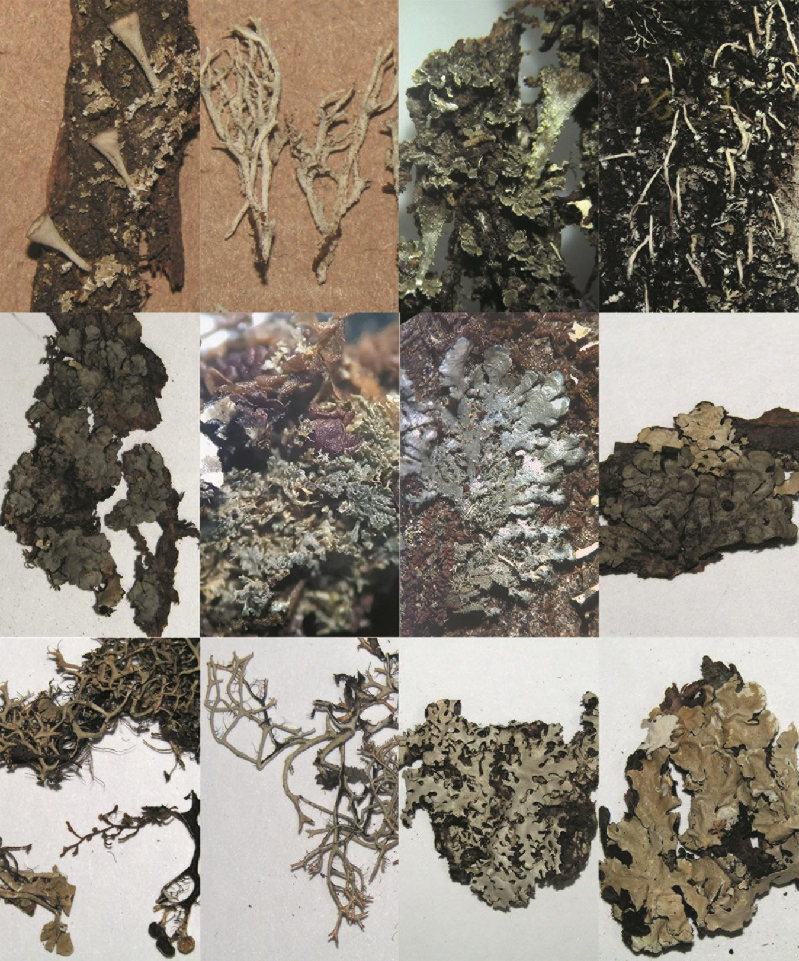
1
5
6
4
3
2
7
8
12
11
10.
9
MSF 1. Especies de macrolíquenes epífitos encontrados en el Parque Nacional Volcán Barú, Panamá. 1. Cladonia chlorophaeae, 2. Cladonia squamosa, 3. Cladonia subsquamosa, 4. Cladonia subradiata, 5. Coccocarpia erythroxyli, 6. Coccocarpia filiformis, 7. Coccocarpia microphylla, 8. Coccocarpia palmicola, 9. Everniastrum cirrhatum, 10. Everniastrum vexans, 11. Hypotrachyna bogotensis, 12. Hypotrachyna costaricensis
SMF 1. Epiphytic macrolichen species found in Baru Volcano National Park, Panama.1. Cladonia chlorophaeae, 2. Cladonia squamosa, 3. Cladonia subsquamosa, 4. Cladonia subradiata, 5. Coccocarpia erythroxyli, 6. Coccocarpia filiformis, 7. Coccocarpia microphylla, 8. Coccocarpia palmicola, 9. Everniastrum cirrhatum, 10. Everniastrum vexans, 11. Hypotrachyna bogotensis, 12. Hypotrachyna costaricensis

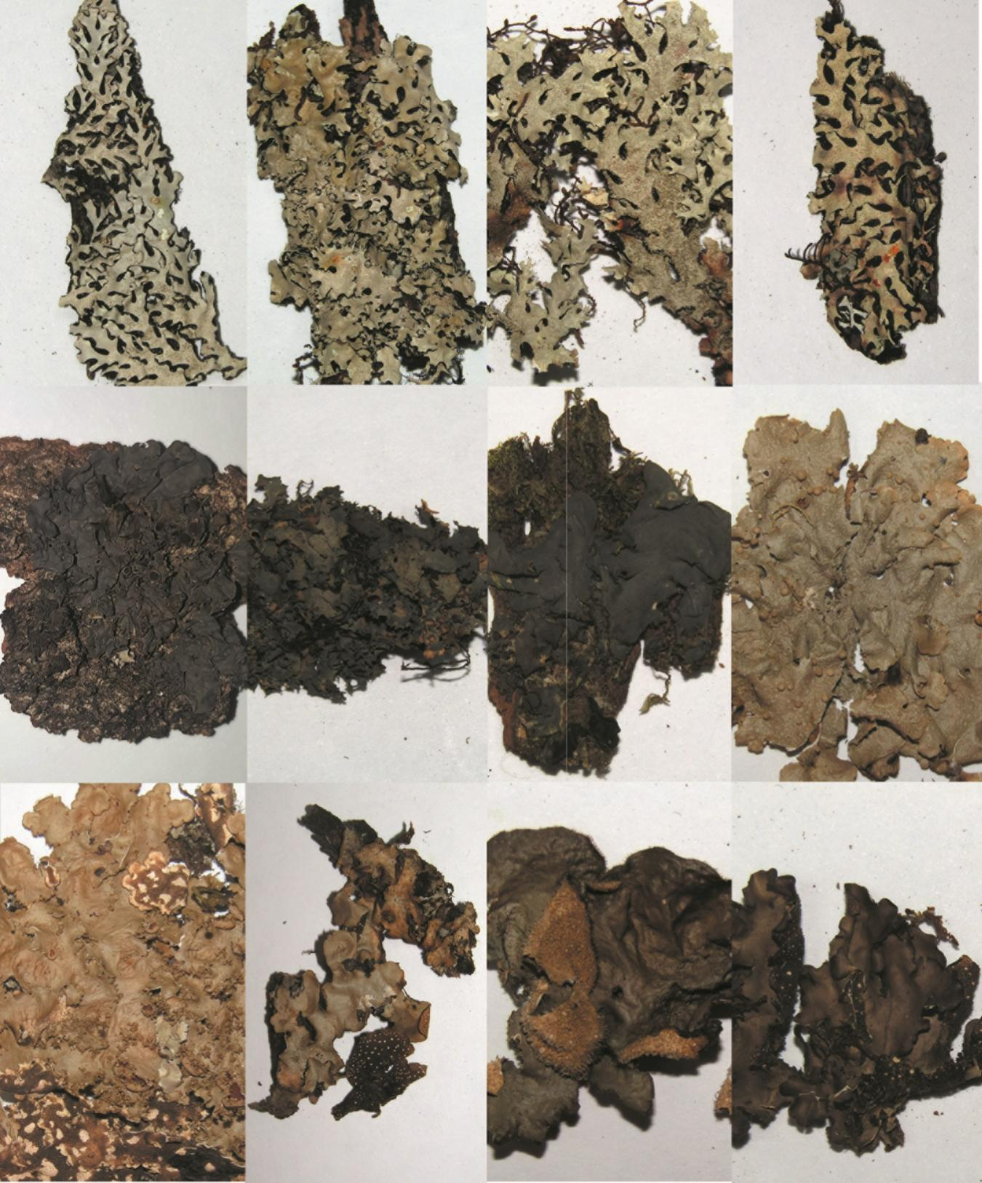

13
14
15
16
17
18
19
20
21
22
23
24
MSF 2. Especies de macrolíquenes epífitos encontrados en el Parque Nacional Volcán Barú, Panamá. 13. Hypotrachyna imbricatula, 14. Hypotrachyna laevigata, 15. Hypotrachyna microblasta, 16. Hypotrachyna reducens, 17. Leptogium azureum, 18. Leptogium burgesii, 19. Leptogium cyanescens, 20. Lobariella crenulata, 21. Lobaria dissecta, 22. Sticta aff. beauvoisii, 23. Sticta fuliginosa, 24. Sticta weigelii
SMF 2. Epiphytic macrolichen species found in Baru Volcano National Park, Panama. 13. Hypotrachyna imbricatula, 14. Hypotrachyna laevigata, 15. Hypotrachyna microblasta, 16. Hypotrachyna reducens, 17. Leptogium azureum, 18. Leptogium burgesii, 19. Leptogium cyanescens, 20. Lobariella crenulata, 21. Lobaria dissecta, 22. Sticta aff. beauvoisii, 23. Sticta fuliginosa, 24. Sticta weigelii.

